Install package
- composer require twilio/sdk
Get key twilio
- TWILIO_AUTH_SID
- TWILIO_AUTH_TOKEN
- TWILIO_SERVICE_SID
- TWILIO_API_SECRET
- TWILIO_API_SID
Login to your Twilio dashboard and copy both your ACCOUNT SID and AUTH TOKEN.
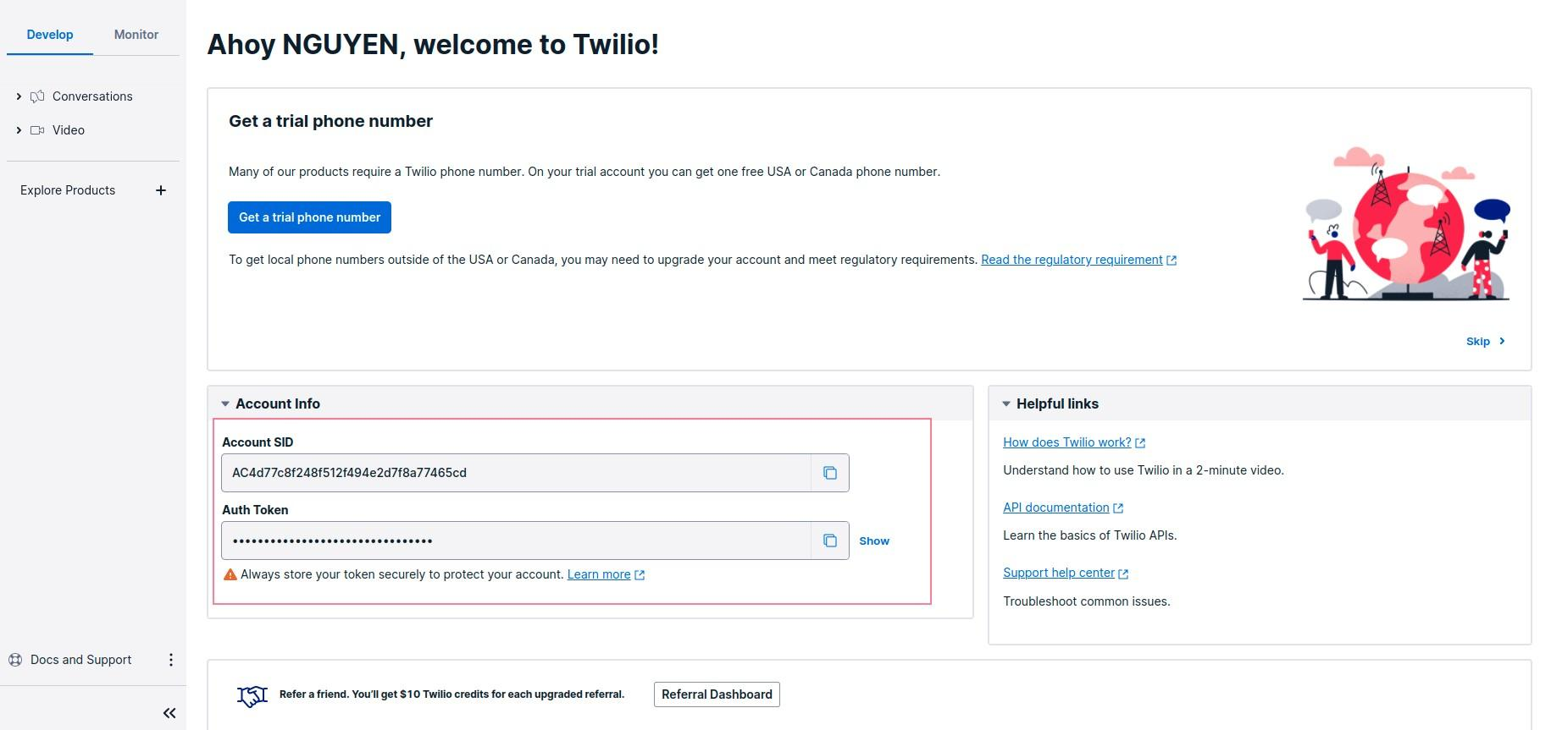

Before you can start using the Twilio Conversation, you need to create a chat service first:
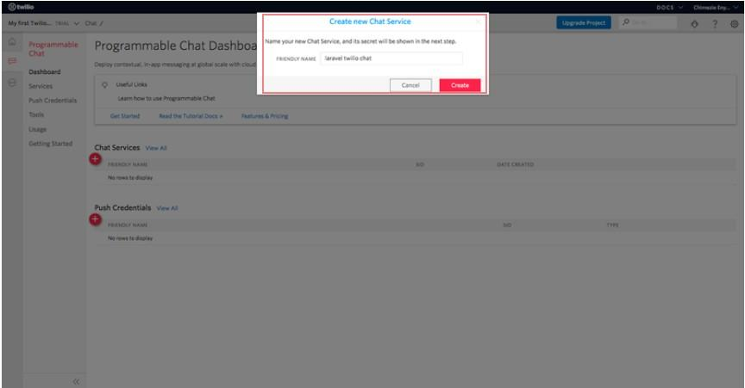

Take note of your SERVICE SID.
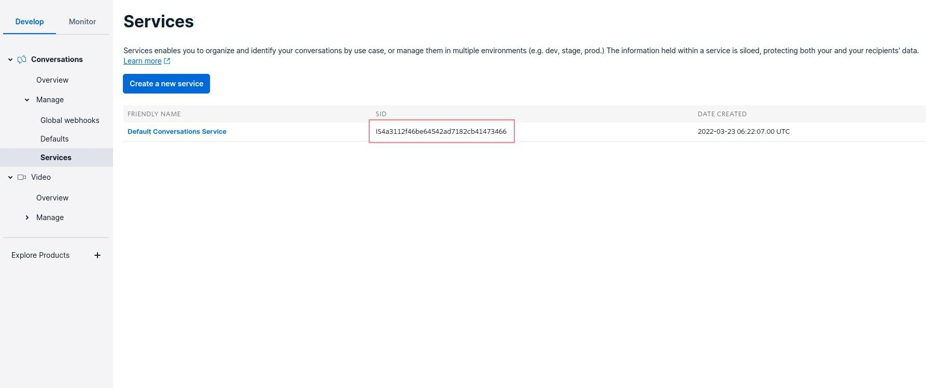

Lastly, you need to create an API key:
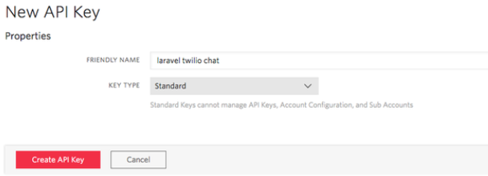
Also, take note of both your API SECRET and API SID.
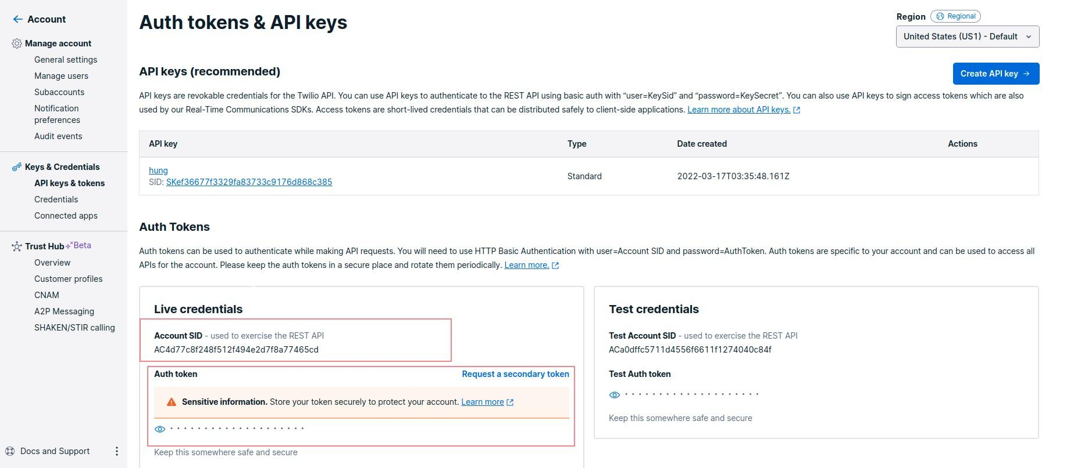

Setup information Twilio to env
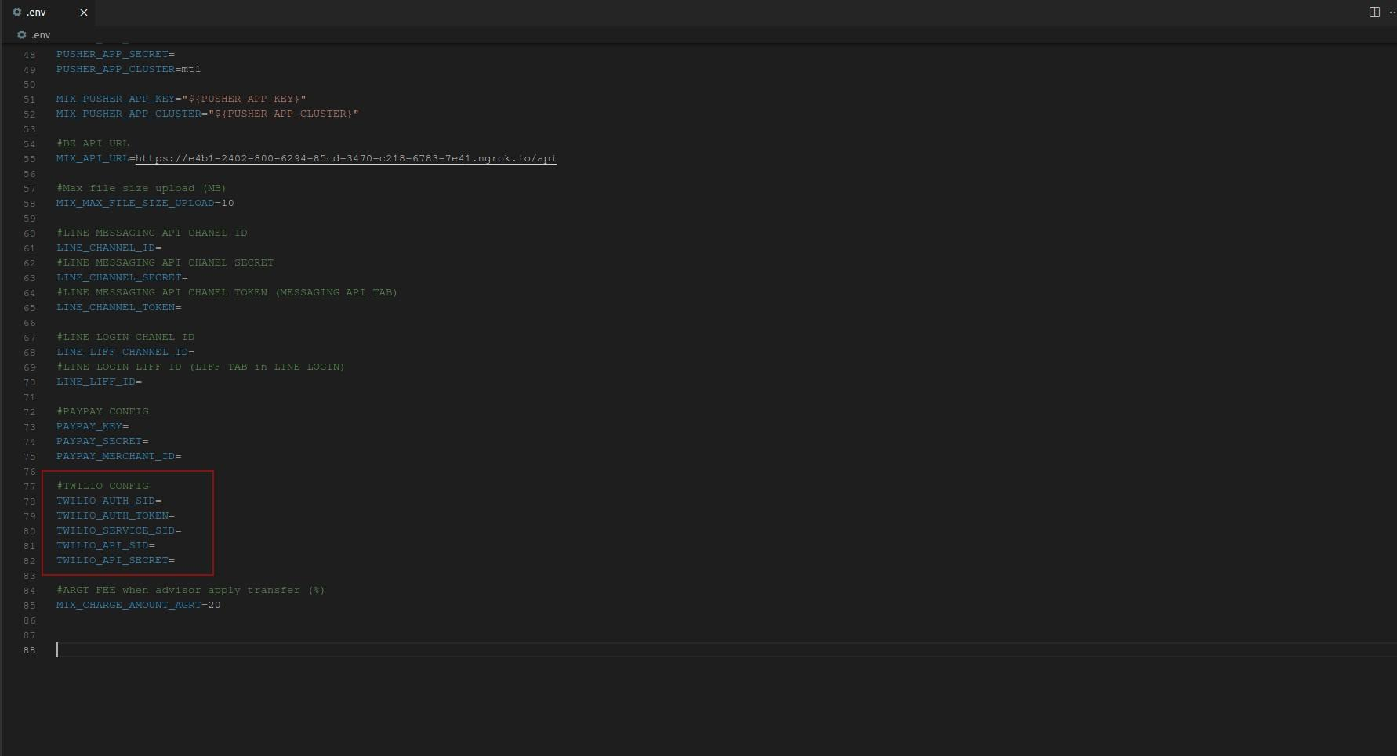
Setup Webhook Twilio
At menu , access Services of Conversation product :
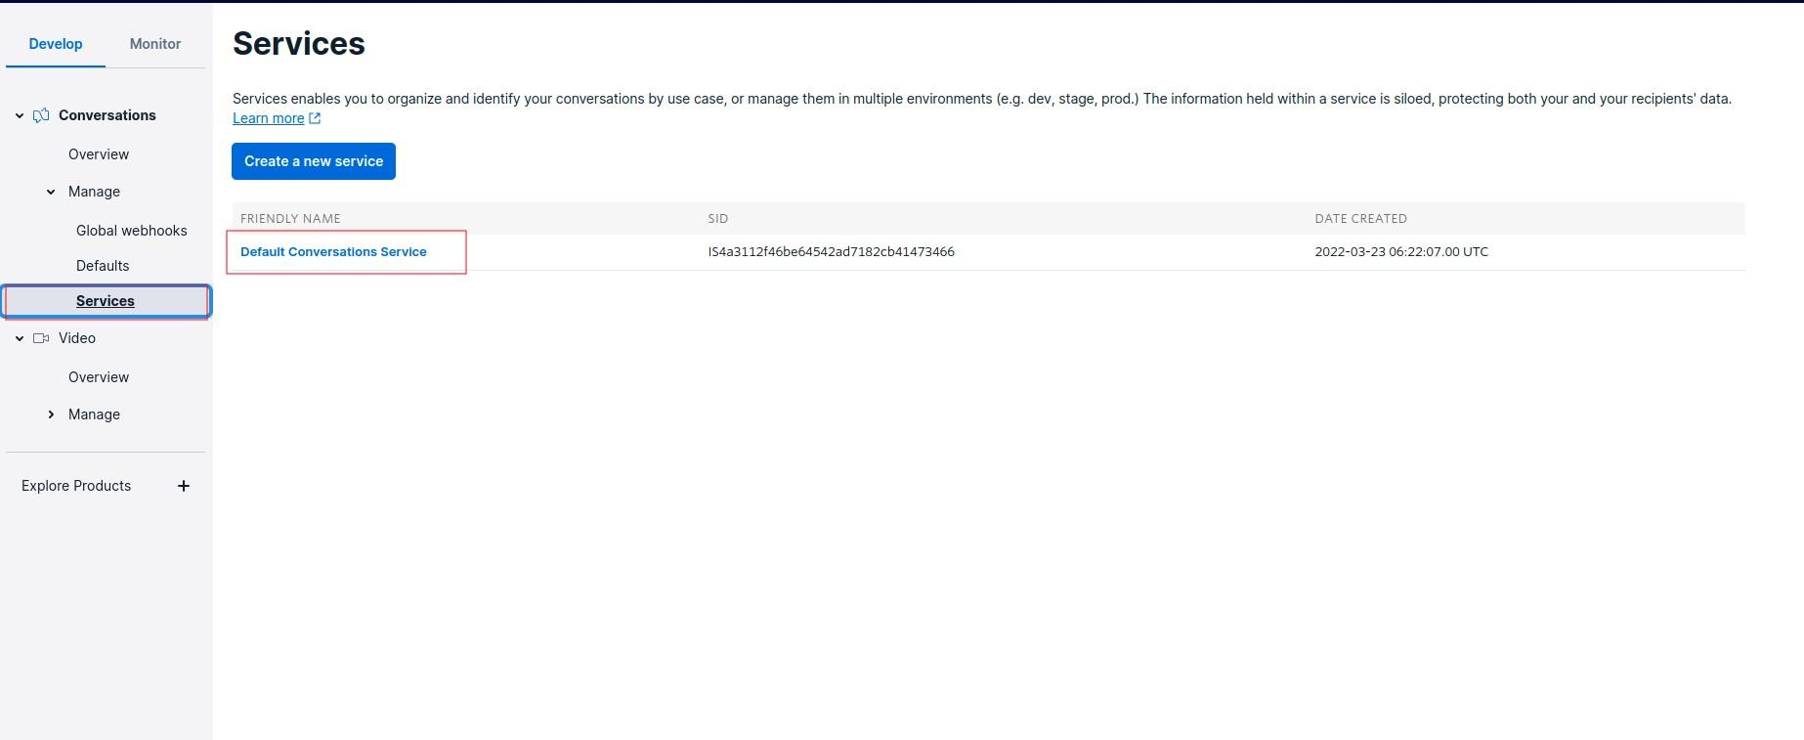

And access webhook of twilio + fill API in Post-Event URL 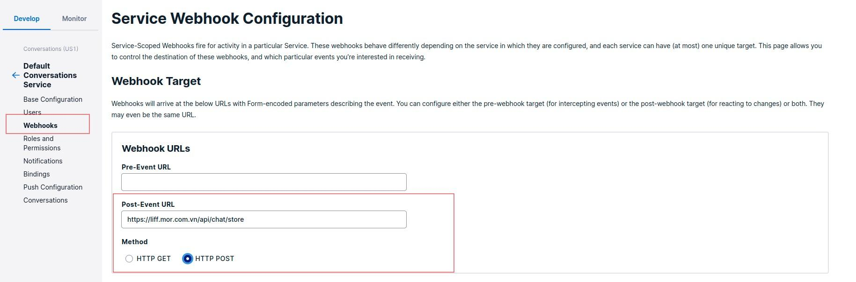
Then , click the onMessageAdd checkbox and save with Save button
