Get key line

- LINE_CHANNEL_ID *= Line Messaging API Channel ID*

- LINE_CHANNEL_SECRET *= Line Messaging API Channel Secret*

- LINE_CHANNEL_TOKEN *= Line Messaging API Channel Token*

- LINE_LIFF_CHANNEL_ID *= Line Login Channel ID*

- LINE_LIFF_ID *= Line Login Liff ID (in tab LIFF - LINE LOGIN)*

Login to your Line Developer console and creat LINE LOGIN + Message API channel

- In Line Login channel , copy channel ID (*Line Login Channel ID*)

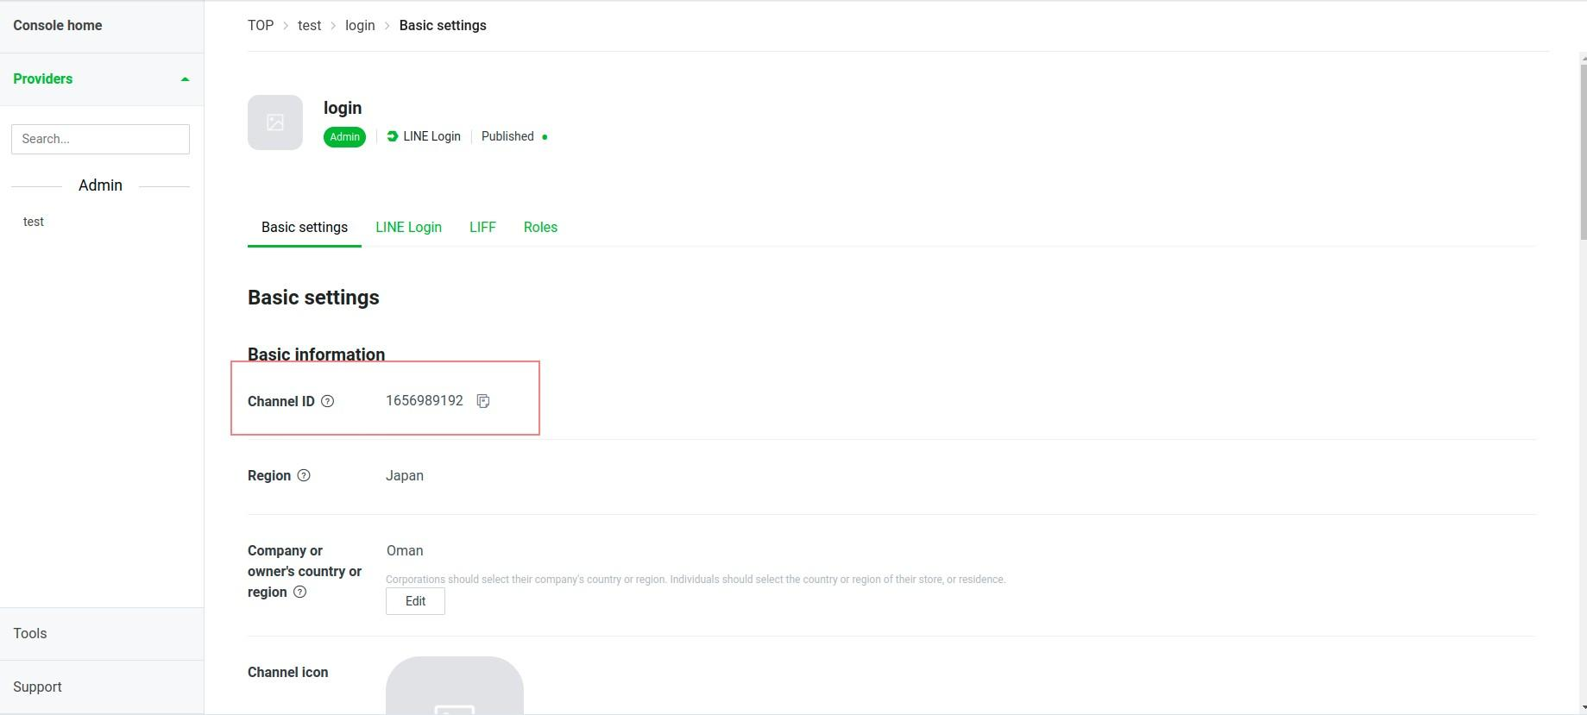

Before that, you need to create Liff app and copy LIFF ID (*Line Login Liff ID (in tab LIFF - LINE LOGIN)*)

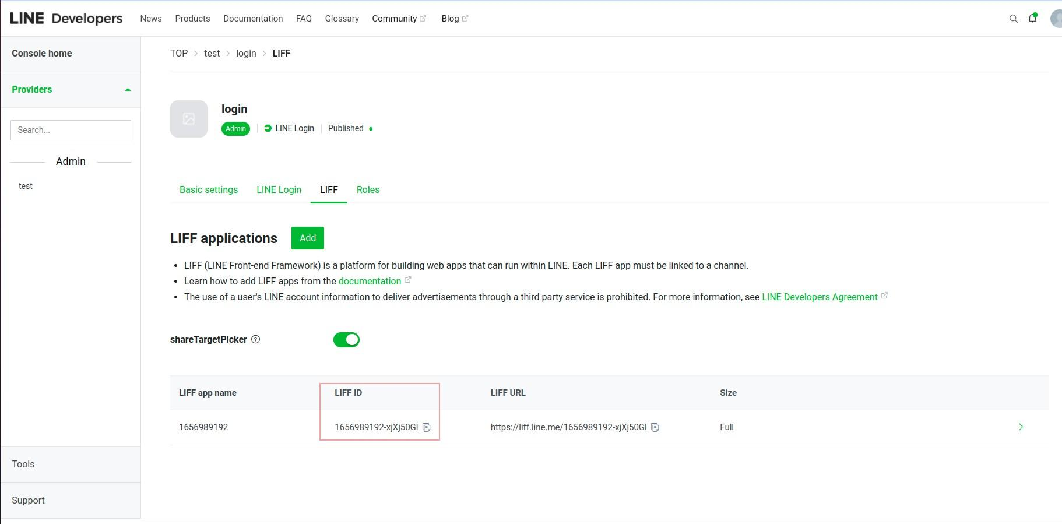

In Message API channel

Take note of your channel id (*Line Messaging API Channel ID*)

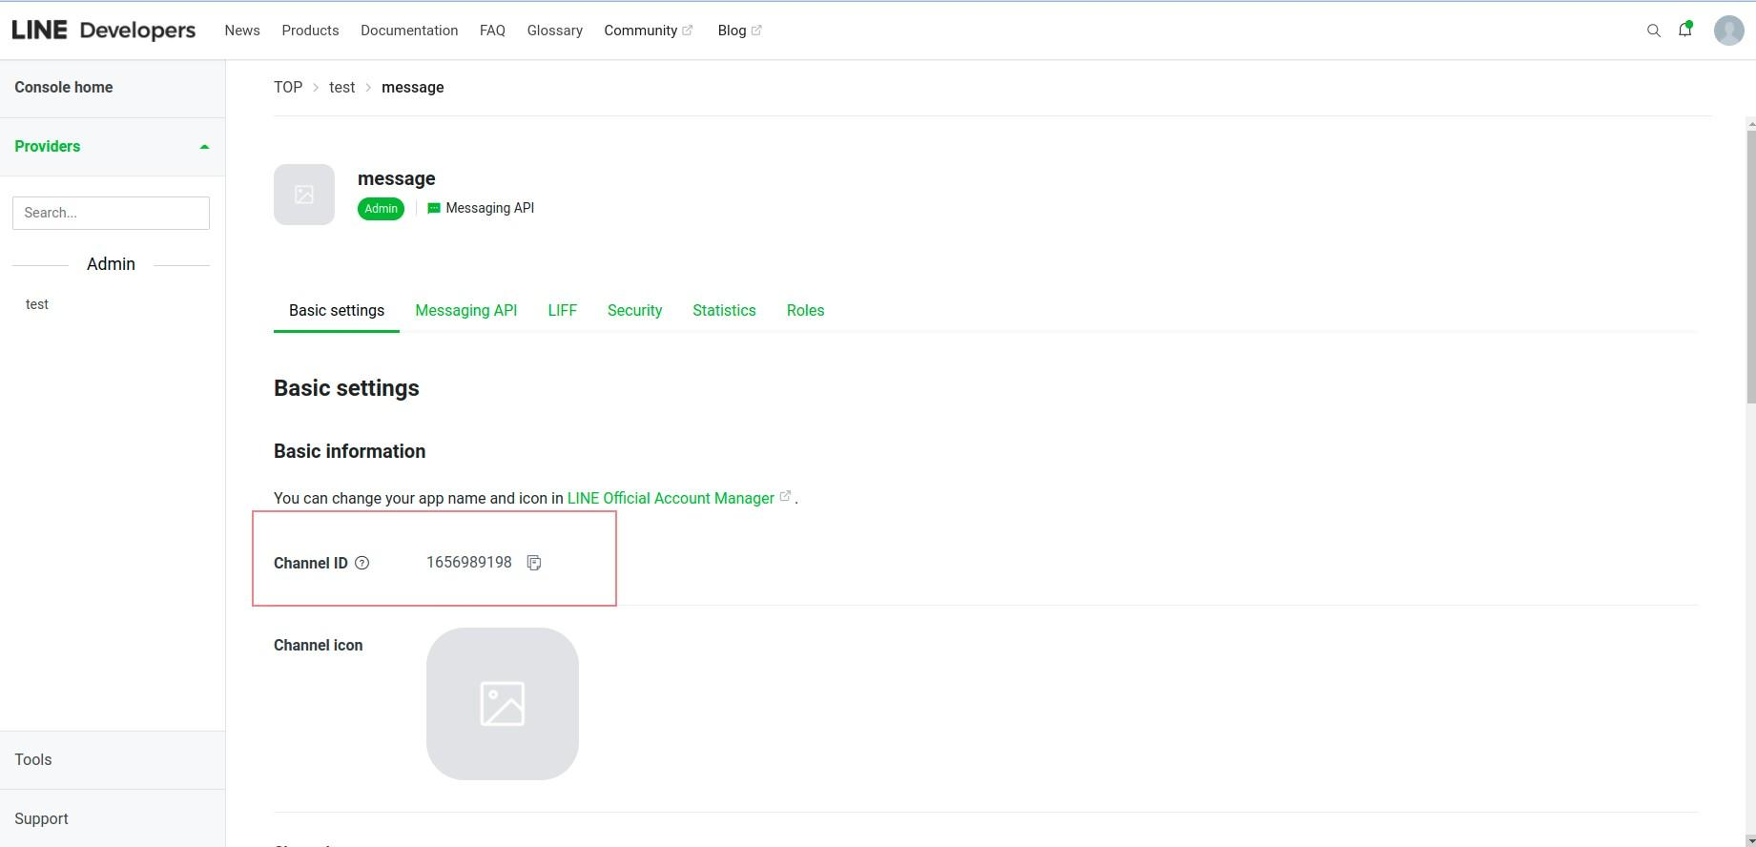

and channel secret (*Line Messaging API Channel Secret*)

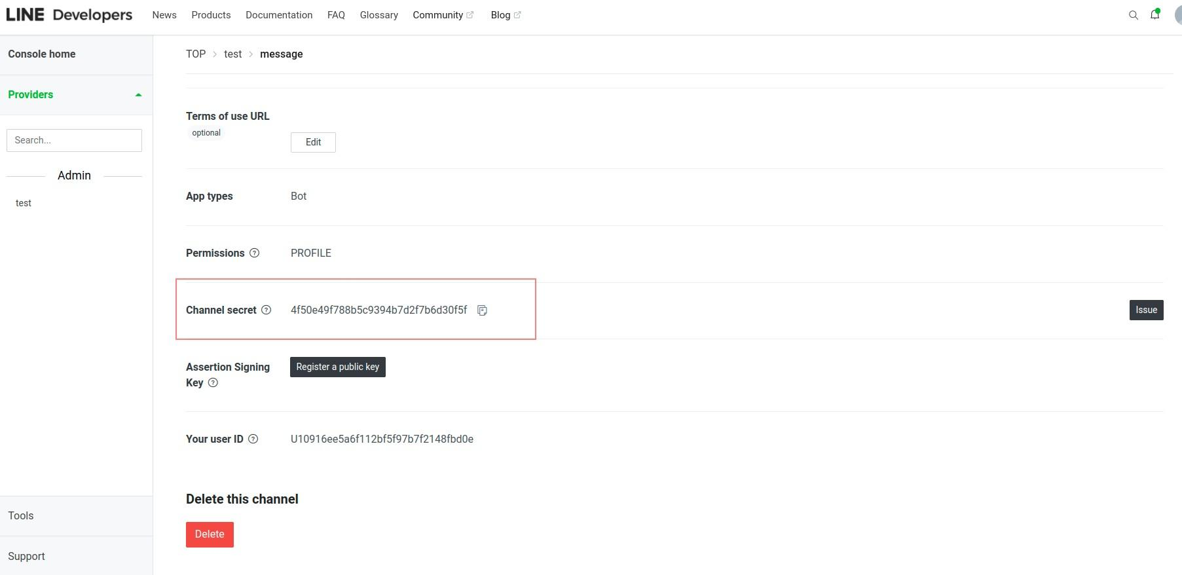

and channel access token (*Line Messaging API Channel Token*)

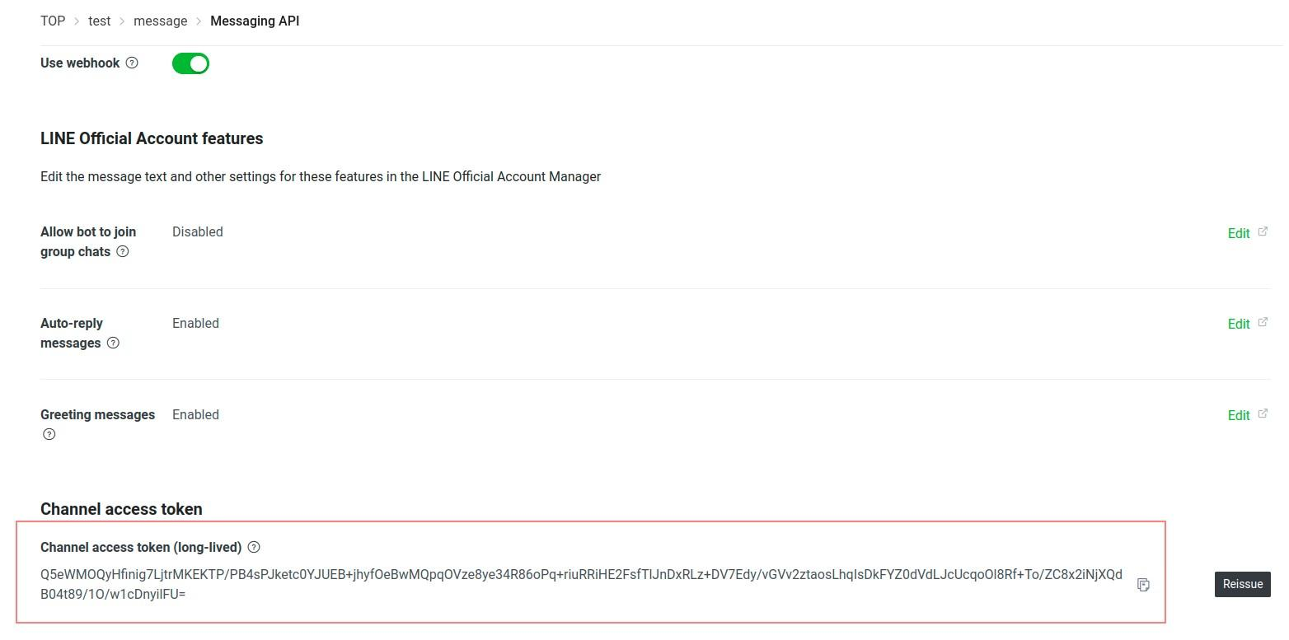

**Setup Line information to env**

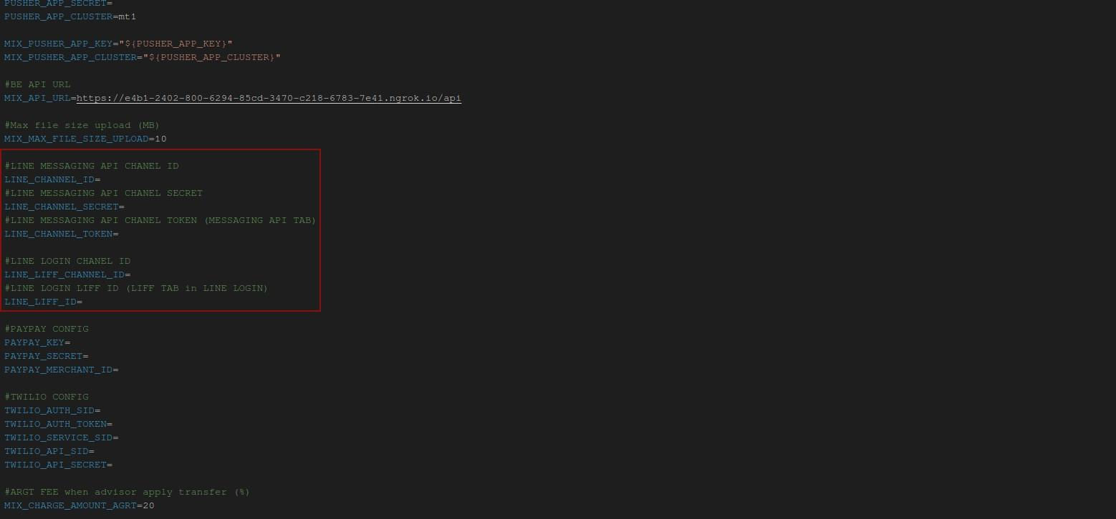

Setup Webhook Line

At menu Messaging API in Messaging API channel,

Fill API in Webhook URL and click the Update button. Then, please verify this webhook

