**Install package**  
- composer require paypayopa/php-sdk

**Get information merchant PAYPAY**- Merchant ID  
- Key ID

- Key Secret

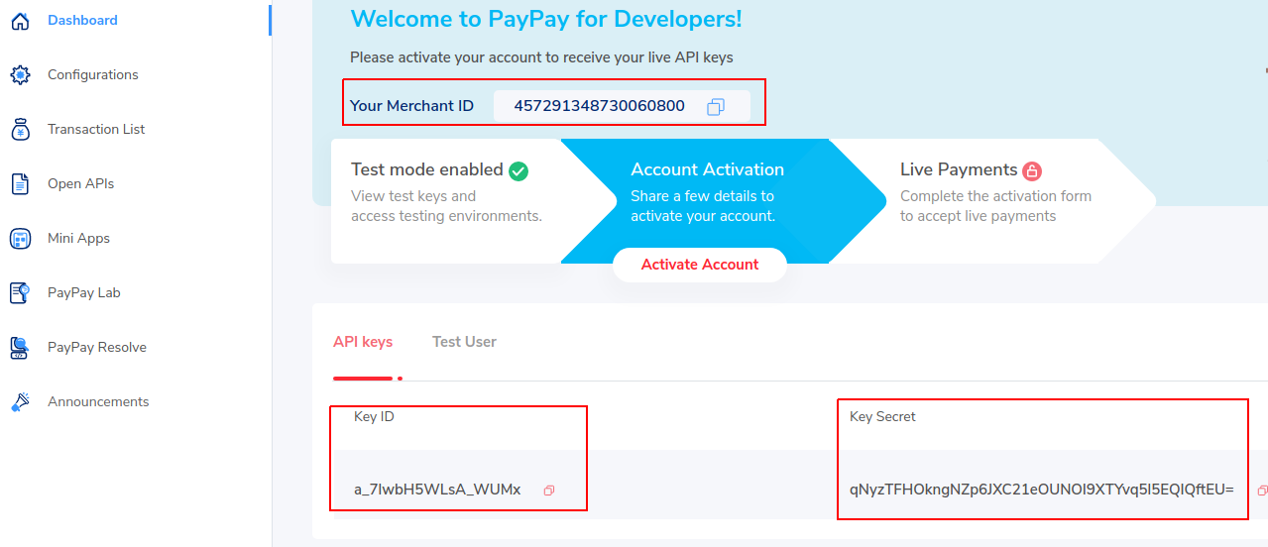- Get Test User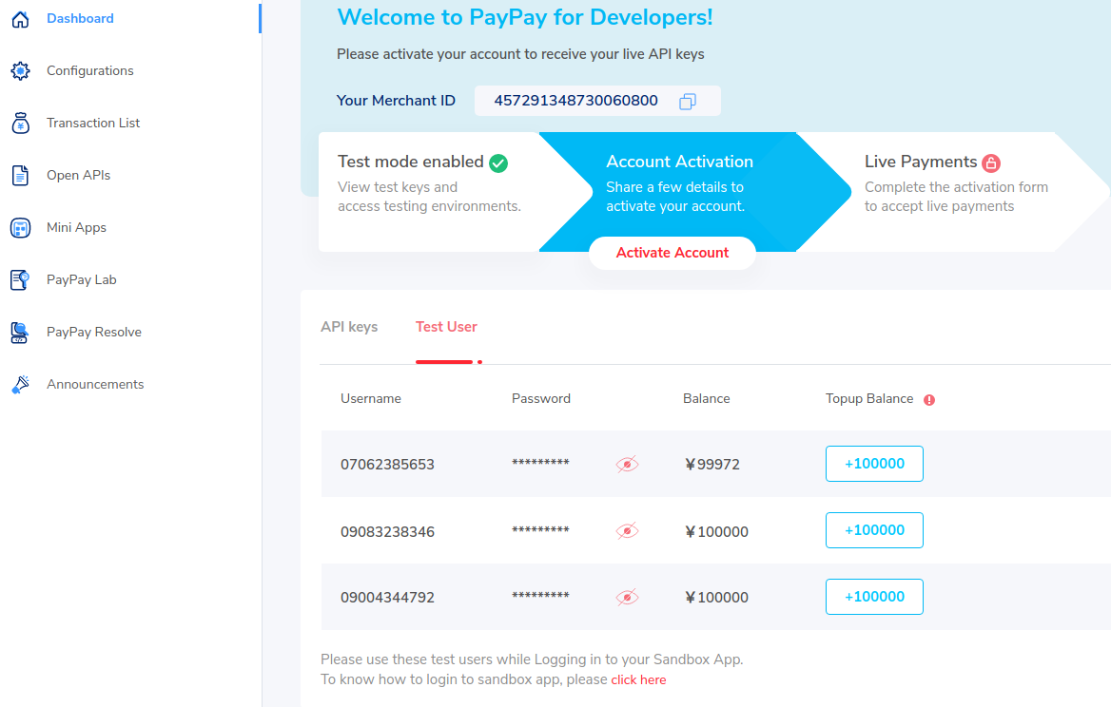

**Setup PAYPAY information to env**

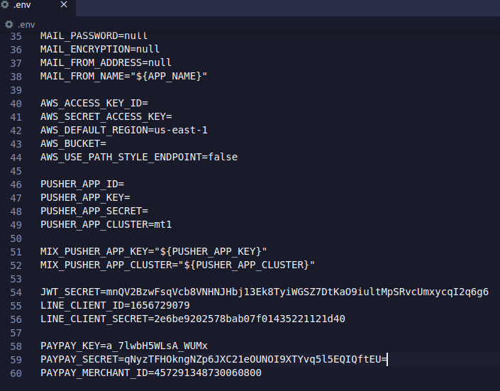  
See more about paypay web payment  
<https://developer.paypay.ne.jp/products/docs/webpayment#dynamic-qr-codeid>

**Setup webhook PayPay**At menu Notifications WebHook & Payment Status WebHook, please add a url so that paypay can return transaction data when there is a payment event on the website.

