**Install package**  
- composer require pusher/pusher-php-server

- npm install --save laravel-echo pusher-js

- Open config/app.php and uncomment the following line in the providers array

// App\Providers\BroadcastServiceProvider

We need to tell Laravel that we are using the Pusher driver in the .env file:

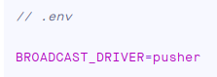

**Get key pusher**

- Create channels pusher

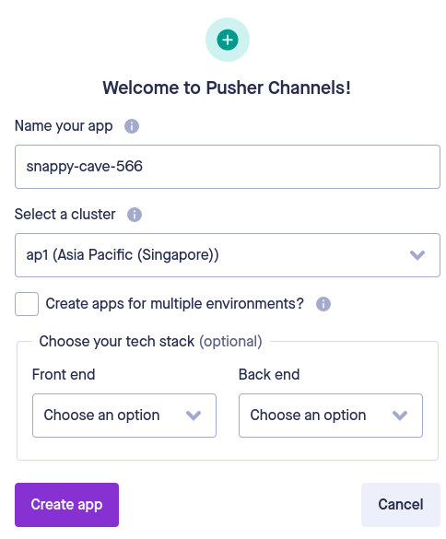

- Get pusher key in page App Keys inside Channels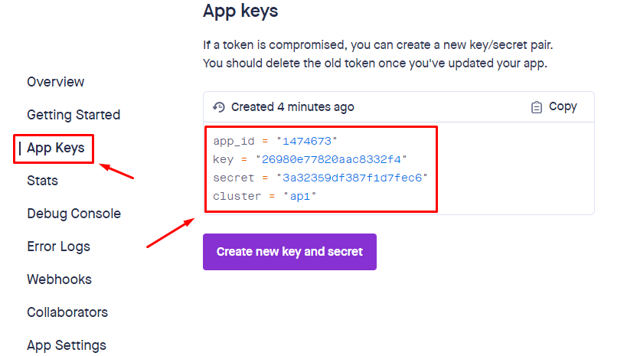

- Next, we need to set the APP_ID, KEY, SECRET and CLUSTER in the environment file

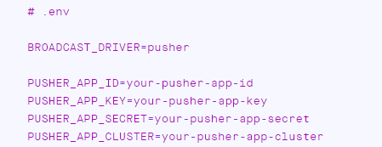

and create a fresh Echo instance in our application’s JavaScript.

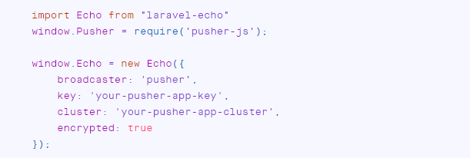

- Testing

The Channels Debug Console can be found within the Channels dashboard and can be used to help you understand what’s happening within your Channels application.

