**Install package**

- composer require twilio/sdk

Get key twilio

- TWILIO_AUTH_SID

- TWILIO_AUTH_TOKEN

- TWILIO_SERVICE_SID

- TWILIO_API_SECRET

- TWILIO_API_SID

Login to your Twilio [dashboard](https://www.twilio.com/console) and copy both your **ACCOUNT SID** and **AUTH TOKEN**.

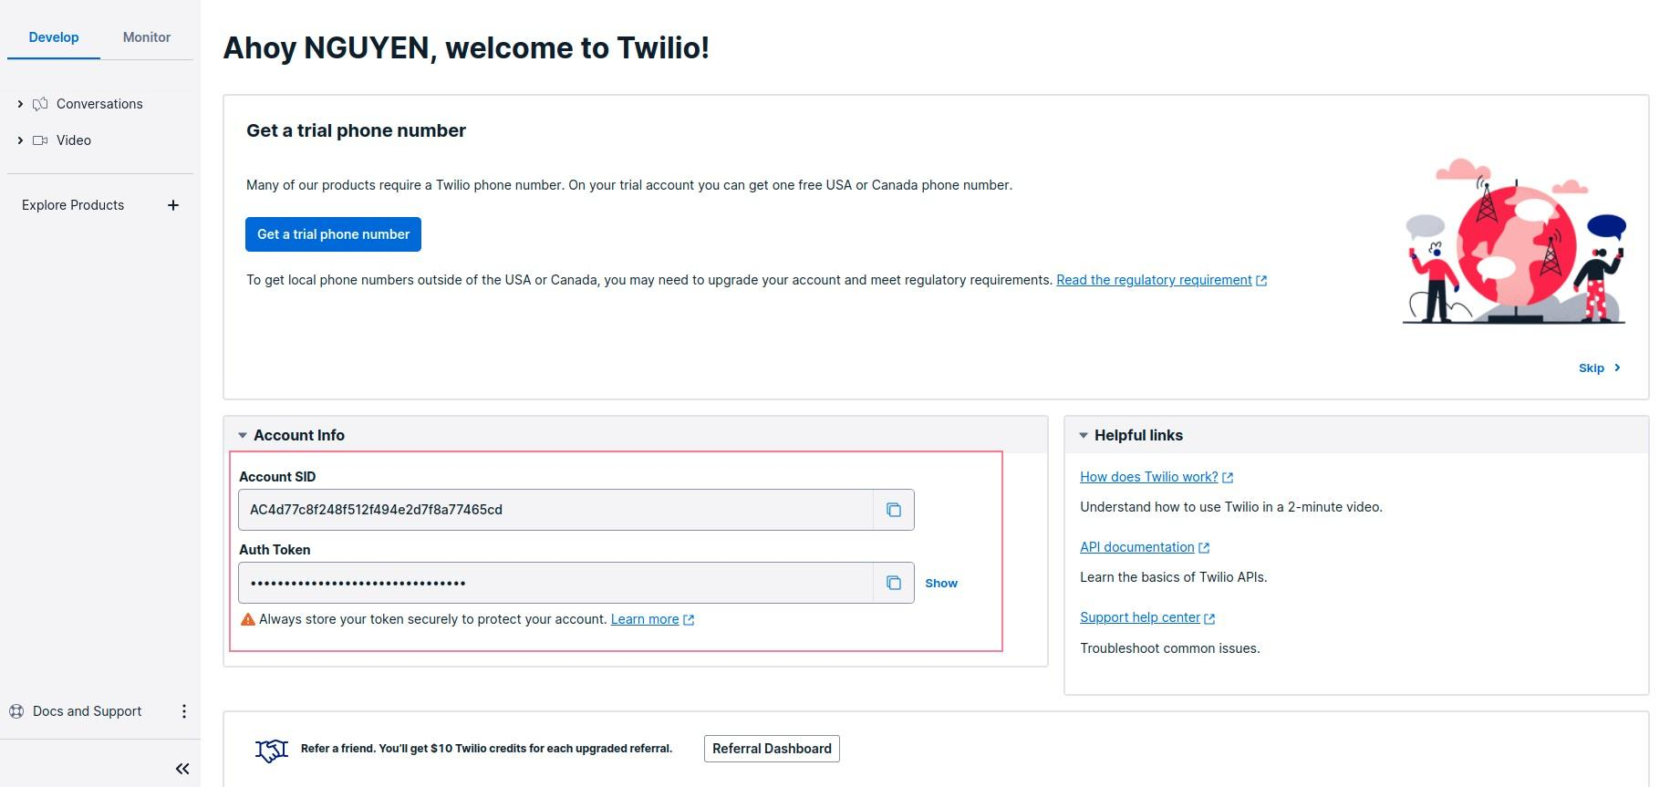

Before you can start using the Twilio Conversation, you need to create a chat service first:

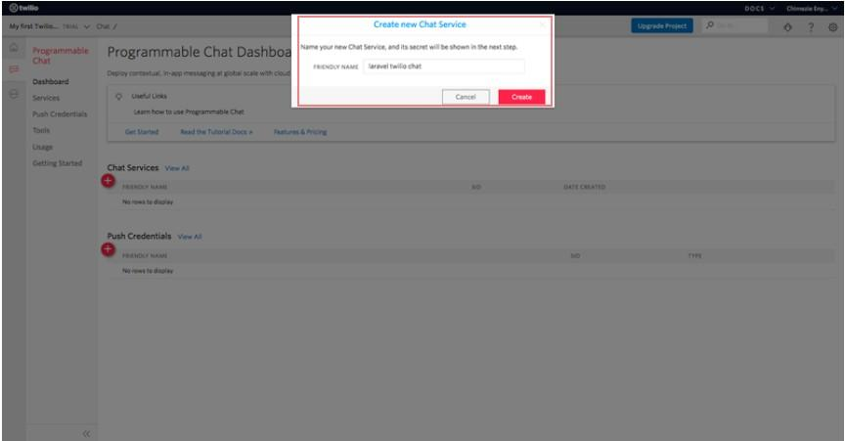

Take note of your **SERVICE SID***.*

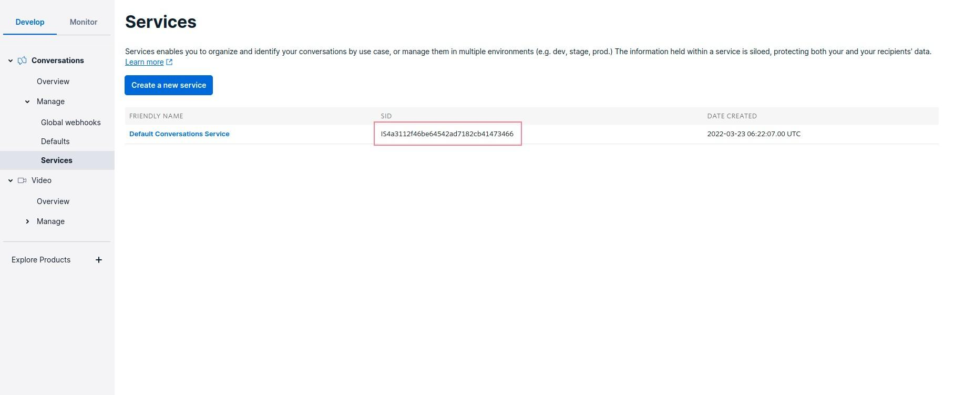

Lastly, you need to create an [API key](https://www.twilio.com/console/chat/project/api-keys):

Also, take note of both your **API SECRET** and **API SID**.

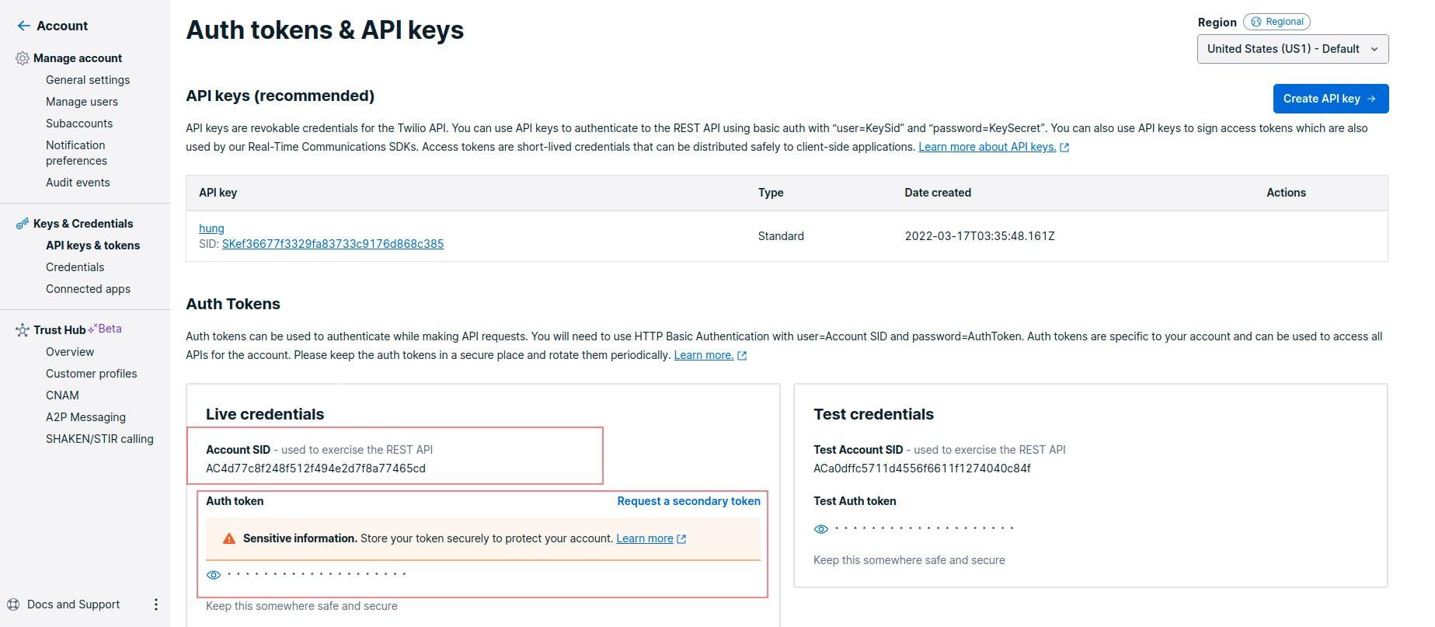

**Setup information Twilio to env**

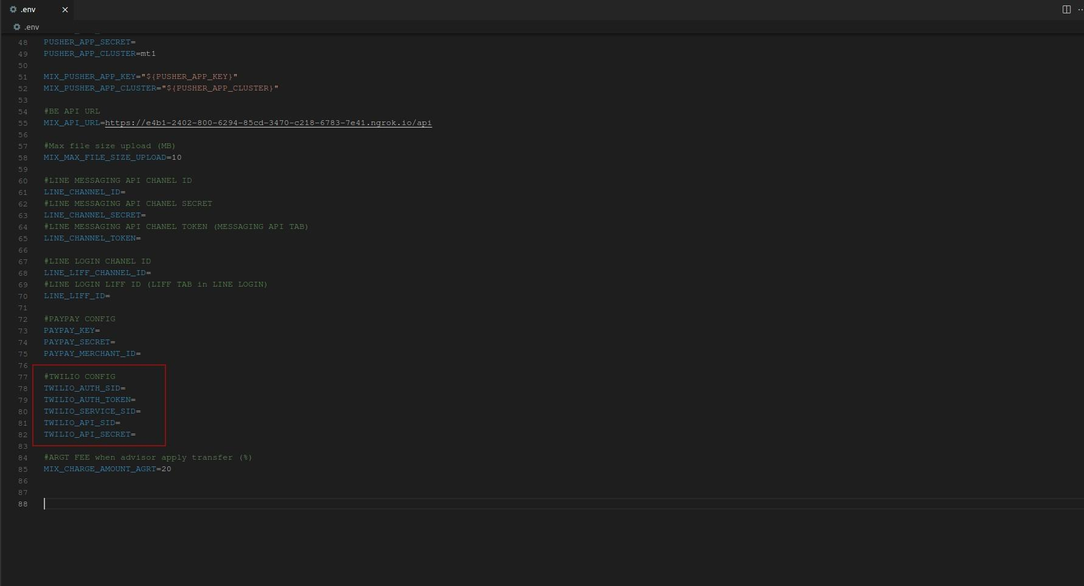

Setup Webhook Twilio

At menu , access Services of Conversation product :

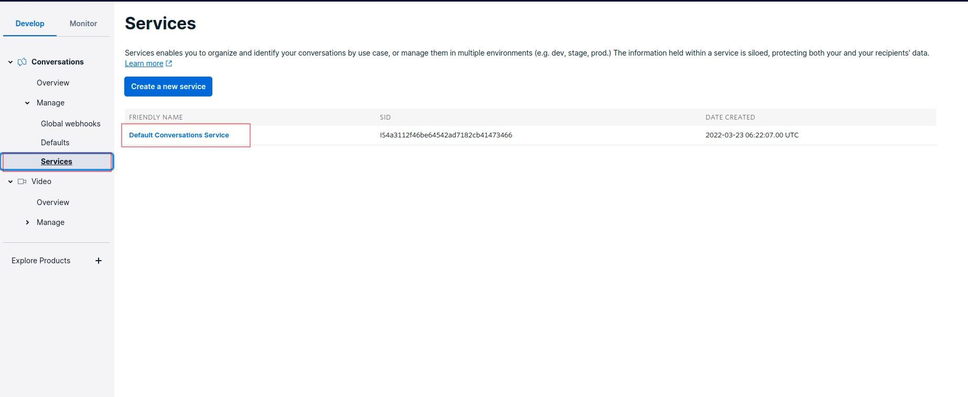

And access webhook of twilio + fill API in Post-Event URL 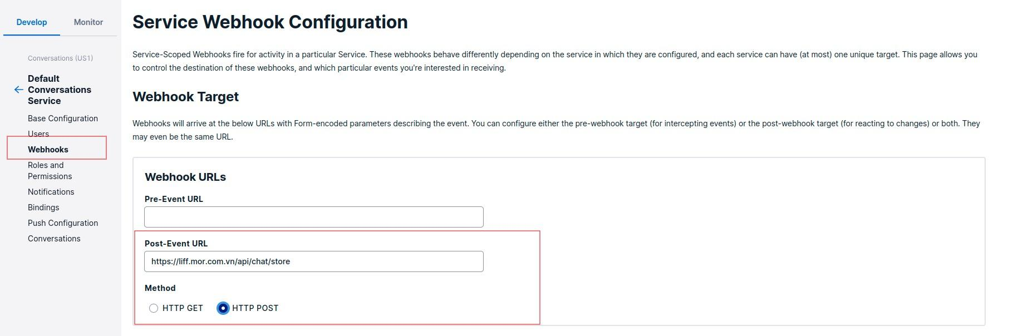

Then , click the onMessageAdd checkbox and save with Save button

