Final Project:
ObjectDraw
Architecture Document

April 10th 2009
Group One
Joseph Trapani
Ben Helppi
Satpreet Singh
Mark D'Souza
Amanda Parker

Contents:

A. Structural View of the system
B. Communication Model Outline – Master control scheme
C. Notes on Technology Choices

Choice of technology: Sockets

Document Networking model
- where the new networking classes fit in with the old architecture
- the hierarchy of classes
- collab-diagram (or something like it) to show client/master initialization, new client connection, peer-list update
- Keep-alive ?
- Chat model and P2P
- Transfer of ownership

Canvas Saving and Loading
-

Reflection
- Tool loading (from file/manual)
- Toal loading (automatic/over network)

Put all old Use Cases?

A. Structural View of the system:

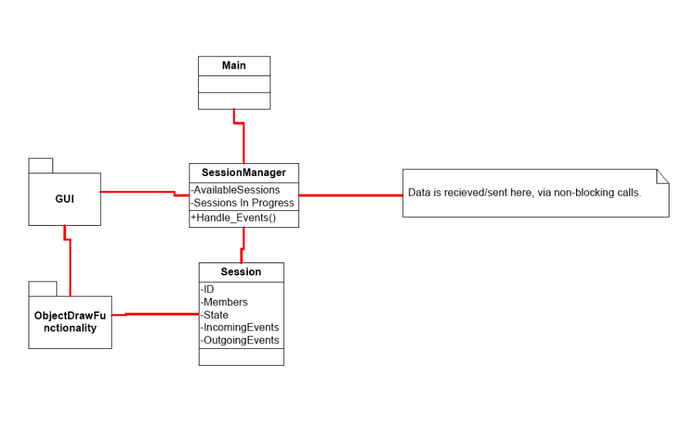
Notes:
- Intent is to have a dedicated session manager, which will abstractly handle a number of sessions.
- Whether it is practical / achievable to have multiple sessions on canvas will be realized as class progresses.
- We intend to make heavy use of object draw functionality, although the design may need to be reworked significantly.

B. Communication Model Outline – Master control scheme

- Establish
  - Machine X creates session ID x1
  - Machine X publishes session x1, so other machines may find it.
  - Machine X may being drawing, will record events e1-e*
- Joining
  - Machine Y sends a request to X to join x1.
  - Machine X accepts, sends state s*, which contains the result of e1-e*
  - Machine X also sends n*, the current network structure state.
- Events
  - Machine X draws further, creating events e*+1 .. e*+*
  - For each event X sends these to all nodes in network
- Others join
  - Machines A-D join network,
  - Machine X accepts them, integrates them, and brings up to state s* (where * is the current state after all events e.)
- Passing ownership in good order
  - Optional step, client C requests session ownership
  - Machine X passes ownership to C.
  - C receives/confirms ownership
  - C informs network of event, and may restructure network as it sees fit.
- Passing ownership in bad order
  - X either quits unexpectedly, or has networking issues.
  - Y being highest in hierarchy decides to take control of the network, and tells A-D that it has done so. State synchronization is done to s*, s* being the latest state the Y has received.
  - If Y dies as well, A-D will automatically go through a mastership decision process resulting in as many nodes that can talk to each other forming their own network
- Fragment
  - If multiple subnets are formed due to spotty communications, when they come in contact again, if every subnet is still in session x1, they may rebuild into a unified network.
  - Basic: largest subnet wins, and their version of data is used. If subnets are of equal size, use start time/randomness to determine master network.
  - More complex/optional models: allow subnets to assert that they want to be master, to become a different session if they don’t want to rejoin, and even to view the fragmented networks current drawing boards.
- Network structure
  - Core algorithms don’t dictate one, but for scalability, a tree structure of some sort may be ideal for network traffic balancing. It can also be used to resolve hierarchy issues. Obviously since there may be reliability issues, bulk data is passed along the tree structure, but layers may be skipped depending on network state, and communication type.
- Other communication schemas
  - A collaborative mode may be setup, where each client can interact with the canvas simultaneously. The master node would process and serialize the events. For example A creates a line, B resizes it, and C deletes it. If C’s event reaches X first, the line would be deleted before it could be resized. Then when B’s event was received by X, it would be discarded since that object no longer existed.
C. Notes on Technology Choices

SOAP (Simple Object Access Protocol)

Benefits:
– Platform-, language-, operating system, etc-, independent access to distributed services.
– Client should be able to find services independent of location, platform, etc.
– Access to services should not be thwarted by firewalls.

Costs:
– Generally, RMI is faster than SOAP.
– Currently, RMI contains greater realm of resources than SOAP.

Java RMI (Java Remote Method Invocation)

Benefits:
- Strong linked with Java (and so also platform-independent etc.)
- In-built mechanisms for security (RMI Security manager)
- Provides quite a high level of abstraction – takes care of a lot of low-level socket/networking/session details

Costs:
- Learning curve: RMI is complicated and requires significant setup effort before it can be used.
- Firewall issues: Requires a separate port to be opened up on the system (by default, RMI uses port 1099)

(Note that we have not yet finalized the technology we intend to use for our project. We shall do so shortly.)

