Estimate the positions of the five markers in meg sensor space.
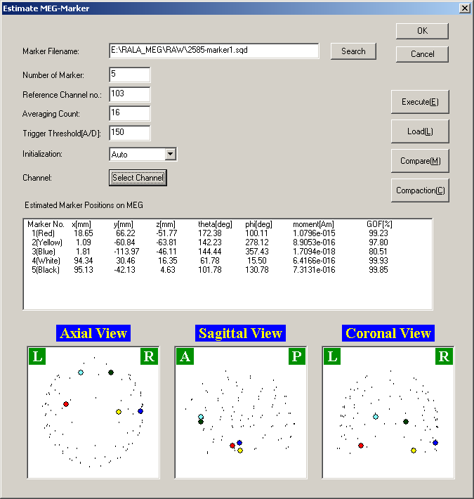

You will need to make note (by hand) of these values as they are not available elsewhere.

Choose three sensors that have high goodness-of-fit estimated locations to do realignment with head shape coordinate frame. One or more of the markers could have a poor estimated location because it was not working properly.

