Learning from open source software projects to improve scientific review

Satrajit S. Ghosh¹, Arno Klein², Brian Avants³, K. Jarrod Millman⁴

¹ Research Laboratory of Electronics, Massachusetts Institute of Technology, Cambridge, MA, USA
² Division of Molecular Imaging and Neuropathology, New York State Psychiatric Institute, Columbia University, New York, NY, USA
³ PICSL, Department of Radiology, University of Pennsylvania School of Medicine, Philadelphia, PA, USA
⁴ Helen Wills Neuroscience Institute, University of California, Berkeley, Berkeley, CA, USA

Correspondence:
Dr. Satrajit Ghosh
50 Vassar St
36-587 MIT
Cambridge, MA 02139, USA

Running title: Code review and scientific publications

Abstract
Over the last decade, scientists, institutions, publishers and funding agencies have made tremendous strides in the way scientific research is disseminated and accessed. With the advent of open-access journals as well as the growing availability of articles freely available online, scientists face an expanding volume of scientific literature. Peer review is the primary means of evaluating the quality and validity of this literature. The current review process for scientific publications is, however, fraught with many problems that undermine the pace, validity, and credibility of science. There are too few reviewers provided with too little information who go unacknowledged, the quality of their reviews goes unmeasured, and reviews take a lot of time and once submitted cannot evolve. In this article, we argue that these problems can be addressed by opening up the review process to include many reviewers, provide them with the data and software to replicate the results of a study, acknowledge their contributions, quantify the quality of their contributions, and ensure that reviews are timely and live on beyond the publication date. We propose that an effective means for implementing these changes would be to enhance current code review systems for software development to support article review.

Keywords: distributed peer review, code review systems, open source software development

Introduction
Peer-reviewed scientific publications continue to be the primary mechanism for dissemination of scientific information and for establishing precedence and credit for scientific research. In the current atmosphere of highly competitive and uncertain research funding, publications are instrumental in determining how resources are distributed, who gets promoted, and in which directions research advances. This has cultivated a publish-or-perish mentality where the focus is on maximizing the number of publications rather than on the validity and reproducibility of research findings, and a decrease in the amount of information apportioned to each article. Moreover, the lack of objective standards for the review process results in great variability in the percentage and quality of articles accepted. This has led to a hierarchy in the status of journals, often quantified by a journal's impact factor (Garfield, 1955). As such, certain journal titles have overtaken the review process as arbiters of quality and significance of research.

Currently the typical review process for an article involves a preliminary screening by a journal editor followed by an anonymous and private review, typically by a small group of (2-5) peers presumed to have expertise in the research topic. The journal editor takes into consideration the reviewers' recommendations to either publish, reject or request revisions of the article. After publication, problems such as fraud or mistakes are addressed via retraction after disclosure or exposure by countering articles or letters to the editor (e.g. Chang et al., 2006). Through the review process and the scientific community's history of policing itself, science is thought to have a self-correcting character. However, with the difficulty for individual reviewers to review the increasing number and complexity of articles, and the use of journal impact factors as proxies for evaluations of individual articles, the integrity of the review process, and indeed of science, suffers (Poschl and Koop, 2008; Smith, 2006). Another danger to the review process, and to scientific articles themselves, is that they are not keeping pace with the dramatic advances in computing resources by which results are obtained and advances in media by which results are disseminated.

In contrast, during open source software development, the typical review process for programs (code review) during software development is often open, collaborative, and interactive, engaging many participants with varying levels of expertise. There is a clear process by which comments get addressed and new code gets integrated into the main project. An example workflow for accepting code patches into the Google Android project is shown in Figure 1. Since computer programs are much more structured and objective than prose, it is more amenable to standardization and therefore to review. These code review systems also take advantage of some of the latest technologies and have the potential to be used for publication review. Despite all of these differences, the purpose of code review systems mirror the purpose of publication review to increase the clarity, reproducibility and correctness of contributions.

For the publication review process to continue to play a critical role in science, there are a number of problems that need to be addressed. In this article, we list five problems and potential solutions that derive from distributed code review in open source software development.

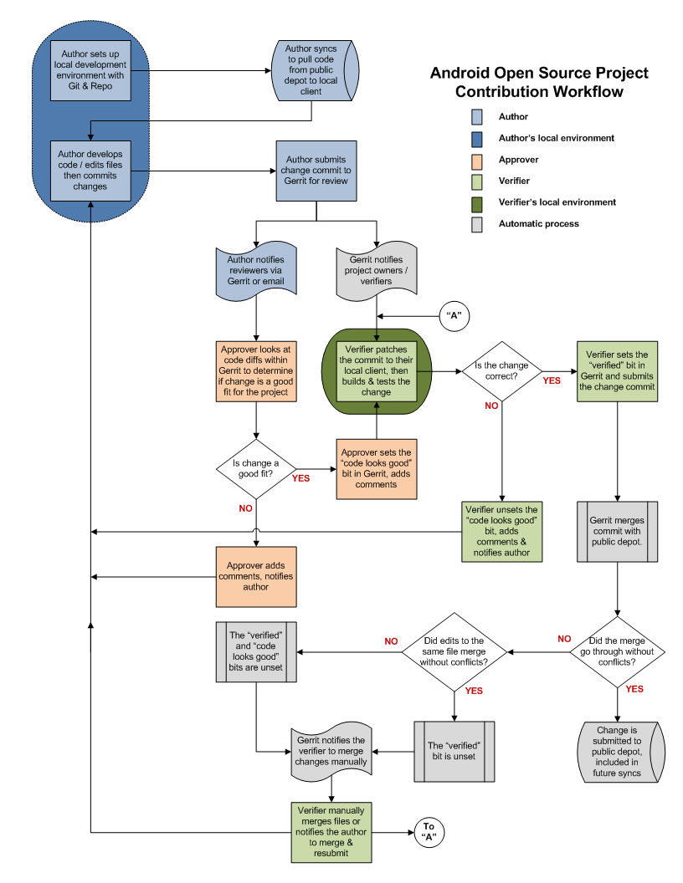
Figure 1. A patch submission workflow for the Android project (http://source.android.com/source/life-of-a-patch.html)

Problems with current peer-review process

1. Reviewers are expected to have comprehensive expertise.
Reviewers are expected to work in isolation, unable to discuss the content of an article with the authors or other reviewers. When faced with an article that may be authored by half a dozen or more experts in their respective disciplines, how could a few reviewers be expected to have the range of expertise necessary to adequately understand and gauge the significance (or insignificance) of all aspects of a given article? Why are the different components of an article, including the background, experimental design, methods, analysis of results, and interpretations handed over as a package to each reviewer, rather than delegated to many experts in each domain? Realistically, it is common practice for a reviewer to criticize portions of an article that he or she understands, is interested in, has time to read, and takes issue with, while falling silent on the rest of the article. This leads an editor to assume these silences are indicators of tacit approval. The unrealistic expectations placed on each of the reviewers, coupled with the delayed and sequential interactions they have with the authors and editors, have made the review process unnecessarily tedious, slow, and inefficient.

2. Reviewers do not have sufficient access to methods and materials to evaluate a study.
The typical review process does not require submission of data or software associated with an article (Association for Computing Machinery Transactions on Mathematical Software was an early exception), and the descriptions provided in methods sections are often inadequate for replication. This makes it impossible for a reviewer, if so inclined, to fully evaluate an article’s methods, data quality, or software, let alone to replicate the results of the study. Failing to expose the methods, data, and software underlying a study can lead to needless misdirection and inefficiency, and even loss of scientific credibility. One example is the case of Geoffrey Chang, whose rigorous and correct experimental work was later retracted due to a software bug that undermined the paper's conclusions (Chang et al., 2006).

3. Reviewers are not acknowledged.
Review is currently considered one's unpaid "duty" to maintain the standards and credibility of scientific research. The reviewer stands to gain by early exposure to relevant areas of research, while a publisher stands to gain financially through either publication or subscription fees. There is little motivation for potential reviewers to participate in the review process, and there is a lack of acknowledgment for their services that could factor into their evaluations for promotion and funding opportunities.

4. There is no measure of the quality of a review.
There is no attempt to quantify the quality, strength, impartiality, or expertise of the reviews or reviewers. Without measures associated with the quality of any portion of a review, the community is forced to trust the judgment of the editor and the journal’s impact factor as proxies for quality. This prevents external scrutiny and makes it impossible to evaluate or standardize the review process.

5. Reviews take a lot of time, and once submitted cannot evolve.
A lengthy review process holds up grant submissions, funding of research programs, and the progress of science itself. And even after this process, for the vast majority of articles none of the information (criticism or feedback) generated during the review is made publicly available (BioMedCentral is one counterexample). Furthermore, after an article has been published, the review process simply ends even for those who participated, as if the work and interpretations of the results are sealed in a time capsule. Data, methods, analysis, and interpretations of the results are all a product of their time and context, and at a later time may not stand up to scrutiny or may yield new insights.

Proposed re-design of the peer review process

While there are notable examples of journals (e.g., Frontiers - frontiersin.org, BioMedCentral - biomedcentral.com, PLoS One - plosone.org) and paper archives (arXiv.org) that address some of the above individual problems, the vast majority of journals do not. In this section, we propose an open evaluation system for scientific publishing that draws on the ideas, experience, and technologies recently developed to support community code review in open source software projects. Opening up the review process to everyone, not just to a select few anonymous reviewers, has the potential to address every one of the problems raised above. For each of the problems listed above, we first describe our proposed solution, then highlight the relevance of current code review systems in addressing the problem and finally describe enhancements to the current systems to support our proposed solution.

1. Distribute reviews to many reviewers.
Reviewers would no longer work in isolation or necessarily in anonymity, benefiting from direct, dynamic, and interactive communication with the authors and the world of potential reviewers. This would help reviewers to clarify points, resolve ambiguities, receive open collegial advice, attract feedback from people well outside of the authors' disciplines, and situate the discussion in the larger scientific community. Because each reviewer's feedback can be focused on portions of the article that reflect the reviewer’s specialty or area of interest, there is less burden placed on any one reviewer, enabling a more comprehensive and timely review.

In case there is a fear of disclosure prior to publication or of an overwhelming amount of participation in a review where anyone could be a reviewer, there are at least three types of compromise available. One would be to assign certain reviewers as moderators for different components of the article, to lessen the burden on the editor. A second would be to restrict the number of reviewers to those solicited from a pool of experts. This would still improve scientific rigor while lessening the burden on each individual reviewer, as long as they review specific components of the article they are knowledgeable about. A third would be to conduct a preliminary review consisting of a limited and expedited review process prior to the full and open review. At different stages of such a tiered review, reviewers might be assigned different roles, such as mediator, editor, or commenter.

Relevance of code review systems
In the same manner that articles are submitted for review and publication in journals, code in collaborative software projects are submitted for review and integration into a codebase. In both scientific research and in complex software projects, specialists focus on specific components of the problem. However, unlike scientific review, code review is not limited to specialists. When multiple pairs of eyes look at code, the code improves, bugs are caught, and all participants are encouraged to write better code. Existing code review systems such as Gerrit (http://code.google.com/p/gerrit) as well as the collaborative development and code review functionality provided by hosting services like GitHub (http://github.com) are built for a distributed review process and provide reviewers the ability to interact, modify, annotate and discuss the contents of submitted code changes.
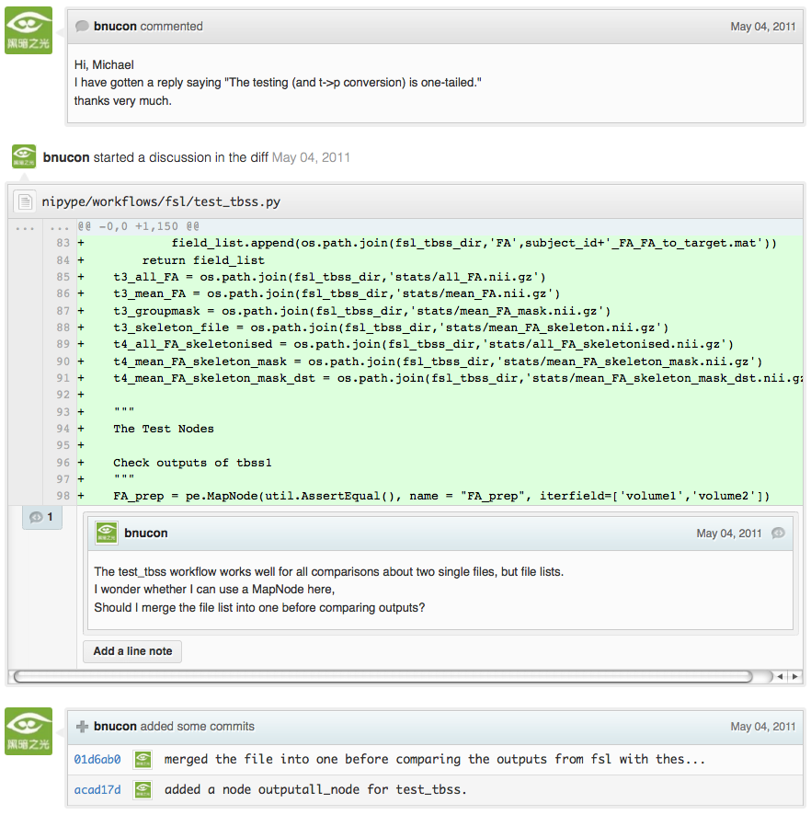
Figure 2. A snapshot from the web interface of a request to merge code into the NiPyPE (nipy.org/nipype) project on GitHub, demonstrating part of a discussion thread, inline commenting of code (for line 98) as well as updates on code changes taking place as a function of the discussion.

Indeed, the purpose of these systems mirror the purpose of scientific review -- to increase the clarity, reproducibility and correctness of works that enter the canon. While no journals provide a platform for performing such open and distributed review, the Frontiers journals do provide an interactive, but non-public discussion forum for authors and reviewers to improve the quality of a submission after an initial closed review. In GitHub, code is available for everyone to view and for registered GitHub members to comment on and report issues on using an interactive web interface. The interface combines a discussion forum that allows inserting comments on any given line of code together with a mechanism for accepting new updates to the code that fix unresolved issues or address reviewer comments (an example is shown in Figure 2). These interactive discussions become part of a permanent and open log of the project.
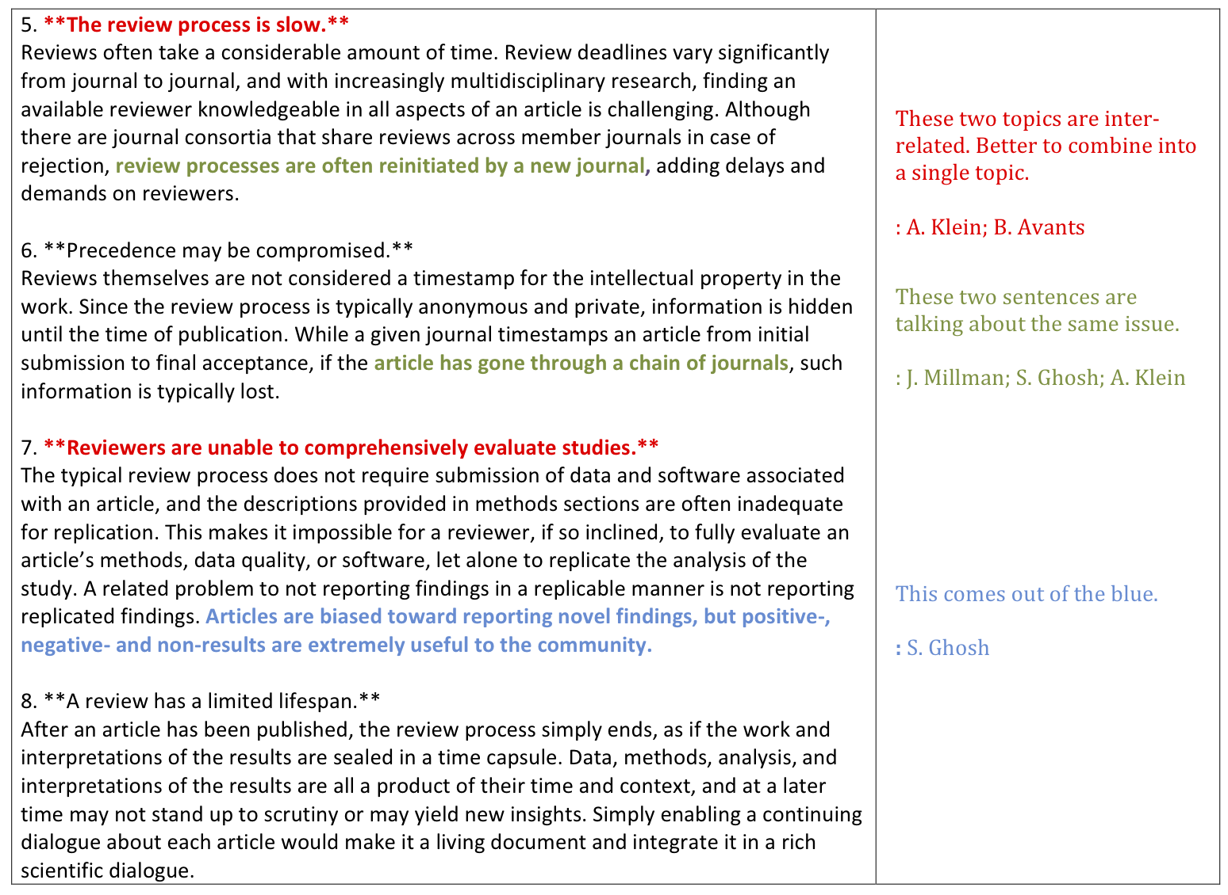
Figure 3. Mock-up of a modified commenting system. The left panel shows the annotated text from a prior revision of this article and the right panel shows the reviewer comments. Comments can be linked to multiple sections of the text and by multiple reviewers.

Enhancing code review systems for article review
These existing code review systems, while suitable for code, have certain drawbacks for reviewing scientific articles. For example, the GitHub interface allows line-by-line commenting which reflects the structure of code. But commenting on an article’s text should follow the loose structure of prose with comments referring to multiple words, phrases, sentences or paragraphs in different parts of the text. For example, a reviewer might come across a sentence in the discussion section of an article that contradicts two sentences in different parts of the results section. The interface should allow multiple reviewers to expose contradictions, unsubstantiated assumptions, and other inconsistencies across the body of an article or across reviews for the article. A mock-up of such a system is shown in Figure 3.

2. Provide reviewers materials and methods to perform comprehensive evaluation.
In a wide-scale, open review, descriptions of experimental designs and methods would come under greater scrutiny by people from different fields using different nomenclature, leading to greater clarity and cross-fertilization of ideas. Software and data quality would also come under greater scrutiny by people interested in their use for unexpected applications, pressuring authors to make them available for review as well, and potentially leading to collaborations, which would not be possible in a closed review process.
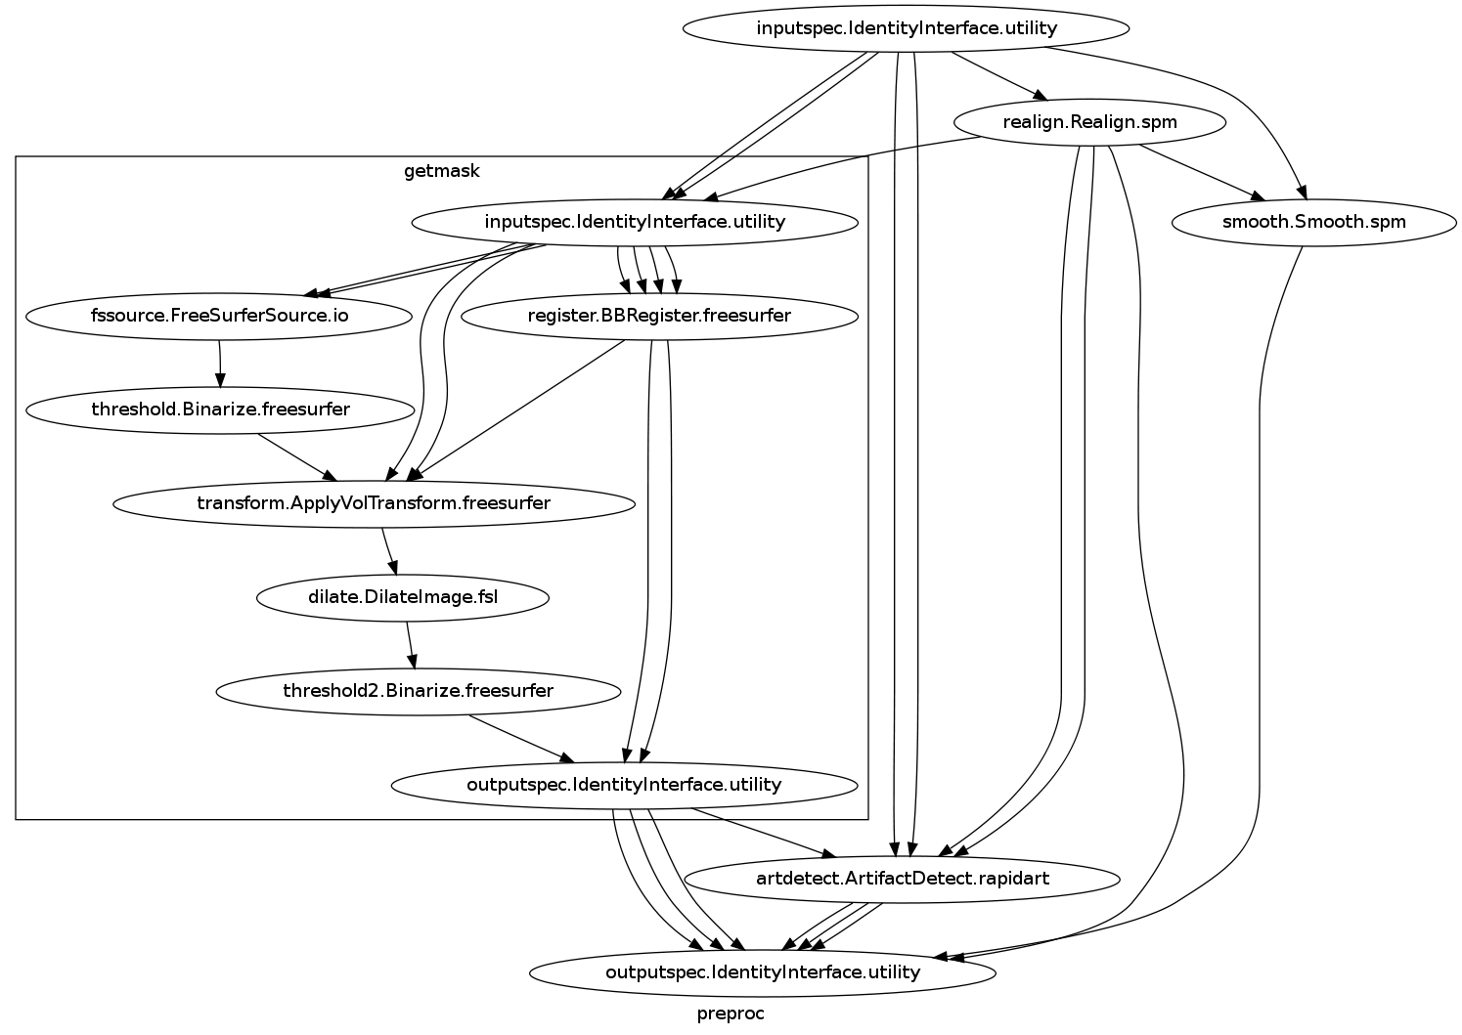
Figure 4: A graph generated by the NiPyPE software package captures a preprocessing workflow for brain image analysis showing which algorithms and software packages were used. Such information can complement an article’s methods section.

We propose that data and software be submitted together with the article. This not only facilitates transparency for all readers including reviewers but also facilitates reproducibility and encourages method reuse. For example, a workflow graph from a neuroimaging analysis captures numerous details in a compact visual form which would otherwise be absent in a methods section (see Figure 4). Furthermore, several journals (e.g. Science - sciencemag.org , Proceedings of the National Academy of Sciences - pnas.org) are now mandating submitting all components necessary to reproduce the results of a study as part of article submission.

While rerunning an entire study’s analysis might not currently be feasible as part of a review, simply exposing code can often help reviewers follow what was done and provides the possibility of replicating the results in the future. In the long run, virtual machines or servers may indeed allow standardization of analysis environments and replication of analyses for every publication.

Relevance of code review systems
While certain journals (e.g., PLoS One, Insight Journal) require code to be submitted for any article describing software or algorithm development, most journals do not require submission of relevant software or data. Currently, it is considered adequate for article reviewers to simply read a submitted article. However, code reviewers must not only be able to read the code, they must also see the output of running the code. To do this they require access to relevant data or to automated testing results. Code review systems are not meant to store data, but complement such information by storing the complete history of the code through software version control systems such as Git (git-scm.com) and Mercurial (mercurial.selenic.com). In addition to providing access to this history, these systems also provide other pertinent details such as problems, their status (whether fixed or not), timestamps and other enhancements. Furthermore, during software development, specific versions of the software or particular files are tagged to reflect milestones during development. Automated testing results and detailed project histories provide contextual information to assist reviewers when asked to comment on submitted code.

Enhancing code review systems for article review
As stated earlier, code review systems are built for code, not for data. In some disciplines (such as neuroimaging) the amount of data can be large. Code review systems should be coupled with database systems (e.g., Extensible Neuroimaging Archive Toolkit - XNAT - xnatcentral.org) to enable storage of such large amounts of data.

3. Acknowledge reviewers
When reviewers are given the opportunity to provide feedback regarding just the areas they are interested in, the review process becomes much more enjoyable. But there are additional factors afforded by opening the review process that will motivate reviewer participation. First, the review process becomes the dialogue of science, and anyone who engages in that dialogue gets heard. Second, it transforms the review process from one of secrecy to one of engaging social discourse. Third, an open review process makes it possible to quantitatively assess reviewer contributions, which could lead to assessments for promotions and grants. There are two things that can be used to acknowledge reviewers. First, reviewer names (e.g., Frontiers) and contributions (e.g., BioMedCentral) are immediately associated with a publication. Second, measures of review quality eventually become associated with the reviewer based on community feedback on the reviews.
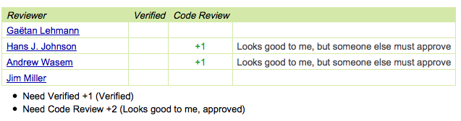
Figure 5: A web page snippet from the Geritt code review system used for ITK (Insight Toolkit, itk.org). This explicitly lists the reviewers who are participating in the review.

Relevance of code review systems
In software development, reviewers are acknowledged implicitly by having their names associated with comments related to a code review. Systems like Geritt and GitHub explicitly list the reviewers participating in the review process. An example from Geritt is shown in Figure 5. In addition, certain social coding websites (e.g., ohloh.net) analyze contributions of developers to various projects and assign “kudos” to indicate the involvement of developers, but not necessarily their proficiency.

Enhancing code review systems for article review
The criterion for accepting code is based on the functionality of the final code rather than the quality of reviews. As such code review systems typically do not have a mechanism to acknowledge and quantify reviewer contributions. We propose that code review systems adapted for article review include quantitative assessment of the contributions of reviewers. This would include a weighted combination of the number of reviews as well as the quality of those reviews as assessed via a metric described later in this article.

4. Quantify review quality.
Although certain journals hold a limited discussion before a paper is accepted, it is still behind closed doors and limited to the editor, the authors, and a small set of reviewers. An open and recorded review ensures that the role and importance of reviewers and information generated during the review would be shared and acknowledged. The quantity and quality of this information (assessed by, for example, voting) can be used to quantitatively assess the importance of a submitted article. Such quantification could lead to an objective standardization of review.

Relevance of code review systems
In general, code review systems use a discussion mechanism, where a code change is moderated through an iterative process as illustrated in Figure 1. In the context of code review, there is often an objective criterion – the code performs as expected and is written using proper style and documentation. Once these standards are met, the code is accepted into the main project. The discussion mechanism facilitates this process. However, in the case of code review, the quality of review is typically not quantified.

Enhancing code review systems for article review
We propose to augment code review systems (and in turn, article review systems) with a mechanism similar to the one used in discussion forums such as stackoverflow.net or mathoverflow.net in order to quantify the quality of reviews. These sites provide a web interface for soliciting responses to questions on topics related to either computer programming or mathematics, respectively. The web interface allows registered members to post or respond to a question, to comment on a response, and to vote on the quality or importance of a question, of a response, or of a comment. Figure 6 shows a screenshot of the response from a registered member to a question submitted to Stack Overflow, where 299 indicates the number of votes received for the response from registered members.

5. Expedite reviews and allow for post-publication review.
Once open and online, reviews can be dynamic, interactive, and conducted in real time (e.g., Frontiers). And with the participation of many reviewers, they can choose to review only those articles and components of those articles that match their expertise and interests. Not only would these two changes make the review process more enjoyable, but they would expedite the review process. And there is no reason for a review process to end after an article has been published. The article can continue as a living document, where the dialogue can continue and flourish (see Figure 7), and references to different articles could be supplemented with references to the comments about these articles, firmly establishing these communications within the dialogue and provenance of science, where science serves not just as a method or philosophy, but as a social endeavor. This could make scientific review and science a more welcoming community, and a more desirable career choice.
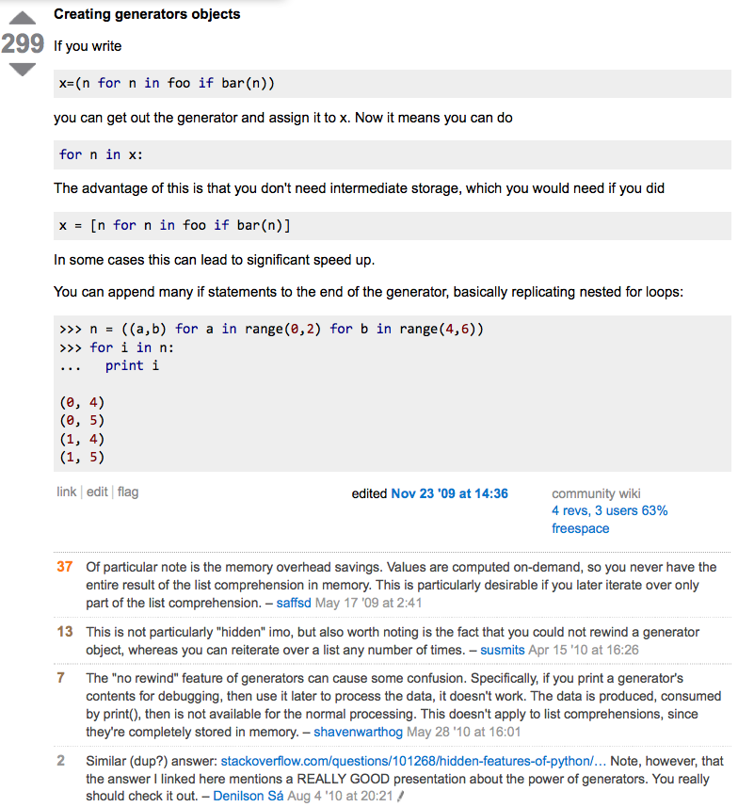
Figure 6. A response to a question on stackoverflow.net. The top left number (299) indicates the number of positive votes this response received. There are comments to the response itself and the number next to the comments reflects the number of positive votes for the comment.

Relevance of code review systems
Code review requires participation from people with differing degrees of expertise and knowledge of the project. This leads to higher quality of the code as well as faster development than individual programmers could normally contribute. These contributions can also be made well beyond the initial code review allowing for bugs to be detected and improvements to be made by new contributors.

Enhancing code review systems for article review
Current code review systems have components for expedited and continued review. Where they could stand to be improved is in their visual interfaces, to make them more intuitive for a non-programmer to quickly navigate, and to enable a temporal view of the evolutionary history of an arbitrary section of text, analogous to Figure 7 (except as an interactive tool).

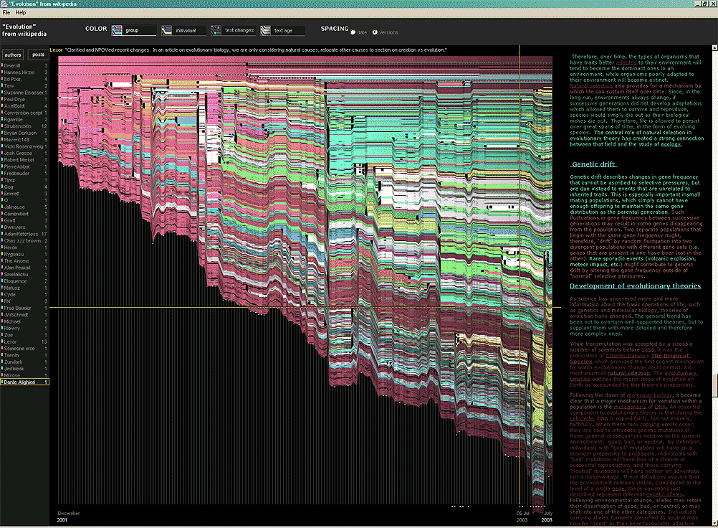
Figure 7. A visualization of the evolutionary history of a Wikipedia entry (“Evolution”) as an example of an evolving body of text. History flow is a tool for visualizing dynamic, evolving documents and the interactions of multiple collaborating authors (http://www.research.ibm.com/visual/projects/history_flow/gallery.htm by Fernanda B. Viégas and Martin Wattenberg at IBM, 2003)

Quantifying an open-review system

There exist metrics for quantifying the importance of an author, article, or journal (Hirsch, 2005; Bollen et al., 2009), but we know of no metric used in either article review or in code review for quantifying the quality, impact, or importance of a review, of a comment on a review, or of any portions thereof. Metrics have many uses in this context, including constructing a dynamic assessment of individuals or ideas (as in the Stack Overflow example in Figure 6) for use in promotion and allocation of funds and resources. Metrics also make it possible to mine reviews and comment histories to study the process of scientific publication. The classic “Like” tally used to indicate appreciation of a contribution in Digg, Facebook, etc., is the most obvious measure assigned by a community, but it is simplistic and vague. In addition to slow and direct measures of impact such as the number of times an article is cited, there are faster, indirect behavioral measures of interest as a proxy for impact that can be derived from clickstream data, web usage, and number of article downloads. Other possibilities include measuring the activity, frequency (Figure 8), impact (Figure 9), and topic range of an author or reviewer or their contributions over time.

It would also be possible to aggregate these metrics to assess the impact or importance of, for example, collaborators, coauthors, institutions, or different areas of multidisciplinary research. As simple examples, one could add the number of quotations by two or more individuals in Figure 8 or the impact of two or more coders in Figure 9. This could be useful in determining what decision to make regarding a statement in an article in the following scenario. Half of a pool of reviewers A agrees with the statement and the other half B disagrees with the statement. A decision in favor of group A could be made if the aggregate metric evaluating A’s expertise on the statement’s topic is higher than that of B. However, such decisions will only be possible once this system has acquired a sufficient amount of data about group A and B’s expertise on reviewing this topic.

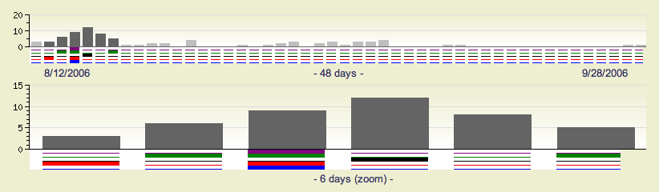
Figure 8. Example of a metric for quantifying contributor frequency. Quotes over Time (www.qovert.info) tracked the top-quoted people from Reuters Alertnet News on a range of topics, and presents their quotes on a timeline, where color denotes the identity of a speaker and bar height the number of times the speaker was quoted on a given day.

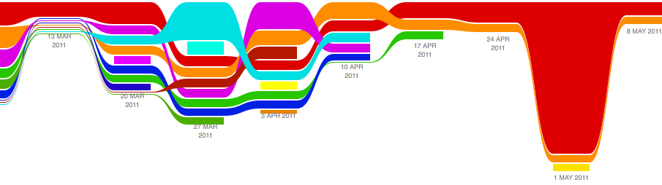
Figure 9. Example of a metric for quantifying contributions over time. This is a screenshot of a ribbon chart visualization in GitHub of the history of code additions to a project, where each color indicates an individual contributor and the width of a colored ribbon represents that individual’s “impact” or contributions during a week-long period.

Discussion

In this article, we raise five problems with the current process for reviewing scientific articles, and argue that we could address all of these problems by opening up the review process to include many reviewers, provide them with the data and software to replicate a study, acknowledge their contributions, quantify the quality of their contributions, and ensure that reviews are timely and live on beyond the publication date. We propose that an effective means for implementing these changes would be to enhance current code review systems for software development to support article review.

The writing of this article was conducted in the spirit of the content of the article, with multiple authors and peer reviewers contributing primarily via GitHub (github.com/satra/scientific-review), followed by dynamic, interactive, real-time collaboration via Google Docs (docs.google.com). We found the collaborative editing and reviewing through the use of these tools to be enjoyable and efficient, while exposing some of the above-mentioned limitations of code review systems for use in article review. Had we solicited many reviewers, we could have experienced more of the real-world challenges of such an open review system. First, as in the content of this article, we assumed that the reviewers did not have selfish motives or egotistical attitudes that affected their reviews. Second, we reached a consensus on most issues, resulting in a very rapid process of writing and reviewing, without conflicts or deadlock. Third, because we had to meet the submission deadline for this article, one or another of us took some decisions on remaining issues without seeking approval from all other reviewers. All three of these point to the problem of reviewers reaching a consensus so that the article could be published in a timely manner. This may be handled by not requiring a consensus, but instead by exploiting metrics that quantify the quality of the reviews and comments on these reviews to make a decision, as discussed earlier.

It may not be practical to immediately adopt the open review process proposed in this article and will require a change of culture that many researchers may resist. Some journals have already adopted aspects of our proposed system (e.g., Frontiers, BioMed Central, Science, PNAS, PLoS One). Initially, our full proposal could be implemented as part of the post-publication system, alongside a more traditional anonymous peer review system (e.g., Atmospheric Chemistry and Physics, atmos-chem-phys.net). As scientists gain familiarity and journals gain experience with our proposed system, it could be refined and improved. In the long run, the review process need not be limited to publication, but can be engaged throughout the process of research, from inception through planning, execution, and documentation (Butler, 2005). This facilitates collaborative research and also ensures that optimal decisions are taken at every stage in the evolution of a project.

In this article, we have proposed a re-design of the current peer review system by incorporating ideas from code review systems associated with open source software development. Such a system should enable an unbiased, comprehensive, and efficient review of scientific work while ensuring a continued, evolving, public dialogue.

Acknowledgements
We would like to thank Fernando Perez for his helpful comments. Arno Klein would like to thank Deepanjana and Ellora, as well as the NIMH for their support via R01 grant MH084029.
References

Bollen, J., Van de Sompel, H., Hagberg, A., and Chute, R. (2009). A principal component analysis of 39 scientific impact measures. PLoS ONE, 4(6):e6022.

Butler, D. (2005). Electronic notebooks: A new leaf. Nature, 436(7047):20–21.

Chang, G., Roth, C. B., Reyes, C. L., Pornillos, O., Chen, Y.-J., and Chen, A. P. (2006). Retraction. Science,
314(5807):1875.

Garfield, E. (1955). Citation indexes to science: a new dimension in documentation through association of ideas. Science, 122(3159):108–11.

Hirsch, J. (2005). An index to quantify an individual’s scientific research output. Proceedings of the National Academy of Sciences of the United States of America, 102(46):16569.

Poschl, U. and Koop, T. (2008). Interactive open access publishing and collaborative peer review for improved scientific communication and quality assurance. Information Services and Use, 28(2):105–107.

Smith, R. (2006). Peer review: a flawed process at the heart of science and journals. Journal of the Royal Society of Medicine, 99(4):178.

Currently, reviewers are solicited by the editors of journals based on either names recommended by the authors who submitted the article, the editors' knowledge of the domain or from an internal journal reviewer database. This selection process results in a very narrow and biased selection of reviewers. An alternative way to solicit reviewers is to broadcast an article to a pool of reviewers and to let reviewers choose articles and components of the article they want to review. These are ideas that have already been implemented in scientific publishing. The Frontiers system (frontiersin.org) solicits reviews from a select group of review editors and the Brain and Behavioral Sciences publication (http://journals.cambridge.org/action/displayJournal?jid=BBS) solicits commentary from the community.
To allay concerns over worldwide pre-publication exposure, precedence could be documented by submission and revision timestamps acknowledging who performed the research.

