**LAPORAN PENGERJAAN UJI KOMPETENSI KEJURUAN SMK MAHARDHIKA BATUJAJAR**

**TAHUN PELAJARAN 2022-2023**

KOMPETENSI KEAHLIAN KELAS

NAMA LENGKAP

NIS

PAKET SOAL JENIS APLIKASI ALOKASI WAKTU

* Rekayasa Perangkat Lunak
* XII RPL II
* SATRIA AJI
* 202110381
* Paket 3 Aplikasi Pengelolaan Laundry
* Web
* 24 jam

1. **PENJADWALAN KEGIATAN** 

|  |  |  |  |  |  |  |  |  |  |  |  |
| --- | --- | --- | --- | --- | --- | --- | --- | --- | --- | --- | --- |
| KEGIATAN | Alokasi waktu | | | | | | | | | | |
| Januari | | | | febuari | | | | maret | | Keterangan |
| Tanggal | 1-6 | 8-13 | 15-21 | 22-30 | 1-6 | 8-13 | 15-21 | 23-29 | 1-6 | 8-11 |
| Analisa Soal |  |  |  |  |  |  |  |  |  |  |  |
| Persiapan Perangkat Keras |  |  |  |  |  |  |  |  |  |  |  |
| Persiapan Perangkat Lunak |  |  |  |  |  |  |  |  |  |  |  |
| Perancangan Algoritma |  |  |  |  |  |  |  |  |  |  |  |
| Desain Bisnis Data |  |  |  |  |  |  |  |  |  |  |  |
| Implementasi Data Ke Mysql |  |  |  |  |  |  |  |  |  |  |  |
| Desain UI |  |  |  |  |  |  |  |  |  |  |  |
| coding Srtuktur HTML |  |  |  |  |  |  |  |  |  |  |  |
| Coding Style CSS |  |  |  |  |  |  |  |  |  |  |  |
| Coding PHP |  |  |  |  |  |  |  |  |  |  |  |
| Uji Coba Aplikasi |  |  |  |  |  |  |  |  |  |  |  |
| Uji Coba Cetak Struk |  |  |  |  |  |  |  |  |  |  |  |
| UJI Coba Buat Laporan |  |  |  |  |  |  |  |  |  |  |  |
| Upload Ke Hosting |  |  |  |  |  |  |  |  |  |  |  |
| Dokumentasi |  |  |  |  |  |  |  |  |  |  |  |

1. **PERSIAPAN PERANGKAT KERAS**

* Processor IntelCore Duo CPU E7500 @ 2.93 GHz 2.92 GHz
* RAM 6 GB
* Monitor
* Keyboard
* Mouse
* Casing CPU

1. **PERSIAPAN PERANGKAT LUNAK**

* Visual Studio Code
* Sublime Text
* XAMPP Control Panel
* Balsamiq
* Astah Pro
* Chrome
* Microsoft Word
* Microsoft Excel

1. **PERANCANGAN ALGORITMA APLIKASI**

**Activity Diagram**

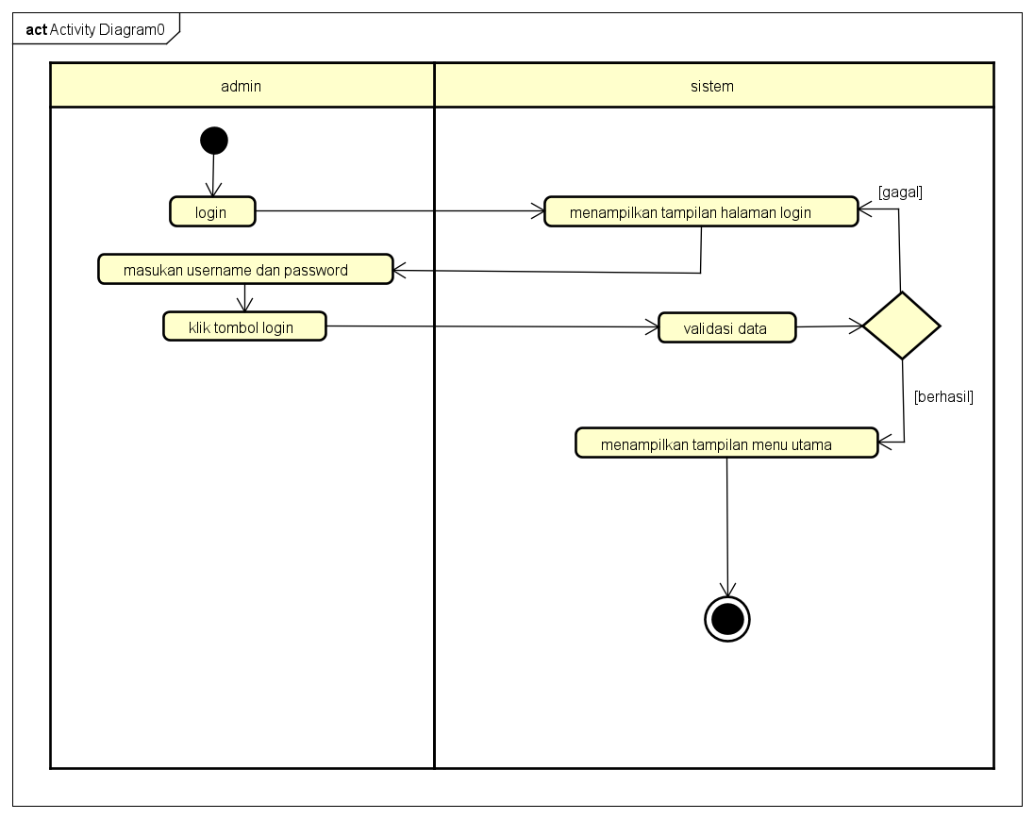

Login

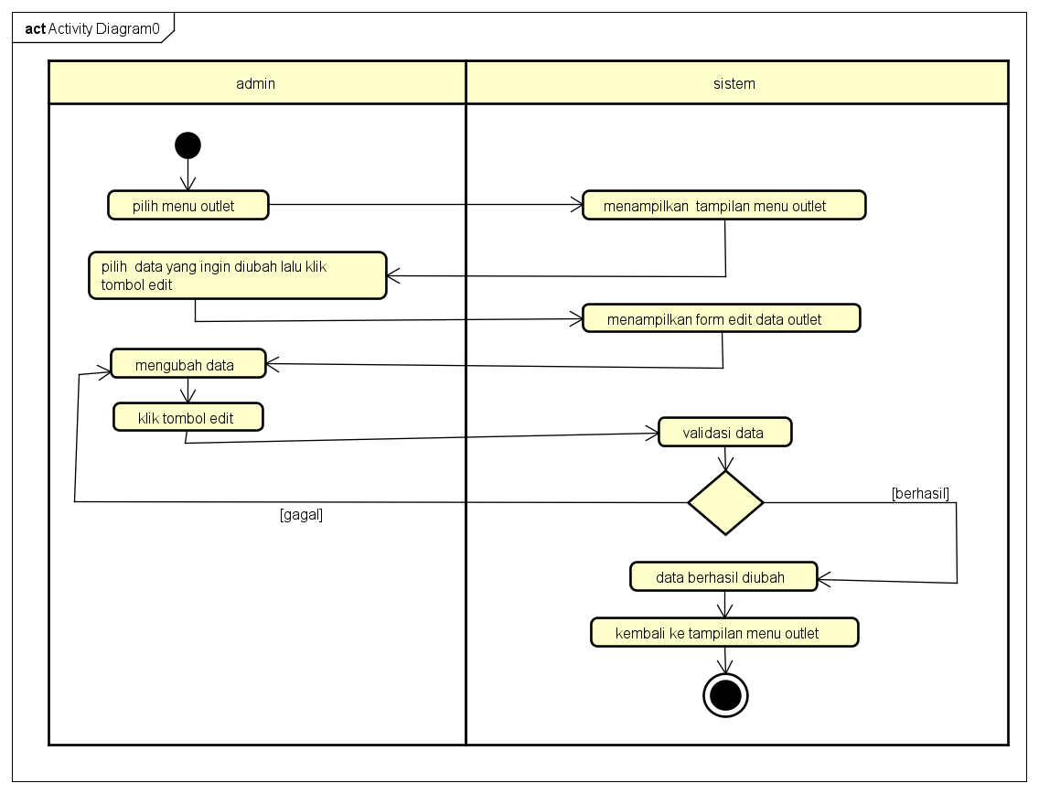

Edit Outlet

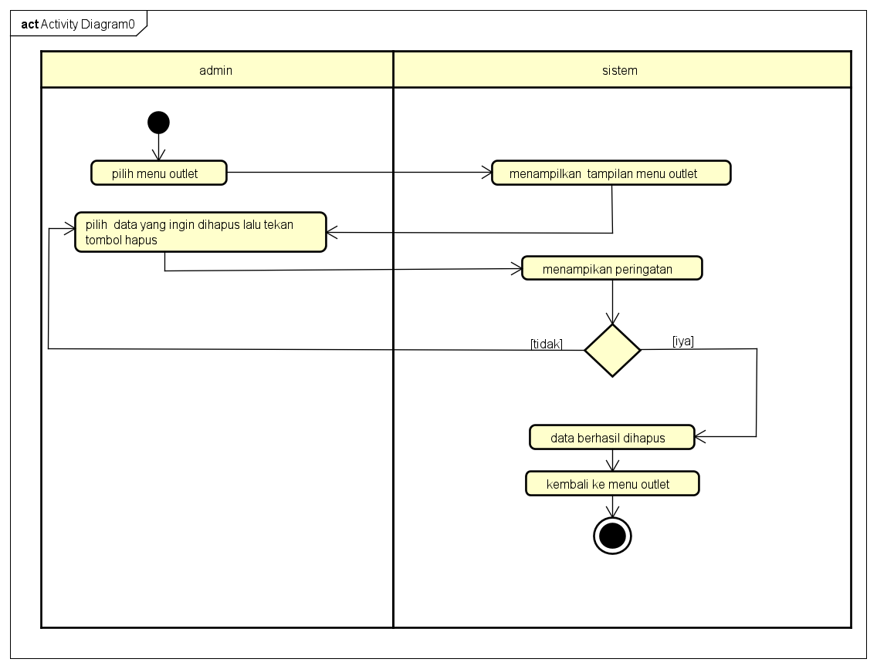

Hapus Outlet

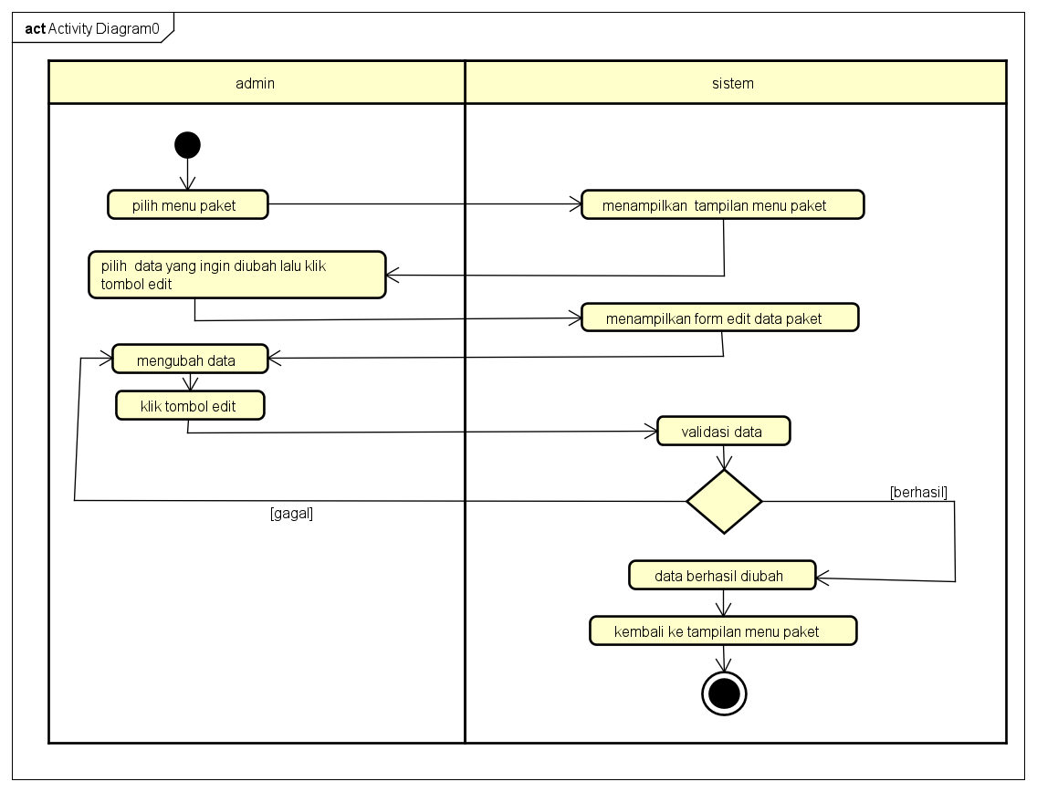

Edit Paket

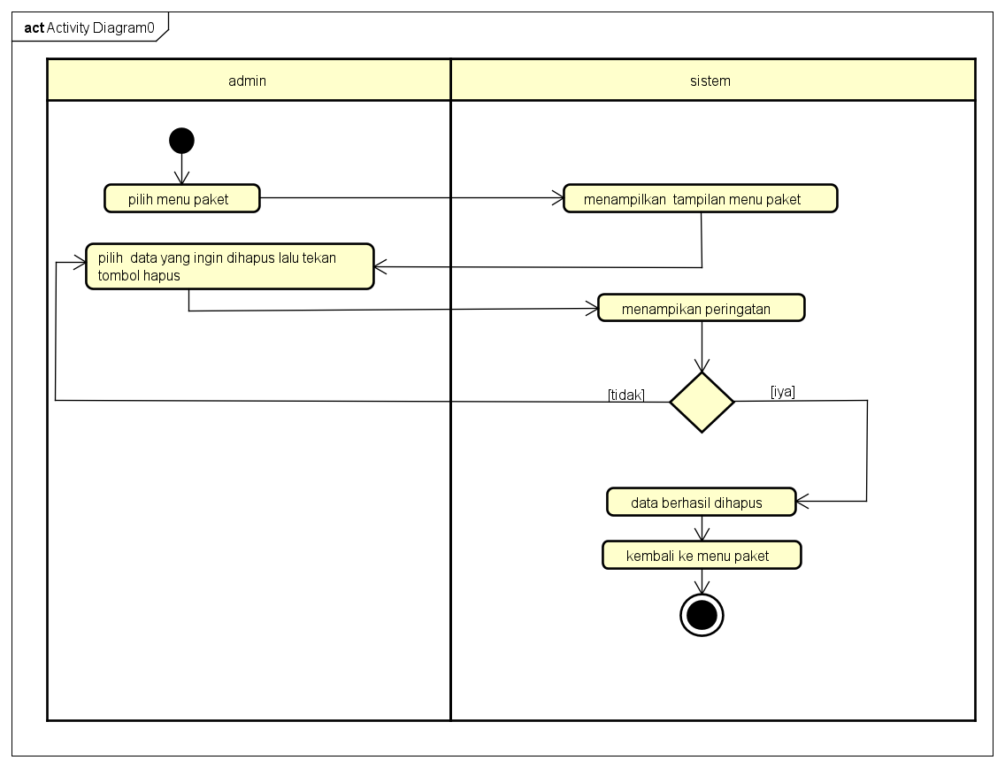

Hapus Paket

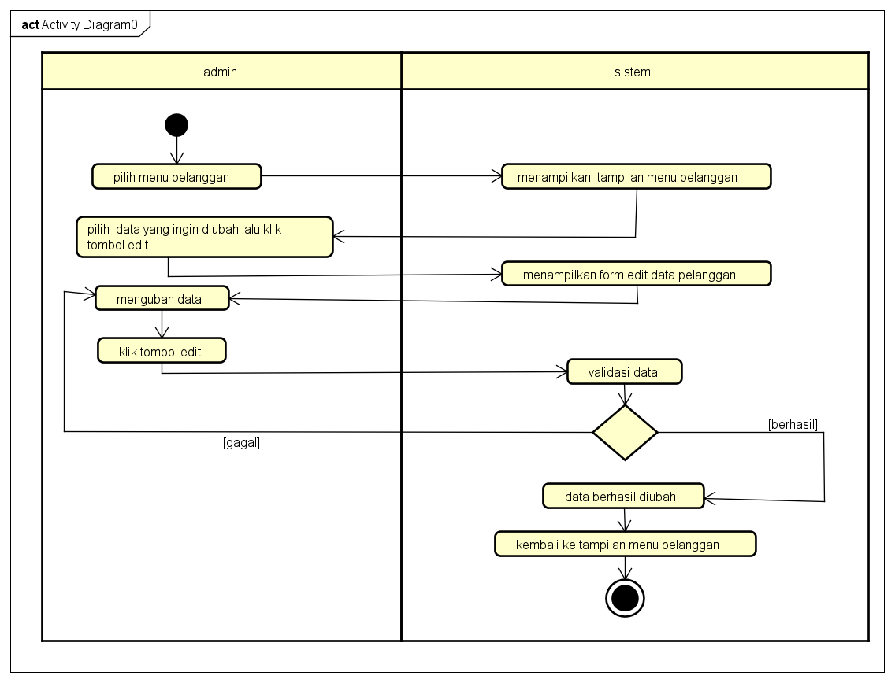

Edit Pelanggan

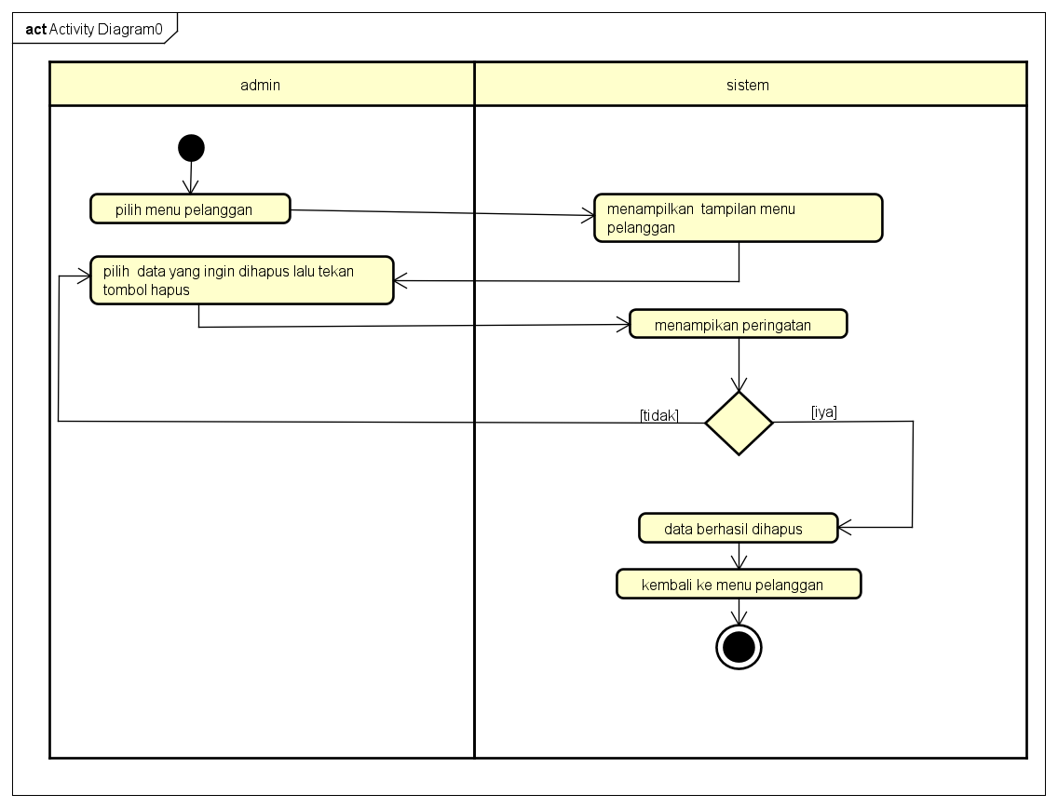

Hapus Pelanggan

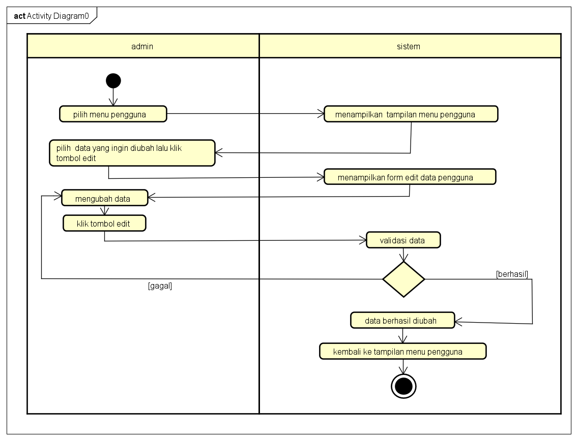

Edit Pengguna

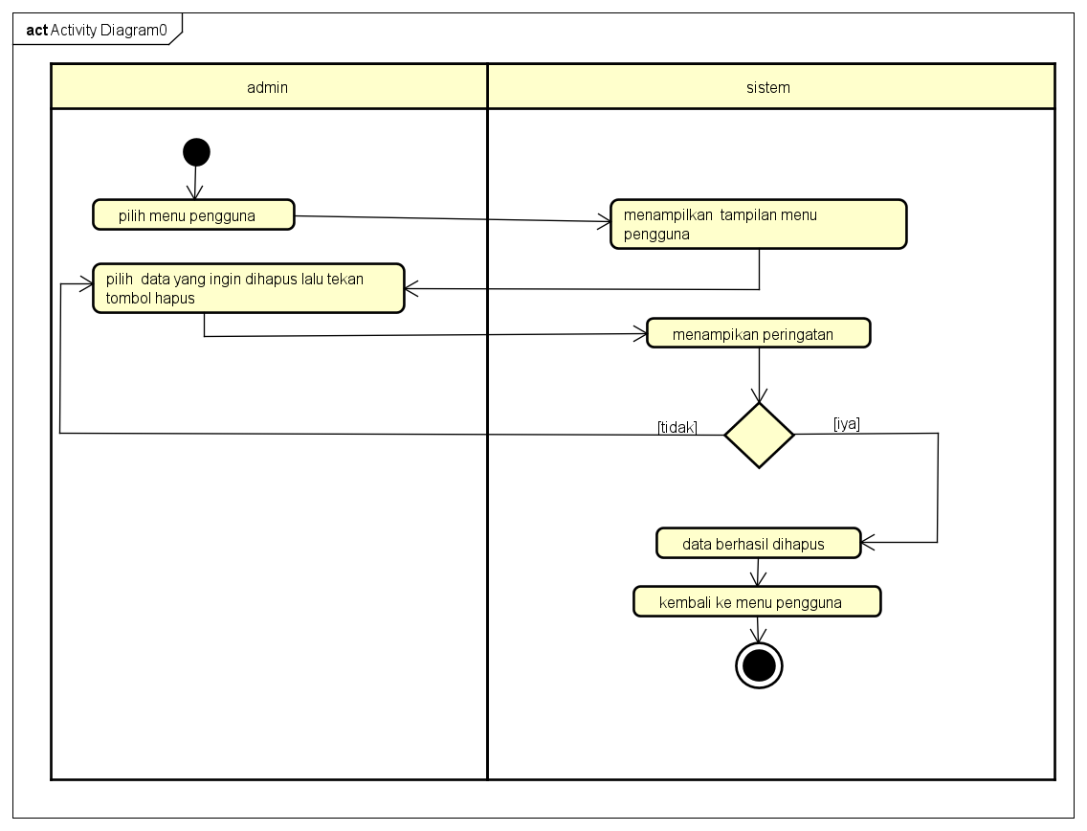

Hapus Pengguna

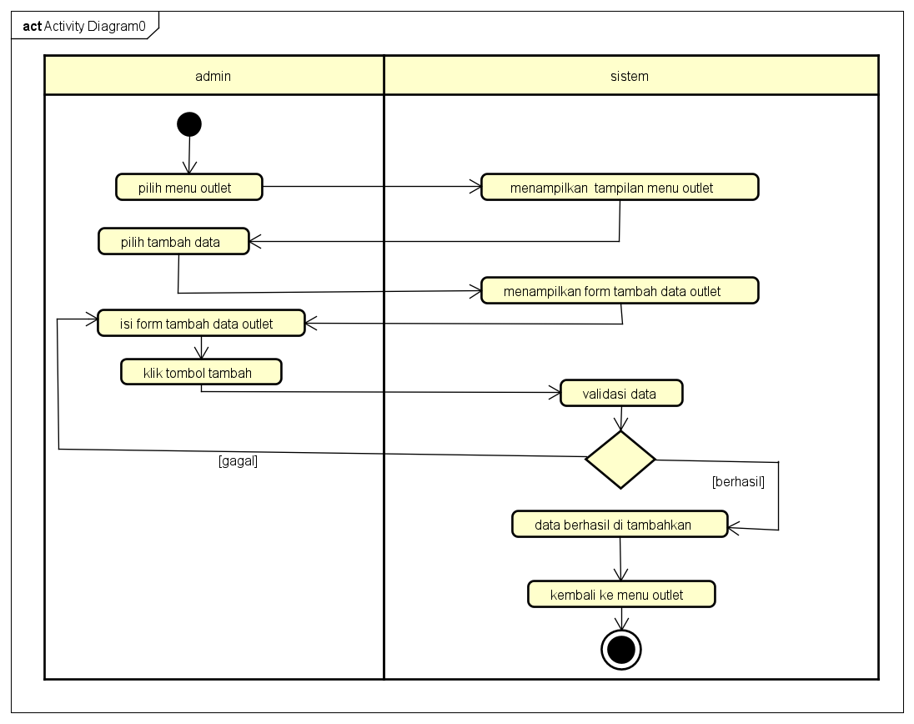

Tambah Outlet

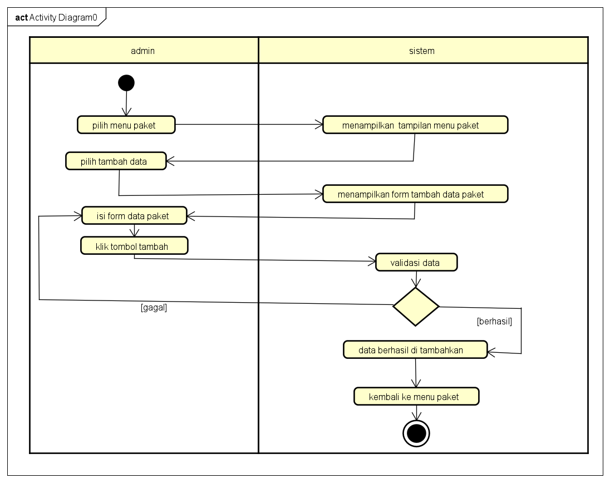

Tambah Paket

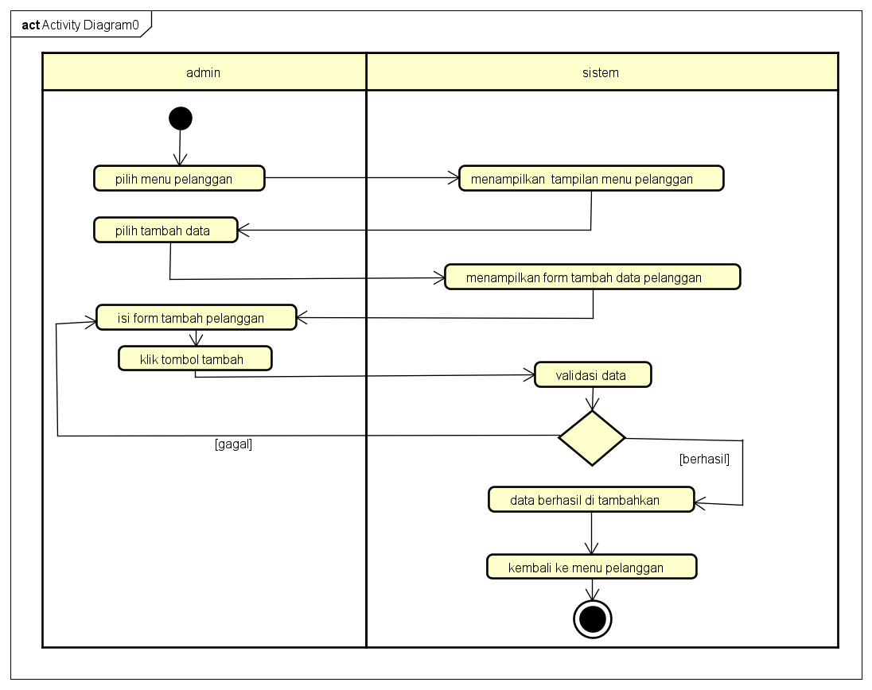

Tambah Pelanggan

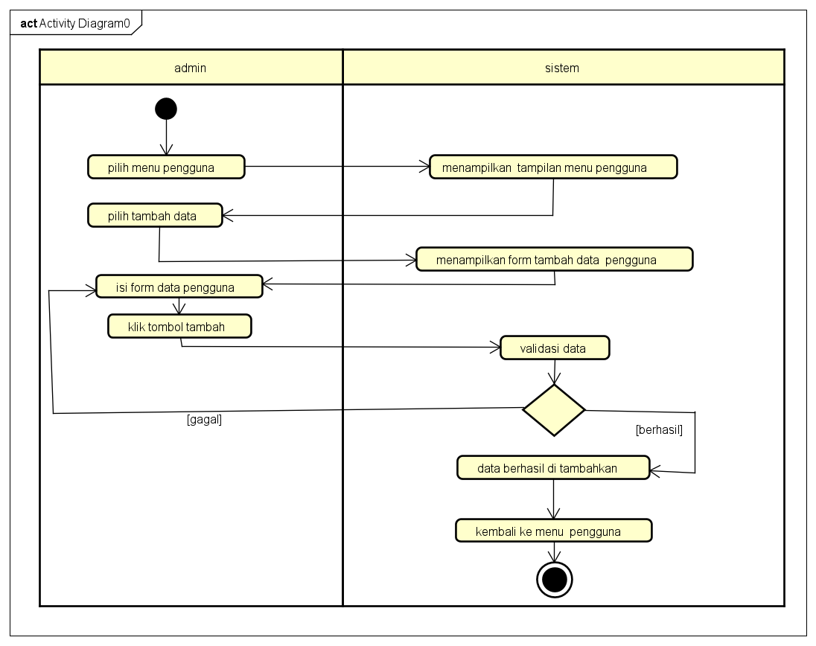

Tambah Pengguna

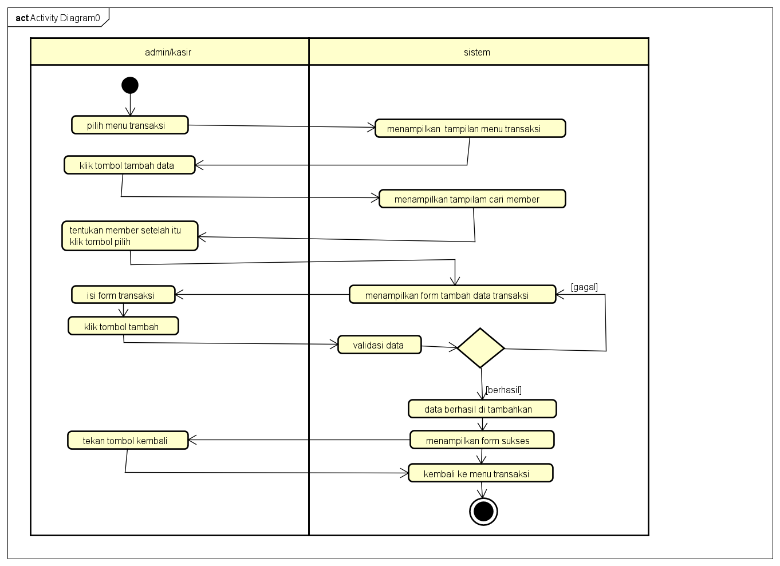

Tambah Transaksi

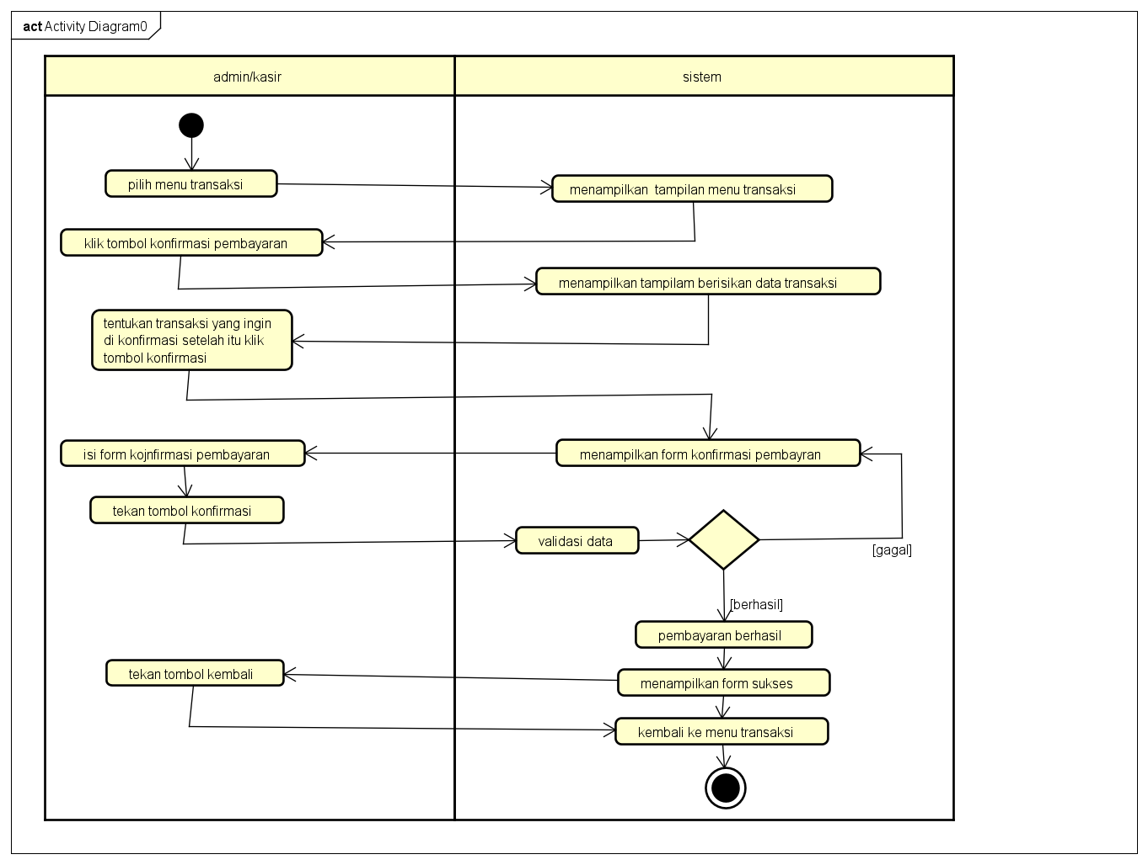

Konfirmasi Transaksi

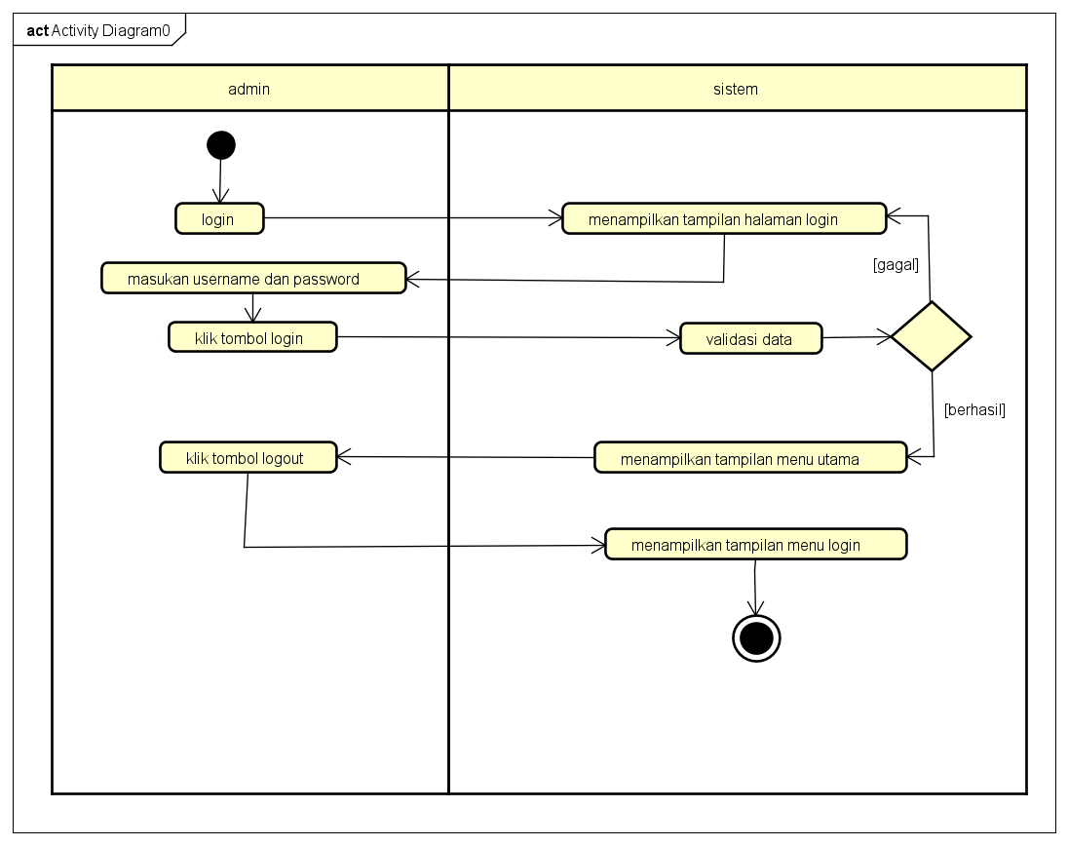

Logout

1. **PERANCANGAN DESAIN BASIS DATA**

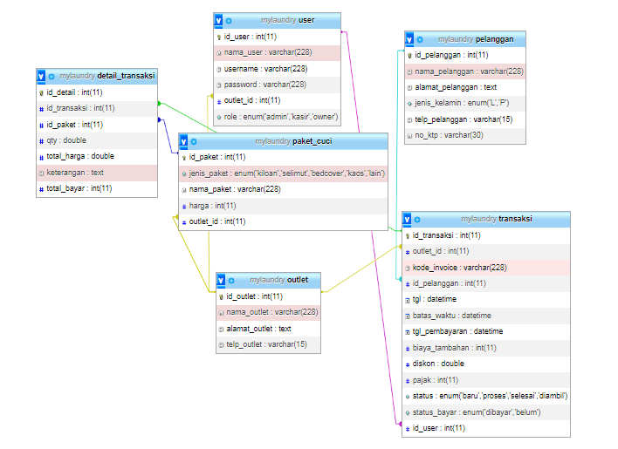

Class Diagram

1. **DUMMY DATA**

Data user



Data outlet



Data paket



Data pelanggan



Data transaksi



Data detail_transaksi



1. **PEMBUATAN BASIS DATA (MySQL Code)**

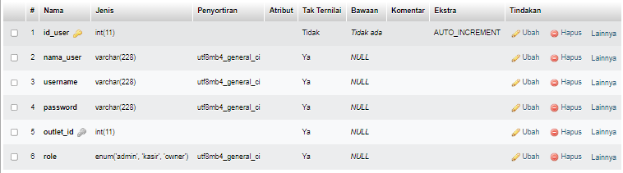

Tabel user

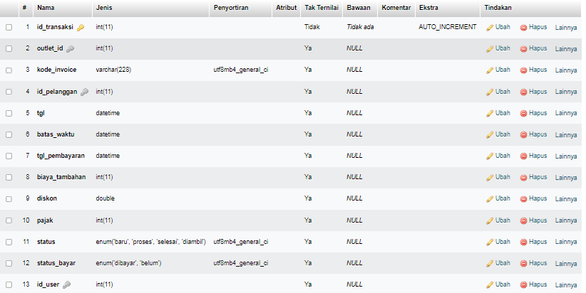

Tabel transaksi

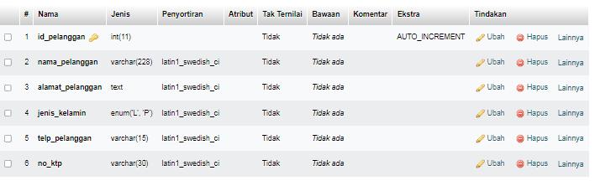

Tabel Pelanggan

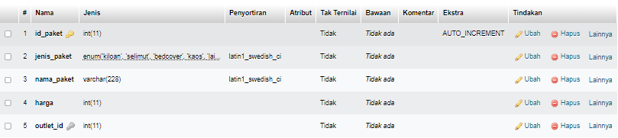

Tabel paket

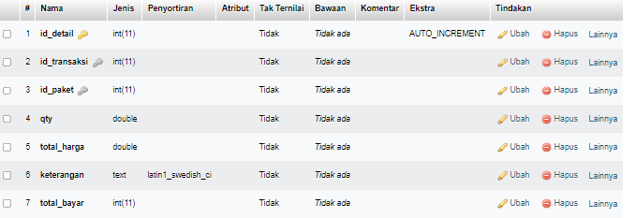

Tabel detail transaksi

1. **PERANCANGAN TAMPILAN ANTARMUKA (UI) WEB**

**Aplikasi pengelolaan laundry**

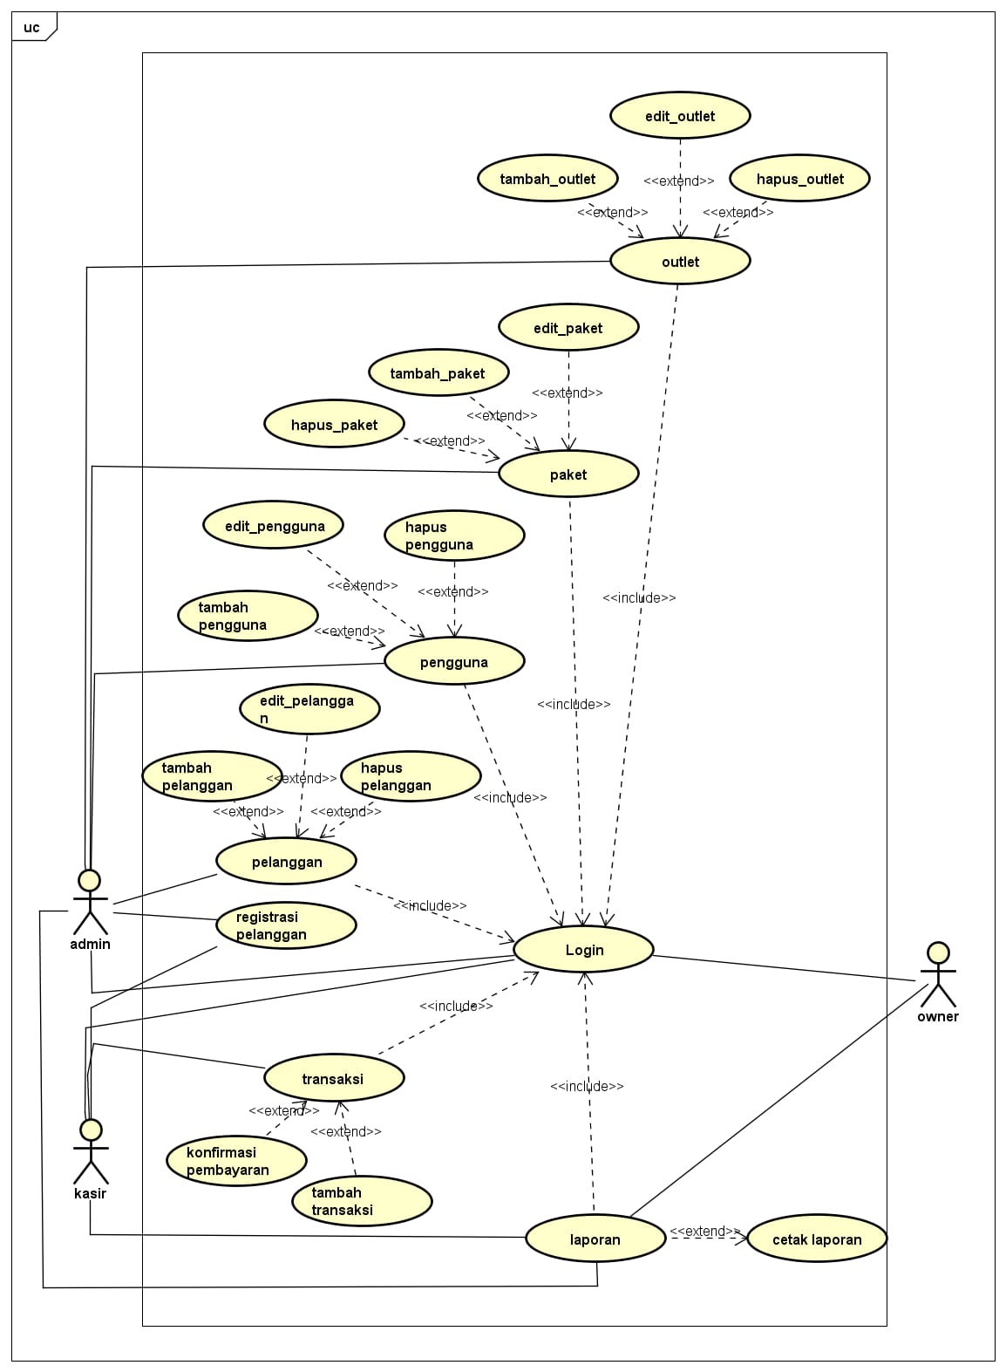

1. Admin dashboard

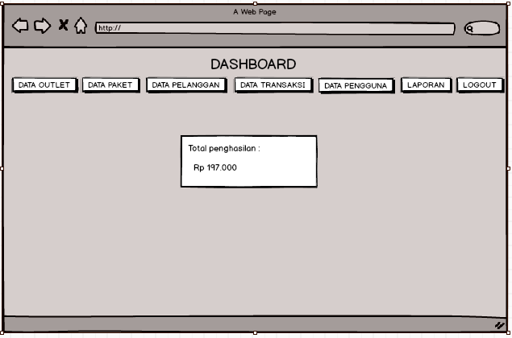

Admin Dashboard

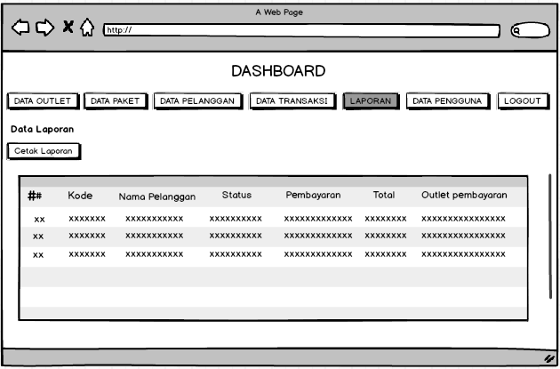

Data Laporan

1. Tampilan Kasir

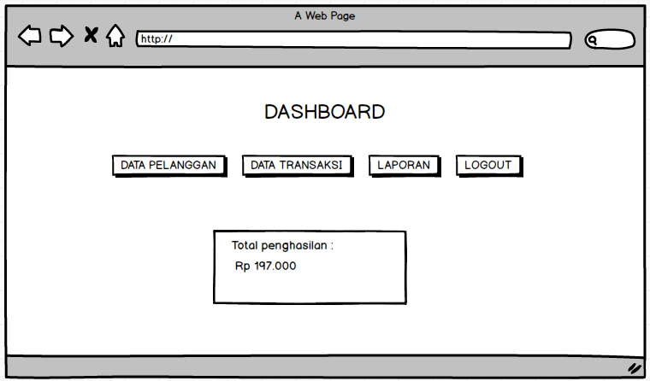

Dashboard kasir

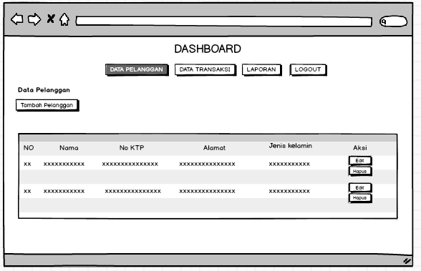

Data Pelanggan

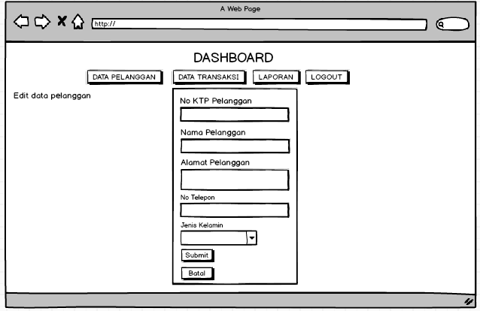

Edit pelanggan

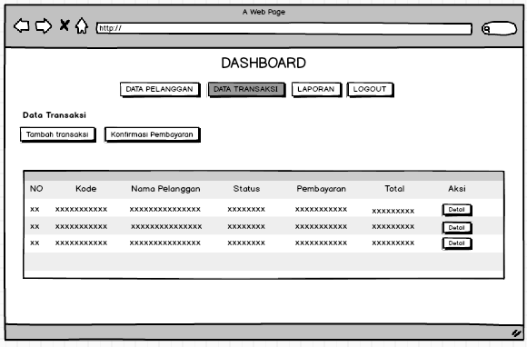

Data transaksi

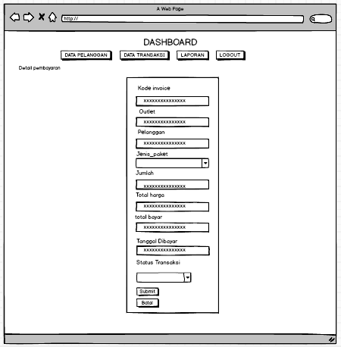

Detail transaksi

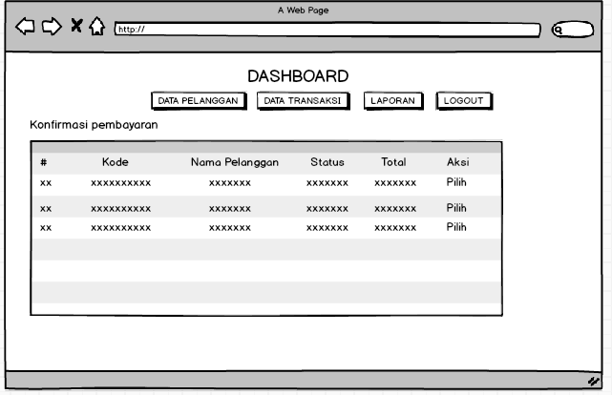

Halaman konfirmasi

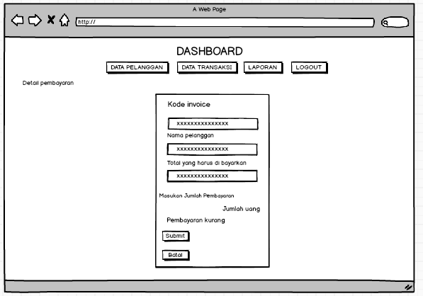

Konfirmasi pembayaran

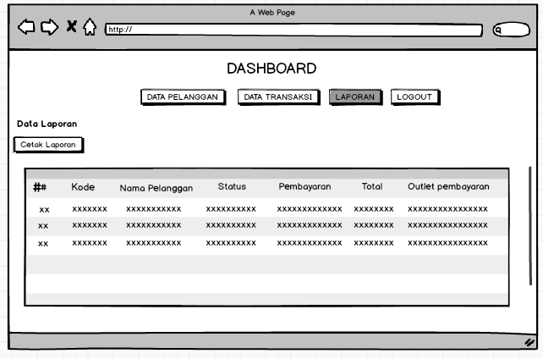

Data laporan kasir

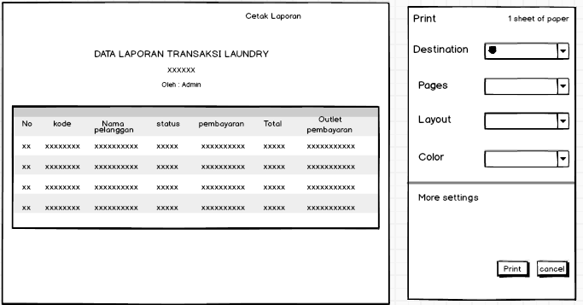

Cetak laporan kasir

1. Tampilan owner

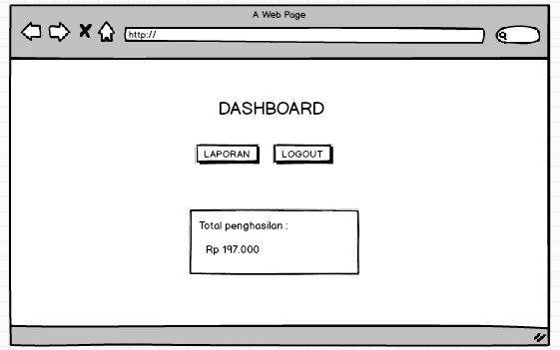

Dashboard owner

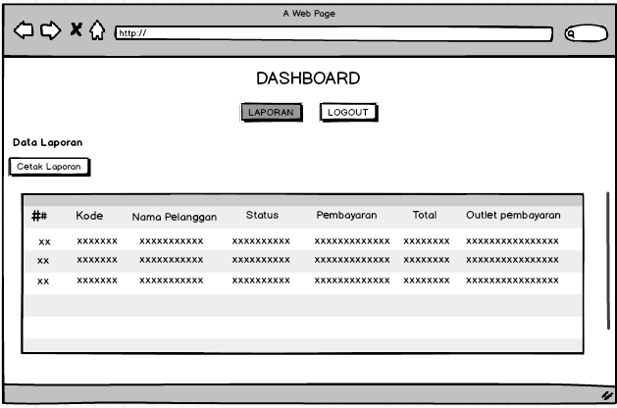

Data laporan owner

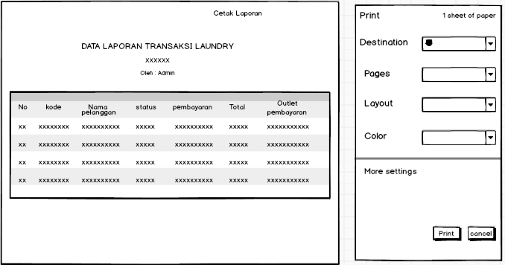

Cetak laporan owner

1. **PEMBUATAN STRUKTUR WEB (HTML)**

transaksi.html

|  |
| --- |
| <!DOCTYPE html>  <html lang="en">  <head>  <style>  button {  padding : 8px 16px;  margin-left : 6px;  margin-right : 6px;  margin-bottom : 10px;  border-radius : 4px ;  color : white;  background-color : #8d68e8;  text-decoration : none;  font-family : Arial,Helvetica, sans-serif ;  }  .button {  padding : 5px 16px;  margin-left : 6px;  margin-right : 6px ;  margin-top : 7px ;  border-radius : 2px ;  color : white;  background-color : #8d68e8;  text-decoration : none;  font-family : Arial,Helvetica, sans-serif ;  }  </style>  <link href="../css/tbl.css?version=<?= filemtime("../css/tbl.css")?>" rel="stylesheet">  </head>  <body>  <?php  $title = 'Data Transaksi';  require 'koneksi.php';  $query = "SELECT transaksi.*, pelanggan.nama_pelanggan, detail_transaksi.total_harga FROM transaksi INNER JOIN pelanggan ON pelanggan.id_pelanggan = transaksi.id_pelanggan INNER JOIN detail_transaksi ON detail_transaksi.id_transaksi = transaksi.id_transaksi";  $data = mysqli_query($conn, $query);  require 'navigasi.php';  ?>  <h4 class="card-title"><?= $title; ?></h4>  <a href="cari.php" class="button">  <i class="fa fa-plus"></i>  Tambah Transaksi  </a>  <a href="konfirmasi.php" class="button">  <i class="fas fa-user-check"></i>  Konfirmasi Pembayaran  </a>  </div>  </div>  <div class="card-body">  <div class="table-responsive">  <table id="basic-datatables" class="display table table-striped table-hover">  <thead>  <tr>  <th style="width: 10%">No</th>  <th>Kode</th>  <th>Nama Pelanggan</th>  <th>Status</th>  <th>Pembayaran</th>  <th>Total</th>  <th style="width: 10%;">Aksi</th>  </tr>  </thead>  <?php  $no = 1;  if (mysqli_num_rows($data) > 0) {  while ($trans = mysqli_fetch_assoc($data)) {  ?>  <br>  <tr>  <td><?= $no++; ?></td>  <td><?= $trans['kode_invoice']; ?></td>  <td><?= $trans['nama_pelanggan']; ?></td>  <td><?= $trans['status']; ?></td>  <td><?= $trans['status_bayar']; ?></td>  <td><?= 'Rp ' . number_format($trans['total_harga']); ?></td>  <td>  <a href="detail.php?id=<?= $trans['id_transaksi']; ?>" ><button class="button">Detail</button></a>    <?php }  }  ?> |

1. PEMBUATAN STYLE WEB

tbl.css

|  |
| --- |
| table {  font-family: Arial, Helvetica, sans-serif;  color: #666;  text-shadow: 1px 1px 0px #fff;  background: #eaebec;  border: #ccc 1px solid;  }    table th {  padding: 15px 35px;  border-left:1px solid #e0e0e0;  border-bottom: 1px solid #e0e0e0;  background: #ededed;  }    table th:first-child{  border-left:none;  }    table tr {  text-align: center;  padding-left: 20px;  }    table td:first-child {  text-align: left;  padding-left: 20px;  border-left: 0;  }    table td {  padding: 15px 35px;  border-top: 1px solid #ffffff;  border-bottom: 1px solid #e0e0e0;  border-left: 1px solid #e0e0e0;  background: #fafafa;  background: -webkit-gradient(linear, left top, left bottom, from(#fbfbfb), to(#fafafa));  background: -moz-linear-gradient(top, #fbfbfb, #fafafa);  }    table tr:last-child td {  border-bottom: 0;  }    table tr:last-child td:first-child {  -moz-border-radius-bottomleft: 3px;  -webkit-border-bottom-left-radius: 3px;  border-bottom-left-radius: 3px;  }    table tr:last-child td:last-child {  -moz-border-radius-bottomright: 3px;  -webkit-border-bottom-right-radius: 3px;  border-bottom-right-radius: 3px;  }    table tr:hover td {  background: #f2f2f2;  background: -webkit-gradient(linear, left top, left bottom, from(#f2f2f2), to(#f0f0f0));  background: -moz-linear-gradient(top, #f2f2f2, #f0f0f0);  } |

bar.css

|  |
| --- |
| *{  margin: ;  padding: 1px;  outline: none;  border: none;  text-decoration: none;  box-sizing: border-box;  font-family: 'Roboto', sans-serif;  }  body {  font-family: 'Montserrat', sans-serif;  line-height: 1.6;  margin: 0;  min-height: 100vh;  }  ul {  margin: 0;  padding: 0;  list-style: none;  }  h2,  h3,  a {  color: #34495e;  }  a {  text-decoration: none;  }  .logo {  margin: 0box-sizing no: border-box;  }  body {  font-family: 'Montserrat', sans-serif;  line-height: 1.6;  margin: 0;  min-height: 100vh;  }  ul {  margin: 0;  padding: 0;  list-style: none;  }  h2,  h3,  a {  color: #34495e;  }  a {  text-decoration: none;  }  .logo {  margin: 0;  font-size: 1.45em;  }  .main-nav {  margin-top: 5px;;  font-size: 1.45em;box-sizing no: border-box;  }  body {  font-family: 'Montserrat', sans-serif;  line-height: 1.6;  margin: 0;  min-height: 100vh;  }  ul {  margin: 0;  padding: 0;  list-style: none;  }  h2,  h3,  a {  color: #34495e;  }  a {  text-decoration: none;  }  .logo {  margin: 0;  font-size: 1.45em;  }  .main-nav {  margin-top: 5px;box-sizing no: border-box;  }  body {  font-family: 'Montserrat', sans-serif;  line-height: 1.6;  margin: 0;  min-height: 100vh;  }  ul {  margin: 0;  padding: 0;  list-style: none;  }  h2,  h3,  a {  color: #34495e;  }  a {  text-decoration: none;  }  .logo {  margin: 0;  font-size: 1.45em;  }  .main-nav {  margin-top: 5px;  }  box-sizing no: border-box;  }  body {  font-family: 'Montserrat', sans-serif;  line-height: 1.6;  margin: 0;  min-height: 100vh;  }  ul {  margin: 0;  padding: 0;  list-style: none;  }  h2,  h3,  a {  color: #34495e;  }  a {  text-decoration: none;  }  .logo {  margin: 0;  font-size: 1.45em;  }  .main-nav {  margin-top: 5px;  .main-nav {  margin-top: 5px;  }  .logo a,  .main-nav a {  padding: 10px 15px;  text-transform: uppercase;  text-align: center;  display: block;  }  .main-nav a {  color: #34495e;  font-size: .99em;  }box-sizing no: border-box;  }  body {  font-family: 'Montserrat', sans-serif;  line-height: 1.6;  margin: 0;  min-height: 100vh;  }  ul {  margin: 0;  padding: 0;  list-style: none;  }  h2,  h3,  a {  color: #34495e;  }  a {  text-decoration: none;  }  .logo {  margin: 0;  font-size: 1.45em;  }  .main-nav {  margin-top: 5px;  }  .logo a,  .main-nav a {  padding: 10px 15px;  text-transform: uppercase;  text-align: center;  display: block;  }  .main-nav a {  color: #34495e;  font-size: .99em;  }box-sizing no: border-box;  }  body {  font-family: 'Montserrat', sans-serif;  line-height: 1.6;  margin: 0;  min-height: 100vh;  }  ul {  margin: 0;  padding: 0;  list-style: none;  }  h2,  h3,  a {  color: #34495e;  }  a {  text-decoration: none;  }  .logo {  margin: 0;  font-size: 1.45em;  }  .main-nav {  margin-top: 5px;  }  .logo a,  .main-nav a {  padding: 10px 15px;  text-transform: uppercase;  text-align: center;  display: block;  }  .main-nav a {  color: #34495e;  font-size: .99em;  }  .main-nav a:hover {  color: #718daa;  }  .header {  padding-top: .5em;  padding-bottom: .5em;  border: 1px solid #C0C0C0;  background-color: #F8F8FF;  -webkit-box-shadow: 0px 0px 5px 0px rgba(0,0,0,0.75);  -moz-box-shmoz-box-shadow: 0px 0px 5px 0px rgba(0,0,0,0.75);  box-shadow: 0px 0px 0px 0px rgba(0,0,0,0.75);  -webkit-border-radius: 5px;  -moz-border-radius: 5px;  border-radius: 5px;  }  /* =================================  Media Queries  ==================================== */  @media (min-width: 769px) {  .header,  .main-nav {  display: flex;  }  .header {  flex-direction: column;  align-items: center;  .header{  width: 80%;  margin: 0 auto;  max-width: 1150px;  }  }  }  @media (min-width: 1025px) {  .header {  flex-direction: row;  justify-content: space-between;  }  }  shadow: 0px 0px 14px 0px rgba(0,0,0,0.75);{  box-shadow: 0px 0px 14px 0px rgba(0,0,0,0.75);  -webkit-border-radius: 5px;  -moz-border-radius: 5px;  border-radius: 5px;  }  /* =================================  Media Queries  ==================================== */  @media (min-width: 769px) {  .header,  .main-nav {  display: flex;  }  }  .header {  flex-direction: column;  align-items: center;    .header {  width: 80%;  margin: 0 auto;  max-width: 1150px;  }    @media (min-width: 1025px) {  .header {  flex-direction: row;  justify-content: space-between;  }  } |

1. PEMBUATAN KODE WEB (PHP)

index.php

|  |
| --- |
| <?php  $title = 'Selamat Datang di Aplikasi Pengelolaan Laundry';  require 'koneksi.php';  require 'navigasi.php';  setlocale(LC_ALL, 'id_id');  setlocale(LC_TIME, 'id_ID.utf8');  $query4 = mysqli_query($conn, "SELECT SUM(total_harga) as total_penghasilan FROM detail_transaksi INNER JOIN transaksi ON transaksi.id_transaksi = detail_transaksi.id_transaksi WHERE status_bayar = 'dibayar'");  $total_penghasilan = mysqli_fetch_assoc($query4);  ?> <div class="form">  <div class="numbers">  <p class="card-body">Total Penghasilan : <br><?= 'Rp ' . number_format($total_penghasilan['total_penghasilan']); ?></p>  </div>  </div>  </div>  </div>  <?php  ?> |

koneksi.php

|  |
| --- |
| <?php  session_start();  if ($_SESSION) {  if ($_SESSION['role'] == 'admin') {  } else {  header("location:../index.php");  }  } else {  header('location:../index.php');  }  $conn = mysqli_connect("localhost", "root", "", "mylaundry");  if (mysqli_connect_error()) {  echo "Koneksi ke database gagal : " . mysqli_connect_error();  } |

CRUD file

tambah_outlet.php

|  |
| --- |
| <?php  $title = 'Tambah Data Outlet';  require 'koneksi.php';  if (isset($_POST['btn-simpan'])) {  $nama = $_POST['nama_outlet'];  $alamat = $_POST['alamat_outlet'];  $telp = $_POST['telp_outlet'];  $query = "INSERT INTO outlet (nama_outlet, alamat_outlet, telp_outlet) values ('$nama', '$alamat', '$telp')";  $insert = mysqli_query($conn, $query);  if ($insert == 1) {  $_SESSION['msg'] = 'Berhasil Menyimpan Data';  header('location: outlet.php');  } else {  $_SESSION['msg'] = 'Gagal menambahkan data baru!!!';  header('location: outlet.php');  }  }  require 'navigasi.php';  ?>  </div>  <form action="" method="POST">  <div class="card-body">  <div class="form-group">  <label for="largeInput">Nama Outlet</label>  <input type="text" name="nama_outlet" class="form-control form-control" id="defaultInput" placeholder="Outlet...">  </div>  <div class="form-group">  <label for="alamat">Alamat Outlet</label>  <textarea class="form-control" rows="5" name="alamat_outlet"></textarea>  </div>  <div class="form-group">  <label for="largeInput">No Telepon</label>  <input type="text" name="telp_outlet" class="form-control form-control" id="defaultInput" placeholder="No Telp..." maxlength="15">  </div>  <div class="button">  <button type="submit" name="btn-simpan" class="btn btn-success">Submit</button>  <!-- <button class="btn btn-danger">Cancel</button> -->  <a href="javascript:void(0)" onclick="window.history.back();" class="link">Batal</a>  </div>  </form> |

outlet.php

|  |
| --- |
| <?php  require 'koneksi.php';  $title = 'Data Outlet' ;  require 'navigasi.php';  $query = 'SELECT outlet.*, user.nama_user FROM outlet LEFT JOIN user ON user.outlet_id = outlet.id_outlet';  $data = mysqli_query($conn, $query);  ?>    <h4 class="card-title"><?= $title; ?></h4>  <a href="tambah_outlet.php" class="button">  <i class="fa fa-plus"></i>  Tambah Outlet  <br>  </a>  <table id="basic-datatables" class="display table table-striped table-hover">  <thead>  <tr>  <br>  <th style="width: 7%">No</th>  <th>Nama</th>  <th>Owner</th>  <th>No Telepon</th>  <th style="width: 25%;">Alamat</th>  <th style="width: 10%">Aksi</th>    </tr>  </thead>  <tbody>    <?php  $no = 1;  if (mysqli_num_rows($data) > 0) {  while ($outlet = mysqli_fetch_assoc($data)) {  ?>  <tr>    <td><?= $no++; ?></td>  <td><?= $outlet['nama_outlet']; ?></td>  <td><?php if ($outlet['nama_user'] == null) {  echo "Belum ada owner";  } else {  echo $outlet['nama_user'];  } ?>  </td>  <td><?= $outlet['telp_outlet']; ?></td>  <td><?= $outlet['alamat_outlet']; ?></td>  <td>  <div class="form-button-action">  <a href="edit_outlet.php?id=<?= $outlet['id_outlet']; ?>" ><button class="button">Edit</button></a>  </a>  <a href="hapus_outlet.php?id=<?= $outlet['id_outlet']; ?>" ><button class="button">Hapus</button></a>  </a>  </div>  </td>    </tr>    <?php }  }  ?>  </tbody>  </table> |

edit_outlet

|  |
| --- |
| <?php  $title = 'Edit Data Outlet';  require 'koneksi.php';  $query = "SELECT outlet.*, user.nama_user, user.id_user FROM outlet LEFT JOIN user ON user.outlet_id = outlet.id_outlet WHERE id_outlet = " . $_GET['id'];  $data = mysqli_query($conn, $query);  $edit = mysqli_fetch_assoc($data);  $query2 = "SELECT user.*, outlet.nama_outlet FROM outlet RIGHT JOIN user ON user.outlet_id = outlet.id_outlet WHERE user.role = 'owner' ORDER BY user.outlet_id ASC";  $data2 = mysqli_query($conn, $query2);  if (isset($_POST['btn-simpan'])) {  $nama = $_POST['nama_outlet'];  $alamat = $_POST['alamat_outlet'];  $telp = $_POST['telp_outlet'];  $query = "UPDATE outlet SET nama_outlet = '$nama', alamat_outlet = '$alamat', telp_outlet = '$telp' WHERE id_outlet = " . $_GET['id'];  if ($_POST['owner_new_id']) {  $query2 = "UPDATE user SET outlet_id = '" . $_GET['id'] . "' WHERE id_user = " . $_POST['owner_new_id'];  $query3 = "UPDATE user SET outlet_id = NULL WHERE id_user = " . $edit['id_user'];  $update3 = mysqli_query($conn, $query3);  } else {  $query2 = "UPDATE user SET outlet_id = '" . $_GET['id'] . "' WHERE id_user = " . $_POST['id_owner'];  }  $update = mysqli_query($conn, $query);  $update2 = mysqli_query($conn, $query2);  if ($update == 1 && $update2 == 1) {  $_SESSION['msg'] = 'Berhasil Mengubah Data';  header('location:outlet.php');  } else {  $_SESSION['msg'] = 'Gagal Mengubah Data!!!';  header('location:outlet.php');  }  }  require 'navigasi.php';  ?>      <div class="row">  <div class="col-md-10">  <div class="card">  <div class="card-header">  <div class="card-title"><?= $title; ?>  : <strong><?= $edit['nama_outlet']; ?></strong></div>  </div>  <form action="" method="POST">  <div class="card-body">  <div class="form-group">  <label for="largeInput">Nama Outlet</label>  <input type="text" name="nama_outlet" class="form-control form-control" id="defaultInput" value="<?= $edit['nama_outlet']; ?>" placeholder="Outlet...">  </div>  <div class="form-group">  <label for="alamat">Alamat Outlet</label>  <textarea class="form-control" rows="5" name="alamat_outlet"><?= $edit['alamat_outlet']; ?></textarea>  </div>  <div class="form-group">  <label for="largeInput">No Telepon</label>  <input type="text" name="telp_outlet" class="form-control form-control" id="defaultInput" value="<?= $edit['telp_outlet']; ?>" placeholder="No Telp..." maxlength="15">  </div>  <div class="form-group">  <?php if ($edit['nama_user'] == null) : ?>  <label for="defaultSelect">Belum Ada Owner</label>  <select name="id_owner" class="form-control form-control" id="defaultSelect">  <?php foreach ($data2 as $owner) : ?>  <option value="<?= $owner['id_user']; ?>"><?= $owner['nama_user']; ?>  <?php if ($owner['outlet_id'] == null) : ?>  (Belum mempunyai outlet)  <?php else : ?>  (Owner di <?= $owner['nama_outlet']; ?>)  <?php endif ?>  </option>  <?php endforeach ?>  </select>  </div>  <?php else : ?>  <label for="defaultSelect">Owner Sekarang : <?= $edit['nama_user']; ?></label>  <select name="owner_new_id" class="form-control form-control" id="defaultSelect">  <!-- <option value="">Pilih Owner Baru</option> -->  <?php foreach ($data2 as $owner) : ?>  <option value="<?= $owner['id_user']; ?>" selected><?= $owner['nama_user'] ?>  <?php if ($owner['outlet_id'] == null) : ?>  (Belum memiliki outlet)  <?php else : ?>  (Owner berada di <?= $owner['nama_outlet']; ?>)  <?php endif ?>  </option>  <?php endforeach ?>  </select>  </div>  <br>  <?php endif; ?>  <div class="card-action">  <button type="submit" name="btn-simpan" class="btn-succes">Submit</button>  <!-- <button class="button">Cancel</button> -->  <br><a href="javascript:void(0)" onclick="window.history.back();" class="btn btn-danger">Batal</a>  </div>  </form>  </html> |

hapus_outlet

|  |
| --- |
| <?php  require 'koneksi.php';  $query = "DELETE FROM outlet WHERE id_outlet = " . $_GET['id'];  $delete = mysqli_query($conn, $query);  if ($delete == 1) {  $_SESSION['msg'] = 'Berhasil Mengahapus Data';  header('location:outlet.php?');  } else {  $_SESSION['msg'] = 'Gagal Hapus Data!!!';  header('location:outlet.php');  } |

1. UJI COBA

|  |  |  |  |  |  |  |  |  |
| --- | --- | --- | --- | --- | --- | --- | --- | --- |
| No. | Kode Uji | Nama | Kasus Uji | Kondisi Awal | Tes Skenario | Hasil Yang di Harapkan | Kondisi Akhir | Status Sesuai / Tidak Sesuai |
| 1 | TC1 | Login Admin | Semua form diisi dengan data akun admin yang benar | Admin mengisi form login dengan data yang sesuai | 1. Admin Mengisi form username dengan benar  2. Admin mengisi password dengan benar  3. Admin menekan tombol login | Halaman berpindah menuju halaman dashboard | Admin memasuki halaman dashboard admin | Sesuai |
| TC2 | Login Admin | Semua form diisi dengan data akun admin yang salah | Admin mengisi form login dengan data yang tidak sesuai | 1. Admin Mengisi form username dengan salah  2. Admin mengisi password dengan salah  3. Admin menekan tombol login | Halaman akan tetap di halaman login | Muncul pesan error bahwa username atau password salah | Sesuai |

1. REVISI

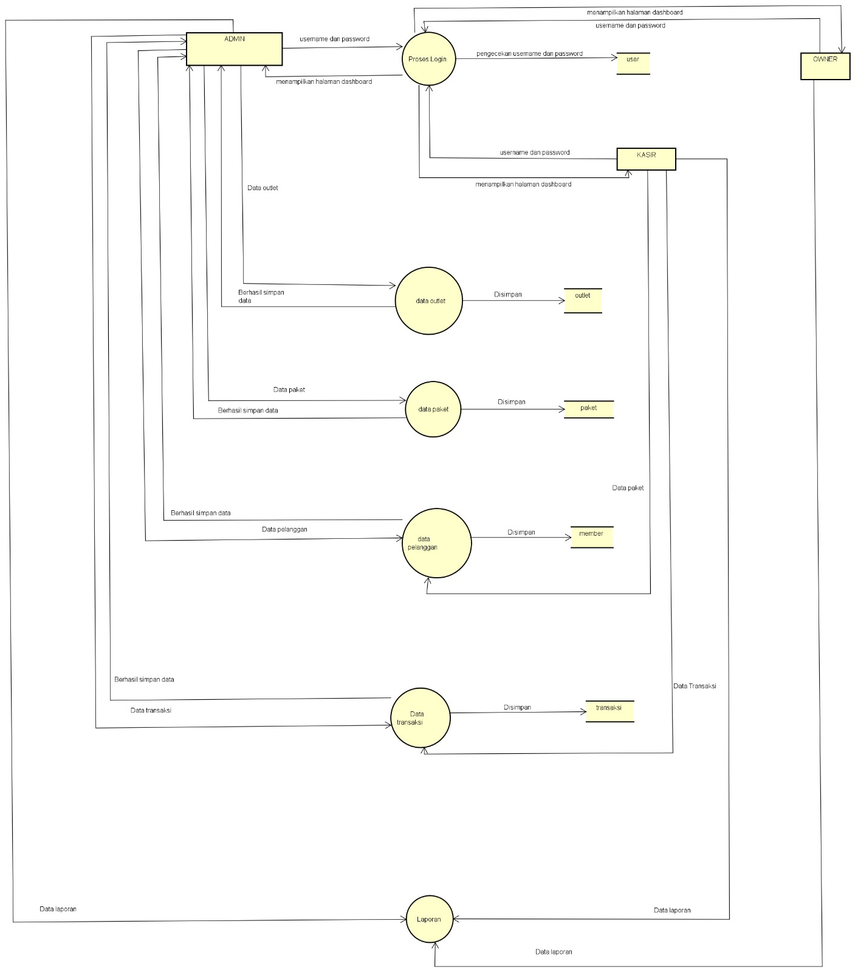

1. PENENTUAN DOMAIN DAN HOSTING
2. UPLOAD WEB KE HOSTING

laundrykazuha.000.webhostapp.com

1. UPLOAD WEB KE GITHUB

https://github.com/satria-cyber/aplikasi_laundry_satria

1. PEMBUATAN USER GUIDANCE

Admin

1. Masuk chrome

2. Ketik localhost/nama folder/

3. Ketik username dan password admin, lalu klik login

4. Masuk ke beranda dashboard admin

5. Lalu di dashboard admin bisa mengakses data outlet, data pelanggan, data paket, data pengguna, data transaksi dan laporan

6. Jika ingin logout klik tombol di navigation bar

Kasir

Masuk chrome

2. Ketik localhost/nama folder/

3. Ketik username dan password kasir, lalu klik login

4. Masuk ke beranda dashboard kasir

5. Lalu di dashboard admin bisa registrasi pelanggan, transaksi dan generate laporan

6. Jika ingin logout klik tombol di navigation bar

Owner

1. Masuk chrome

2. Ketik localhost/nama folder/

3. Ketik username dan password owner, lalu klik login

4. Masuk ke beranda dashboard owner

5. Lalu di dashboard owner bisa generate laporan

6. Jika ingin logout klik tombol logout di navigation bar