**原计划的缺点**

（原计划led的图片）

（原计划动画的设计图片）

We showed our initial plan at the first Group Crit, using common anode RGB LEDs to make a 5*5*5 RGB cube, using SCD-30 to read three kinds of data, and use one animation to display the temperature, humidity and CO2 data at the same time. The week after Group Crit we tried making and soldering some LEDs, but then we discovered the disadvantages of using common anode RGB LEDs: The common anode RGB LED uses three GPIO pins to control the brightness of red, green, and blue colors. This means that if we want to individually control the color of each LED in the cube, each LED requires three motherboard GPIO pins. So we must use additional hardware (such as shift registers or LED drivers) to expand the GPIO pins. Even a small cube of 5*5*5 will require dozens of registers and hundreds of resistors, which will cause Circuit design has become very complicated, whether it is LED welding or PCB design, it is not an easy task. And we also found the 5*5*5 cube to be too small at 125 LEDs, which limits the level of detail in the animation that the cube can show, and fewer LEDs means that fewer pixel points are changing at any given time, which can result in animations that don't look smooth or coherent. Less 3D space is provided, which limits creativity in spatial animation.

**计划变动**

（APA106 pin脚图片）

So after careful consideration, we changed our plan during reading week. Our new plan use APA106, which is addressable RGB LED with built-in controller IC and register, each LED only need one wire to connect data in pin to motherboard GPIO pin to control the colour, so we don't need any register and other Components, compared to common RGB LEDs, it is much easier to use and build, greatly simplifying the circuit, we only use three jumpers to control hundreds of rgb led, and also allows us to easily build larger rgb cube.

In addition, we upgraded the cube to 8*8*8, using 512 LEDs, compared to 5x5x5 with 125 LEDs, which can display more complex and detailed images and animations, providing a richer visual experience. The larger 3D space allows for more complex animation effects to be achieved in a three-dimensional space. This increased spatial dimension provides more possibilities for designing animations that allow for more animation effects to be explored with respect to light and shadow, depth and perspective. The new plan changed from showing three pieces of data in one animation to designing a separate animation for each piece of data, as we found that showing three pieces of data at the same time would make it difficult to understand and get the visualisation of the data from the animation.

**制作步骤**

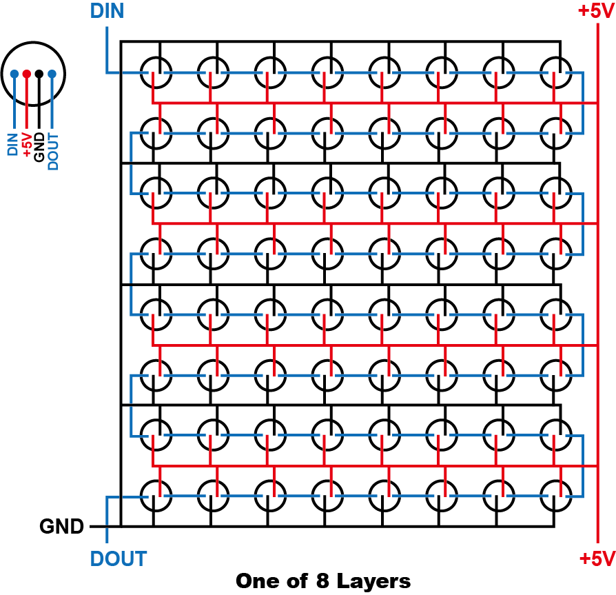

We first designed the wiring of the cube, our design is to divide the cube into eight 8*8 led layers, each layer is actually a strip of 64 leds as shown in the figure, because the APA106 has a built-in controller IC and uses the same protocol as the WS28 LEDs, we can make it an rgb strip by connecting the data of the previous led data out to the data in of the next led to connect the led in series and make it a rgb strip. As shown in the picture, the blue line is the data pin which connects all the LEDs in series, the black and red lines are the ground and power supply, all the LEDs share the ground and power supply.

（holder 的图片）

Next we weld layer, in order to ensure that the welding neat and beautiful, we first 3d printed 3 welding holder, holder on the holes reserved for placing the led and wire, we first put the leds into the holes, will be welded in series with the led's data pin, and then use the straightened copper wire as the power rail welding grounding and power supply.

（layer通电的图片）

We soldered 8layers and powered up to check if eachlayer is soldered correctly, tested to control the rgb colour using the test code, the APA106 supports the same protocol as the WS28 LEDs, so we used Adafruit_NeoMatrix and NeoPixel to control the colour and brightness of the led.

（cube图片）

After soldering eight layers, we stacked the layers on top of each other and soldered the data pins between them to make the layers into a long strip of 512 leds, which of course look like cubes in appearance. we used the SCD-30 to take readings of temperature, humidity and co2 and connected the sensors and the cube to the feather M0 board.

**代码**

After completing the cube assembly, we started writing the animation code. Since the cube is actually a strip of lights on the circuit connections, we use the Adafruit_NeoMatrix library to simulate the led strip as a cube, this will reassign the coordinates of the leds and allowing us to write the animation more easily, and then use the Adafruit_NeoPixel library to control the led colours.

（led函数图片）

There are a couple of key functions in the code, one for lighting up the led, led() takes the coordinates and colours it receives and then uses NeoPixel library commands to control the lighting of the led.

（color数组和函数图片）

We put the rgb values of commonly used colours into the color array to be used to change colours more easily. When used, the GetColor() function assigns the rgb values to the NeoPixel library colour command.

（按钮函数）

Our cube has a button to toggle the animation, and the button is called using attachInterrupt() so that the button can be detected in real time while the animation function is running, and all the animation functions will detect when the button's state changes by checking to see if the button is break; or return;, to skip the rest of the function that is not executed in order to to toggle the animation on-the-fly.

We have four animation functions, three for data visualisation and one for numeric and alphabetic animation to display the data. The code structure of the animation functions is actually quite simple, we make extensive use of for and while statements, and use the led() function in a loop to change the coordinates and colour of the lit led to compose the animation. The most difficult part was designing the coordinates of the led in each loop, and we spent a lot of time testing and envisioning the logic of the led changes.