Nama : Satria Nugraha

NPM : 085020007

Tugas 1 Pemrogaman Mobile 1

Screenshot CodeLab

1.Bicycle

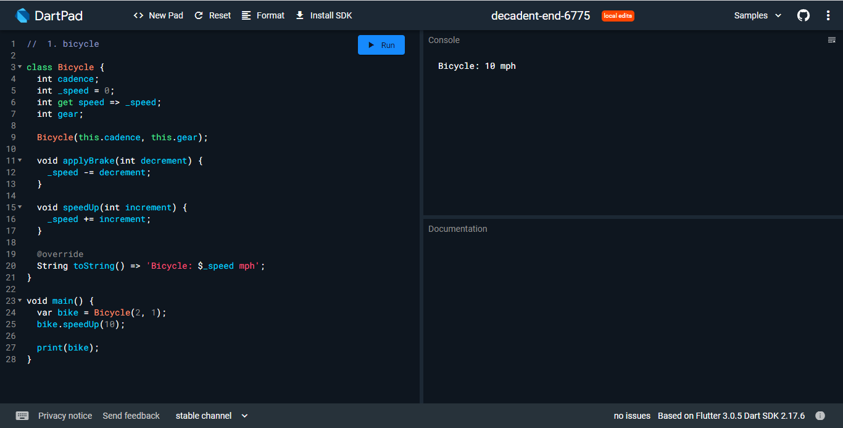

2.Rectangle

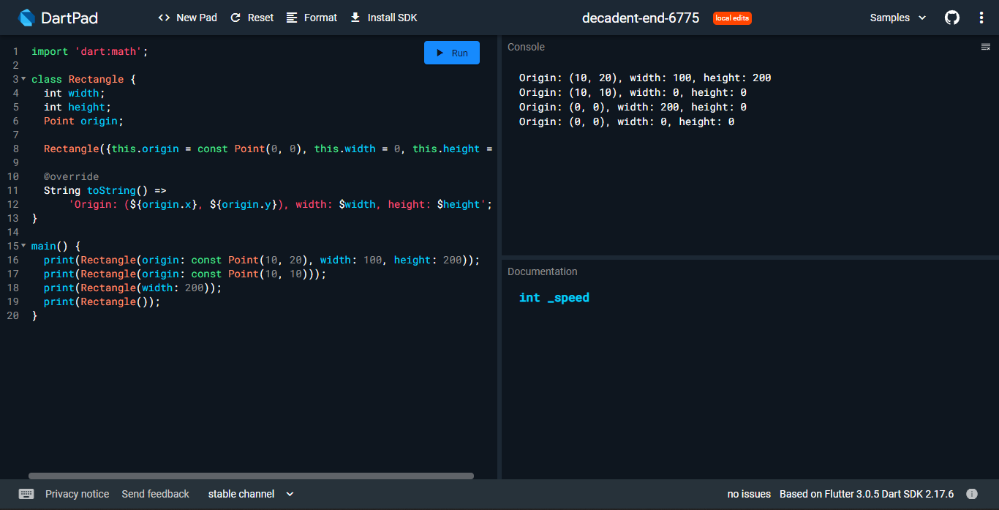

3.Factory

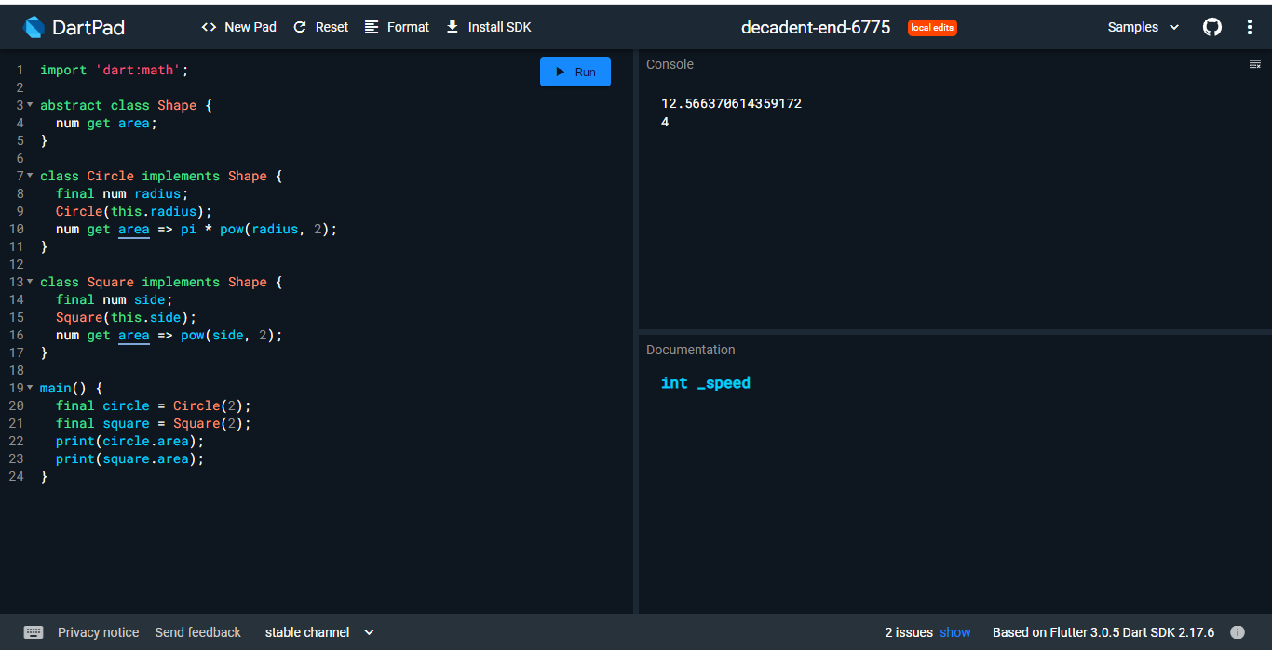

4.Functional

