Pertemuan-6-.R
Amar
2026-10-07
# Tipe data
print("Numeric")
## [1] "Numeric"
a <- 10
class(a)
## [1] "numeric"
print("Integer")
## [1] "Integer"
b <- 1000L
class(b)
## [1] "integer"
print("Character")
## [1] "Character"
c <- "nama saya adalah Amar"
class(c)
## [1] "character"
print("complex")
## [1] "complex"
d <- 9i + 3
class(d)
## [1] "complex"
print("boolean")
## [1] "boolean"
e <- TRUE
class(e)
## [1] "logical"
# Struktur data
buah = c("Mangga", "Manggis", "Semangka")
buah #vector
## [1] "Mangga" "Manggis" "Semangka"
list_buah = list("Mangga", "Manggis", "Semangka", 10, 20)
list_buah #data list
## [[1]]
## [1] "Mangga"
##
## [[2]]
## [1] "Manggis"
##
## [[3]]
## [1] "Semangka"
##
## [[4]]
## [1] 10
##
## [[5]]
## [1] 20
matrix_angka <- matrix(c(1,2,3,4,5,6),nrow=3, ncol=2)
matrix_angka
## [,1] [,2]
## [1,] 1 4
## [2,] 2 5
## [3,] 3 6
# Data frame (DF)
statistik_game_RPG = data.frame(
stat = c("Power","Mana","HP"),
marksman = c(100,40,50),
fighter = c(80,60,70)
)
statistik_game_RPG
## stat marksman fighter
## 1 Power 100 80
## 2 Mana 40 60
## 3 HP 50 70
# Vector numerik
angka = c(1,2,3)
angka
## [1] 1 2 3
urutan = 1:20
urutan
## [1] 1 2 3 4 5 6 7 8 9 10 11 12 13 14 15 16 17 18 19 20
urutan_desimal = 1.5:6.5
urutan_desimal
## [1] 1.5 2.5 3.5 4.5 5.5 6.5
urutan_desimal = 1.5:6.3
urutan_desimal #angka terakhir tidak masuk
## [1] 1.5 2.5 3.5 4.5 5.5
# Panjang vektor
length(urutan_desimal)
## [1] 5
length(buah)
## [1] 3
# Mengurutkan vektor
fruits = c("Banana", "Apple", "Mango", "Lemon")
sort(fruits)
## [1] "Apple" "Banana" "Lemon" "Mango"
# Mengakses vektor
fruits[1]
## [1] "Banana"
fruits[-1]
## [1] "Apple" "Mango" "Lemon"
# Mengganti item
fruits[1] = "Pear"
fruits
## [1] "Pear" "Apple" "Mango" "Lemon"
# Data frame
statistik_game_RPG
## stat marksman fighter
## 1 Power 100 80
## 2 Mana 40 60
## 3 HP 50 70
summary(statistik_game_RPG)
## stat marksman fighter
## Length :3 Min. : 40.00 Min. :60
## N.unique :3 1st Qu.: 45.00 1st Qu.:65
## N.blank :0 Median : 50.00 Median :70
## Min.nchar:2 Mean : 63.33 Mean :70
## Max.nchar:5 3rd Qu.: 75.00 3rd Qu.:75
## Max. :100.00 Max. :80
# mengakses data frame
statistik_game_RPG[1]
## stat
## 1 Power
## 2 Mana
## 3 HP
statistik_game_RPG$marksman
## [1] 100 40 50
# Menambahkan baris baru di data frame
statistik_game_RPG
## stat marksman fighter
## 1 Power 100 80
## 2 Mana 40 60
## 3 HP 50 70
statistik_game_RPG = rbind(statistik_game_RPG, c("Shield",60,80))
statistik_game_RPG
## stat marksman fighter
## 1 Power 100 80
## 2 Mana 40 60
## 3 HP 50 70
## 4 Shield 60 80
RPG = statistik_game_RPG
RPG
## stat marksman fighter
## 1 Power 100 80
## 2 Mana 40 60
## 3 HP 50 70
## 4 Shield 60 80
# Menambahkan kolom di data frame
RPG = cbind(RPG, assassin = c(70,40,50,60))
RPG
## stat marksman fighter assassin
## 1 Power 100 80 70
## 2 Mana 40 60 40
## 3 HP 50 70 50
## 4 Shield 60 80 60
# menghapus baris dan kolom di data frame
RPG_hapusbariskolom = RPG[-c(1), -c(1)]
RPG_hapusbariskolom
## marksman fighter assassin
## 2 40 60 40
## 3 50 70 50
## 4 60 80 60
# Mencari dimensi
dim(RPG)
## [1] 4 4
dim(RPG_hapusbariskolom)
## [1] 3 3
# Melihat data frame
View(RPG)
View(RPG_hapusbariskolom)
# Menggabungkan dua data frame
data_frame1 <- data.frame(
senjata = c("AKM", "M762", "Uzi"),
skin = c("Glacier", "Stray Rebellion", "The Fool"),
damage = c(48, 45, 25)
)
data_frame2 <- data.frame(
senjata = c("Thompson", "M416", "Groza"),
skin = c("Candy Cane", "Techno Core", "Ryomen Sukuna"),
damage = c(42, 41, 48)
)
FPS = rbind(data_frame1, data_frame2)
View(FPS)
## Grafik
# Plot
plot(1,3)
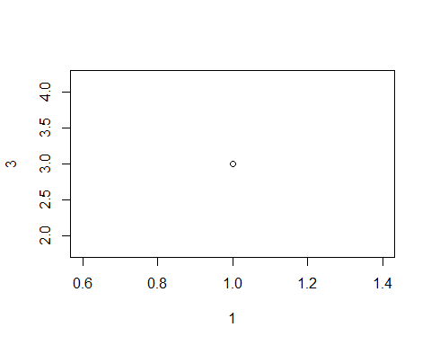
plot(c(1,8),c(7,9))
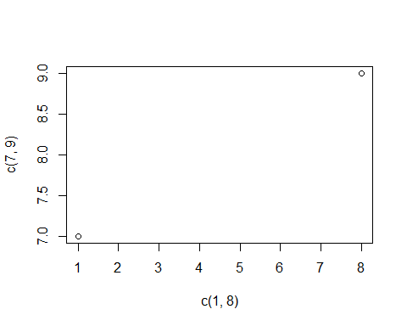
x = c(1,2,3,4,10)
y = c(6,7,8,9,10)
plot(x,y)
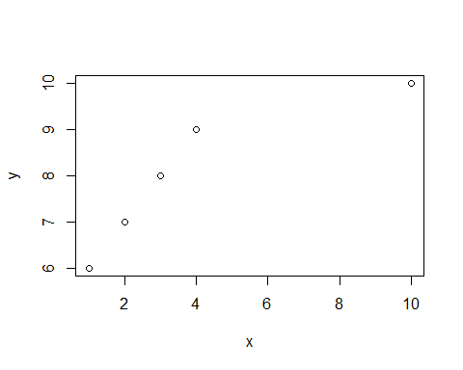
plot(3:10) # urutan
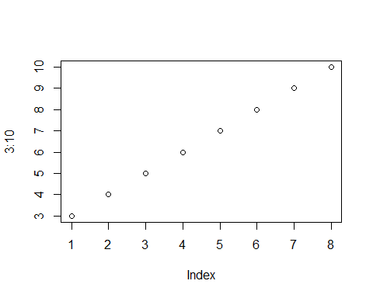
plot(3:10, type = "l")
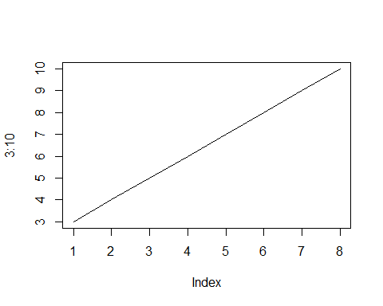
plot(3:10, main = "grafik lurus", xlab = "sumbu X", ylab = "sumbu Y", type = "l", col = "red")
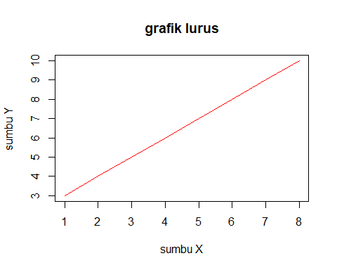
plot(1:10)
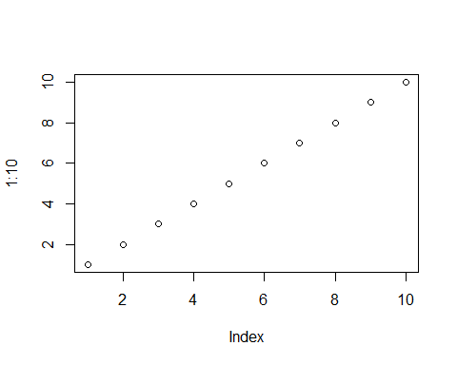
plot(1:10, pch = 11)
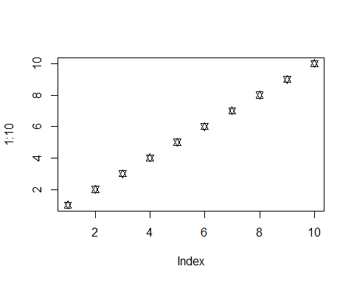
plot(1:10, pch = 11, type = "l")
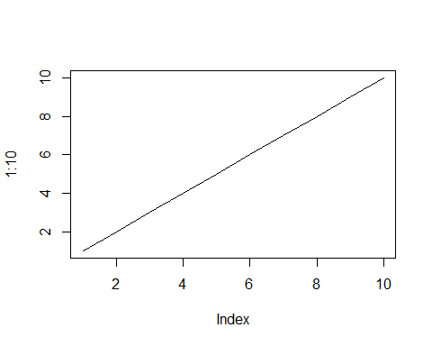
plot(1:10, pch = 11, type = "l", lwd = 5)
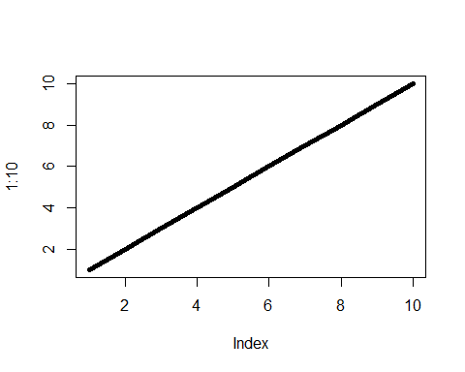
x <- c(1,2,3,4,10)
y <- c(6,7,8,9,10)
plot(x, type = "l", col = "blue")
lines(y, type = "l", col = "green")
