Project Report: Hospital Efficiency

  - Name: Satria Pamungkas
  - Student Number: 21522611
  - Date: 22 October 2025

Overview
In any situation, hospitals are required to respond as quickly as possible, especially when the situation is between life and death (Yazdani, Shahriari, and Haghani 2025). To respond promptly and, most importantly, accurately, there is a need for proper coordination among each hospital’s elements. The introduction of specific algorithms can facilitate swift and accurate decision-making.

Data Structure Used
In this report, the writer explores the use of Data Structures and Algorithms methodologies to answer the challenge in hospital coordination. The methodologies covered in this activity and the justifications are as follows:
- Graphs: Vieira Brodt, Lopes Rijo, and Alves (2025) As stated in their writing, the use of graphs helps them find optimal paths.
- Hash Tables: Vieira Brodt, Lopes Rijo, and Alves (2025) also stated that the hash table’s average-case complexity for insertion, finding, and removal is O(1), which is ideal for dynamic patient data.
- Heaps: Azadeh et al. (2014); Ajmi et al. (2024) highlighted that the use of the heap’s methodology helps with improving the management of emergency patients, with O(log n) time complexity.
- Advanced Sorting: Nainamalai et al. (2024) underlined that there is a need for data sorting before analysis, and a reliable methodology is needed, such as advanced sorting, that can sort with a relatively fast time complexity of O(n log n).
Module Integration
Below is the UML diagram illustrating the interaction between the modules, data structures, and classes in navigation and emergency scheduling.
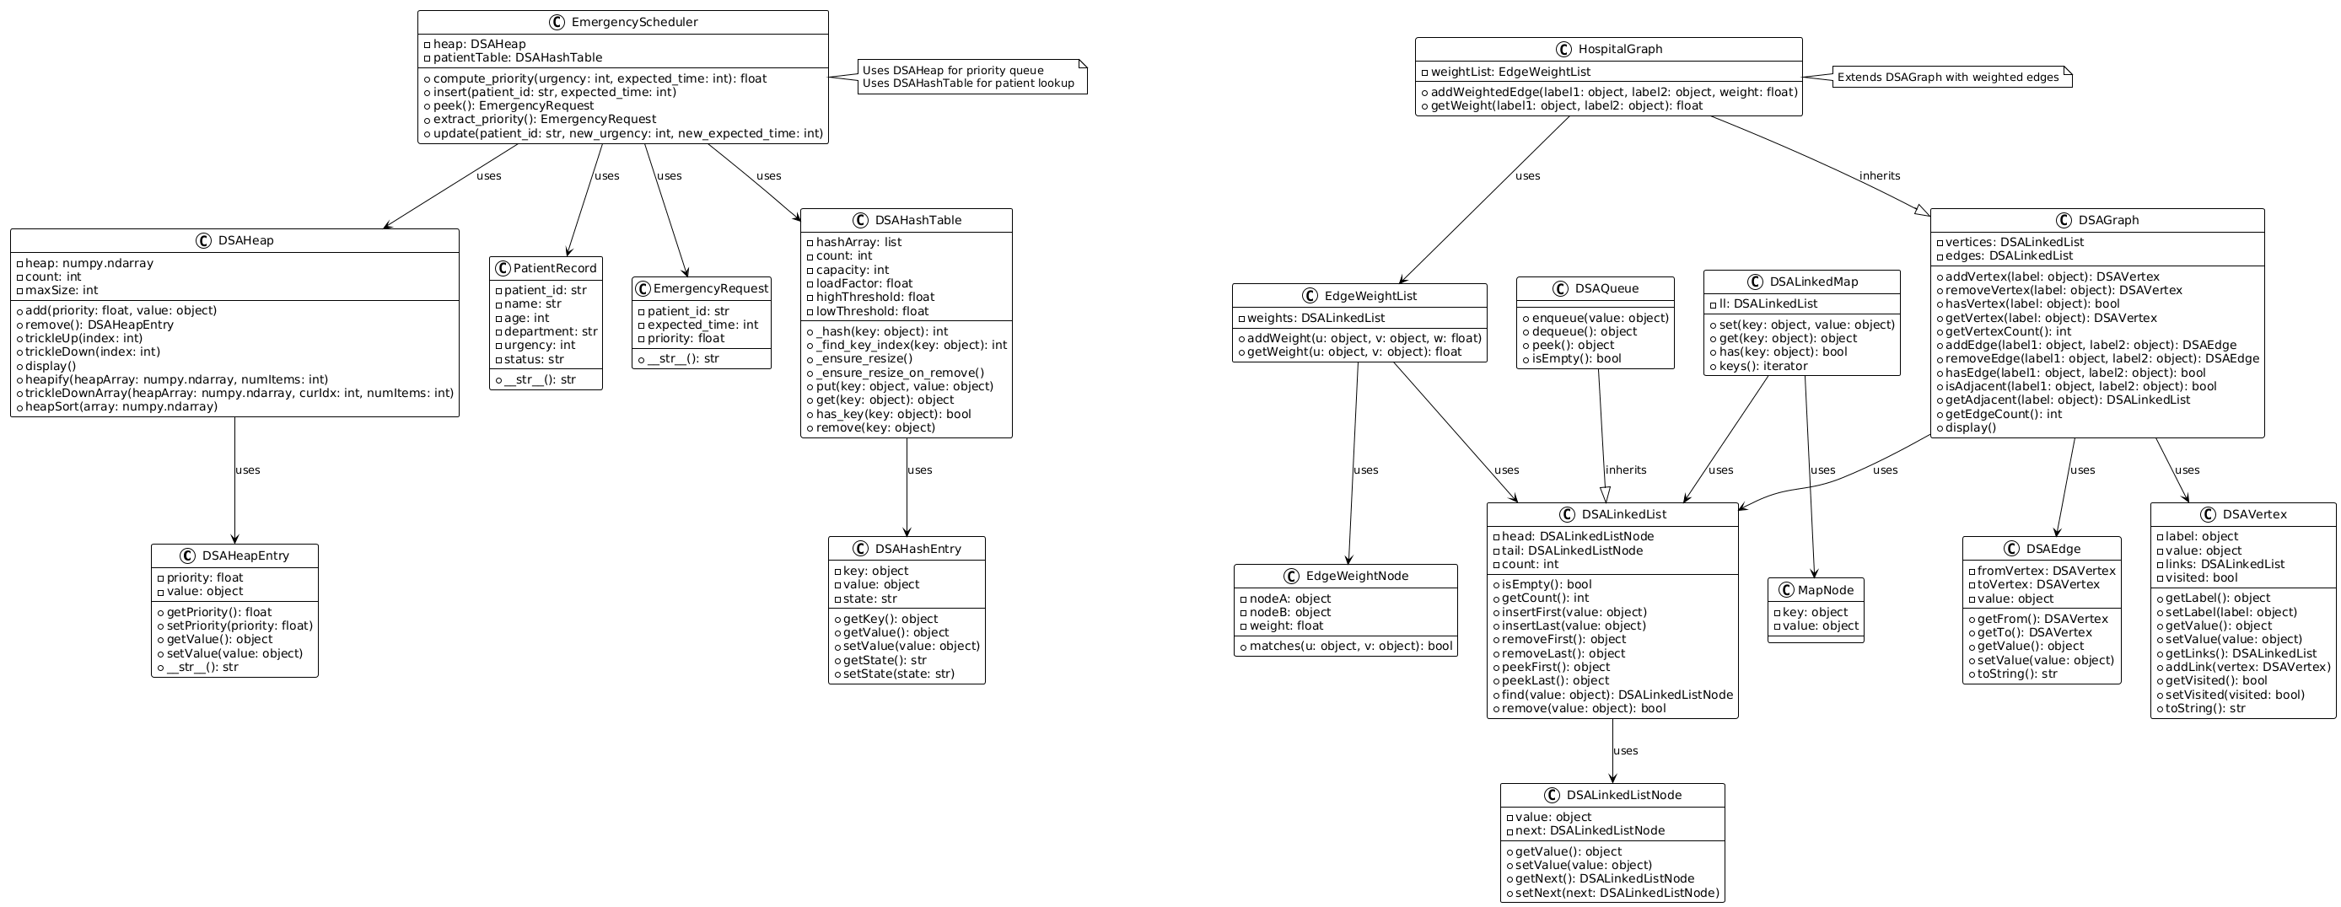
Figure 1. UML Diagram of the Hospital System (Photo by Author)
Hospital Graph and Navigation
The use of HospitalGraph is to describe the hospital’s layout, with each node representing a department and each edge representing the time (in minutes) required to walk from one node to another. To support the pathfinding and navigation in the hospital, EdgeWeightList and EdgeWeightNode are used. To ensure the most efficient path for staff, equipment, or patient navigation, the writer uses the A* algorithm.
Patient Data Flow
To initiate patient management, patient data is entered into the system through PatientRecord objects, which store information about patients, including patient identifiers, names, ages, departments, urgencies, and the latest treatment statuses. Then, with the use of DSAHashTable, the users can look up the records stored. Additionally, with the help of DSAHashTable, users can insert and remove elements, and the module automatically handles collisions and resizes as needed when more data is added.
Heap Operations and Scheduling for Emergency Cases
The writer uses EmergencyRequest to process emergency cases as quickly as possible. The primary process for determining which case to prioritise and manage is by using DSAHeap (specifically, a max heap). The EmergencyRequest will require users to input the patient’s identifier and the estimated time of treatment (in minutes). After that, the priority level is defined by taking the user’s input of Urgency Level with the formula as follows:
$$Priority =(6-Urgency)+1000/Treatment Time in minute$$

Algorithm Complexity Analysis
The modules used in this activity have different space and time complexities, as each module uses different methodologies. Below is the breakdown:
Hospital Graph
The time complexity of using the graph algorithm is O(V + E), where V represents the number of vertices and E represents the number of edges. Meanwhile, since an adjacency list is used in this activity, the space complexity is also O(V + E). Because the module uses Breadth-First Search (BFS) for level detection, BFS requires a time complexity of O(V + E) and a space complexity of O(V) for visited nodes and queues. Additionally, Depth-First Search (DFS) is used for cycle detection with a similar time complexity of O(V + E) and space complexity of O(V) for a recursion stack of visited stacks. Finally, to determine the most efficient path, the A* algorithm is employed, with a time complexity of O((V + E) log V) (Liu et al. 2024) due to the use of a priority queue and adjacency list, and an O(V + E) space complexity for calculating distances, maintaining the priority queue, and storing predecessor maps.
Patient Data
The average time to insert, search, and delete patient data into the HashTables is O(1) – O(n), where n represents the number of data already in the HashTables, with space complexity of O(n) because the table size also grows with more inputs.
Emergency Scheduling
The use of heap-based emergency scheduling results in a time complexity of O(log n) for inserting (because percolating up the leaf to restore the heap property) and replacing the root with the last element, followed by percolating down for extraction. Meanwhile, the space complexity for inserting is O(1) per insert and O(1) per extract operation. To peek, since the root is directly accessible, the time complexity is O(1).
Sorting Patient Records
The time complexity of sorting patient records with MergeSort is O(n log n), with a space complexity of O(n) for an additional array used for merging. On the other hand, the use of QuickSort with the Median of Three method (the most efficient choice of pivot compared to random and leftmost pivot choice) yields a time complexity of O(n log n) and a space complexity of O(log n).
Sample Outputs
In this activity, for easy visualisation, the writer uses Streamlit to visualise how the system works. Below are the explanations of each scenario:

Scenario 1 – Hospital and Its Navigation
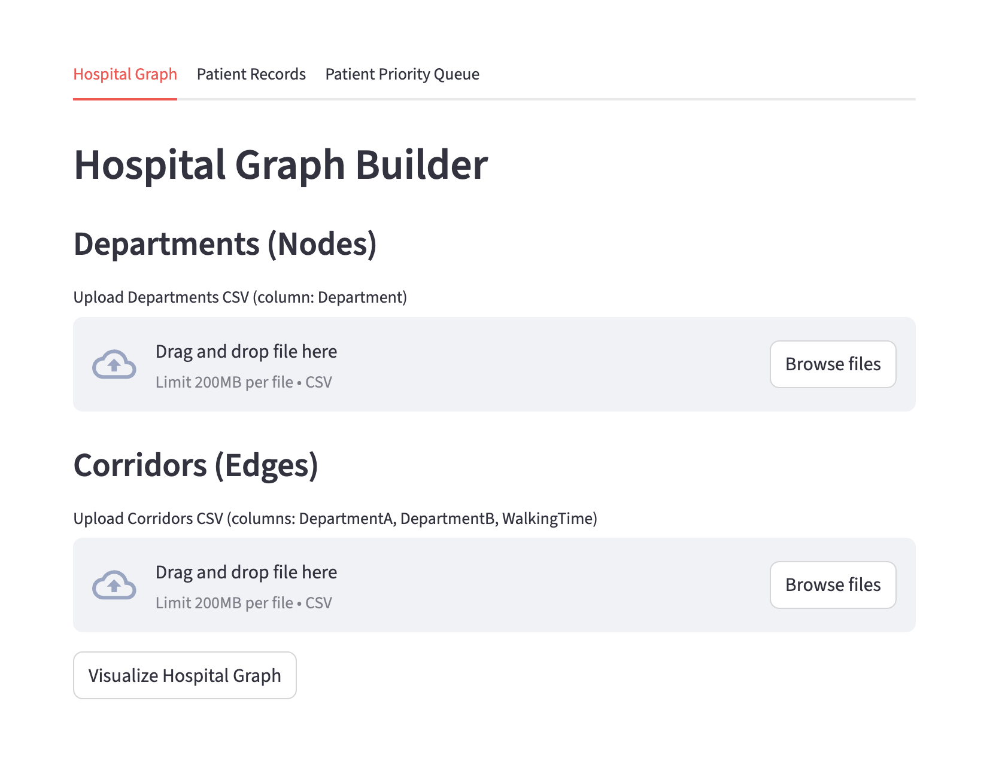
Figure 2. The user is prompted to upload the available departments and the connection of each department (Photo by Author)
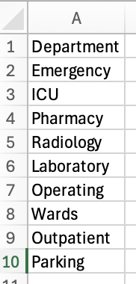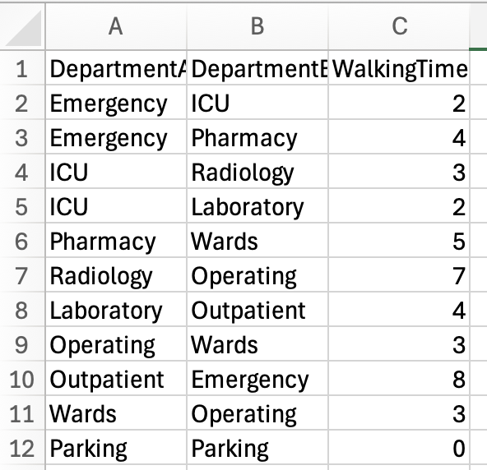
Figure 3. Sample Department Input (Left) and Corridors - Walking Time Minutes (Right) (Photo by Author)
Once the files have been successfully uploaded, the user can generate the visualisation of the hospital, for example in the figure below:
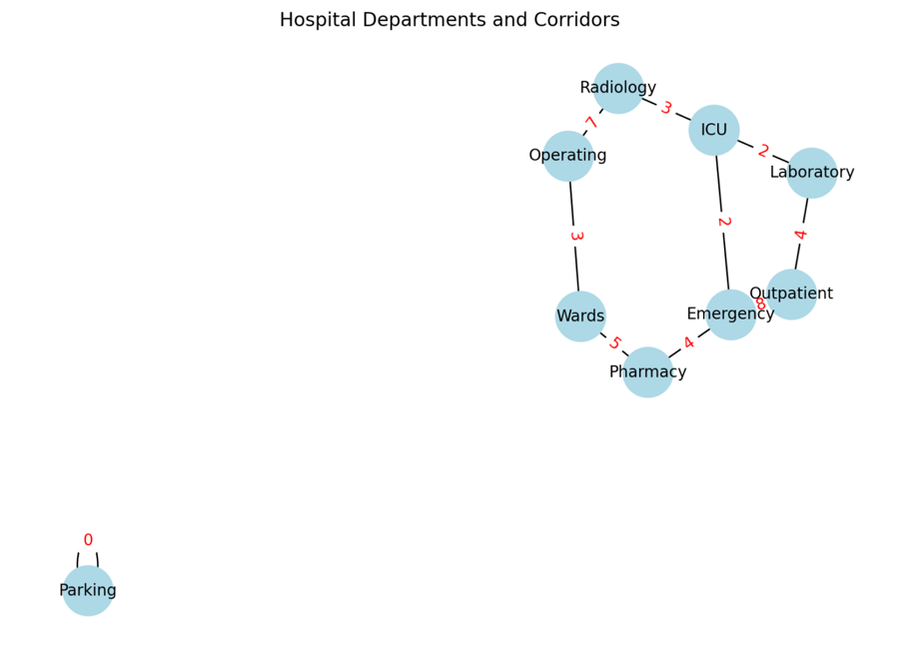
Figure 4. Visual of the Hospital Departments – Corridors – Walking Time in minutes in red (Photo by Author)
Once the visual is generated, the user can generate the BFS to understand the department levels based on another department as a reference, or to detect if there are cycles with DFS. Below is an example of the output of BFS and DFS:
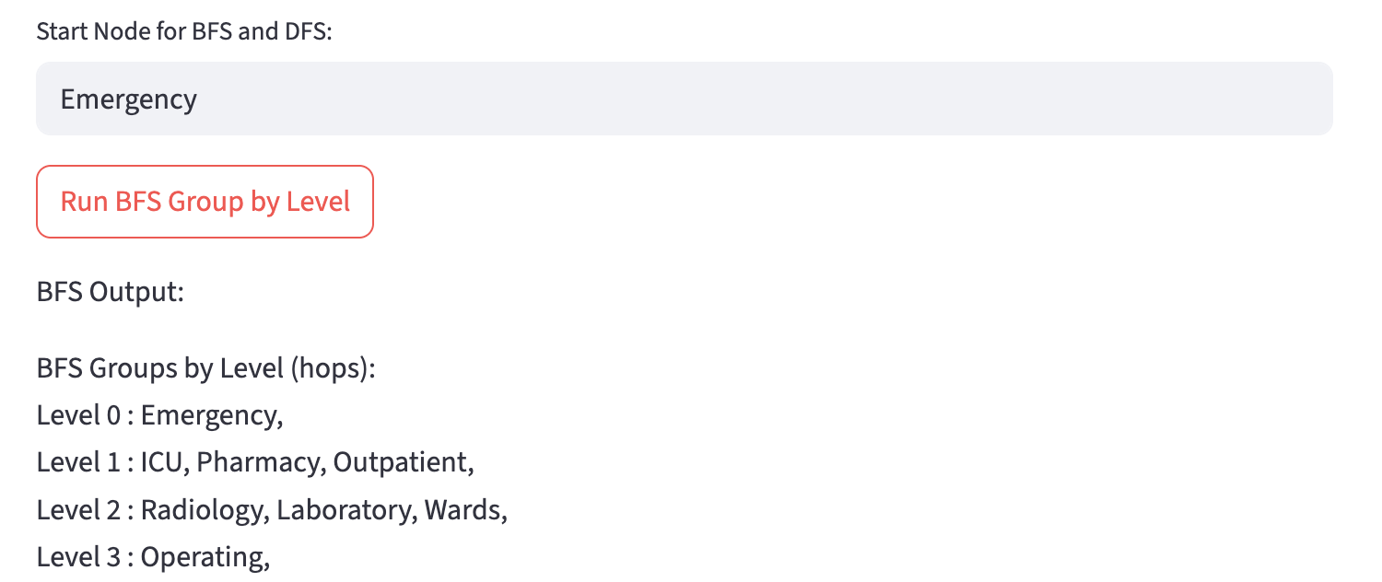
Figure 5. BFS Result when taking Emergency as a reference (Photo by Author)

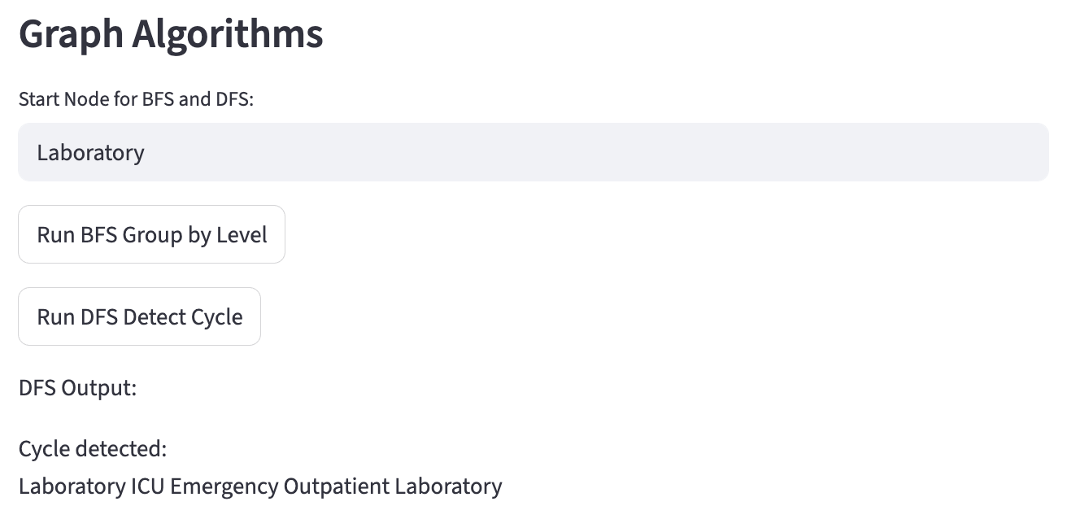
Figure 6. DFS Result when taking Emergency as a reference (Photo by Author)
The user can also calculate the shortest walking time to travel between departments. Below is the sample output:
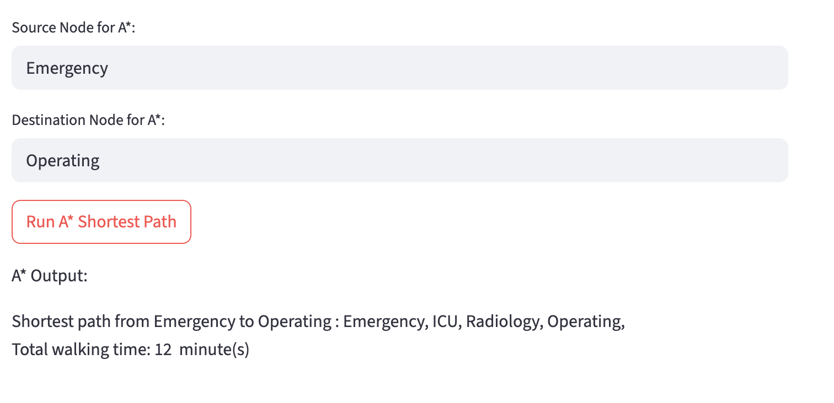
Figure 7. Shortest Walking Distance from Emergency to Operating (Photo by Author)

Scenario 2 – Patient Management
The patient management system utilises hash tables, with an initial table size of 7, and this number is always increased to the nearest prime number. The prime selection is done by finding the first prime number greater than or equal to the requested size. Moreover, the hash function uses polynomial rolling hash with the multiplier 31, this number is considered simple and effective. In the UI, the user can load patients’ data in bulk CSV in a tab called “Patient Records”, the example is below:
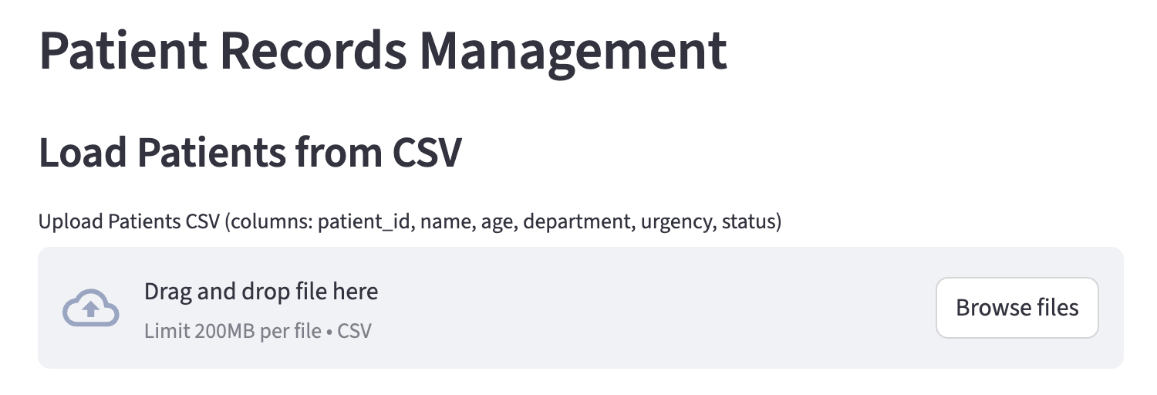
Figure 8. System to load patient’s data from CSV (Photo by Author)
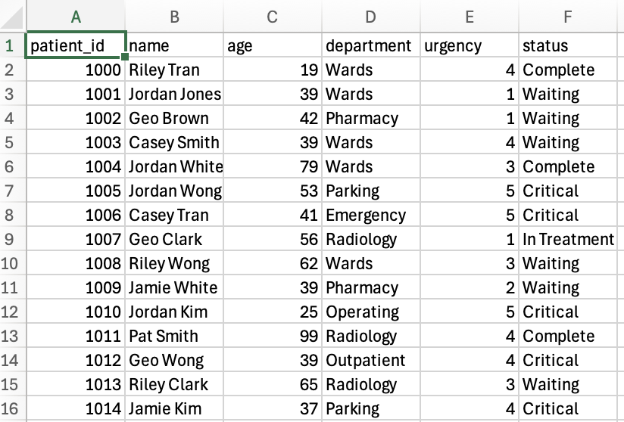
Figure 9. Sample CSV of patient data CSV (Photo by Author)
Once the patient data is successfully loaded, a table of patients’ information is presented at the bottom of the page.
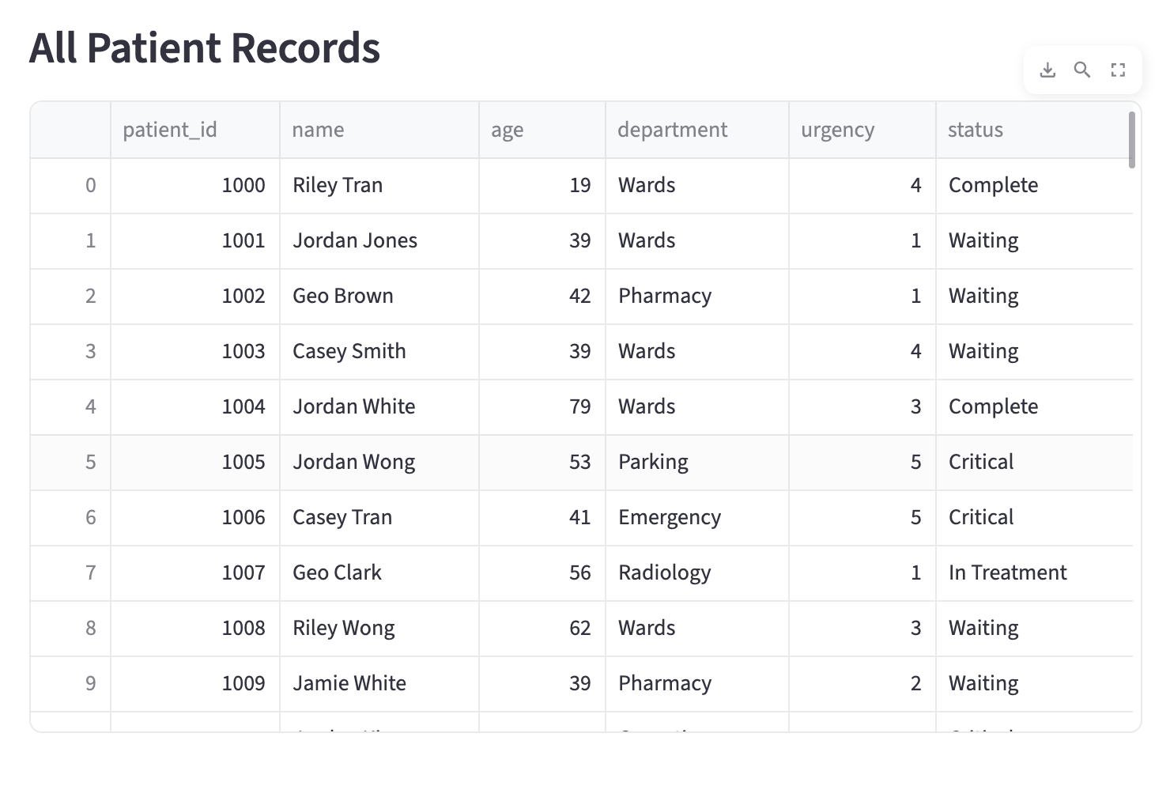
Figure 10. Sample data presented on the webpage (Photo by Author)
The system also enables users to insert new patient information into the system (but it will not be saved in the CSV, only in the webpage table).
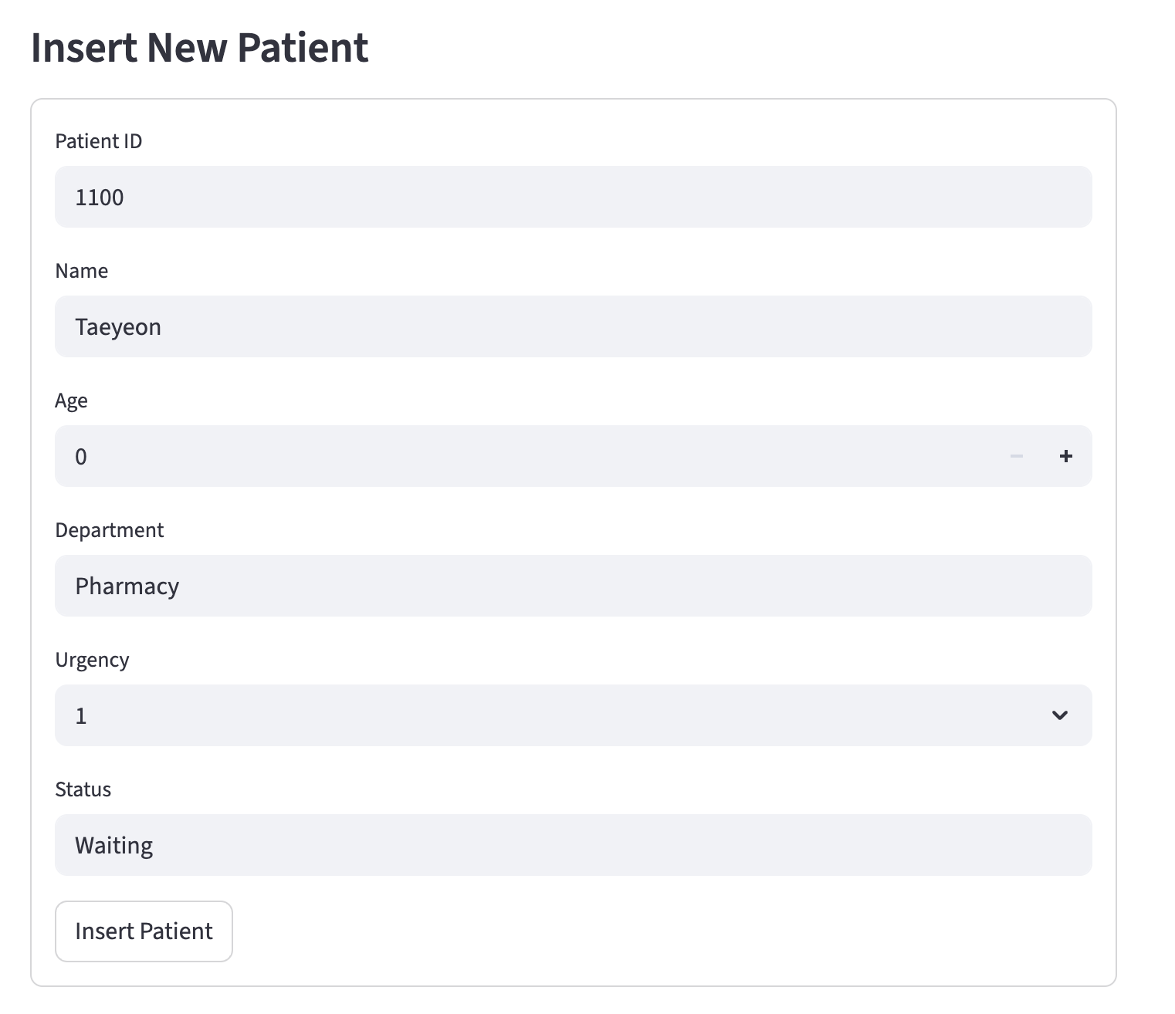
Figure 11. Sample when inserting new data into the system (Photo by Author)
Because the system uses linear probing, when a user with the same ID is added, it will override the old data with the new one.
The system can also search a patient’s details by using the patient ID.
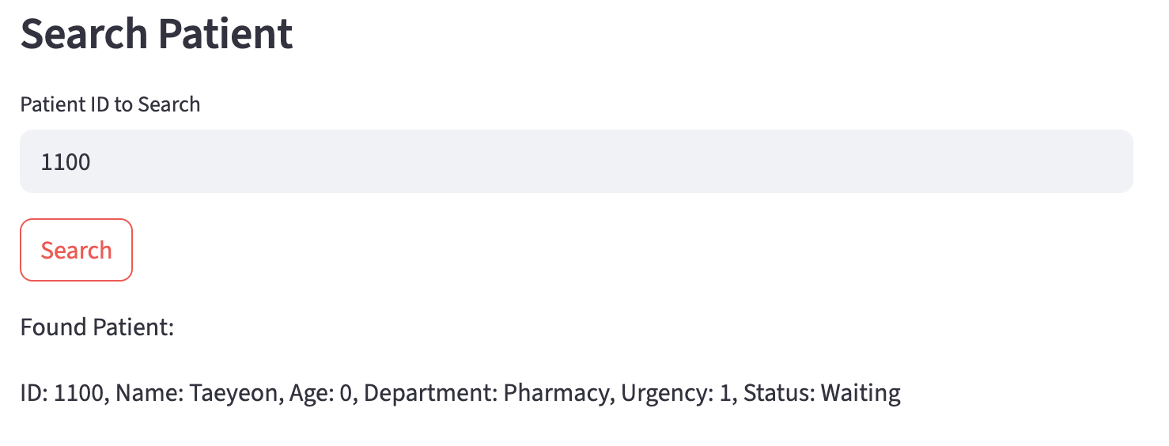
Figure 12. Sample when searching for a patient’s details using the patient’s ID (Photo by Author)
The user can also delete the patient’s record. This will only delete from the webpage, not from the CSV. If the data is inserted from the webpage, it can be deleted from the webpage. Otherwise, the deleted patient record will still appear in the table at the bottom of the webpage but will remain unsearchable on the webpage.
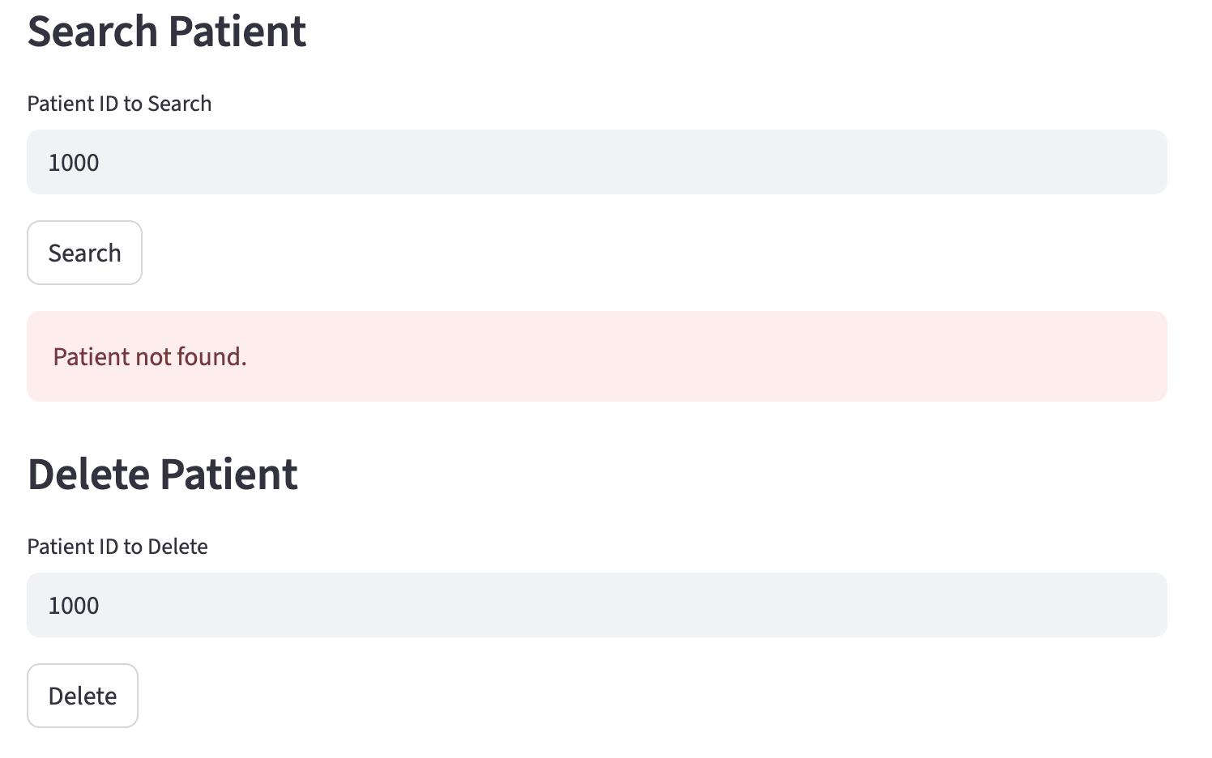
Figure 13. Searching for a patient when it is already deleted will result in “Patient not found” (Photo by Author)

Scenario 3 – Emergency Scheduler
If the patient's record is in the webpage system, the user can go to the “Patient Priority Queue” to see which patient is next in line for treatment. The user must upload the required CSV file, which contains all the necessary information.
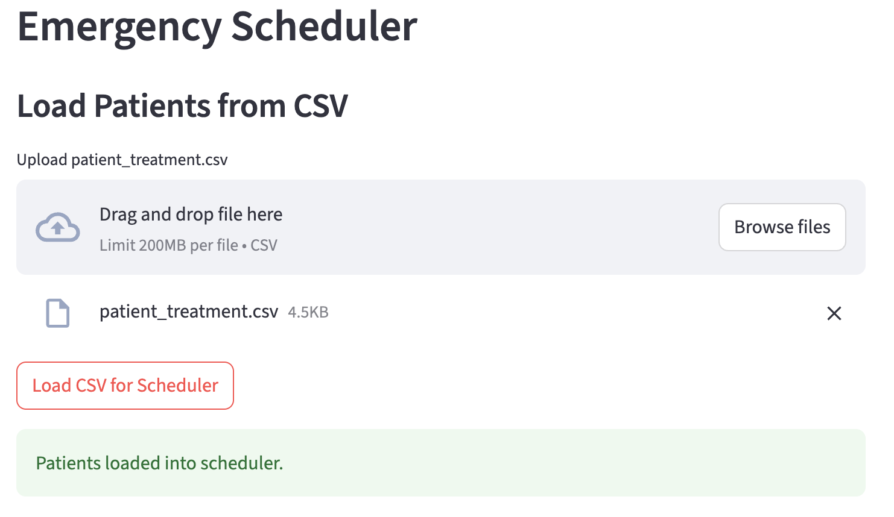
Figure 14. Patient’s Priority Queue upload CSV interface (Photo by Author)
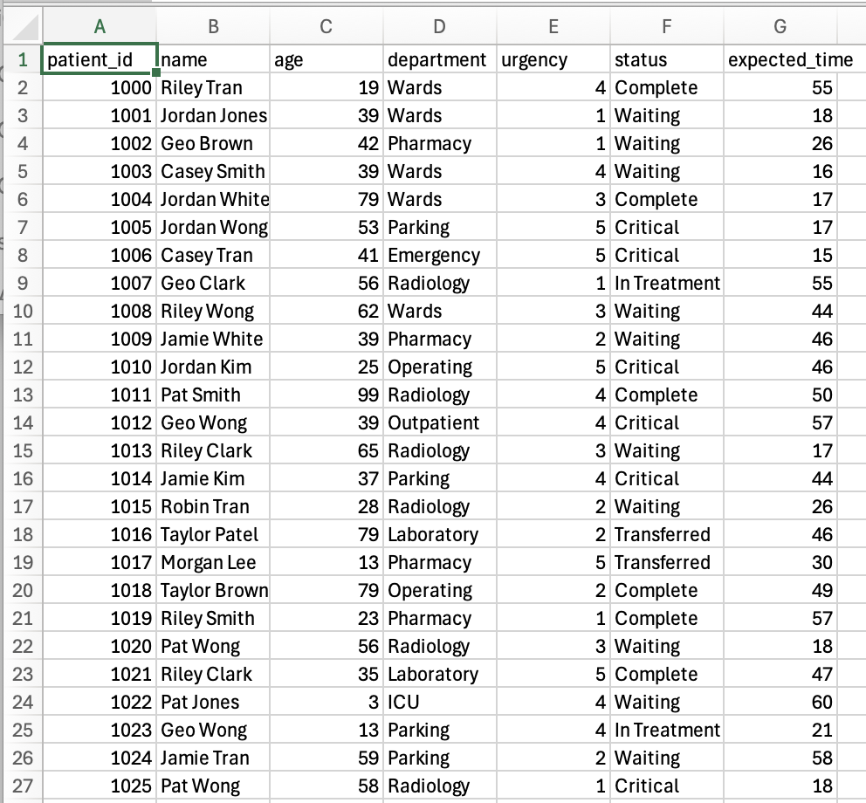
Figure 15. Sample CSV for Patient’s Priority Queue (Photo by Author)
The user can then view the next patient in line for treatment based on the highest priority with an example below:
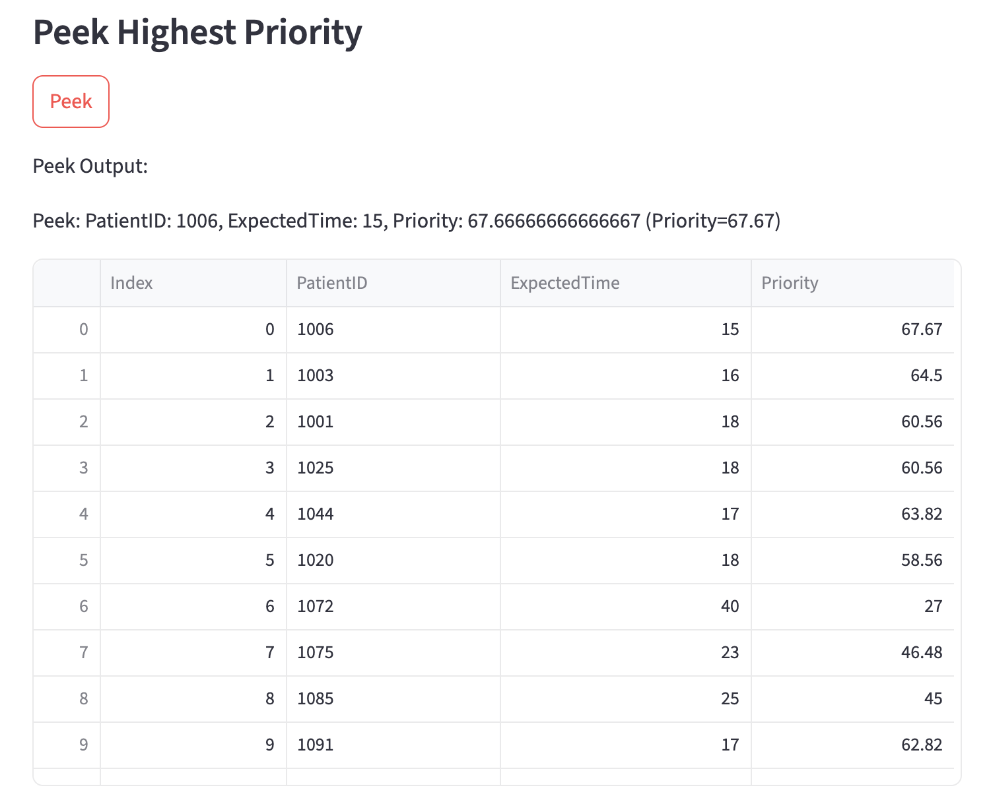
Figure 16. Sample Output of Next Patient for Treatment based on Priority (Photo by Author)
Once the patient is treated, the user can “extract” the patient and proceed to the next one, as shown in the figure below.
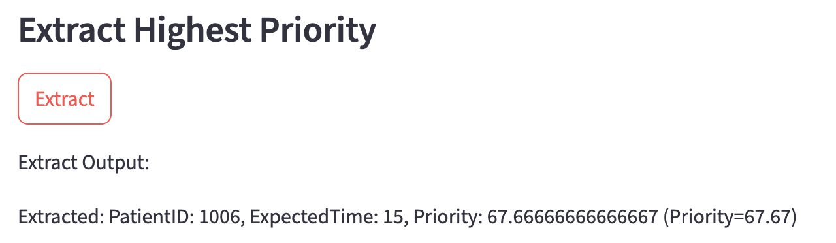
Figure 17. Sample output when the patient is already treated and moving on to the next patient (Photo by Author)
If we peek after the extract, the next patient to be treated will be displayed in the first row, sample output below:
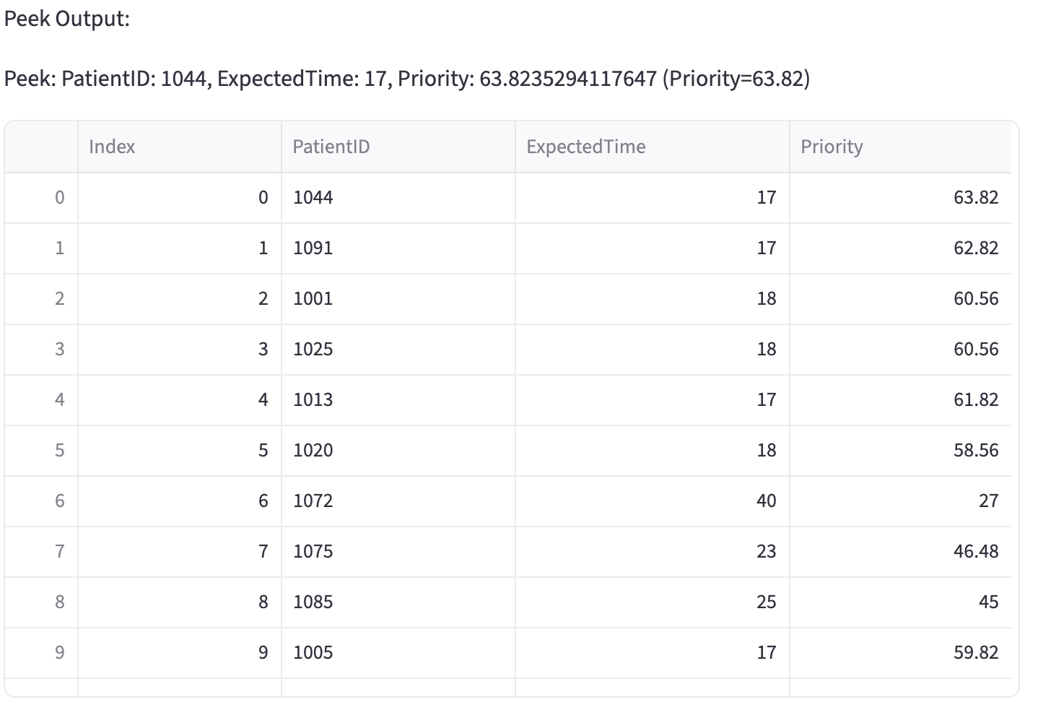
Figure 18. Sample output of peek after extracting the previous priority (Photo by Author)
Additionally, the user can modify the priority by inputting the urgency and expected treatment time, the sample below:
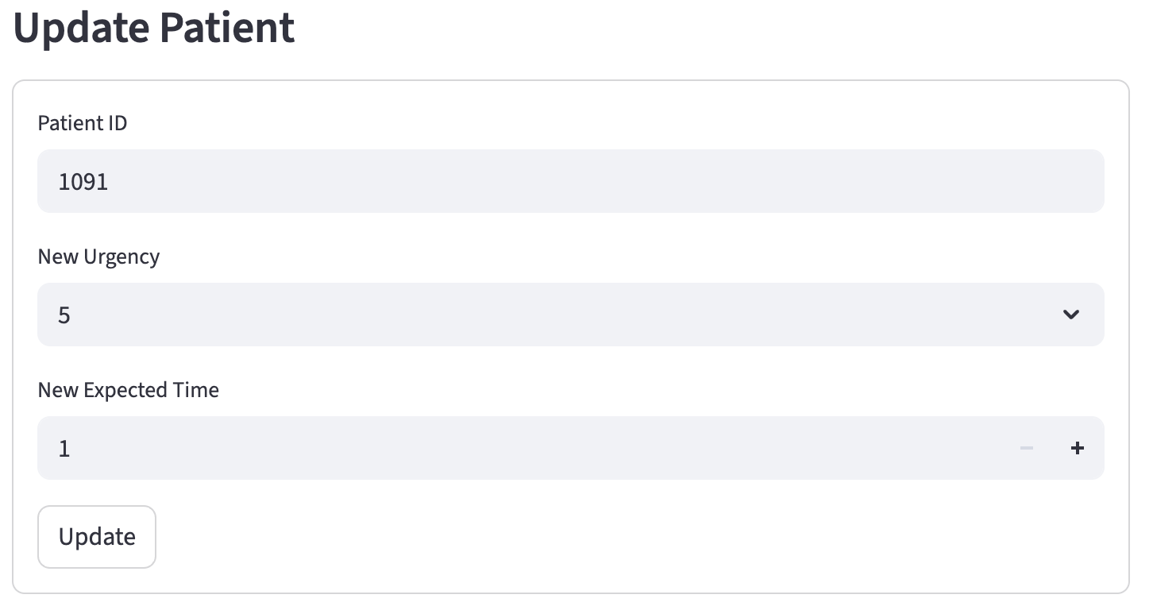
Figure 19. Sample input of updating a patient’s priority based on Urgency and Expected Treatment Time (Photo by Author)
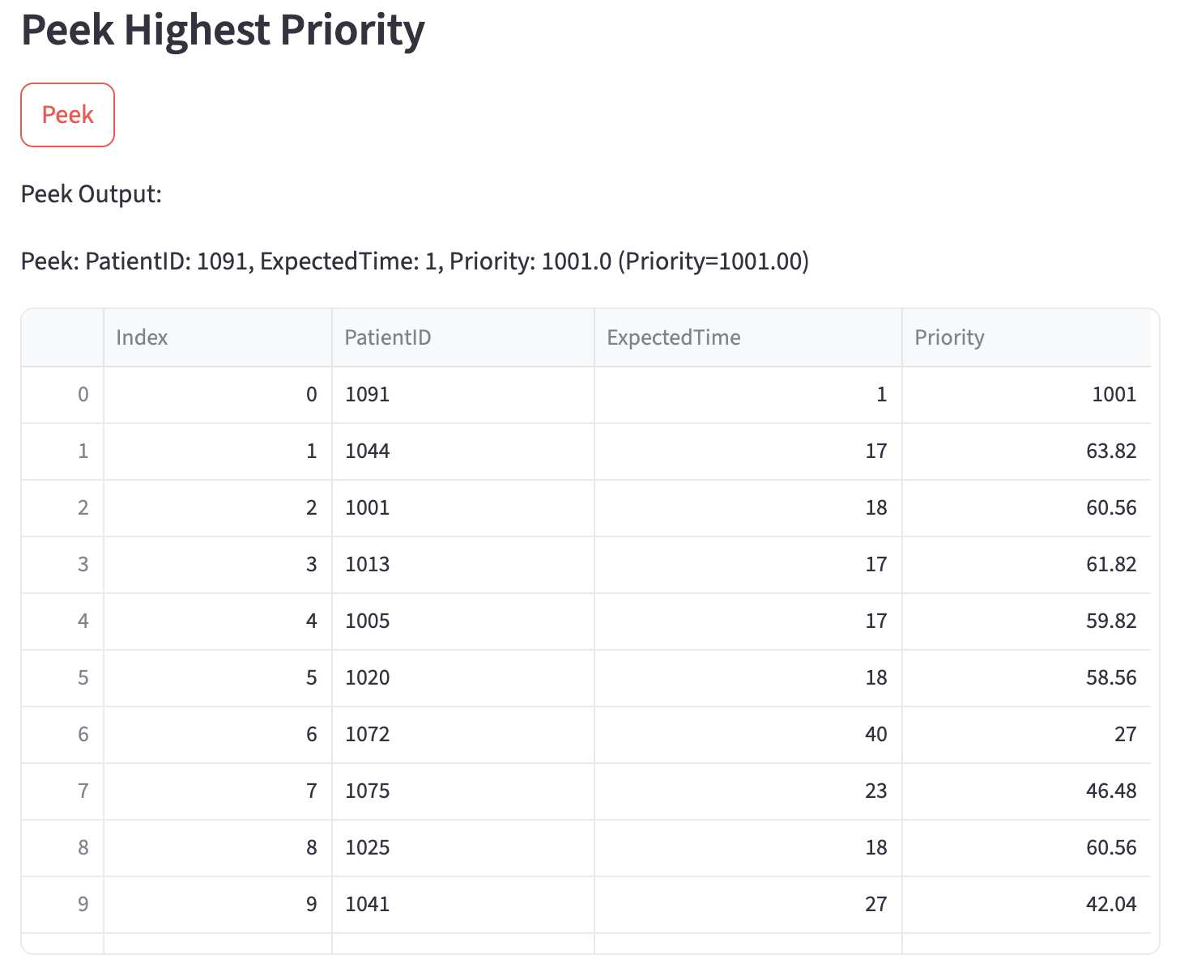
Figure 20. Sample output after updating the patient’s priority. Previously, patient ID 1044 was next in line, but was replaced with patient ID 1091 (Photo by Author)

Scenario 4 – Patient Sorting
During the patient sorting step, the writer also implements the simulation on the webpage. The sorting algorithms used are quick sort with a pivot of the median of three and merge sort. The reason why the writer chooses the median of three as the pivot of quick sort is that the writer tried to avoid the chance of bad splits and aimed for consistent O(n log n) behaviour. Below are the results for random, nearly sorted, and reversed conditions:
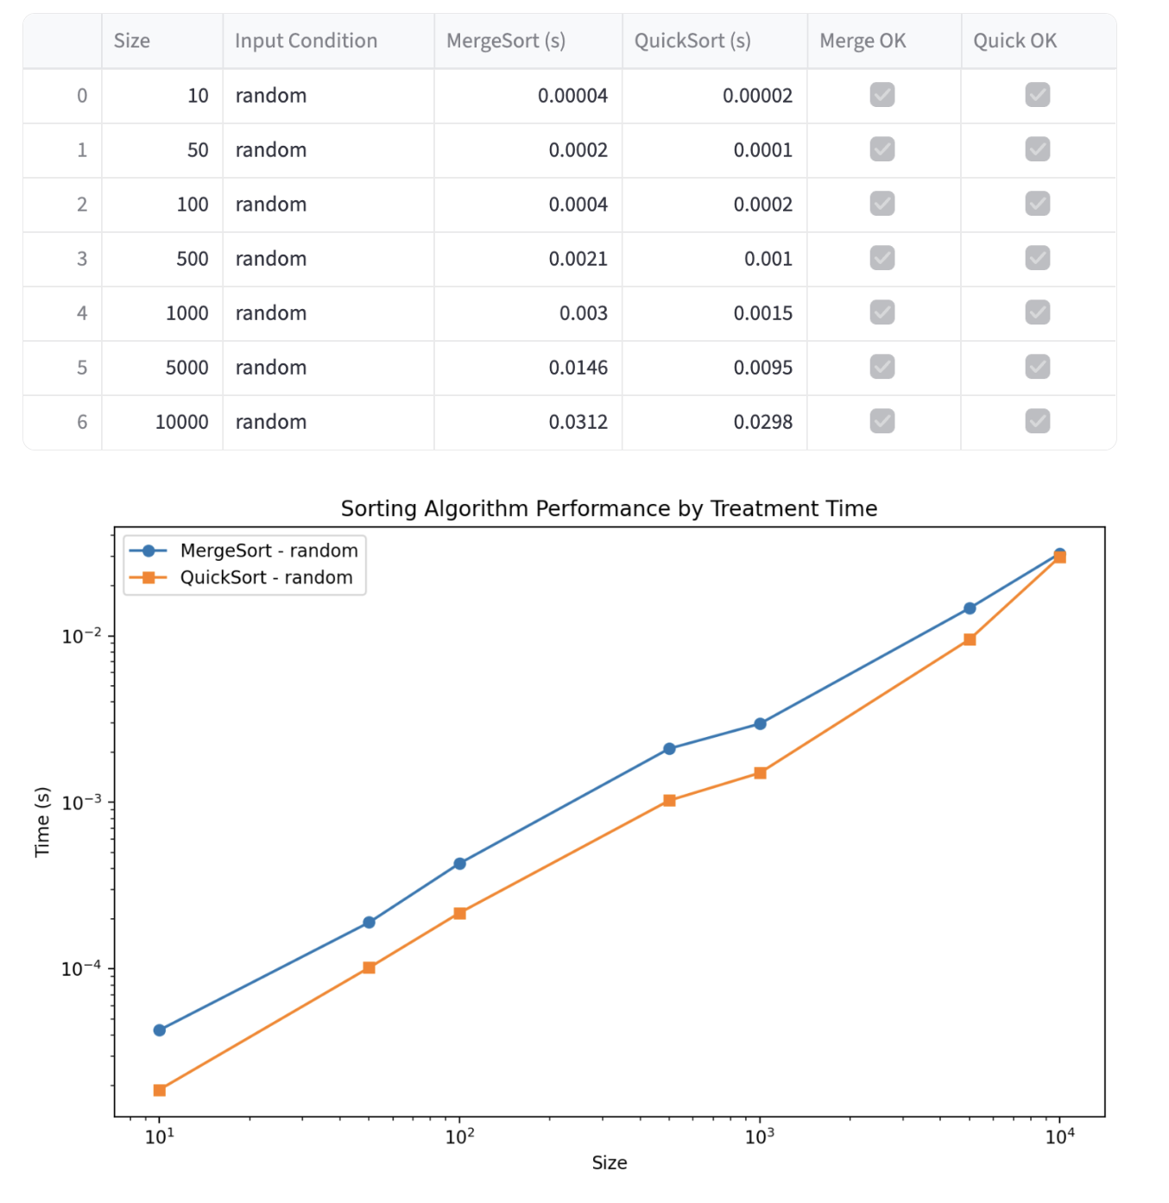
Figure 21. Sample output of sorting with random disorder across different numbers of data (Photo by Author)
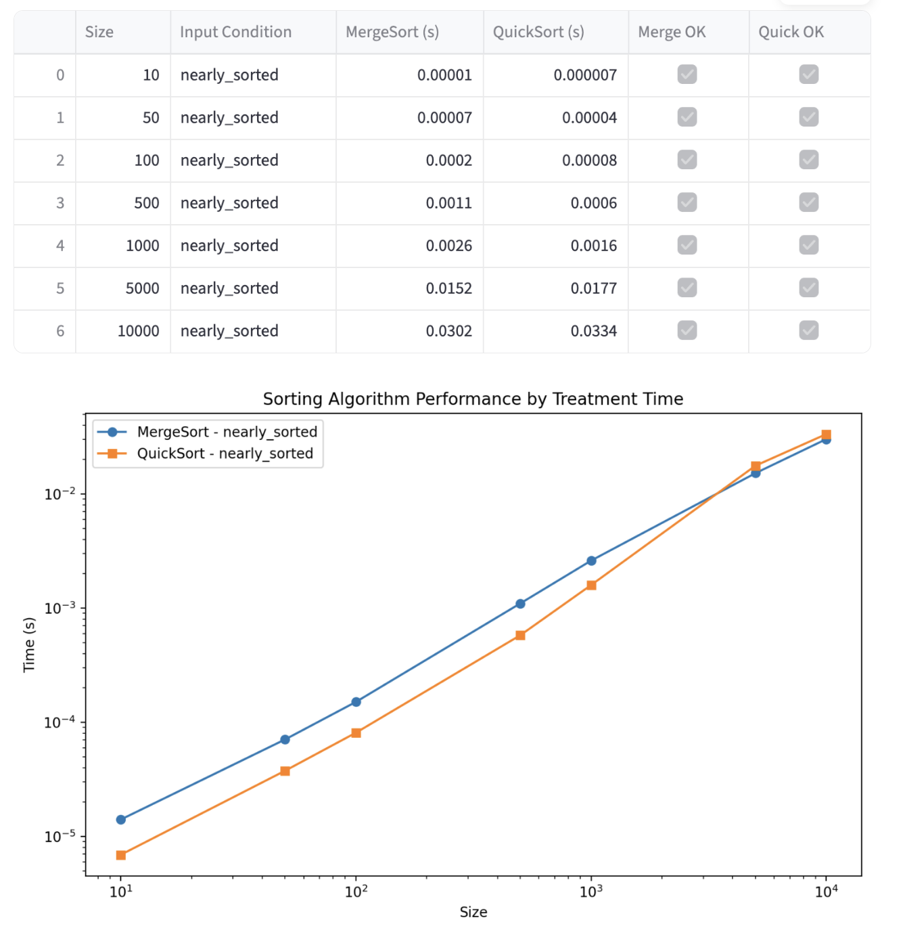
Figure 22. Sample output of sorting with nearly sorted disorder across different numbers of data (Photo by Author)
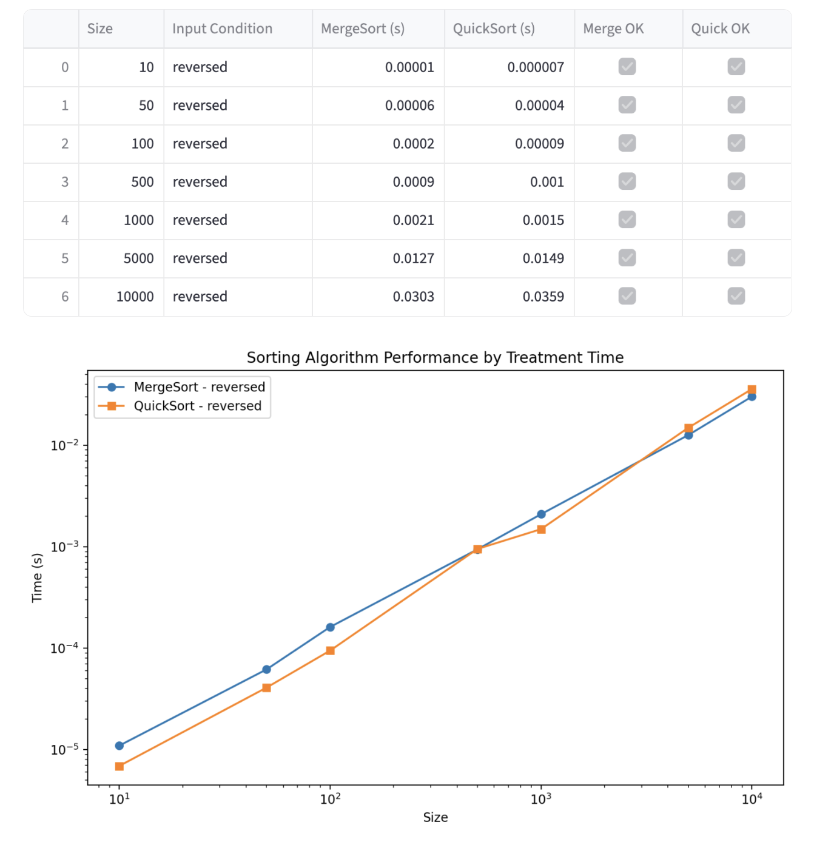
Figure 23. Sample output of sorting with reversed disorder across different numbers of data (Photo by Author)
Based on the sorting result, the quicksort algorithm, on average, is faster than the merge sort in sorting different amounts of data in various orders. This is because quick sort uses the median of three as the pivoting method, making it unlike merge sort, which requires extra space allocation and memory. However, the performance of randomly sorted data with an enormous size is almost similar. Additionally, when the number of data is large and in reverse and nearly sorted order, merge sort can be better than quicksort. Merge sort is better in reverse and nearly sorted orders because it is not affected by input order, unlike quicksort.

Reflections
Reflecting on the assignment’s expected output, below are the fulfillments of the code and this report:
- Graph-Based Hospital Navigation
  - A visual graph is generated to understand the “map” of the hospital. Textual output of the adjacency list is also provided as a validator.
  - BFS for levelling also generates correct textual output when compared to the visual graph.
  - DFS for cycle detection detects the cycle correctly when compared to the visual graph.
  - The implementation of the A* algorithm is also capable of generating the shortest walking distance when travelling from one node to another.
- Hash-Based Patient Lookup
  - When data is inserted or deleted, the table on the webpage will display the updated table. Meanwhile, when searched, a result will be displayed indicating whether it is found or not found.
  - When a new record is created but the ID already exists, the information associated with the ID will be updated instead of adding new data.
  - The hash table source code is provided, taken from the writer’s Practical Code.
  - Upon inserting, searching, deleting, and handling collisions, the results are presented on the webpage.
  - The hash strategy, table size, and hash function for patients’ records are explained and justified in the first and second sections of this report.
- Heap-Based Emergency Scheduling
  - The list generated is in correct order (based on the calculation of priority, from the highest priority to the lowest).
  - The system can upload (get input), and once processed, the user can also download the sorted list based on the priority.
  - The system also consistently processes / serves the highest priority patient first.
  - The heap code is functioning as expected and includes adequate comments.
  - The webpage system can show the table of patients in descending order based on the priority calculation.
  - The system’s operation is also explained in Sections 2 and 3.
- Sorting Patients Records
  - The list is correctly sorted, as indicated by Merge OK and Quick OK, which confirm that the list is sorted accordingly.
  - The webpage also displays a timing table and plot that compares merge sort and quicksort when faced with different data sizes and disorders.
  - A brief reflection of the sorting performance (based on the time) is also presented in this report.
  - The code for merge sort and quicksort is provided in the folder.
  - The code for the sorting benchmark is provided in a table, and the presentation is in tables and plots.
  - A brief paragraph on how each sorting algorithm performs is also presented in Section 4.

Limitations, Assumptions, and Future Work
In this project, the writer acknowledges that there are limitations, such as the webpage's inability to display more than one output per button click, which necessitates further investigation and development. Moreover, using a webpage as the main UI may not be suitable for the hospital environment, which primarily utilises software-based systems and does not rely heavily on external libraries to run the system, due to privacy concerns. This is because the writer assumes that the hospital needs a comprehensible system as quickly as possible to manage patients in an orderly manner. Additionally, the writer assumes that healthcare professionals are aware of the treatment time. Due to the limitations and assumptions, the writer sees potential for further work to perfect the program.

References
Ajmi, Faiza, Faten Ajmi, Sarah Ben Othman, Hayfa Zgaya-Biau, Mariagrazia Dotoli, Jean-Marie Renard, and Slim Hammadi. 2024. "Real time patient scheduling orchestration for improving key performance indicators in a hospital emergency department." Journal of computational science 82: 102422. https://doi.org/10.1016/j.jocs.2024.102422.
Azadeh, A., M. Hosseinabadi Farahani, S. Torabzadeh, and M. Baghersad. 2014. "Scheduling prioritized patients in emergency department laboratories." Computer methods and programs in biomedicine 117 (2): 61-70. https://doi.org/10.1016/j.cmpb.2014.08.006.
Liu, Yuanmin, Xinyu Gao, Bo Wang, Jiaxin Fan, Qiurong Li, and Wen Dai. 2024. "A passage time–cost optimal A* algorithm for cross-country path planning." International Journal of Applied Earth Observation and Geoinformation 130: 103907. https://doi.org/https://doi.org/10.1016/j.jag.2024.103907. https://www.sciencedirect.com/science/article/pii/S1569843224002619.
Nainamalai, Varatharajan, Hemin Ali Qair, Egidijus Pelanis, Håvard Bjørke Jenssen, Åsmund Avdem Fretland, Bjørn Edwin, Ole Jakob Elle, and Ilangko Balasingham. 2024. "Automated algorithm for medical data structuring, and segmentation using artificial intelligence within secured environment for dataset creation." European journal of radiology Open 13: 100582-100582. https://doi.org/10.1016/j.ejro.2024.100582.
Vieira Brodt, João Pedro, Rui Pedro Charters Lopes Rijo, and Domingos Alves. 2025. "Improving Hospital Experience through Indoor Localization Implementation." Procedia computer science 256: 1326-1332. https://doi.org/10.1016/j.procs.2025.02.245.
Yazdani, Maziar, Siroos Shahriari, and Milad Haghani. 2025. "Real-time decision support model for logistics of emergency patient transfers from hospitals via an integrated optimisation and machine learning approach." Progress in disaster science 25: 100397. https://doi.org/10.1016/j.pdisas.2024.100397.

