**Creating New Alexa Skill – Lazy Guide**

1. Open AWS console: Create IAM role – AWS Lambda– basic – , choose AWS lambdabasicexecution.
2. In AWS console, open Lambda on different browser tab.
3. Create Lambda, in “select blueprint” tab, select Blank Blueprint
4. Configure Trigger: Choose Alexa Skills set from drop down
5. Choose language for Runtime, e.g. Python 2.7
6. Configure Function: paste the python code here.

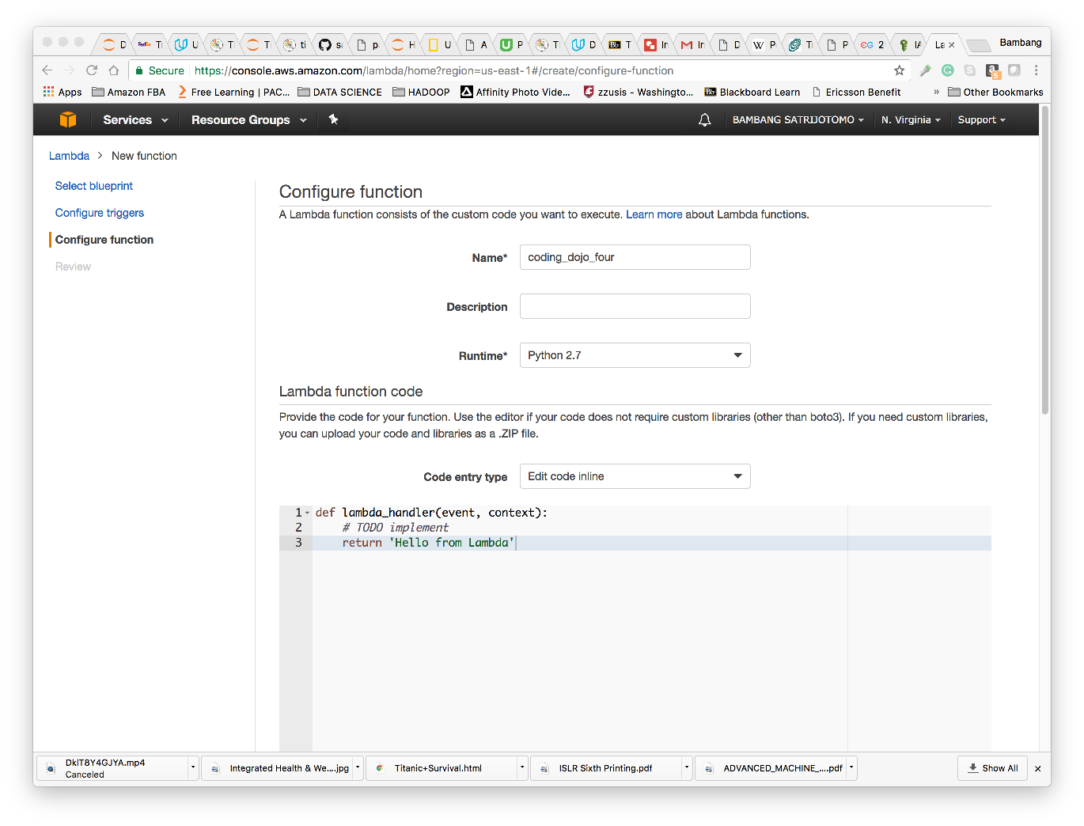

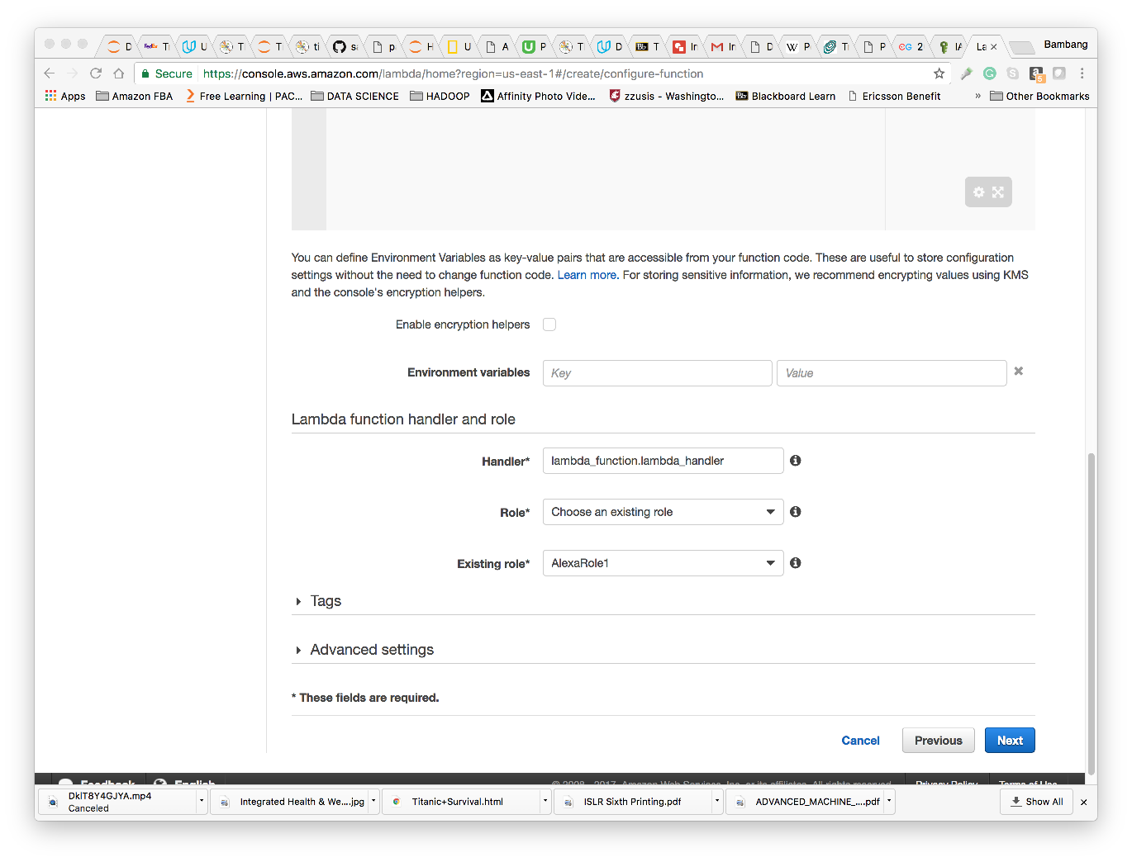

Source: https://github.com/pmckinney8/Alexa-Dojo-Skill

1. Copy index.py from lambda_function_code folder to Lambda
2. Next -> Create Function
3. Open developer account
4. Open Developer account: <https://developer.amazon.com/home.html>
5. Click ALEXA tab
6. Select Alexa Skills set, Get Started

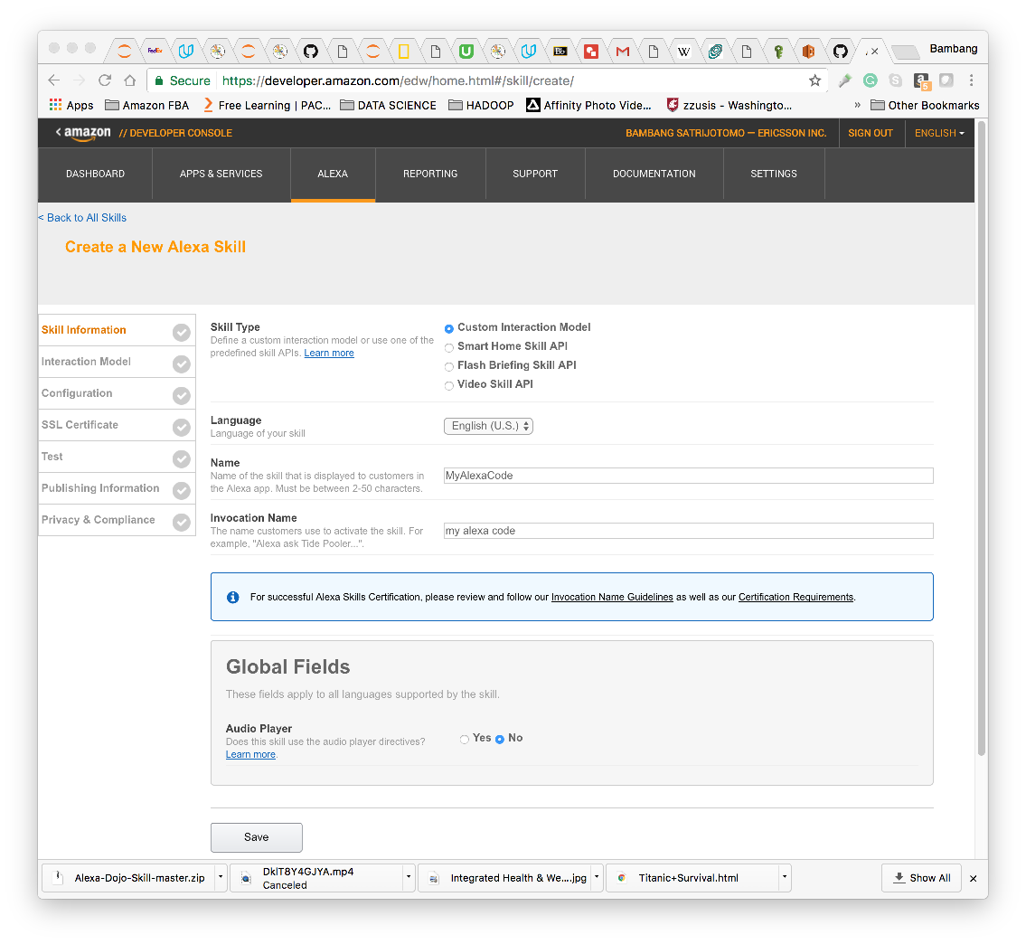

1. Save, next
2. Open intent_schema.json, copy it to intent schema

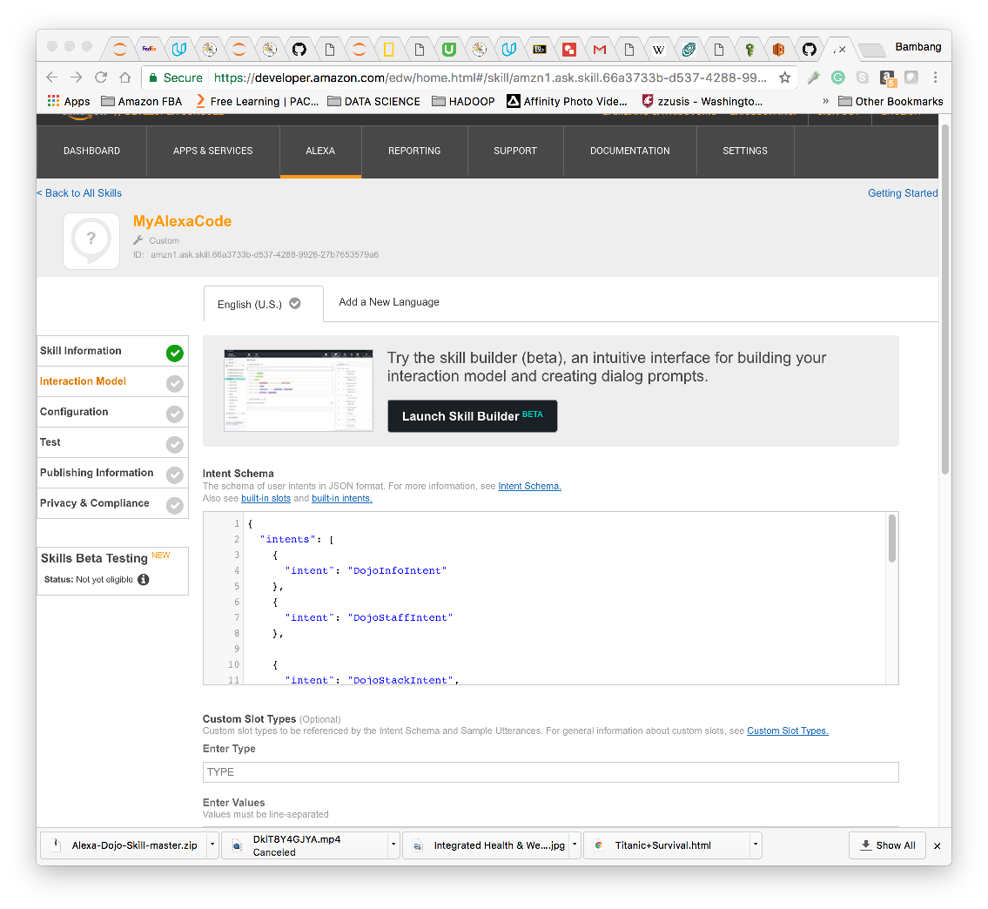

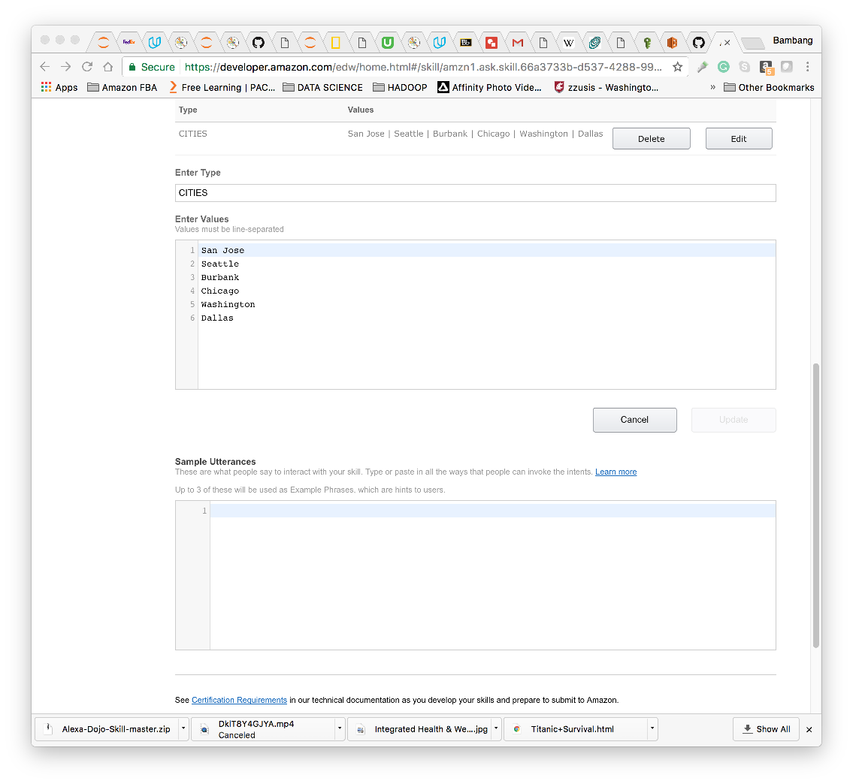

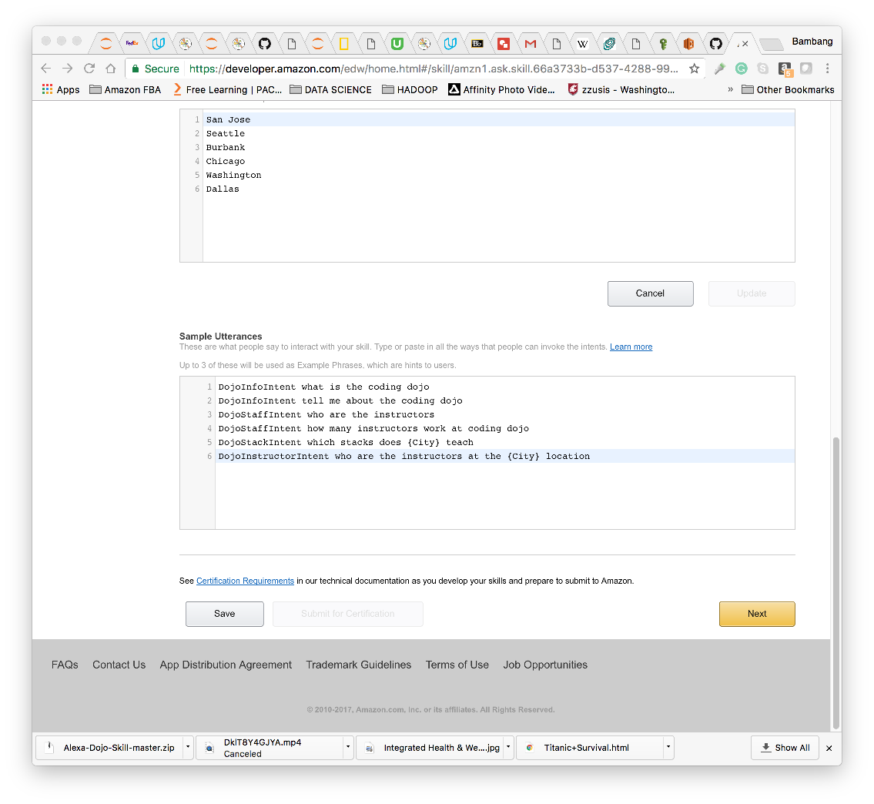

1. Click Save, Next
2. Insert ARN from other tab, click NEXT

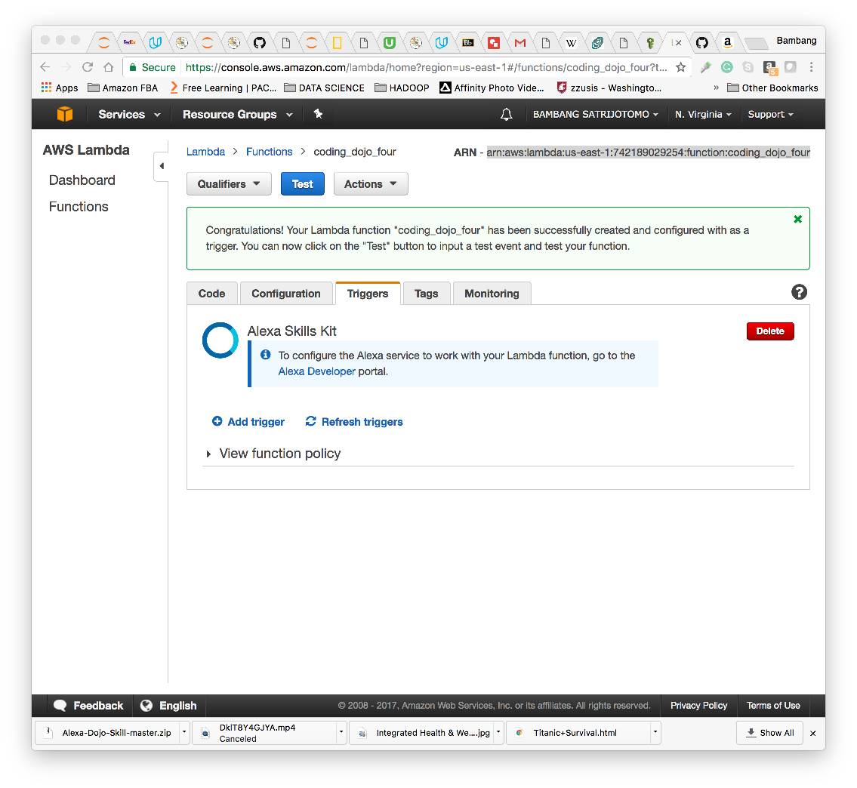

1. Test: Enter Utterance: type Start Bambang, click Ask MyAlexaCode

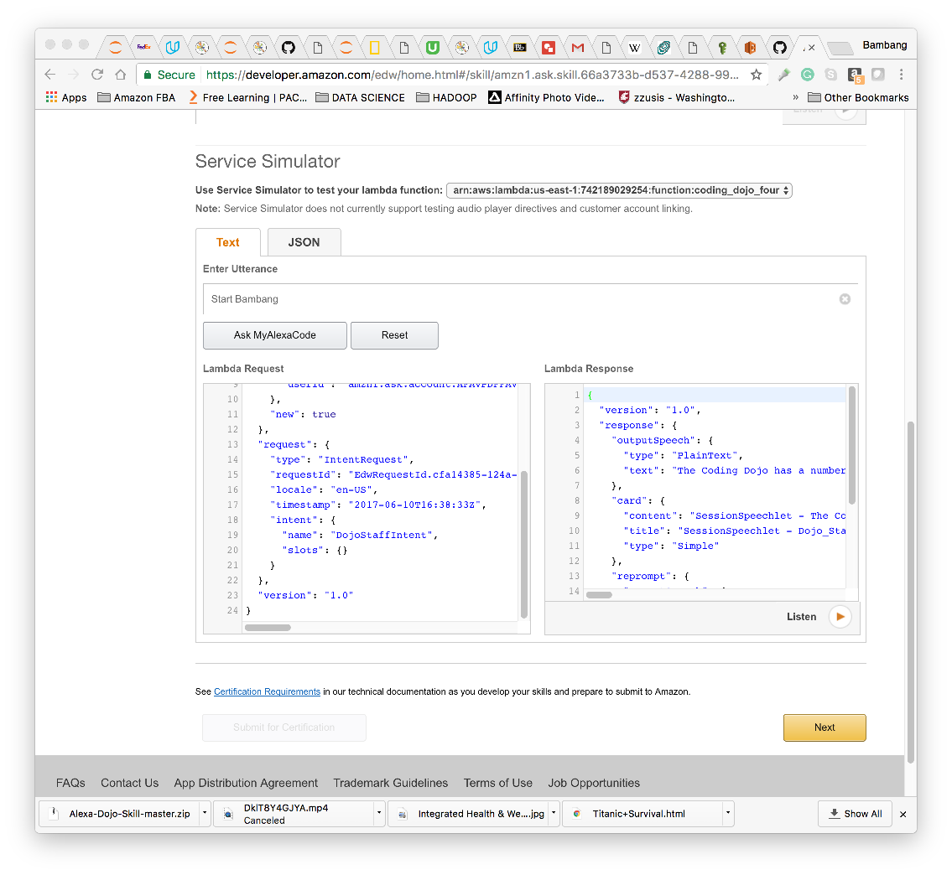

1. Click Listen
2. Use simulator / virtual Echo to test: <https://echosim.io/>
3. To Start: Check the invocation Name and use it

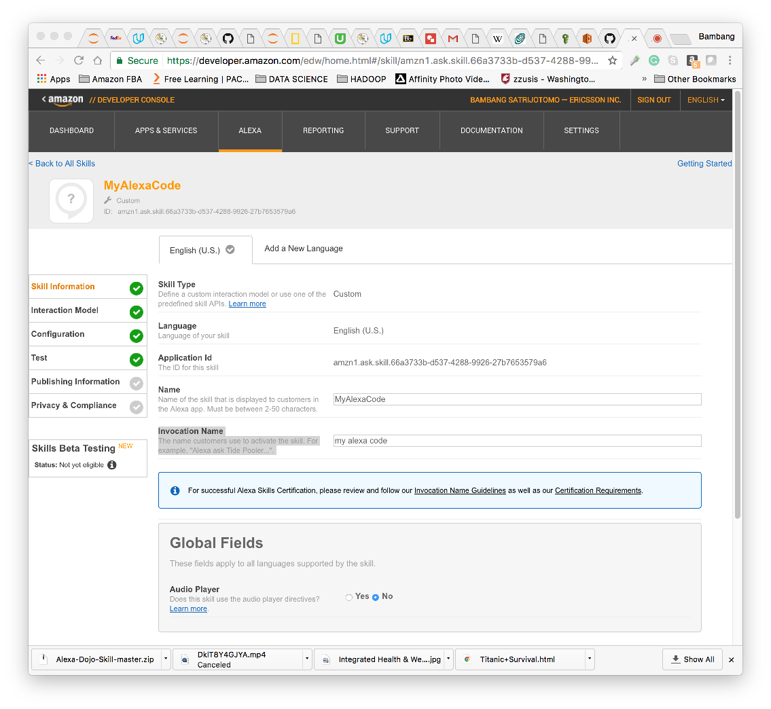

1. Alexa, start my alexa code (while pushing the mic button)

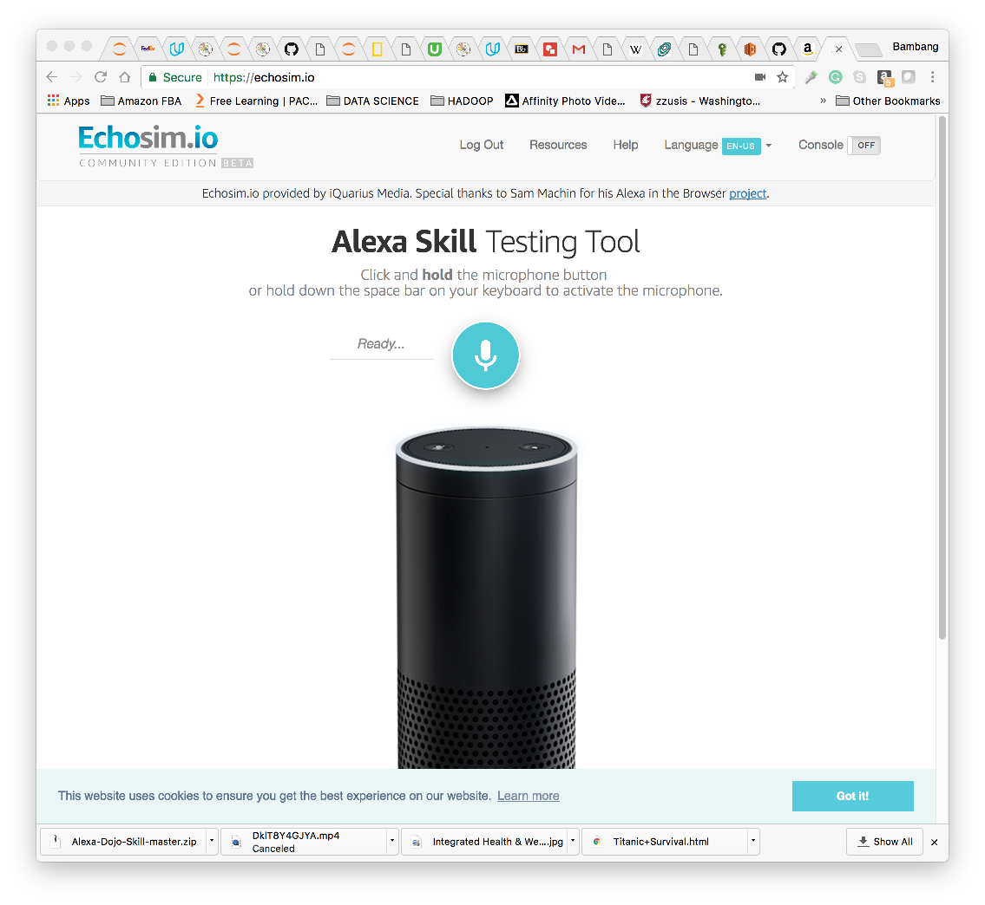

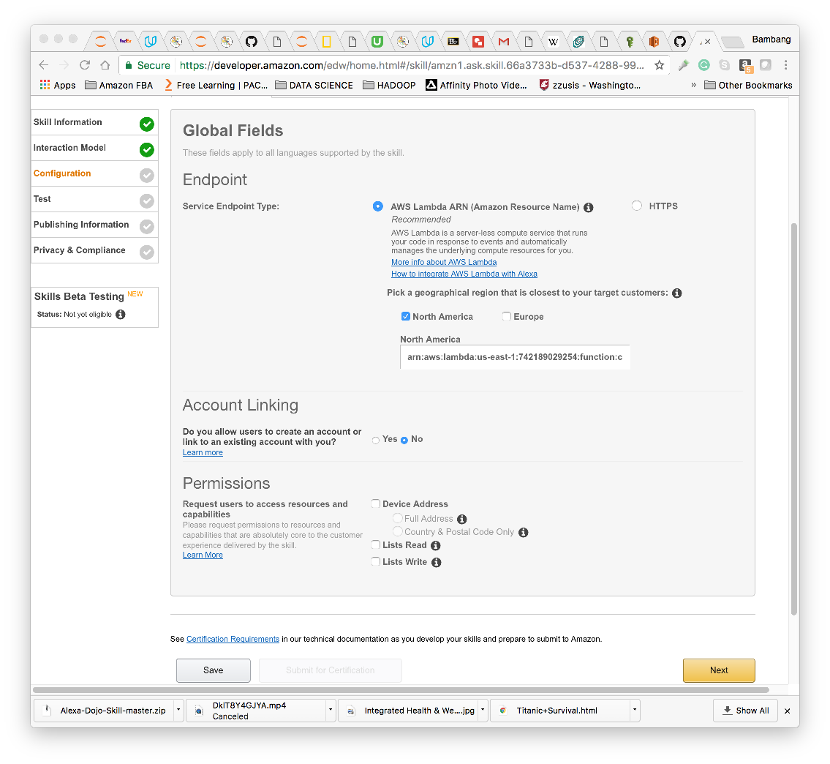

1. Continue publishing the skill.