**TUGAS LATIHAN PROGRAM PROCEDURE**

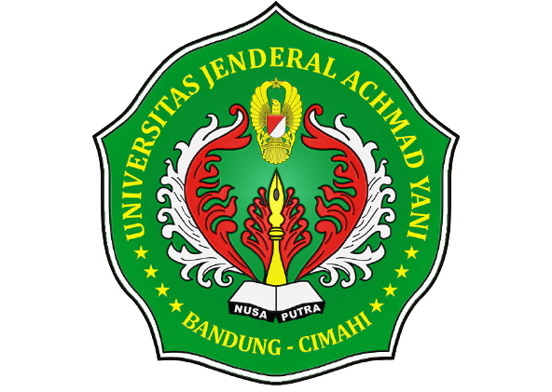

**Disusun Oleh :**

**3411201122 – Akbar Satrio Nugroho**

**Kelas E**

**7 Desember 2020**

**PROGRAM STUDI INFORMATIKA**

**FAKULTAS SAINS DAN INFORMATIKA**

**UNIVERSITAS JENDERAL ACHMAD YANI**

**BANDUNG – CIMAHI**

**2020**

1. **Program Menghitung Bilangan Bulat**
2. **Source Code**

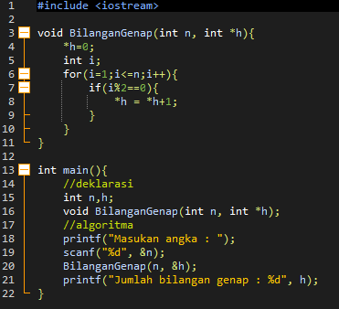

1. **Screenshot program**

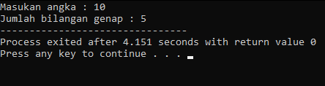

1. **Program Menghitung Nilai Rata-rata**
2. **Source Code**

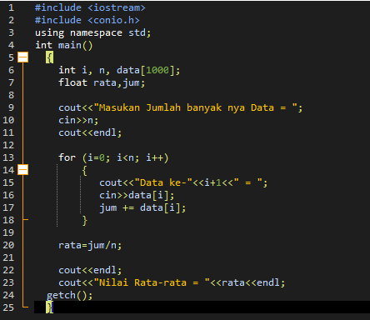

1. **ScreenShot program**

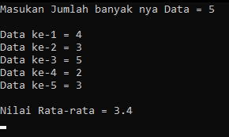

1. **Program Mencari Nilai Terkecil**
2. **Source Code**

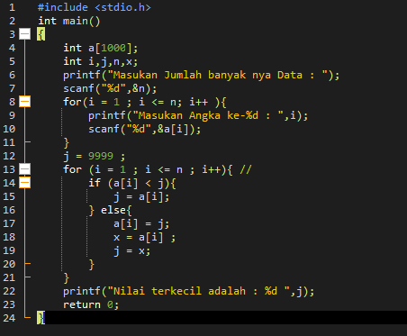

1. **Screenshot Program**

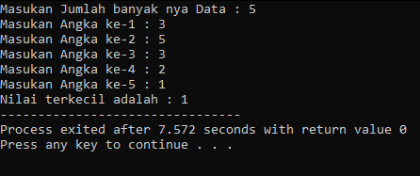

1. **Program Menghitung Bunga**
2. **Source Code**

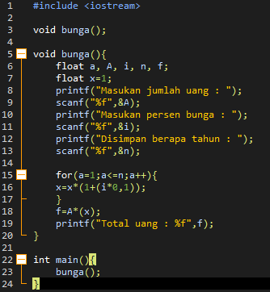

1. **Screenshot Program**

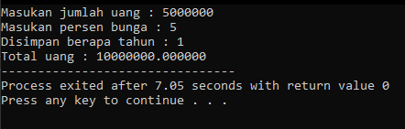

1. **Program Konversi Angka Kehuruf**
2. **Source Code**

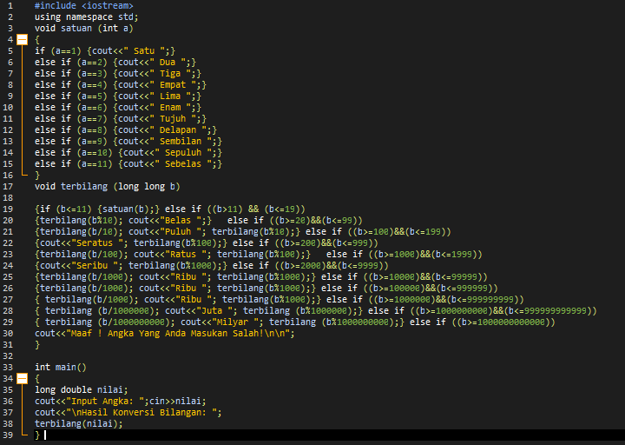

1. **Screenshot Program**

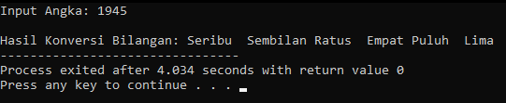

1. **Program Membuat Segitiga Pascal**
2. **Source Code**

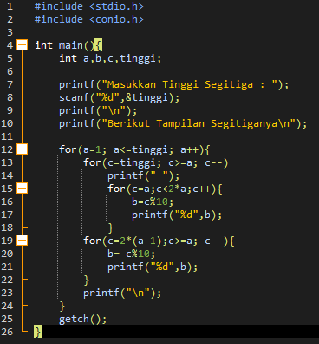

1. **Screenshot Program**

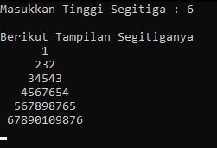

1. **Program Membuat Segitiga**
2. **Source Code**

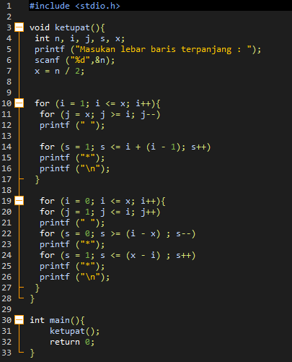

1. **Screenshot Program**

