**Nama : Mohammad Tanio Manunggal**

**NIM : 202053010**

**Kelas : P (Sore)**

Tugas Pemprograman Web

Minggu ke 3

1. Menambahkan tooltip

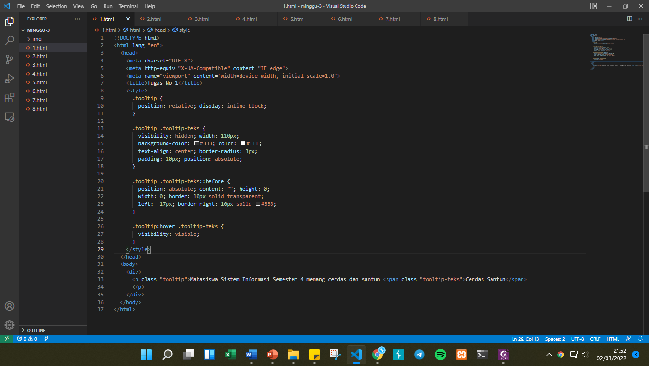

*Gambar 1.1 Source Code Pembuatan Tooltip*

*Gambar 1.2 Hasil Pembuatan Tooltip*

1. Mengubah ukuran gambar

*Gambar 2.1 Source Code Mengubah Ukuran Gambar*

*Gambar 2.2 Hasil Pengubahan Ukuran Gambar*

1. Mengubah text menjadi link

*Gambar 3.1 Sourcode Mengubah Text Menjadi Link*

*Gambar 3.2 Hasil Mengubah Text Menjadi Link*

1. Membuat alternatif text gambar

*Gambar 4.1 Sourcode Membuat Alternatif Text pada Gambar*

*Gambar 4.2 Hasil Pembuatan Alternatif Text pada Gambar*

1. Menambah garis horizontal

*Gambar 5.1 Sourcode Menambah Garis Horizontal*

*Gambar 5.2 Hasil Pembuatan Garis Horizontal*

1. Mengubah jenis order list

*Gambar 6.1 Sourcecode Mengubah Jenis Order List*

*Gambar 6.2 Hasil Mengubah Jenis Order List*

1. Mengubah format text menjadi italic (miring)

*Gambar 7.1 Sourcecode Formatting Text Menjadi Miring*

*Gambar 7.2 Hasil Formatting Text Menjadi Miring*

1. Membuat subscript

*Gambar 8.1 Membuat subscript*

*Gambar 8.2 Hasil Membuat Subscript*