Webb Brief: Fukuda Train Tunnel Validation
Background of Toby’s Work
To ensure that our solver is approximating reality to an acceptable level, we must perform validation studies (note, this section does not discuss verification, although this is a large requirement that precedes validation!). My aim was to give you an acceptable starting point to enable these two checks to be performed and so the background of this work is discussed here.
I started with the literature that we commenced this work with: Chen et al, 2023. Here, we have a tunnel connecting two large atmospheric domains.
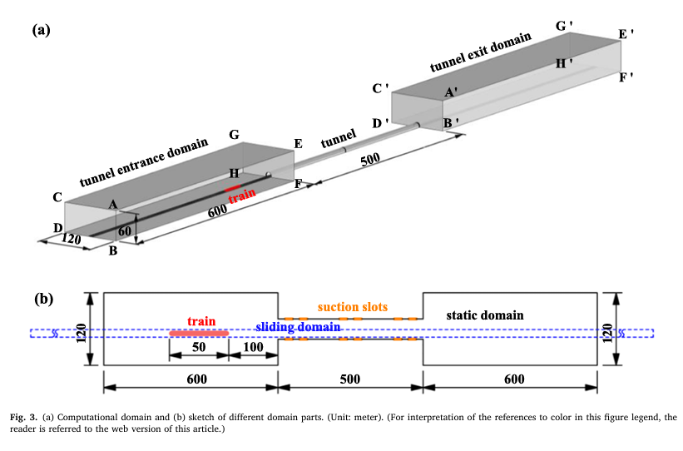
I created a mesh that aimed to replicate one of their test cases, with probes measuring the micro-pressure wave (MPW) at the exit (Figure 20 in their paper). At each timestep, the train would move forward by $∆x=∆t*v_{t}$, where vt is the train speed. Now, the Courant number, $Co= {u∆t}/{∆x}$ , where u is the characteristic velocity, should always be below 1 to ensure that information does not propagate faster than one cell size at a time. As per default, I set $u=v_{t}$ for this calculation to set $∆t$, but the solver immediately went unstable (spike in residuals) when the train entered the tunnel.
My mistake here was that the characteristic velocity should be set to the local speed of sound, not the train speed. The critical information for the MPW is the compression wave, not the train. This is obvious in hindsight! The problem is that the local speed of sound is 3.3 times higher than the train speed, thus we have to reduce our timestep to account for this. The result was that the simulation took 4 days to run on my local PC (16 cores), which would take around 30 days on a laptop. Thus, I moved away from Chen’s setup as validation lost feasibility (typically this stage requires ~10 full solves, so we’d still be here in Spring 2027!).
So, I looked at experimental works that use model-scales to capture the same flow physics. One example of this is the work of Ricco et al, 2007, who had a 6m long tunnel and a model train at 150kmh. Pierre Ricco is one of the most well-revered researchers in the world, so I did not see this as a step down in quality – citing his work is something of good practice among my research group due to this! The benefit? Instead of simulating a train passing 600m at a low timestep, we only have to pass it through 8m of tunnel, but the timesteps remain similar. Not only this, the number of cells in the mesh drops, so each timestep features on the order of 100 fewer calculations. Solve time reduces to ~20 minutes on my local computer, towards 4-5 hours on any laptop. The benefits of this transfer should be obvious!
While Ricco confirms that a model-based approach is good for this topic area, I found Fukuda and Saito (2023) had far better data to compare, plus they were looking specifically at the pressure gradient of the compression wavefront, which is exactly the metric for MPW reduction. This is the paper I highly recommend for validation to be simple.
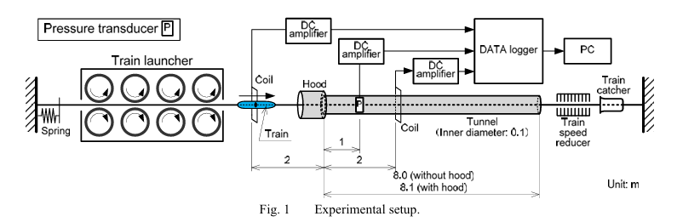
Handover:
So I think the most valuable thing I can breakdown for you is what I would do next in your position. Inheriting a CFD solver written by someone else is a task in itself, so these are the steps that I’d do in your shoes:
- Without running anything, look through the key parts of the solver and understand/document what it is trying to do. This includes:
  - Domain and train geometry – how have I defined the train shape and the domain boundaries?
  - Initial conditions – what are the first cell values inherited by each cell at startup?
  - Fluid solvers – do we model turbulence? If so, how?
  - Numerical solvers – how is the finite volume method numerically solved in time and in space? What order are these in?
  - Mesh – how is the mesh defined? What are the key controls for mesh refinement?
  - Processing – what data is being saved and how can you visualise it during the run?
- Then, I’d look to run a case. What do you see in the baseline condition? Does it run fully? How can you save data, then restart the solver?
I would expect steps 1 and 2 to take a couple of days for someone new to CFD and especially OpenFOAM. Getting a good workflow to view each file is a non-trivial first step. I tend to find most people find Visual Studio Code the easiest way to flick between files. Do not stress if something isn’t obvious, I want you to explore the files to develop an idea on how OpenFOAM solvers are structured. If anything is unclear, I can point it out to you over an email.
- Once you’re happy with the above, I would begin planning the mesh independence study. Specifically, what controls are you going to systematically vary and what outputs are you going to test for convergence? The answer to this likely depends on what your research question requires.
At this point, we should have a quick meeting to discuss your plans and any uncertainties that you have from steps 1 and 2. This is a critical first step and it will result in your first paper figure.
- The mesh convergence study should then be performed. Keep basic data from the sweep and resort to the lecture slides to apply GCI etc to the results.
At this point, we should have another meeting to evaluate the success or failure of this study. A failure could occur through no fault of your own, but stemming from solver inadequacies.
- Once the mesh convergence is performed, we can then test the match to that of the experimental data of Fukuda. In terms of what to replicate, we would be looking at trying to show the unhooded data in Figure 4.
While steps 1-5 seem trivial, we will never get into a journal without getting this bit right. This section of work should be up to 50% of the main project time.
From this point, we will have a solver that is validated and ready to test the research question(s) that you wish to test.
What should you find for Step 2?
I’ve put the bash commands that I use below this prose, but on your first run, I think it’s always nice to know whether you have the same behaviour (such that nothing has been lost in compiling). The monitor script will show you the screen as below:
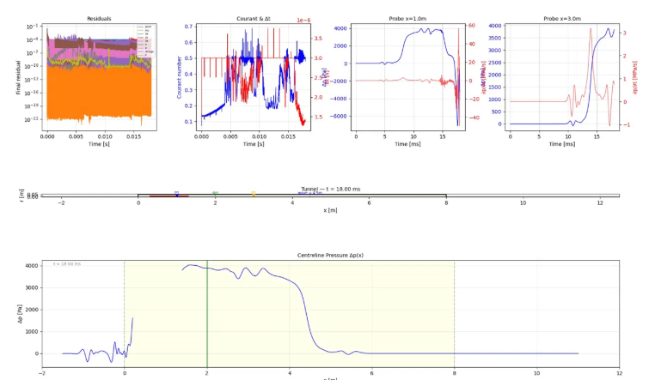
Working through, you can see top left residuals are all really low, showing that on each timestep, the solution approaches a state of convergence. To the right, you see the acoustic courant number (based on speed of sound) and variable timestep plot. The solver adjusts the timestep to ensure Co does not explode out of control. Then, the next two plots on the top row are the pressure and dp/dt plots at two locations. The middle plot shows the progress of the train, and the bottom plot shows the pressure at the centreline of the tunnel.
You will notice that there is some noise in the pressure readings away from the signal, this is to do with the overset mesh. The key is that it is smaller than the signal of the pressure wave, which it is.
Bash Commands:
To get this running, download the .tar file that I’ll send you containing all of the files and move to the Ubuntu system. Then, ‘untar’ it using:
tar -xzf train_tunnel.tar.gz
cd train_tunnel
From then on, I’ve been doing the following steps:
Step 1 — Clean everything from previous runs
rm -rf 0.[0-9]* [1-9]* constant/polyMesh log.* postProcessing processor*
rm -rf 0 && cp -r 0.orig 0
This just removes old time directories and restores the original ICs.
Step 2 — Build the mesh and set up overset zones
blockMesh > log.blockMesh 2>&1
topoSet > log.topoSet 2>&1
setFields > log.setFields 2>&1
This reads blockMeshDict, sets the train and tunnel regions, then writes zone IDs. Have a look into these files to work out how.
Step 3 — Launch the solver

Serial (1 core, simpler):
overRhoPimpleDyMFoam > log.overRhoPimpleDyMFoam 2>&1 &
Runs on a single core. Slower but no setup needed. Probe data goes directly to postProcessing/.

Parallel (N cores, faster), change 16 for your value of cores:
cat > system/decomposeParDict << 'EOF'
FoamFile
{
version 2.0;
format ascii;
class dictionary;
object decomposeParDict;
}
numberOfSubdomains 16;
method scotch;
EOF

decomposePar > log.decomposePar 2>&1
mpirun -np 16 overRhoPimpleDyMFoam -parallel > log.overRhoPimpleDyMFoam 2>&1 &
ln -sf processor0/postProcessing postProcessing
Splits the mesh across 16 cores (change the number to match your machine), then launches. decomposePar only needs to run once per mesh — if you're restarting the same case, skip it. The symlink makes probe data visible for monitoring.
After a parallel run finishes, reconstruct back to a single mesh for post-processing:
reconstructPar > log.reconstructPar 2>&1

Step 4 — Monitor progress
If you type:
top
you should see the solver process live (N rows for N cores). If it’s not there, then something has broken. For more detail on how it is progressing:
python3 plot_tunnel_monitor.py
this opens the monitoring file.

This hasn’t even covered debugging, but I hope the solver will work first time for you. From there, if you encounter any issues, please come to me and I will endeavour to fix it asap. I sometimes find that debugging on OpenFOAM can be assisted with GenAI too. I sometimes use Claude to help me diagnose issues faster, although it is no replacement for understanding your model fully, so use with care.

