Korean Welfare

1Team

2017년 8월 18일

## R Markdown

This is an R Markdown document. Markdown is a simple formatting syntax for authoring HTML, PDF, and MS Word documents. For more details on using R Markdown see <http://rmarkdown.rstudio.com>.

When you click the **Knit** button a document will be generated that includes both content as well as the output of any embedded R code chunks within the document. You can embed an R code chunk like this:

library(foreign)  
library(ggplot2)  
library(dplyr)

##   
## Attaching package: 'dplyr'

## The following objects are masked from 'package:stats':  
##   
## filter, lag

## The following objects are masked from 'package:base':  
##   
## intersect, setdiff, setequal, union

library(readxl)  
  
raw_welfare <- read.spss(file = "Koweps_hpc10_2015_beta1.sav", to.data.frame = T)

## Warning in read.spss(file = "Koweps_hpc10_2015_beta1.sav", to.data.frame  
## = T): Koweps_hpc10_2015_beta1.sav: Compression bias (0) is not the usual  
## value of 100

welfare <- raw_welfare  
welfare <- rename(welfare, sex = h10_g3, birth = h10_g4, marriage = h10_g10, religion =  
h10_g11, income = p1002_8aq1, code_job = h10_eco9, code_region = h10_reg7)  
table(welfare$sex)

##   
## 1 2   
## 7578 9086

welfare$sex <- ifelse(welfare$sex == 9, NA, welfare$sex)  
welfare$sex <- ifelse(welfare$sex == 1, "male", "female")  
qplot(welfare$sex)

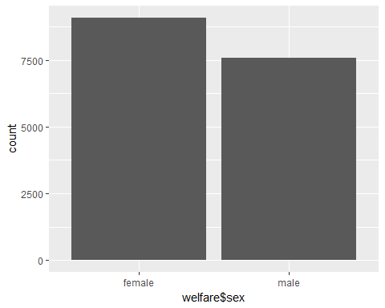

summary(welfare$income)

## Min. 1st Qu. Median Mean 3rd Qu. Max. NA's   
## 0.0 122.0 192.5 241.6 316.6 2400.0 12030

qplot(welfare$income)+xlim(0, 1000)

## `stat_bin()` using `bins = 30`. Pick better value with `binwidth`.

## Warning: Removed 12051 rows containing non-finite values (stat_bin).

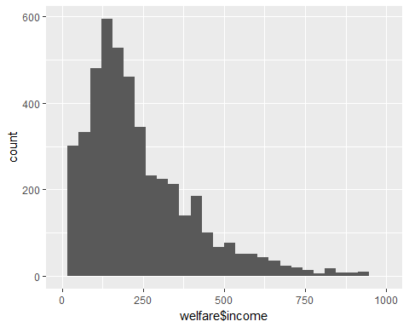

## Including Plots

You can also embed plots, for example:

Note that the echo = FALSE parameter was added to the code chunk to prevent printing of the R code that generated the plot.