**SIM800c Using Putty in PC**

1. Insert SIM card in SIM800 and connect it to USB port of a PC.
2. Open putty terminal
   1. Select Session in the navigation bar to the left.
   2. In Connection type, select Serial.
   3. In Serial line, enter the COM port your modem is connected to.
   4. In Speed, enter the maximum port speed (baud rate) of your modem. In our example, the COM port is COM12, and the speed is 115200.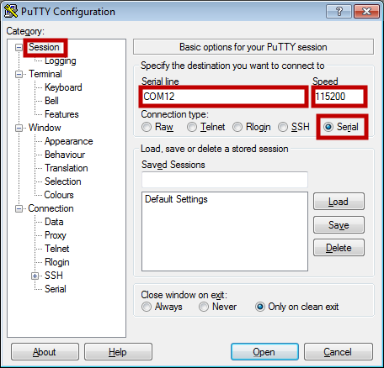
3. Then select Open at the bottom of the screen to open the connection to the modem. The window shown below will appear; you may now type commands to the modem.

**Call from SIM800 using AT commands**

1. Type “AT” and wait for “OK”
2. The AT+CMGF=0 command (followed by enter) sets the GSM Modem in SMS text mode.
3. To make a call type ATD<phone number>;
   1. e.g.: ATD9086XXXXXX;
4. To disconnect the call type “ATH” & press enter.

**Sending a text message from SIM800 using AT Commands**

1. Type “AT” and wait for “OK”
2. AT+CMGF=1 command (followed by enter) sets the GSM Modem in SMS text mode.
3. AT+CMGS=<number>followed by enter
   1. Example AT+CMGS=”01234567899” and enter
   2. Now type your message
   3. Press <Ctrl+z>When you finish entering the SMS message body

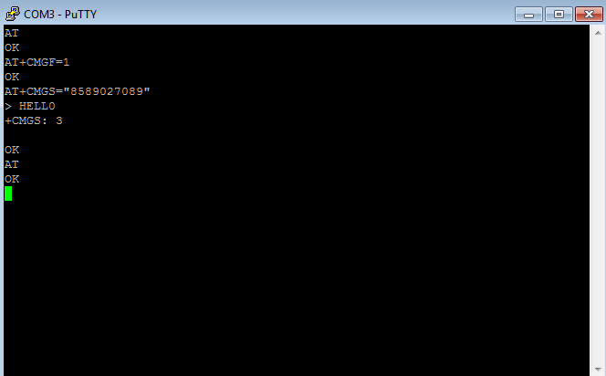

**Reject Incoming Call** AT+GSMBUSY AT command is used to reject incoming call.

|  |  |  |
| --- | --- | --- |
| Test Command | Response | Remarks |
| AT+GSMBUSY=? | +GSMBUSY: (0,1,2)  OK | For current status |
| AT+GSMBUSY? | +GSMBUSY: 0  OK | Current setting for call rejection |
| AT+GSMBUSY=0 | OK | Allow incoming call |
| AT+GSMBUSY=1 | OK | Reject incoming calls |