TimeCart — System Documentation
Professional Technical Report
Documentation Team
2026-09-14
v0.1.0

Table of Contents
1. Introduction ...
2. Database Design ...
3. Key Workflows ...

1. Introduction
TimeCart ("Where Time Meets Style") is a premium watch e-commerce storefront. From the project README and source, it is built with Next.js 16 (App Router), Supabase (Postgres / Auth / Storage), Prisma 7, Tailwind CSS 4, and Recharts. It supports customer browsing, cart, checkout, order tracking and reviews, plus an admin area for products, coupons, customers and orders.
- Frontend and API: Next.js 16 App Router (evidence: package.json, src/app).
- Database engine: relational Postgres via Supabase (evidence: prisma/schema.prisma, datasource db).
- Authentication: Supabase Auth with custom middleware (evidence: src/middleware.ts, src/lib/session.ts).
- Email delivery: Resend (evidence: package.json dependency + usage).
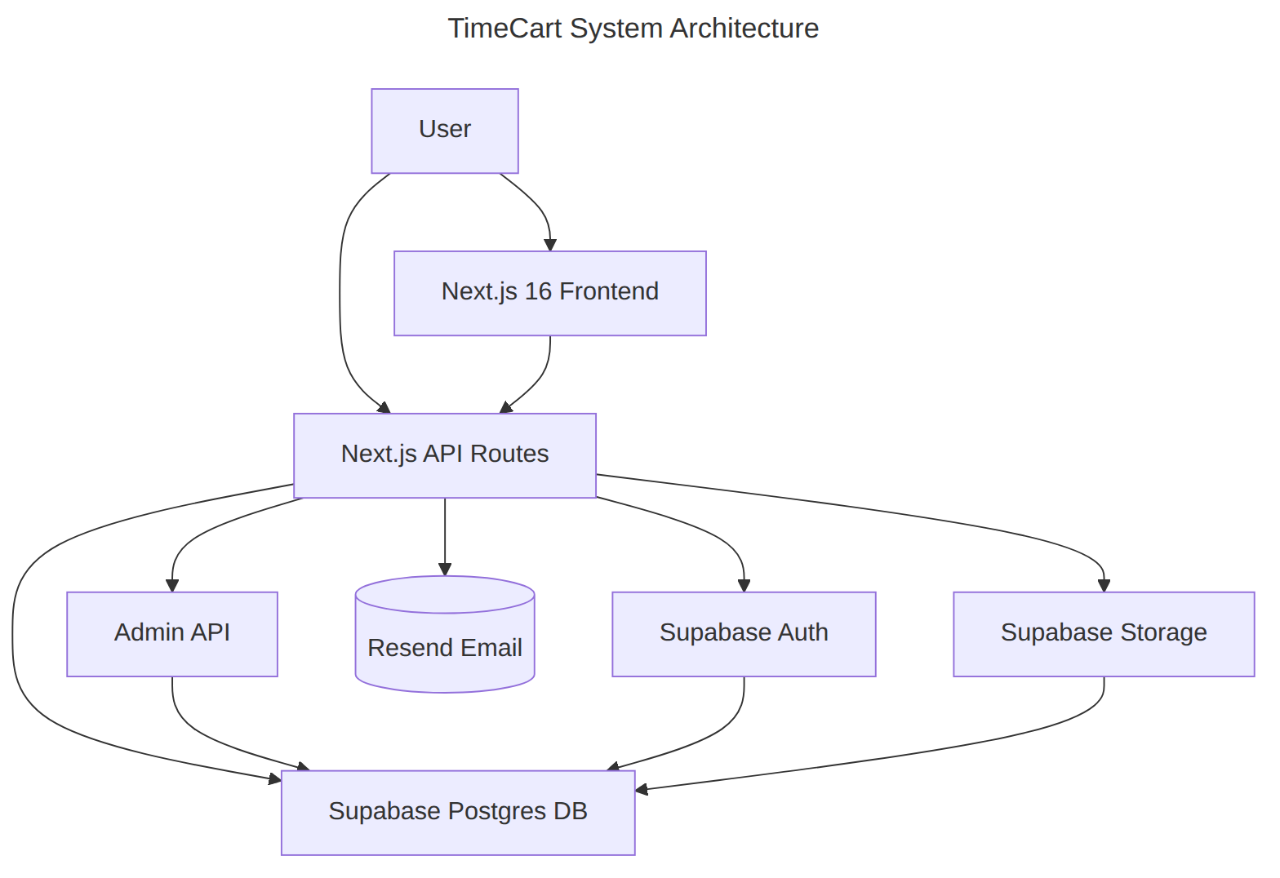
Figure 1.1 — System architecture (from source structure and configuration).

2. Database Design
The relational schema is defined in prisma/schema.prisma as a Postgres database with 23 models (e.g. User, Profile, Product, Order, OrderItem, Payment, Review, Coupon) and 10 enums (UserRole, OrderStatus, PaymentMethod, …).
Table 2.1 — Core tables detected in the Prisma schema.
Table | Key fields / purpose
User | auth accounts; role enum CUSTOMER | ADMIN
Profile | 1:1 with User; name, contact details
Product | catalog item; brand and category relations
ProductVariant | size/color stock per product
Order | customer order; status enum lifecycle
OrderItem | line items per order; product relation
Payment | 1:1 with Order; method + status
Review | product reviews by user
Coupon + CouponUsage | discounts and their redemption tracking

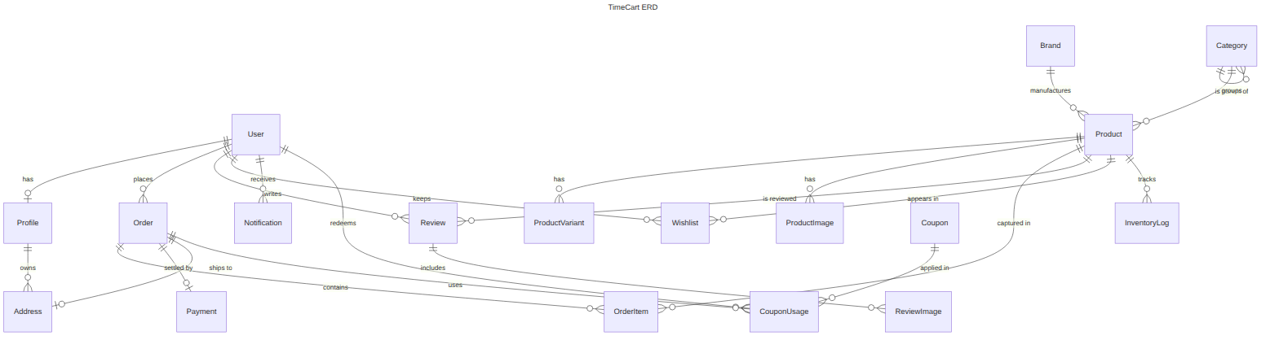
Figure 2.1 — Entity Relationship Diagram (generated from prisma/schema.prisma relations).

3. Key Workflows
Authentication flow: the user signs in to the Next.js frontend, the API route delegates to Supabase Auth and a session is stored; subsequent requests go through middleware and read session data (evidence: src/app/auth/callback, src/lib/session.ts, src/middleware.ts).
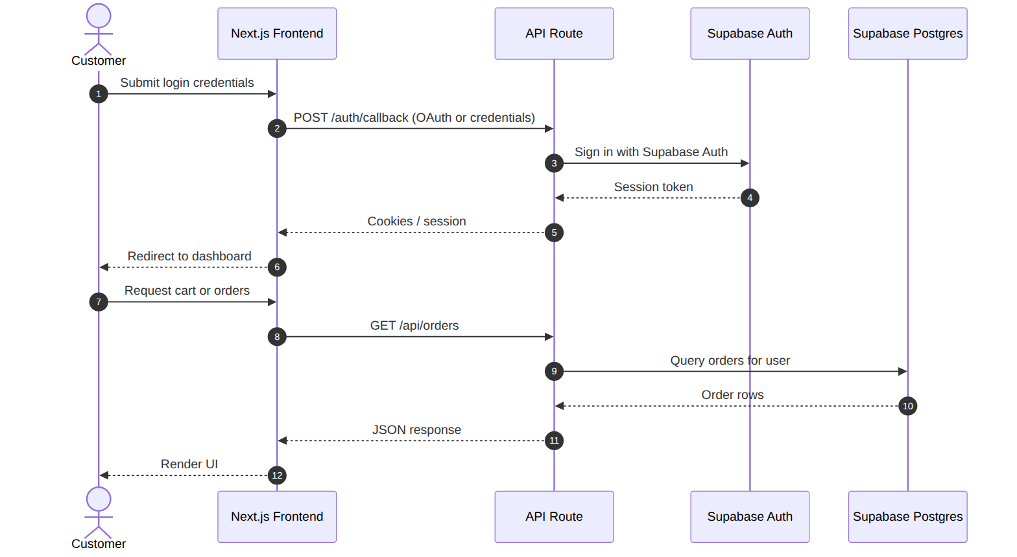
Figure 3.1 — Login / session sequence (from auth callback route and lib code).
Public API surface observed (src/app/api): products, search, reviews, coupons/validate, orders, track-order, wishlist-related, newsletter, contact, config, upload, profile, and an /api/admin/* set (customers, orders, products, reviews, brands, coupons, categories, contact).

