1)Basic Routing:
Code:
import { BrowserRouter, Routes, Route, Link } from "react-router-dom";

function Home() {
return <h1>Home Page</h1>;
}

function About() {
return <h1>About Page</h1>;
}

function Contact() {
return <h1>Contact Page</h1>;
}

function App() {
return (
<BrowserRouter>
<div>
<nav>
<Link to="/">Home</Link> |{" "}
<Link to="/about">About</Link> |{" "}
<Link to="/contact">Contact</Link>
</nav>

<hr />

<Routes>
<Route path="/" element={<Home />} />
<Route path="/about" element={<About />} />
<Route path="/contact" element={<Contact />} />
</Routes>
</div>
</BrowserRouter>
);
}

export default App;

Output: 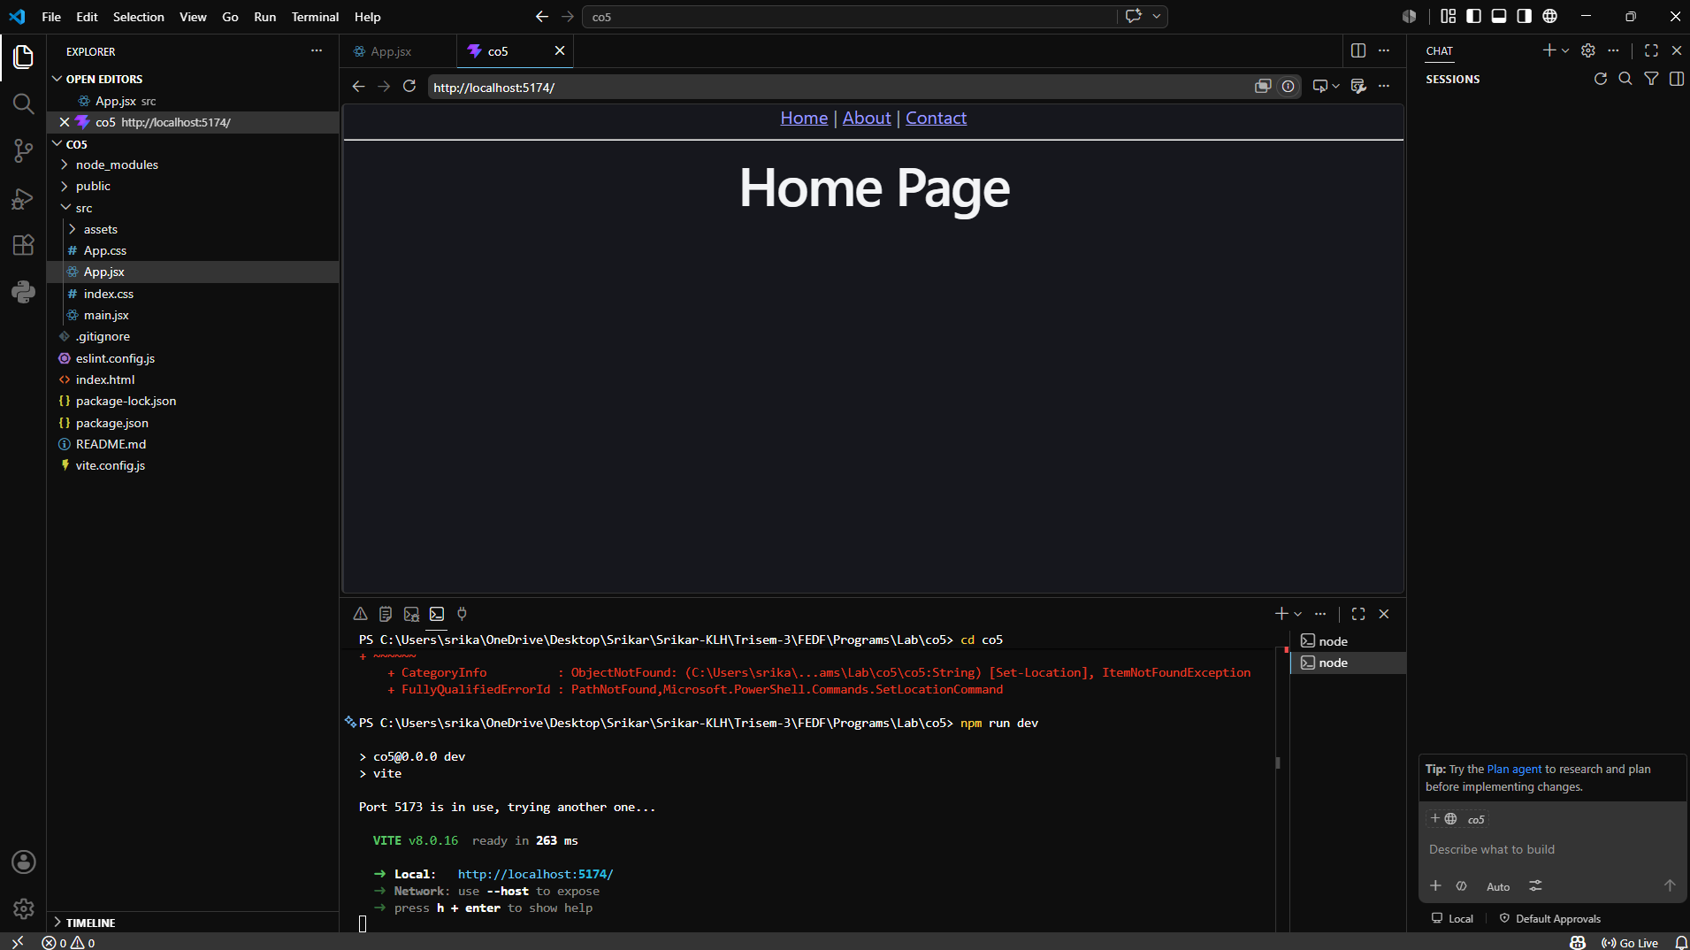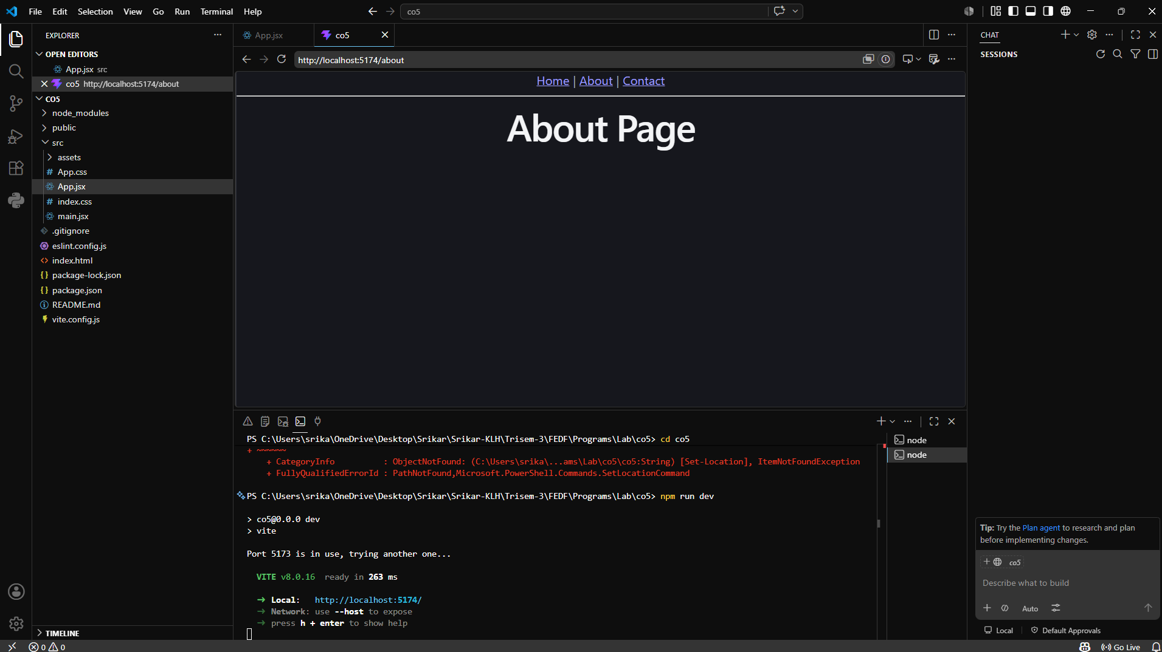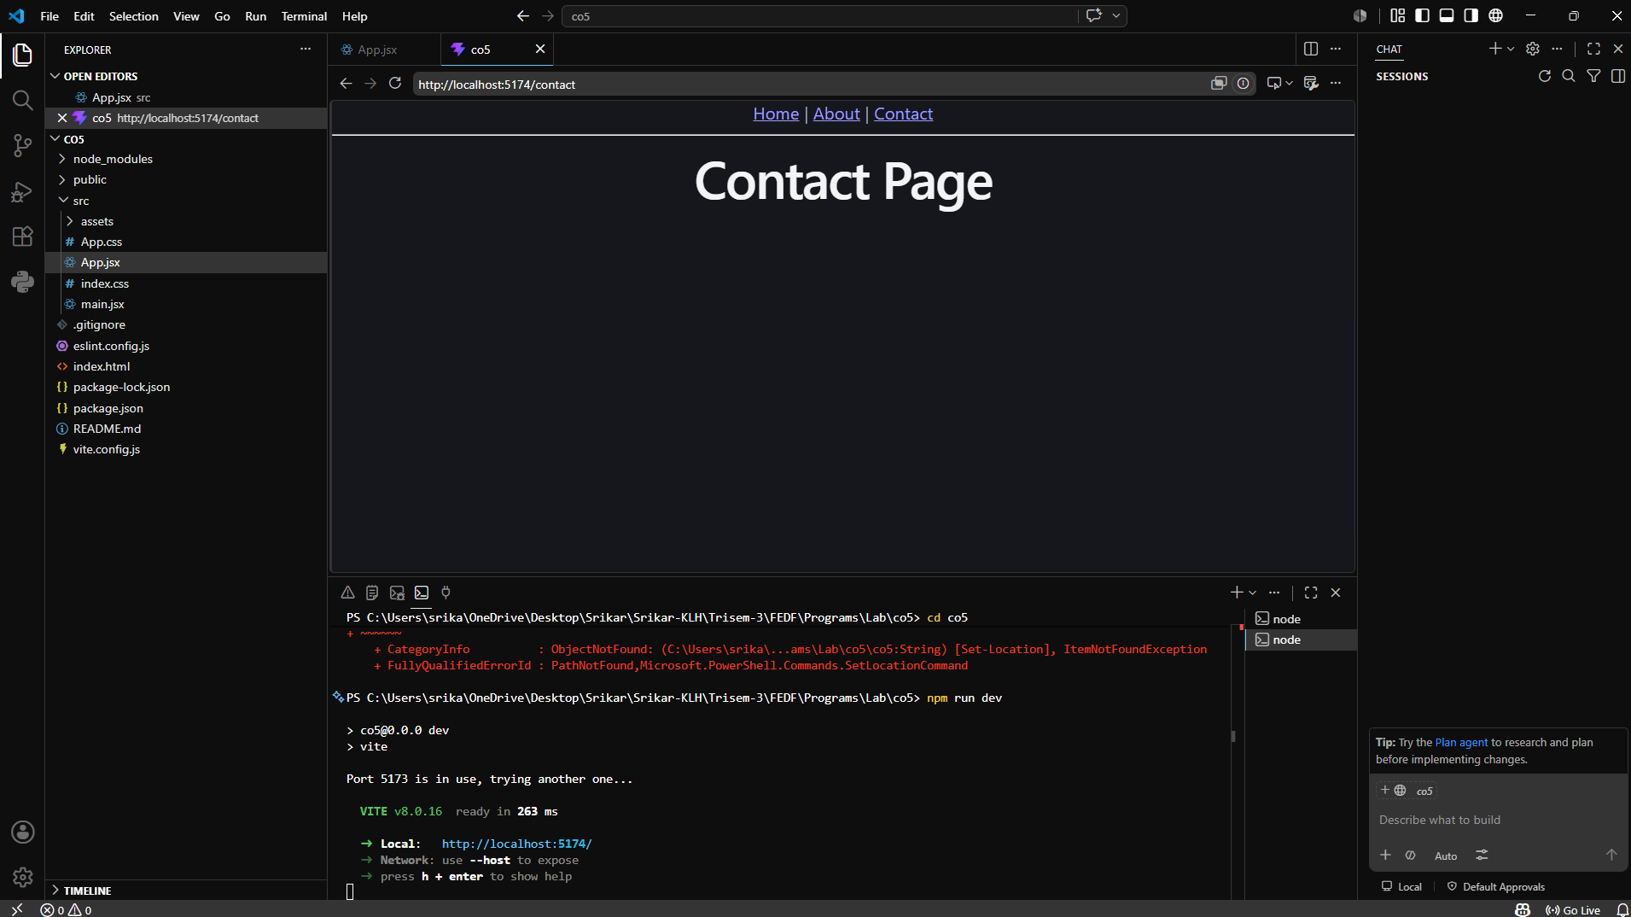
2)Nested Routing:
Code:
import React from "react";
import { BrowserRouter, Routes, Route, Link, Outlet } from "react-router-dom";

function Home() {
return <h1>Home Page</h1>;
}

function Products() {
return (
<div>
<h1>Products Page</h1>

<nav>
<Link to="car">Cars</Link> |{" "}
<Link to="bike">Bikes</Link>
</nav>

<hr />

<Outlet />
</div>
);
}

function CarProducts() {
return (
<div>
<h2>Cars</h2>
<ul>
<li>Audi</li>
<li>BMW</li>
<li>Volvo</li>
</ul>
</div>
);
}

function BikeProducts() {
return (
<div>
<h2>Bikes</h2>
<ul>
<li>Yamaha</li>
<li>Suzuki</li>
<li>Honda</li>
</ul>
</div>
);
}

function Contact() {
return <h1>Contact Page</h1>;
}

export default function App() {
return (
<BrowserRouter>
<nav>
<Link to="/">Home</Link> |{" "}
<Link to="/products">Products</Link> |{" "}
<Link to="/contact">Contact</Link>
</nav>

<hr />

<Routes>
<Route path="/" element={<Home />} />

<Route path="/products" element={<Products />}>
<Route path="car" element={<CarProducts />} />
<Route path="bike" element={<BikeProducts />} />
</Route>

<Route path="/contact" element={<Contact />} />
</Routes>
</BrowserRouter>
);
}
Output:
