- Component as Deterministic UI Function
function Product(props) {
return <h2>{props.name}</h2>;
}
function App() {
return <Product name="iPhone 15" />;
}
OUTPUT:
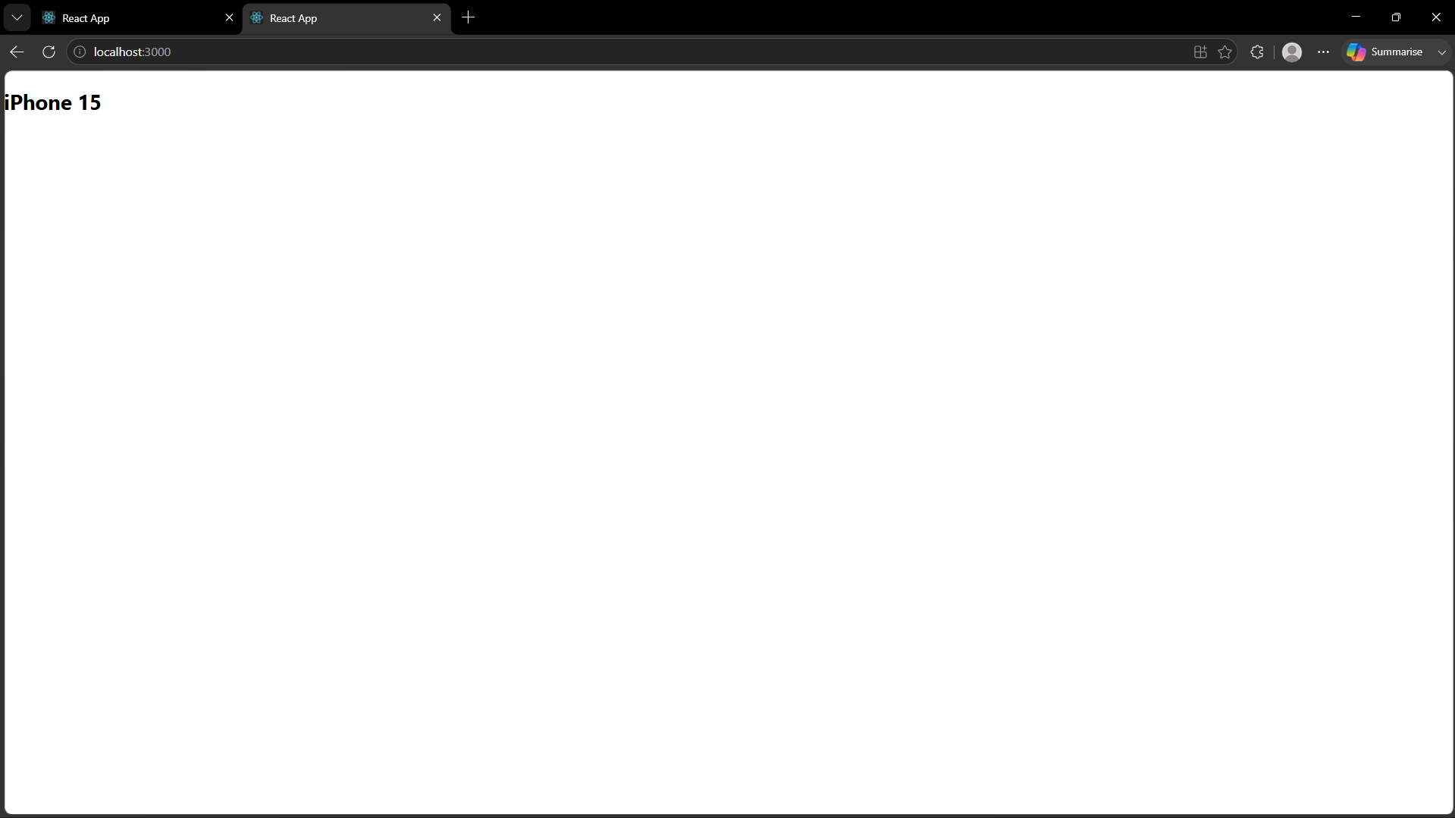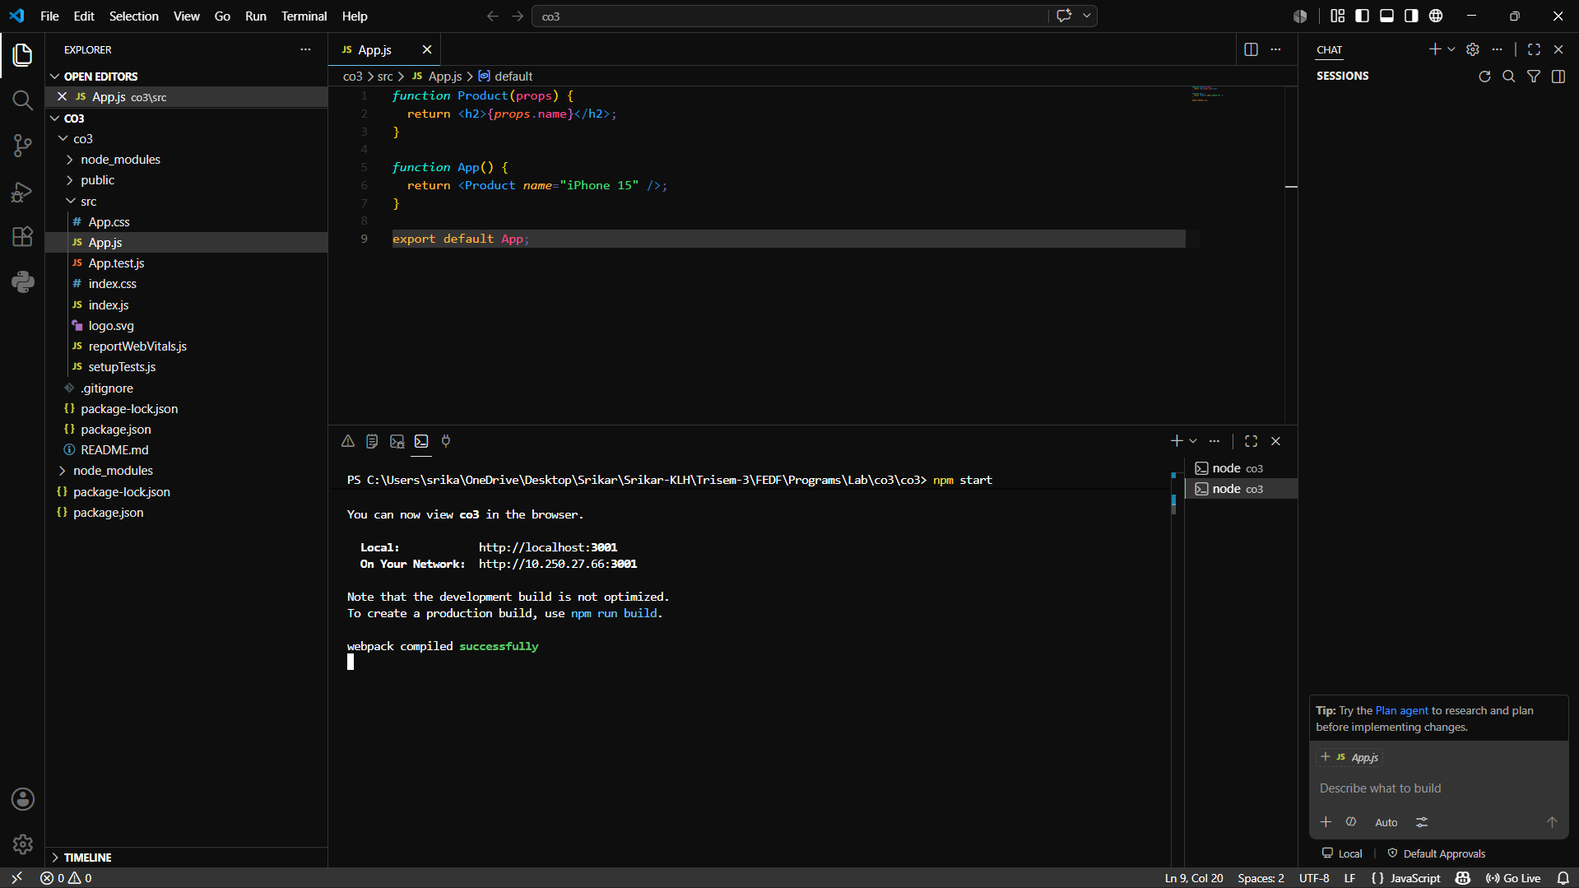

- Props as Configuration Contract
function Product(props) {
return (
<div>
<h2>{props.name}</h2>
<p>Price: ₹{props.price}</p>
</div>
);
}

function App() {
return (
<Product name="Laptop" price="55000" />
);
}
export default App;

OUTPUT:
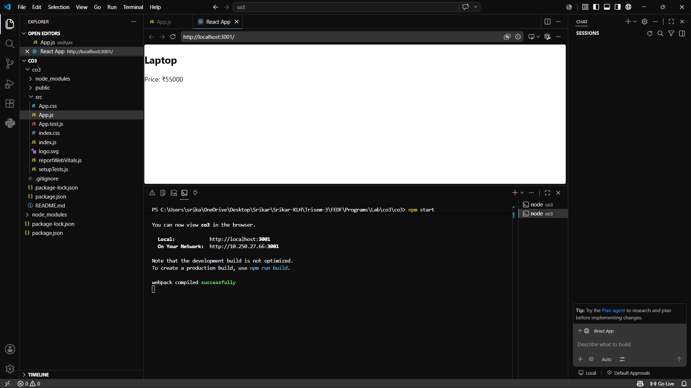

- State as Dynamic Runtime
import { useState } from "react";

function Cart() {
const [quantity, setQuantity] = useState(1);

return (
<div>
<h2>Quantity: {quantity}</h2>

<button onClick={() => setQuantity(quantity + 1)}>
Add More
</button>
</div>
);
}

export default Cart;

OUTPUT:
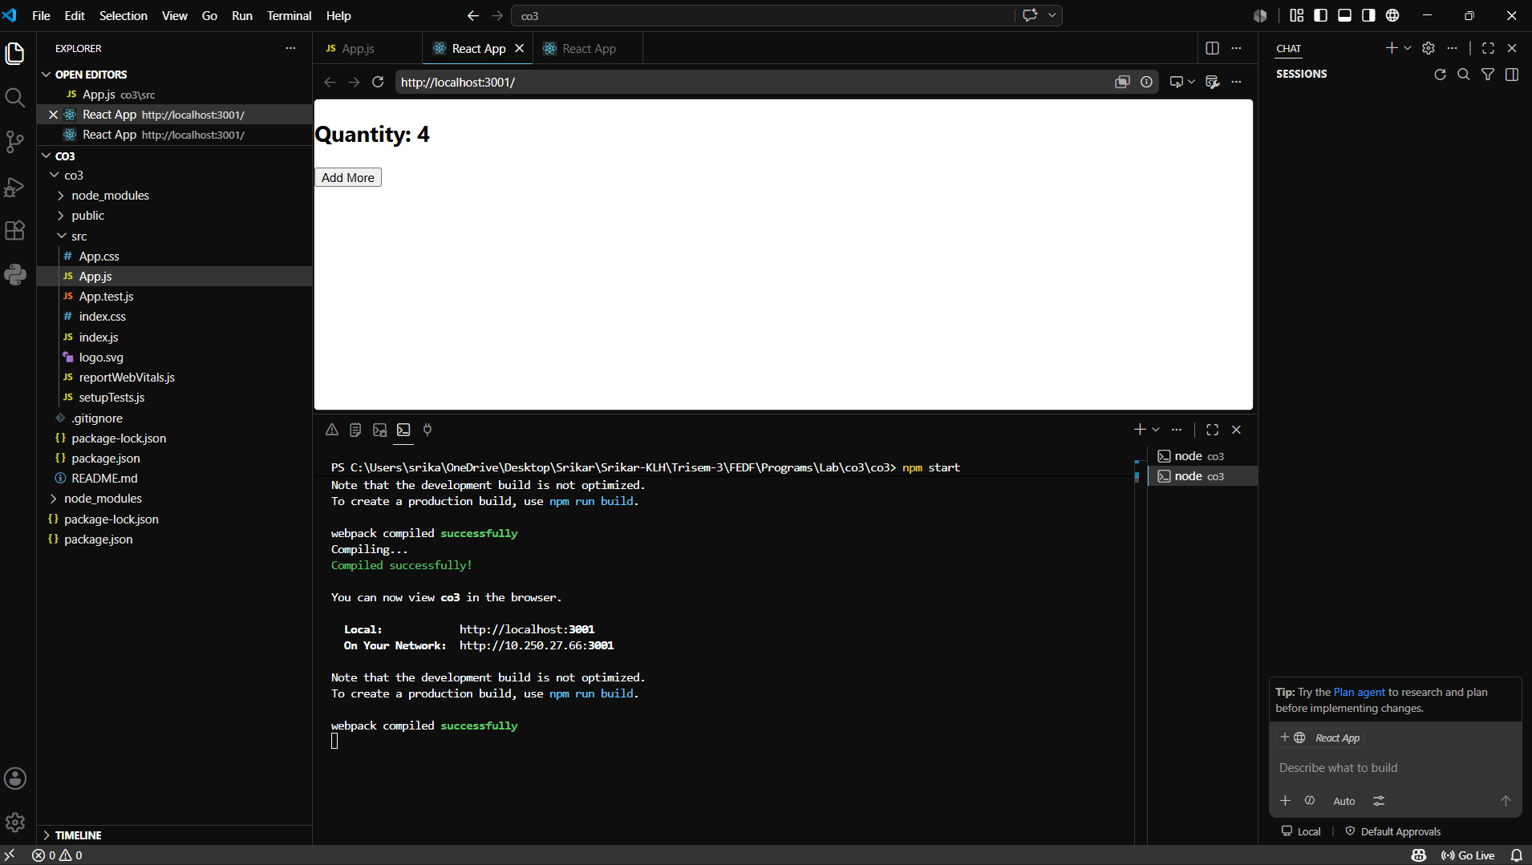

- Props vs State
Example: Product with Dynamic Likes
import { useState } from "react";

function Product(props) {
const [likes, setLikes] = useState(0);

return (
<div>
<h2>{props.name}</h2>

<p>Likes: {likes}</p>

<button onClick={() => setLikes(likes + 1)}>
Like Product
</button>
</div>
);
}

function App() {
return <Product name="Headphones" />;
}

OUTPUT:
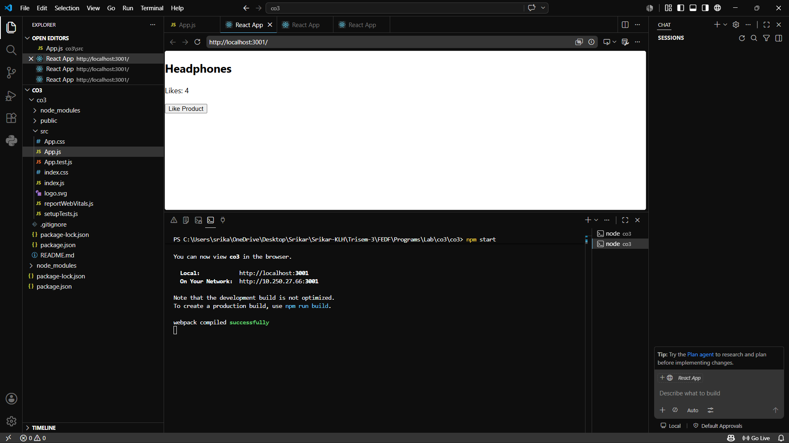

- Side Effects using useEffect
Example: Fetch Product Data
import { useEffect } from "react";

function ProductPage() {

useEffect(() => {
console.log("Fetching Product Details...");
}, []);

return <h1>Product Details</h1>;
}

export default ProductPage;

OUTPUT:
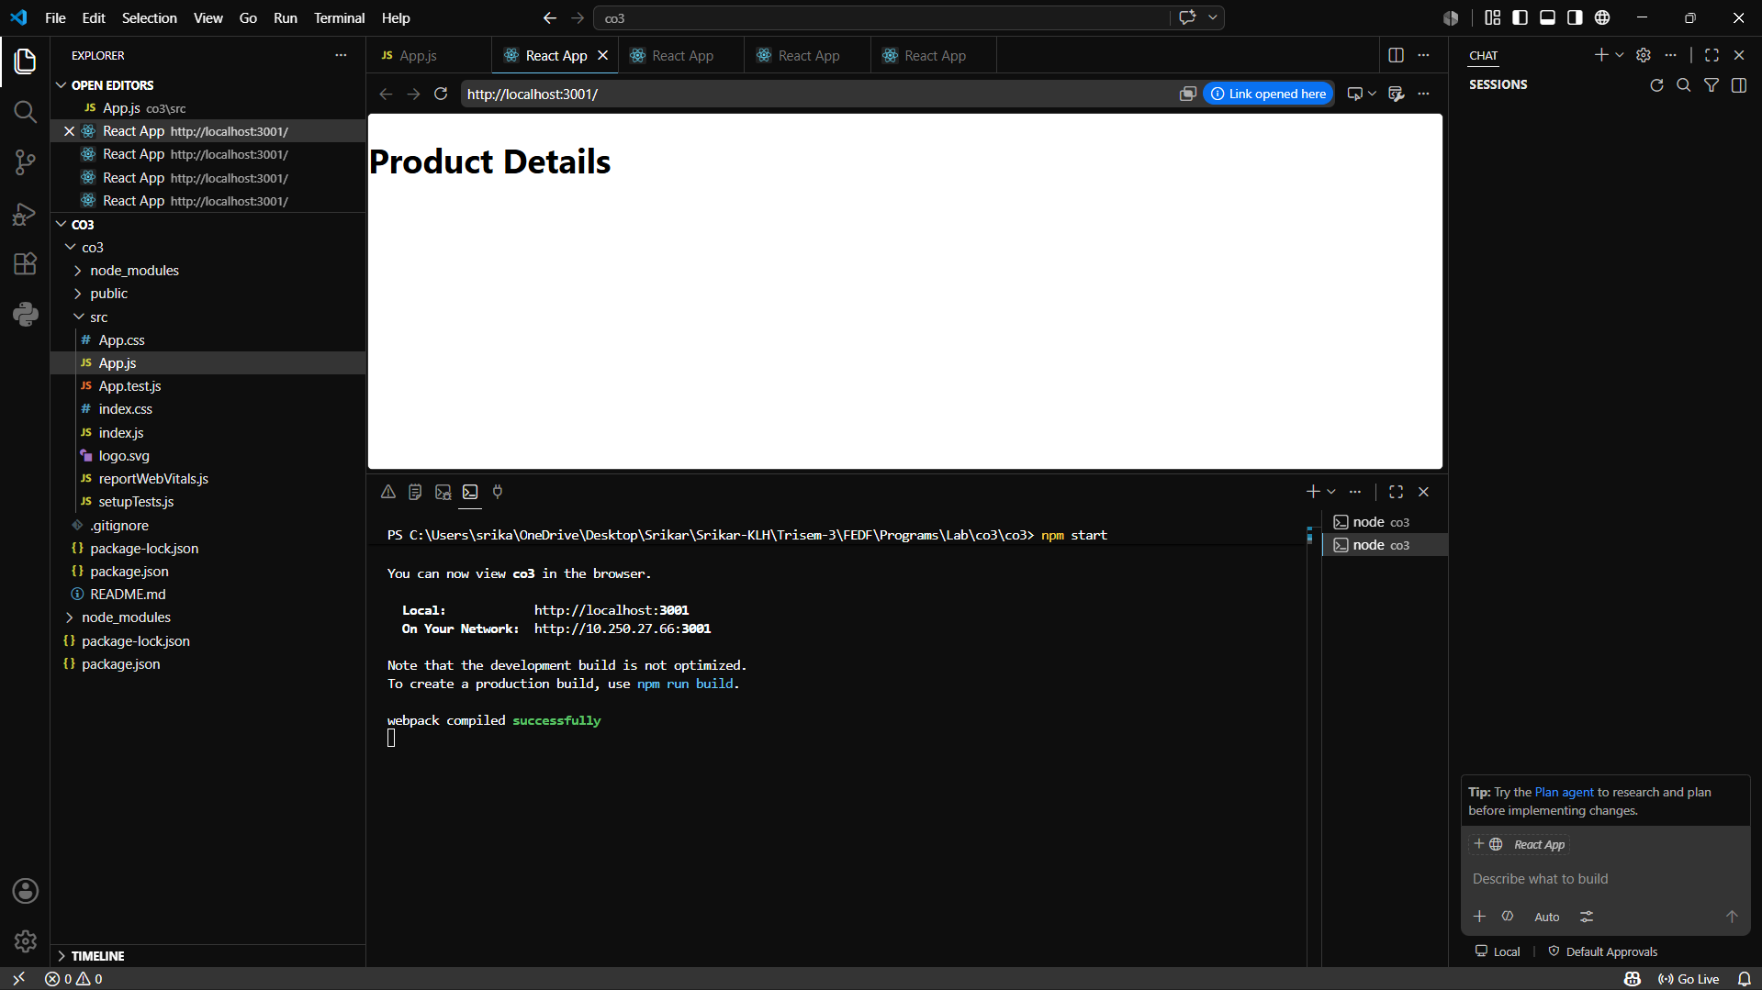

- Hooks as Lifecycle Abstraction
Example: Product View Counter

import { useEffect, useState } from "react";

function Product() {

const [views, setViews] = useState(0);

useEffect(() => {
setViews(views + 1);
}, []);

return <h2>Views: {views}</h2>;
}
export default Product;

OUTPUT:
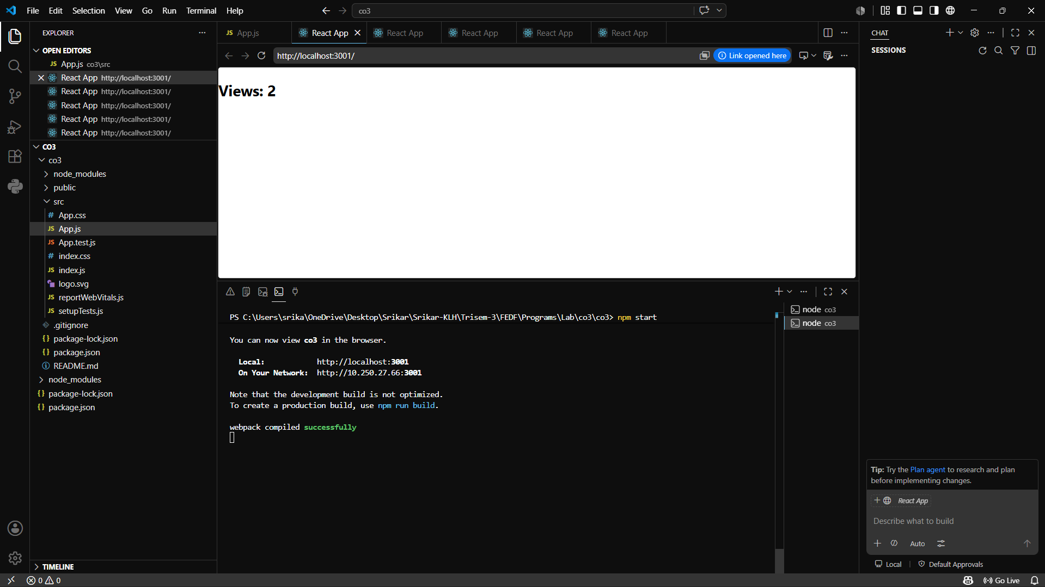

- Reconciliation (Re-rendering)
Example: Cart Total Update
import { useState } from "react";

function Cart() {

const [total, setTotal] = useState(1000);

return (
<div>
<h2>Total: ₹{total}</h2>

<button onClick={() => setTotal(total + 500)}>
Add Item
</button>
</div>
);
}

export default Cart;

OUTPUT:
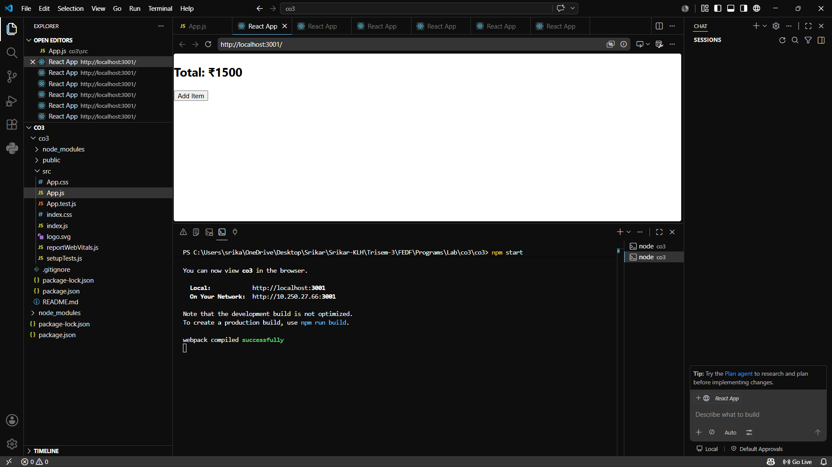

- Controlled Component
Example: Search Bar
import { useState } from "react";

function Search() {

const [text, setText] = useState("");

return (
<div>
<input
type="text"
value={text}
onChange={(e) => setText(e.target.value)}
placeholder="Search Product"
/>

<p>You searched: {text}</p>
</div>
);
}

export default Search;

OUTPUT:
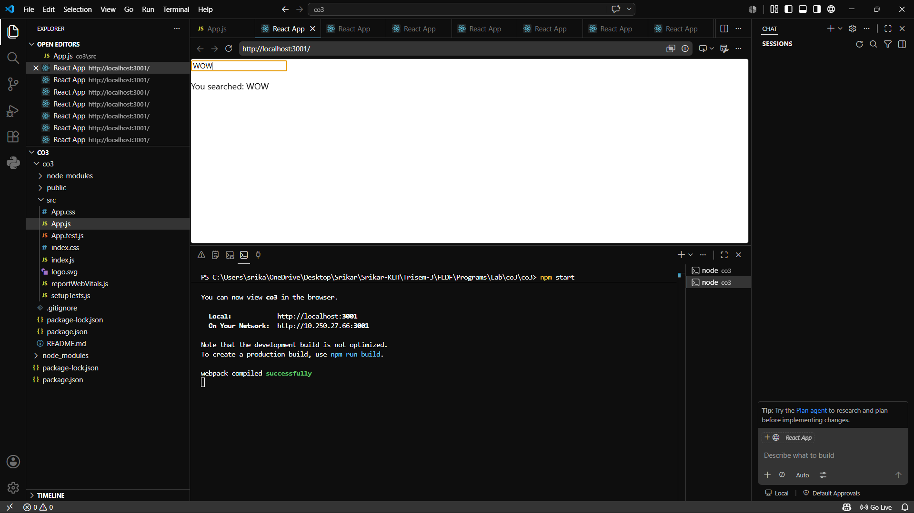

- Uncontrolled Component
Example: Coupon Code Input
import { useRef } from "react";

function Coupon() {

const inputRef = useRef();

function applyCoupon() {
alert(inputRef.current.value);
}

return (
<div>
<input type="text" ref={inputRef} />

<button onClick={applyCoupon}>
Apply Coupon
</button>
</div>
);
}

OUTPUT:

export default Coupon;
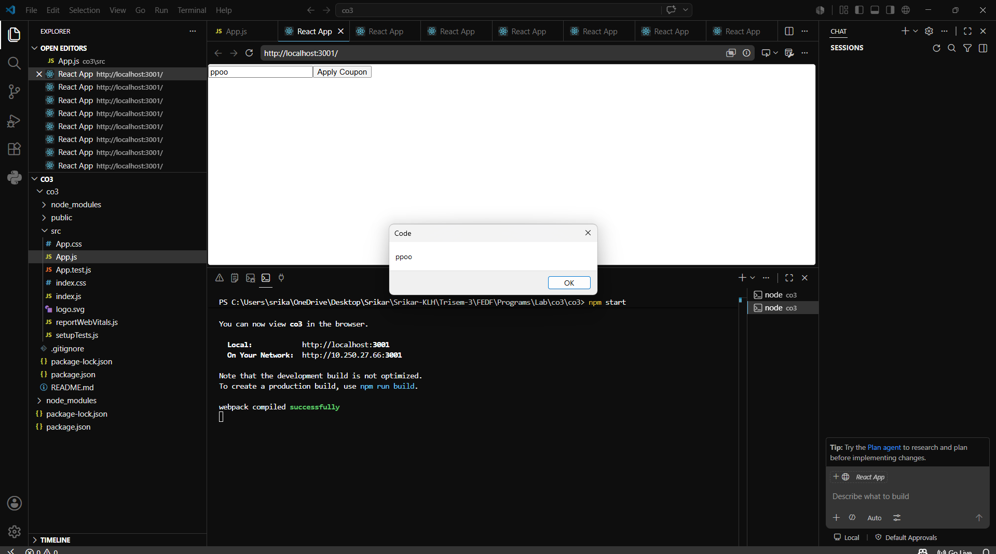

- Component Composition
Example: Product Card using Smaller Components
function ProductName() {
return <h2>Smart Watch</h2>;
}

function ProductPrice() {
return <p>₹3000</p>;
}

function ProductCard() {
return (
<div>
<ProductName />
<ProductPrice />
</div>
);
}

export default ProductCard;

OUTPUT:
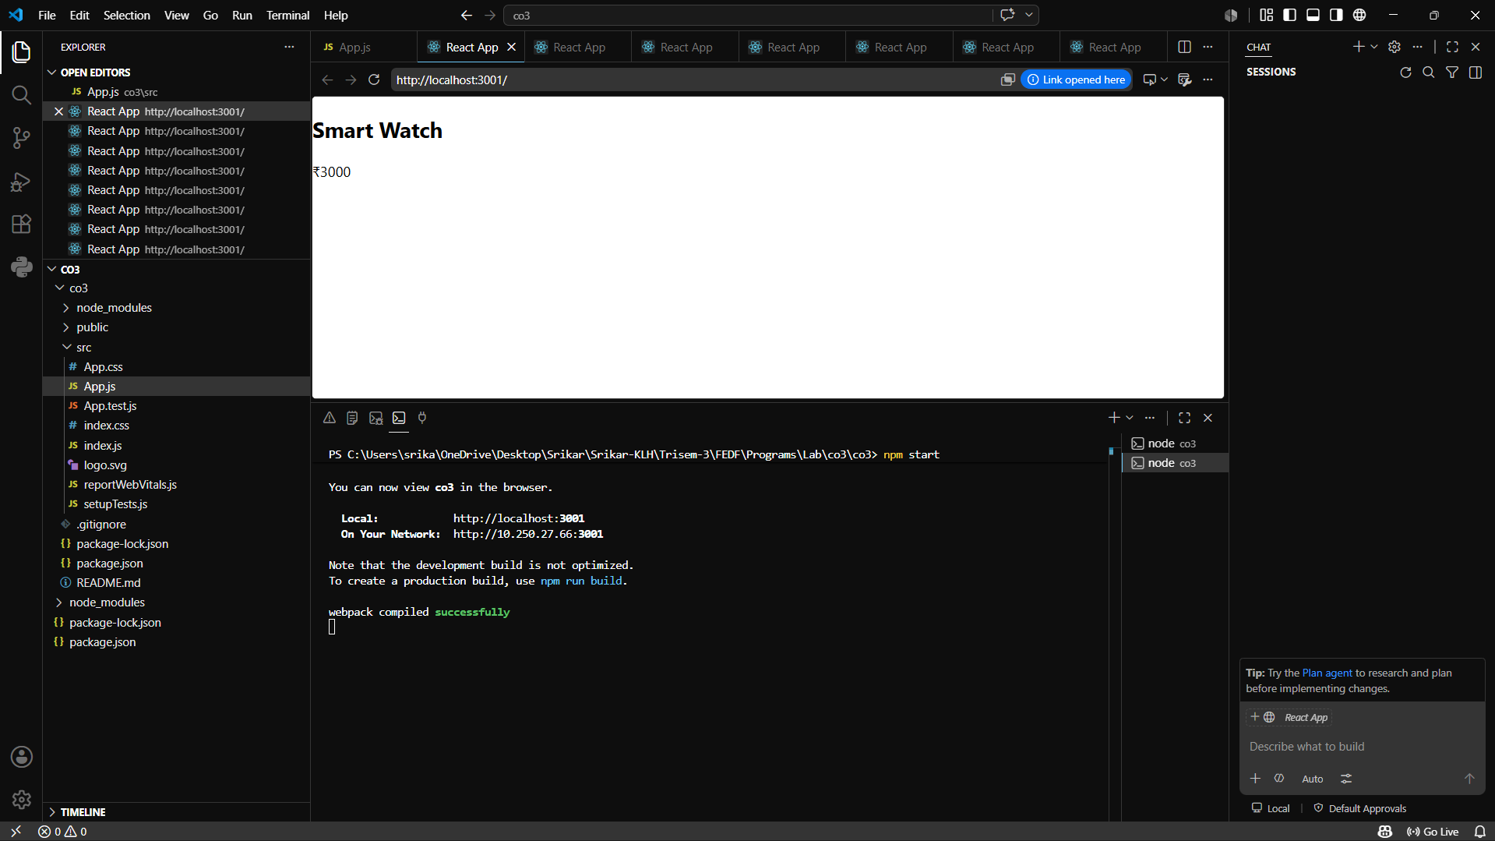

- Reusable Components
Example: Reusable Button
function Button(props) {
return (
<button>
{props.label}
</button>
);
}

function App() {
return (
<div>
<Button label="Buy Now" />
<Button label="Add to Cart" />
</div>
);
}

OUTPUT:
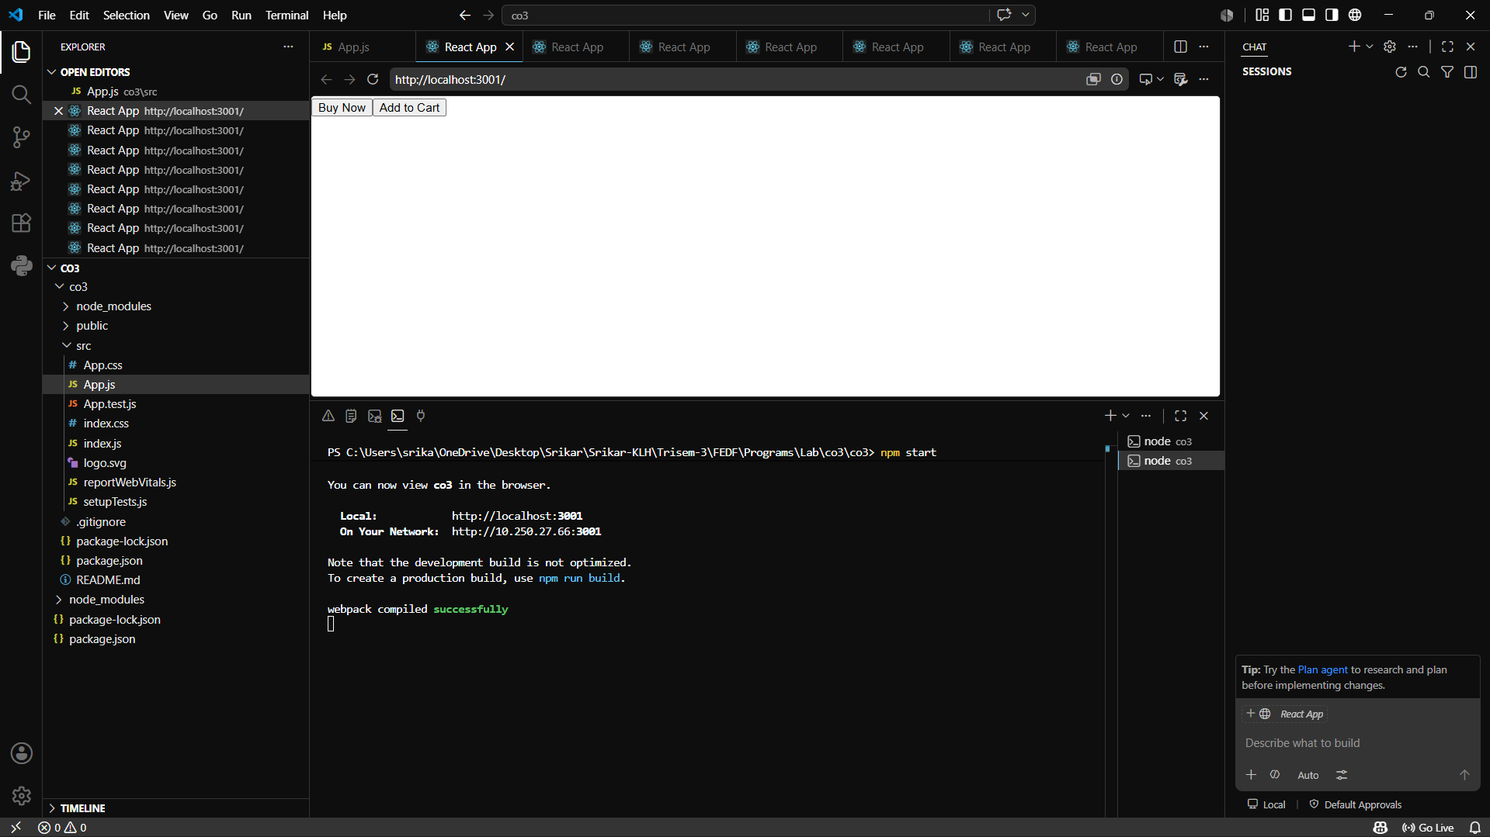
- Event Handler Example

Example: Add to Cart

function Product() {

function addToCart() {
alert("Product Added to Cart");
}

return (
<button onClick={addToCart}>
Add to Cart
</button>
);
}

export default Product;

OUTPUT:
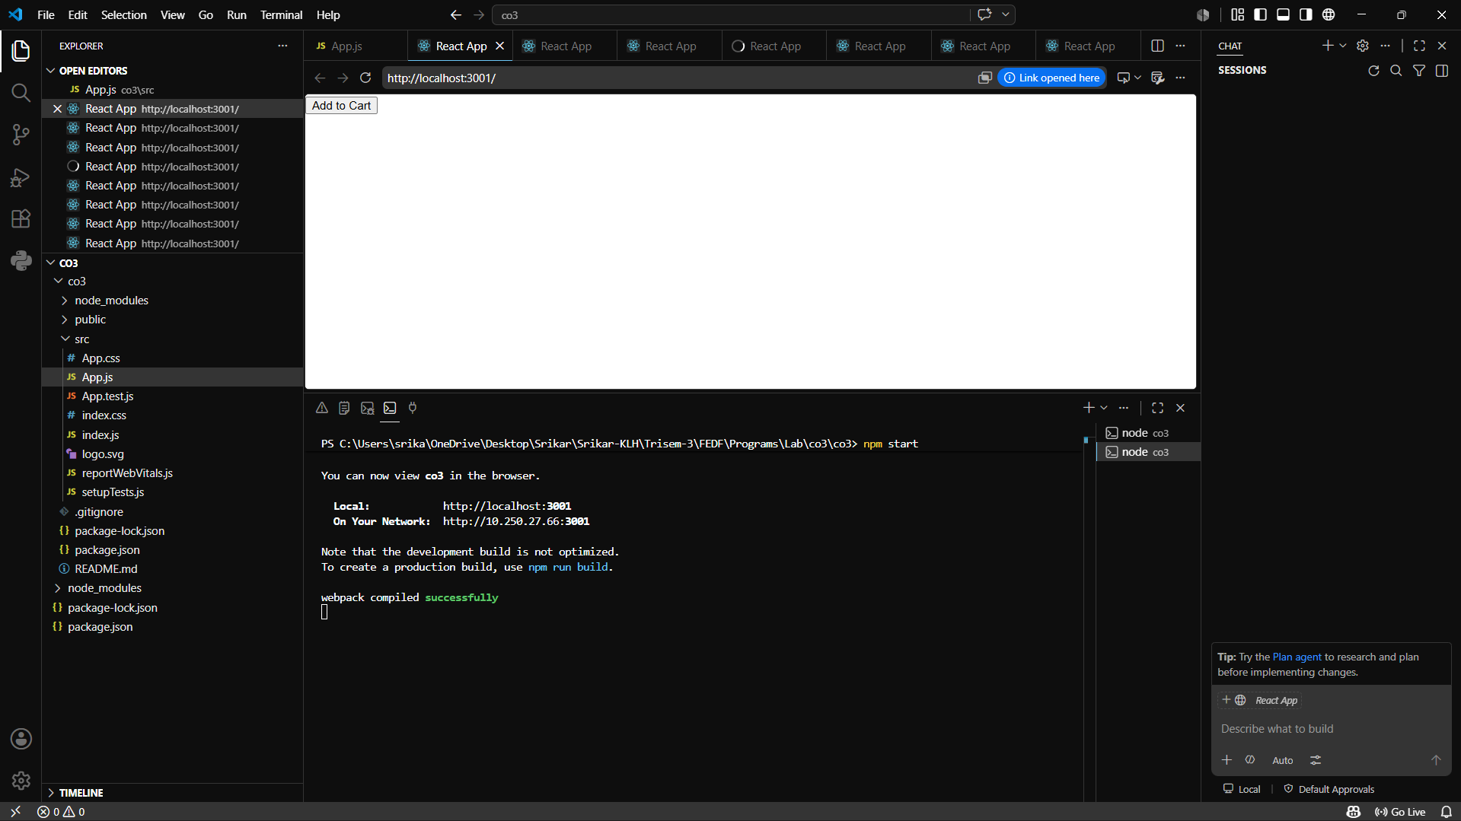
- Children Props Example
Example: Product Card Layout

function Card(props) {
return (
<div style={{border:"1px solid black", padding:"10px"}}>
{props.children}
</div>
);
}

function App() {
return (
<Card>
<h2>Shoes</h2>
<p>₹2000</p>
</Card>
);
}

OUTPUT:
