- Lifting State
import React, { useState } from "react";

function App() {

// Cart state in parent component
const [cart, setCart] = useState([]);

// Function to add product to cart
function addToCart(product) {
setCart([...cart, product]);
}

return (
<div style={{ padding: "20px" }}>
<h1>Simple E-Commerce App</h1>

<h2>Products</h2>

{/* Child Components */}
<Product
name="Laptop"
price={50000}
addToCart={addToCart}
/>

<Product
name="Mobile"
price={20000}
addToCart={addToCart}
/>

<Product
name="Headphones"
price={3000}
addToCart={addToCart}
/>

<Cart cart={cart} />
</div>
);
}

// Product Component
function Product(props) {

return (
<div
style={{
border: "1px solid black",
padding: "10px",
margin: "10px",
width: "200px"
}}
>
<h3>{props.name}</h3>

<p>Price: ₹{props.price}</p>

<button
onClick={() =>
props.addToCart({
name: props.name,
price: props.price
})
}
>
Add to Cart
</button>
</div>
);
}

// Cart Component
function Cart(props) {

return (
<div>
<h2>Cart Items</h2>

{props.cart.length === 0 ? (
<p>Cart is Empty</p>
) : (
props.cart.map((item, index) => (
<div key={index}>
{item.name} - ₹{item.price}
</div>
))
)}
</div>
);
}

export default App;

Output:
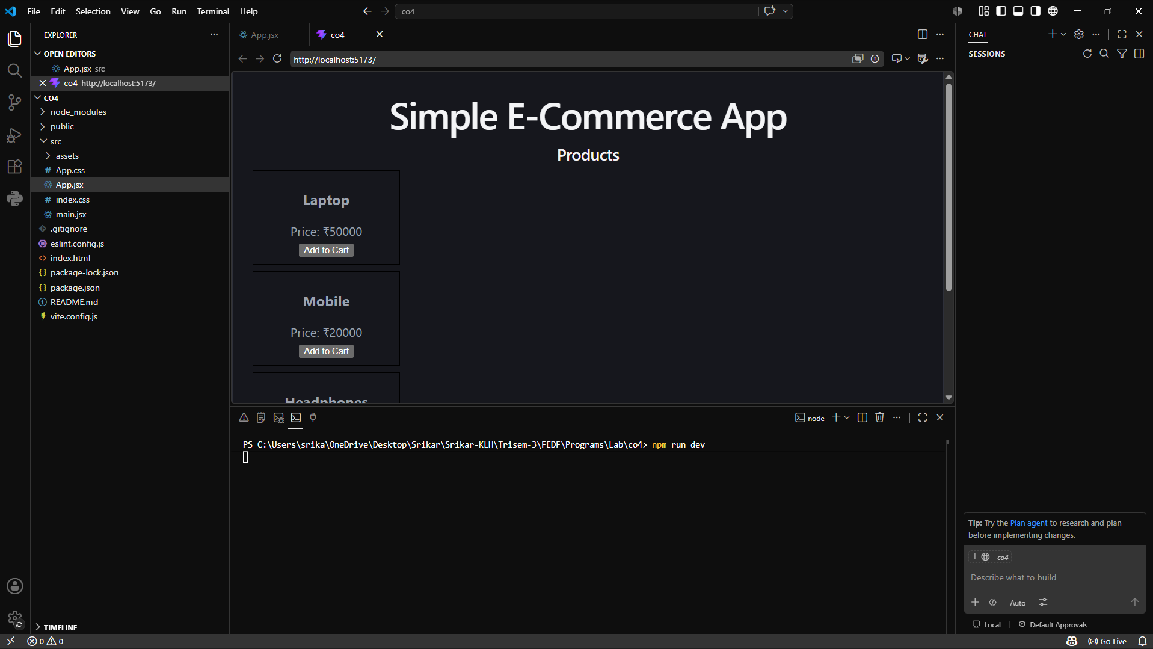
- State Co-Location
import { useState } from "react";

function App() {
return (
<div>
<h1>Amazon Store</h1>

<SearchBox />
</div>
);
}

function SearchBox() {
// State kept close to where it is used
const [search, setSearch] = useState("");

return (
<div>
<input
type="text"
placeholder="Search products"
value={search}
onChange={(e) => setSearch(e.target.value)}
/>

<p>Searching for: {search}</p>
</div>
);
}

export default App;

Output:
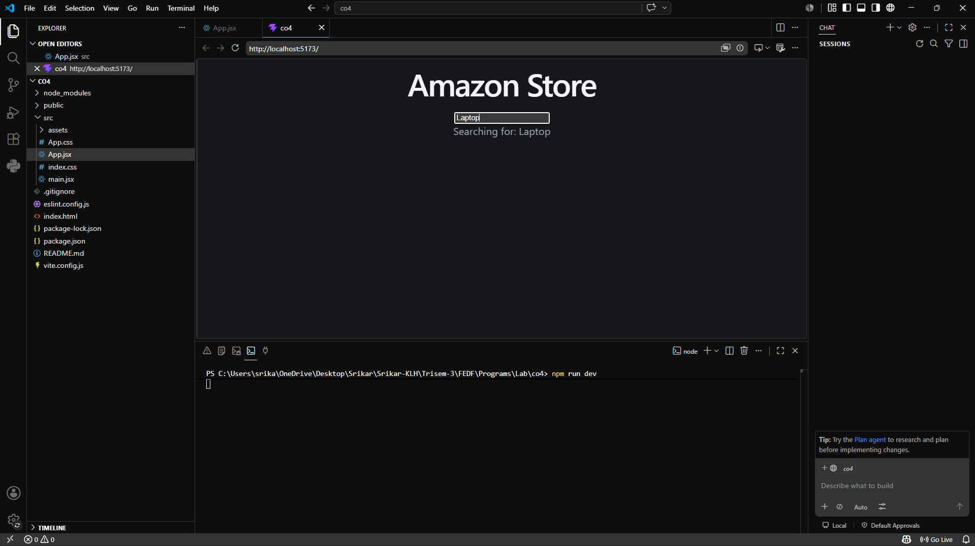

- Derived State
import React, { useState } from "react";

function Cart() {

const [price, setPrice] = useState(1000);
const [quantity, setQuantity] = useState(2);

// Derived State
const total = price * quantity;

return (
<div>
<h2>Price: {price}</h2>

<h2>Quantity: {quantity}</h2>

<h2>Total: {total}</h2>

<button onClick={() => setQuantity(quantity + 1)}>
Increase Quantity
</button>
</div>
);
}

export default Cart;

Output:
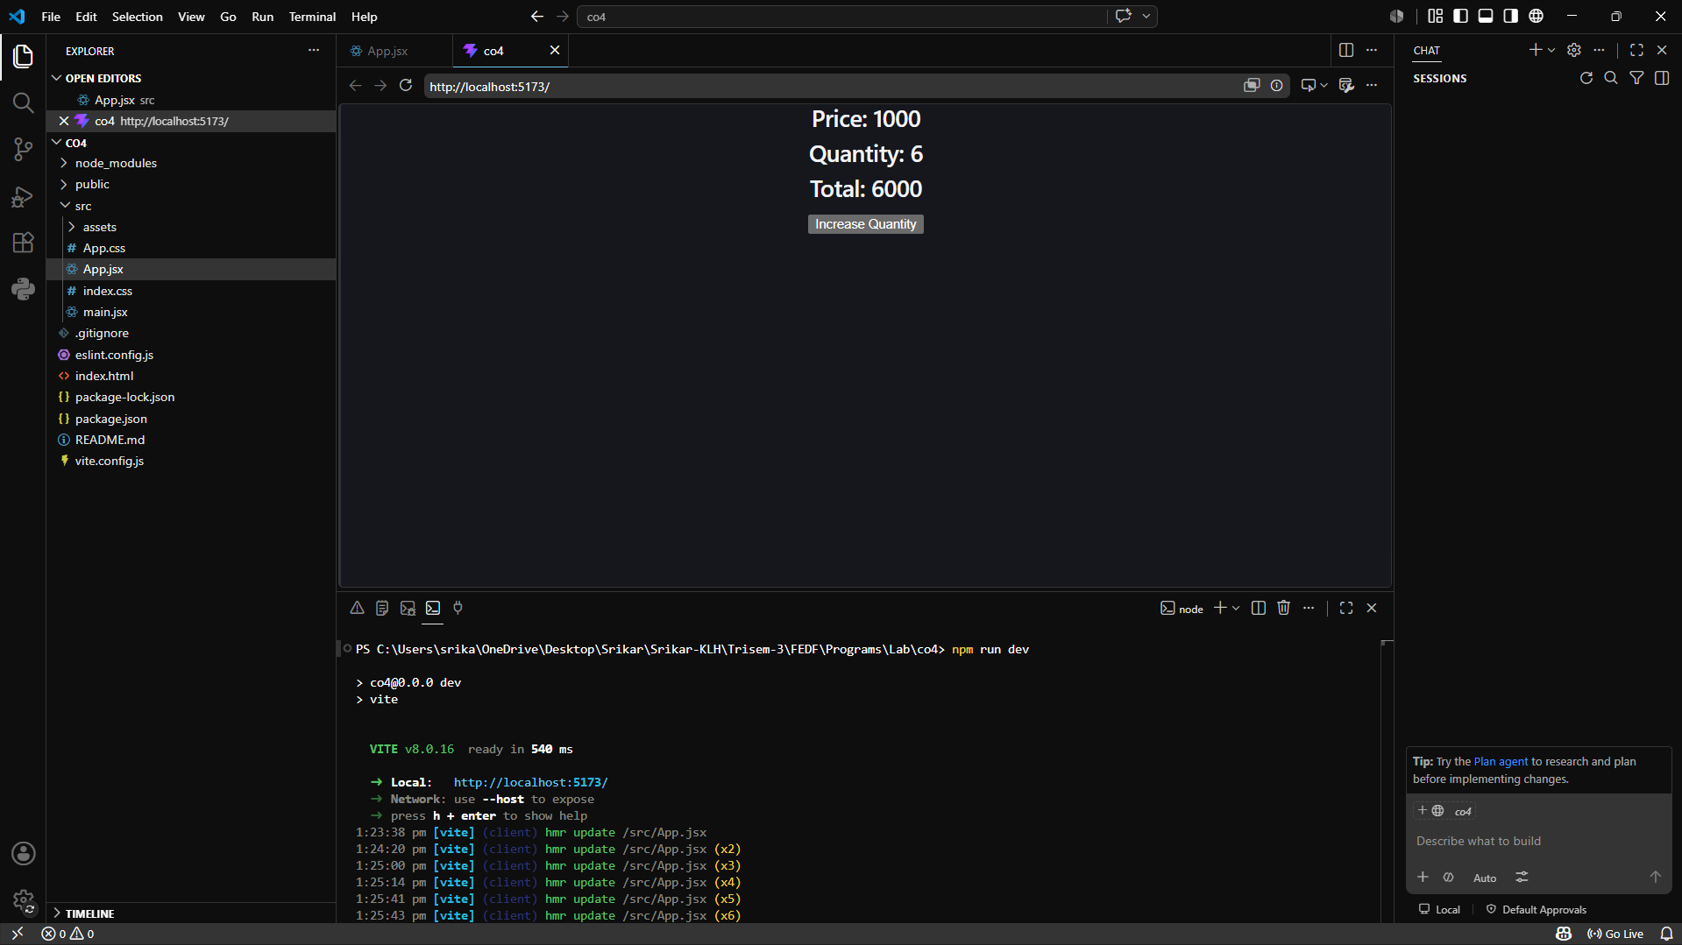

- Props Drilling
function App() {
const username = "Anusha";

return (
<div>
<Parent username={username} />
</div>
);
}

// Parent Component
function Parent({ username }) {
return (
<div>
<Child username={username} />
</div>
);
}

// Child Component
function Child({ username }) {
return (
<div>
<GrandChild username={username} />
</div>
);
}

// GrandChild Component
function GrandChild({ username }) {
return (
<h2>Welcome {username}</h2>
);
}

export default App;

Output:
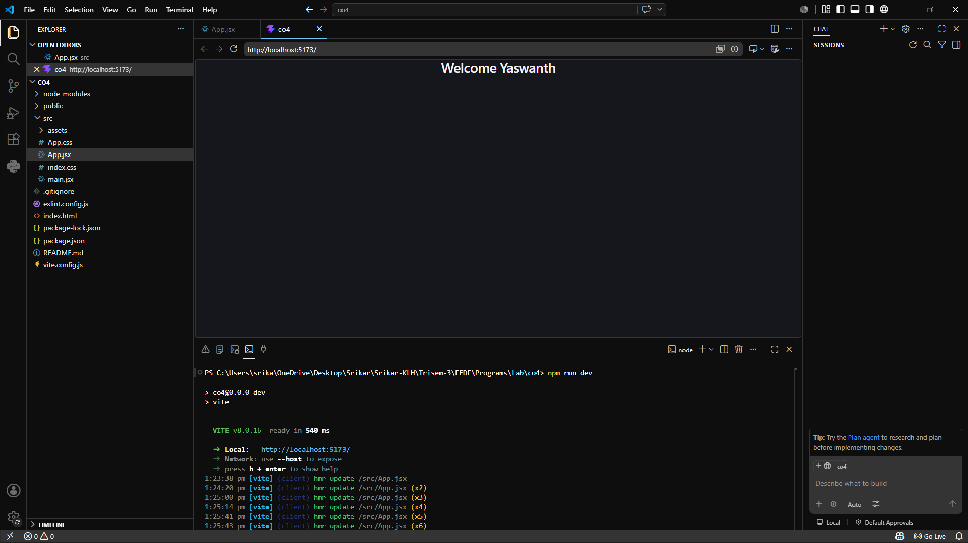

- Global State
import { createContext, useContext } from "react";

// Create Context
const UserContext = createContext();

function App() {
const username = "Anusha";

return (
<UserContext.Provider value={username}>
<Parent />
</UserContext.Provider>
);
}

// Parent Component
function Parent() {
return (
<div>
<Child />
</div>
);
}

// Child Component
function Child() {
return (
<div>
<GrandChild />
</div>
);
}

// GrandChild Component
function GrandChild() {
// Access global data directly
const username = useContext(UserContext);

return (
<h2>Welcome {username} using ReactContext</h2>
);
}

export default App;

Output
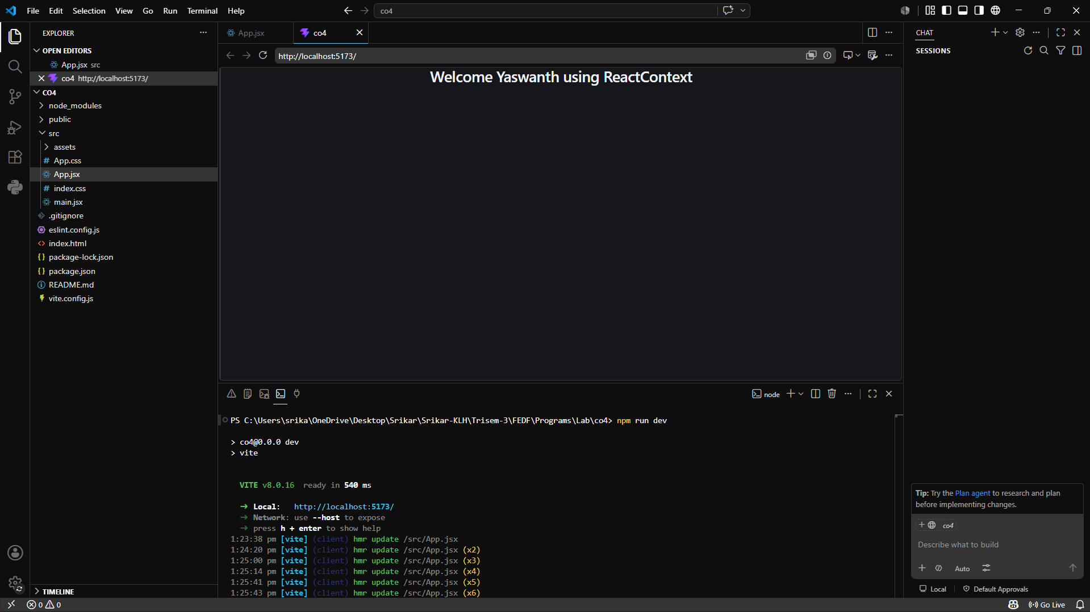
- API Service Layer
ApiService.jsx
export async function getUsers() {

const response = await fetch("https://jsonplaceholder.typicode.com/users");

const data = await response.json();

return data;
}

App.jsx

import React, { useEffect, useState } from "react";

import { getUsers } from "./apiService";

function App() {

const [users, setUsers] = useState([]);

useEffect(() => {

async function fetchData() {

const data = await getUsers();

setUsers(data);
}

fetchData();

}, []);

return (
<div>

<h1>User List</h1>

{users.map((user) => (
<p key={user.id}>
{user.name}
</p>
))}

</div>
);
}

export default App;

Output:
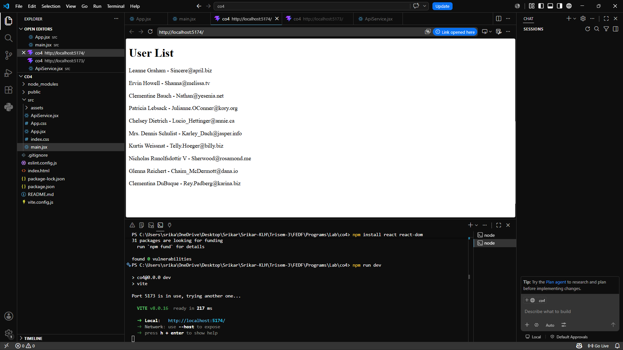

- Async Flow comtrol
import { useEffect, useState } from "react";

function App() {
const [user, setUser] = useState(null);
const [posts, setPosts] = useState([]);

useEffect(() => {
async function loadData() {
// Step 1: Get user
const userResponse = await fetch(
"https://jsonplaceholder.typicode.com/users/1"
);
const userData = await userResponse.json();

setUser(userData);

// Step 2: Get posts of that user
const postResponse = await fetch(
`https://jsonplaceholder.typicode.com/posts?userId=${userData.id}`
);
const postData = await postResponse.json();

setPosts(postData);
}

loadData();
}, []);

return (
<div>
<h2>User Details</h2>

{user && <p>Name: {user.name}</p>}

<h2>Posts</h2>

<ul>
{posts.map((post) => (
<li key={post.id}>{post.title}</li>
))}
</ul>
</div>
);
}

export default App;

Output:
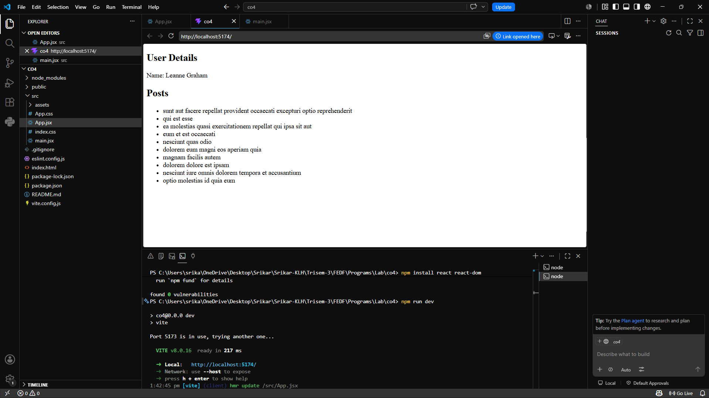

- Race Condition
import { useState } from "react";

function App() {
const [message, setMessage] = useState("");

function startRace() {
// Request 1
setTimeout(() => {
setMessage("First Request");
}, 3000);

// Request 2
setTimeout(() => {
setMessage("Second Request");
}, 1000);
}

return (
<div>
<h2>Race Condition Example</h2>

<button onClick={startRace}>
Start
</button>

<h3>{message}</h3>
</div>
);
}

export default App;

Output:
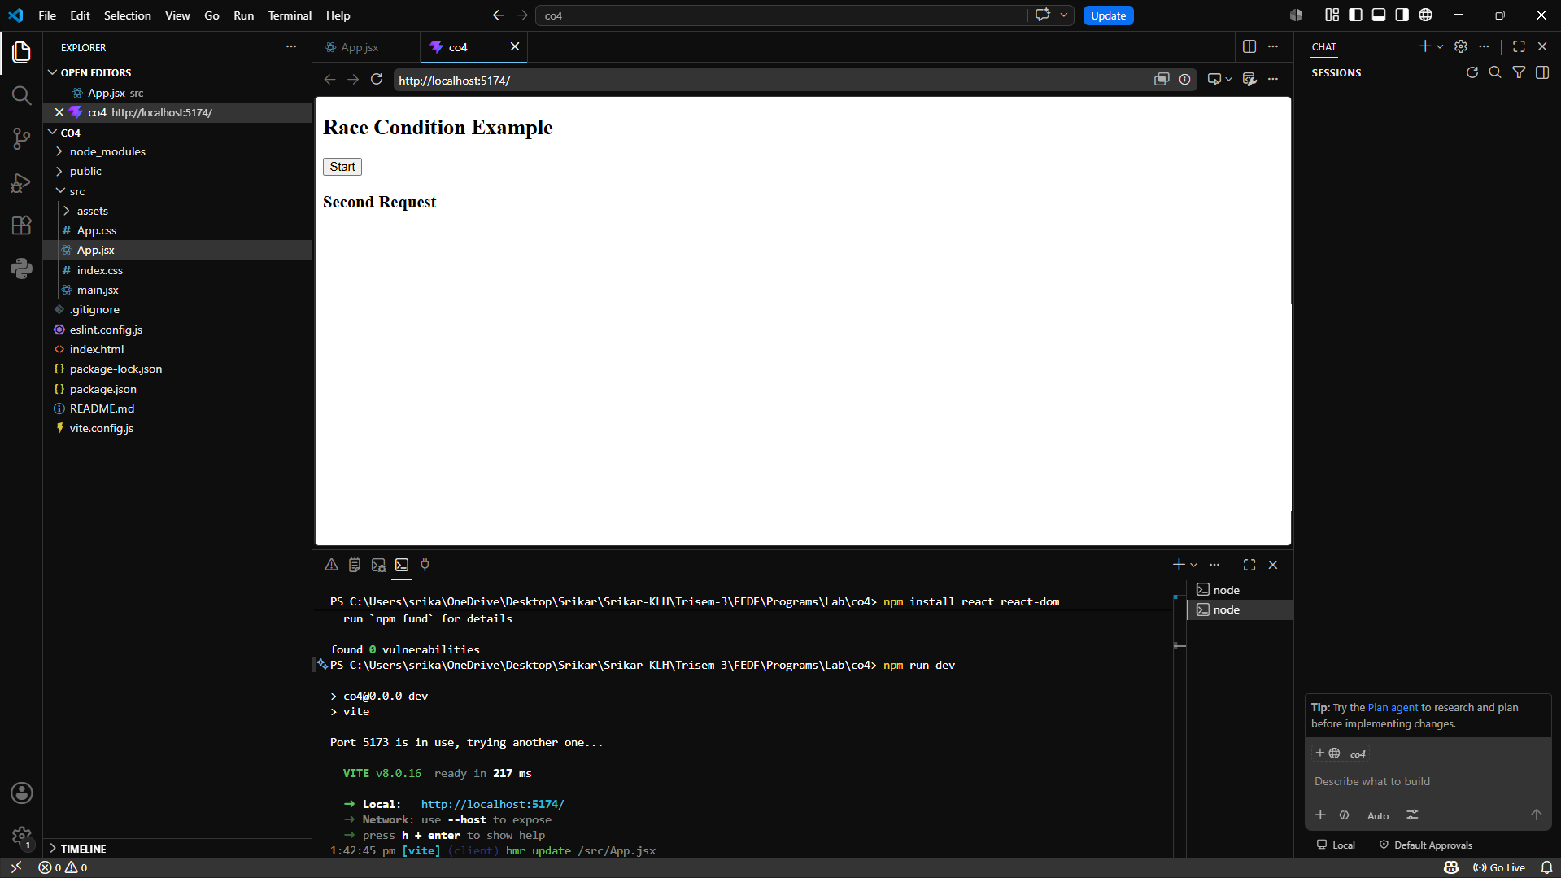

- StaleState Problem
import {useState } from "react";

function App() {
const [cartCount, setCartCount] = useState(0);

function addTwoItems() {
setCartCount(cartCount + 1);
setCartCount(cartCount + 1);
}

return (
<div>
<h2>Cart Items: {cartCount}</h2>

<button onClick={addTwoItems}>
Add 2 Products
</button>
</div>
);
}

export default App;

Output:
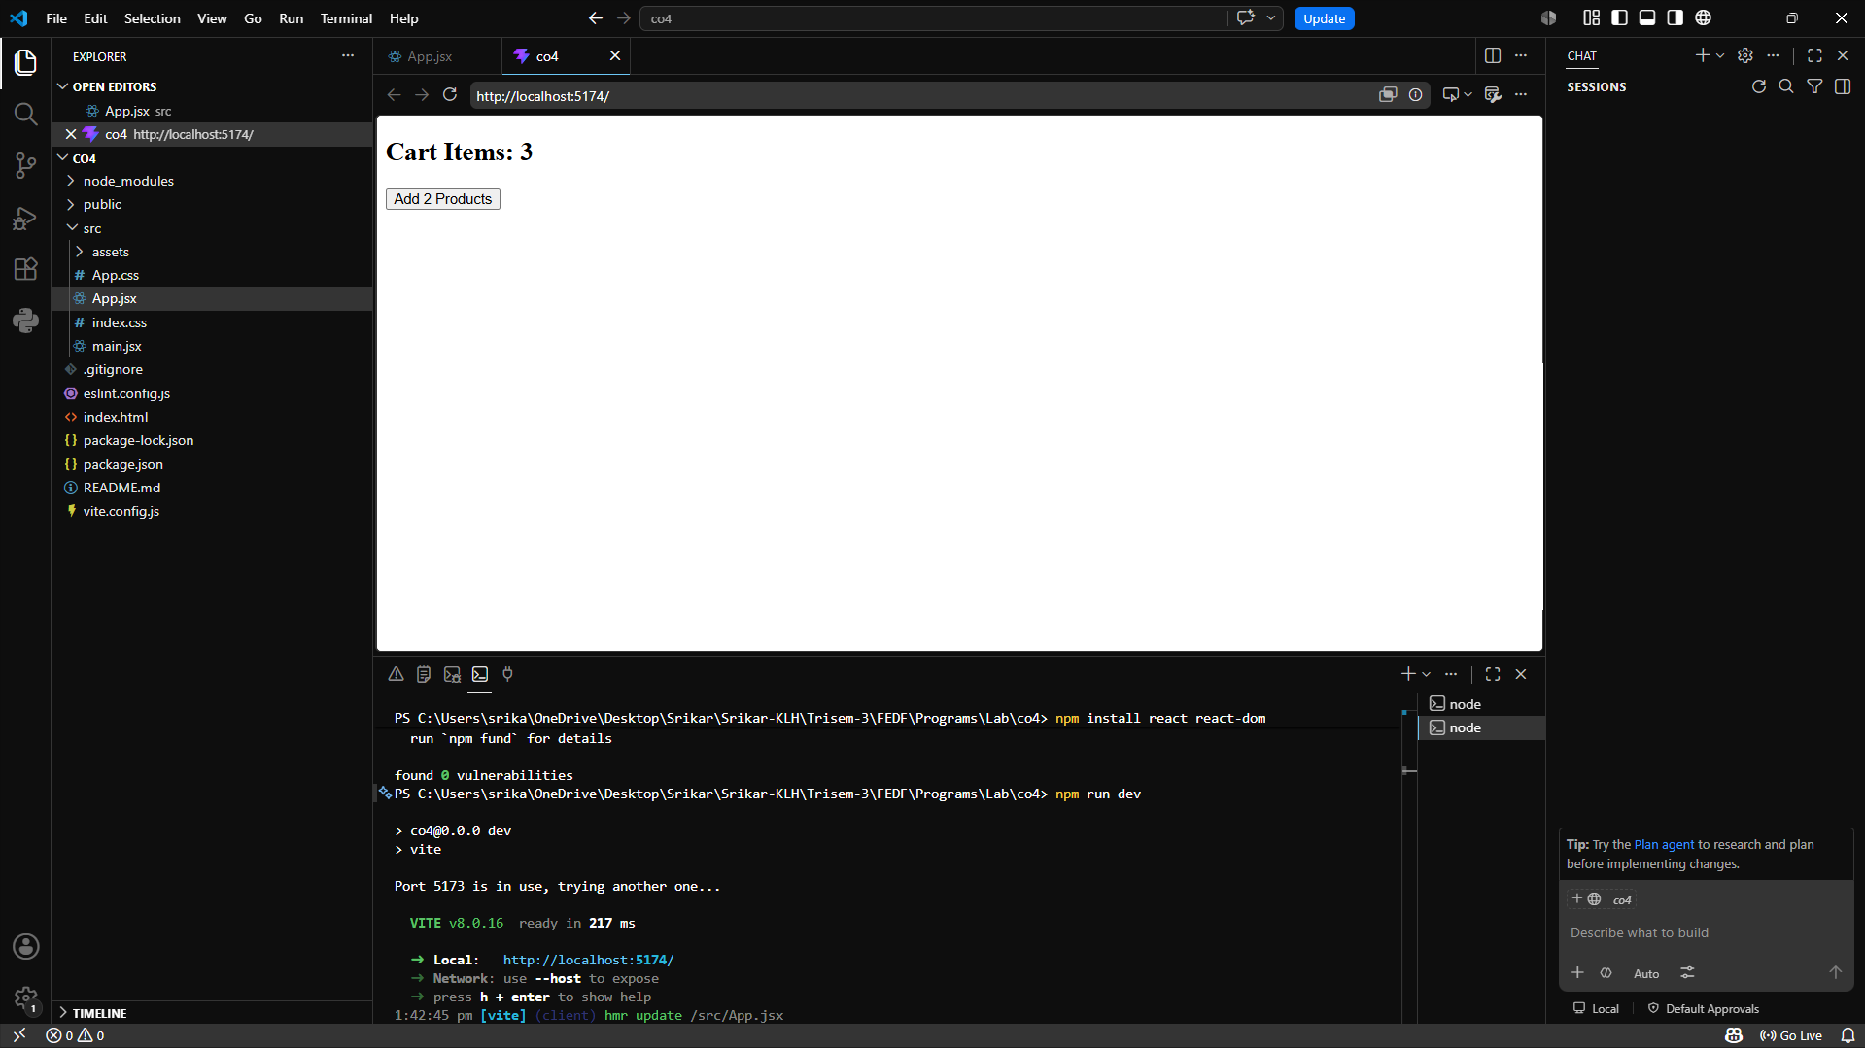
- data caching strategies
import { useState } from "react";

function App() {
const [message, setMessage] = useState("");

function loadData() {

const cachedData =
localStorage.getItem("message");

if (cachedData) {
console.log("Loaded from Cache");
setMessage(cachedData);
return;
}

console.log("Fetching Data...");

const data = "Welcome to React";

localStorage.setItem(
"message",
data
);

setMessage(data);
}

return (
<div>
<h2>{message}</h2>

<button onClick={loadData}>
Load Data
</button>
</div>
);
}

export default App;

Output:
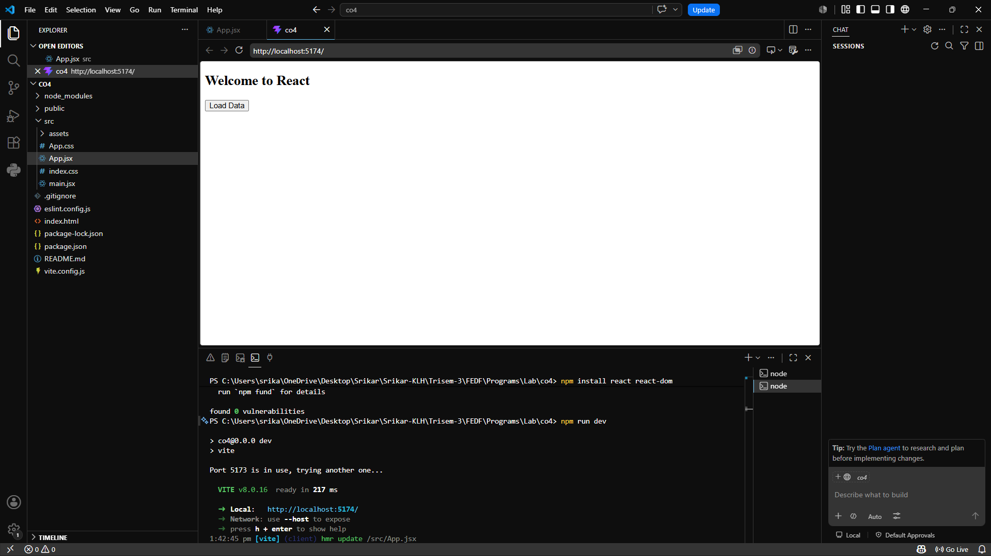

- Skeleton UI

import { useEffect, useState } from "react";

function App() {
const [products, setProducts] = useState([]);
const [loading, setLoading] = useState(true);

useEffect(() => {
setTimeout(() => {
setProducts([
"Laptop",
"Mobile",
"Headphones"
]);

setLoading(false);
}, 3000);
}, []);

if (loading) {
return (
<div>
<h2>Loading Products...</h2>

<div>████████████</div>
<div>████████████</div>
<div>████████████</div>
</div>
);
}

return (
<div>
<h2>Products</h2>

{products.map((product, index) => (
<p key={index}>{product}</p>
))}
</div>
);
}

export default App;
Output:
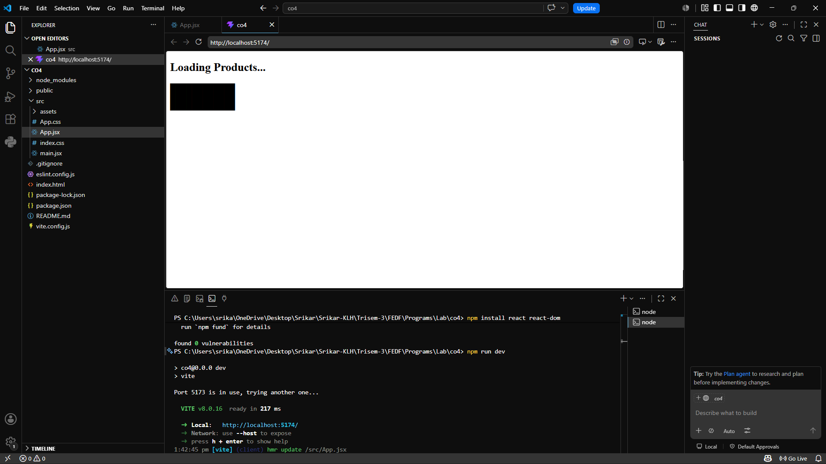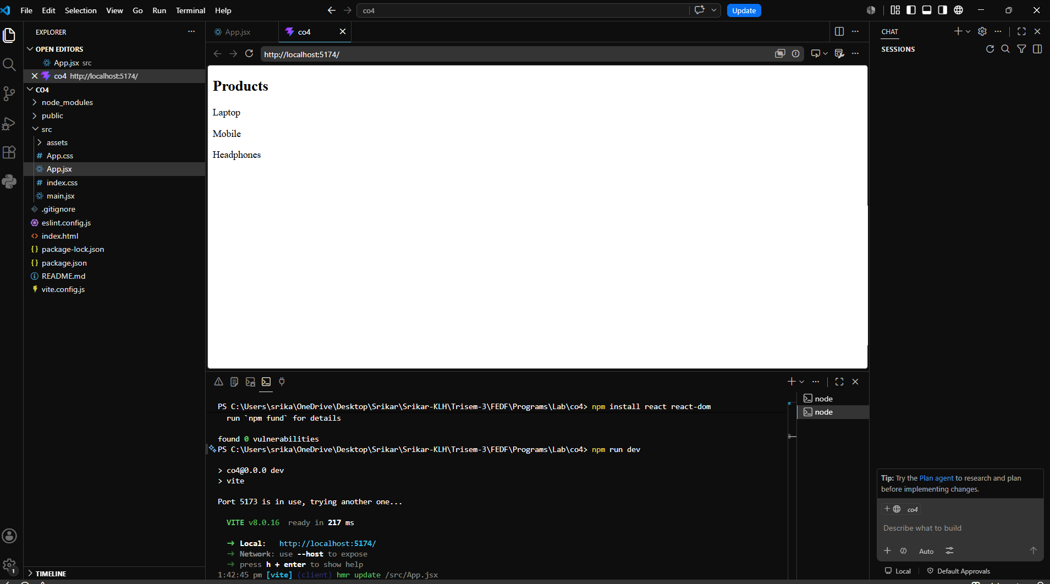

- ErrorBoundary:
ErrorBoundary.jsx

import React from "react";

class ErrorBoundary extends React.Component {
constructor(props) {
super(props);

this.state = {
hasError: false,
};
}

static getDerivedStateFromError(error) {
return { hasError: true };
}

componentDidCatch(error, errorInfo) {
console.log("Error:", error);
console.log("Error Info:", errorInfo);
}

render() {
if (this.state.hasError) {
return (
<div>
<h2>Something went wrong!</h2>
<p>The component crashed, but the app is still running.</p>
</div>
);
}

return this.props.children;
}
}

export default ErrorBoundary;

BuggyComponent.jsx
function BuggyComponent() {
const students = null;

// This will cause an error
return <h2>Total Students: {students.length}</h2>;
}

export default BuggyComponent;

App.jsx

import ErrorBoundary from "./ErrorBoundary";
import BuggyComponent from "./BuggyComponent";

function App() {
return (
<div>
<h1>React Error Boundary Example</h1>

<ErrorBoundary>
<BuggyComponent />
</ErrorBoundary>

<h3>This part of the app still works!</h3>
</div>
);
}

export default App;

main.jsx

import React from "react";
import ReactDOM from "react-dom/client";
import App from "./App";

ReactDOM.createRoot(document.getElementById("root")).render(
<React.StrictMode>
<App />
</React.StrictMode>
);

Output:
