1)Basic Routing:
Code:
import { BrowserRouter, Routes, Route, Link } from "react-router-dom";

function Home() {
return <h1>Home Page</h1>;
}

function About() {
return <h1>About Page</h1>;
}

function Contact() {
return <h1>Contact Page</h1>;
}

function App() {
return (
<BrowserRouter>
<div>
<nav>
<Link to="/">Home</Link> |{" "}
<Link to="/about">About</Link> |{" "}
<Link to="/contact">Contact</Link>
</nav>

<hr />

<Routes>
<Route path="/" element={<Home />} />
<Route path="/about" element={<About />} />
<Route path="/contact" element={<Contact />} />
</Routes>
</div>
</BrowserRouter>
);
}

export default App;

Output: 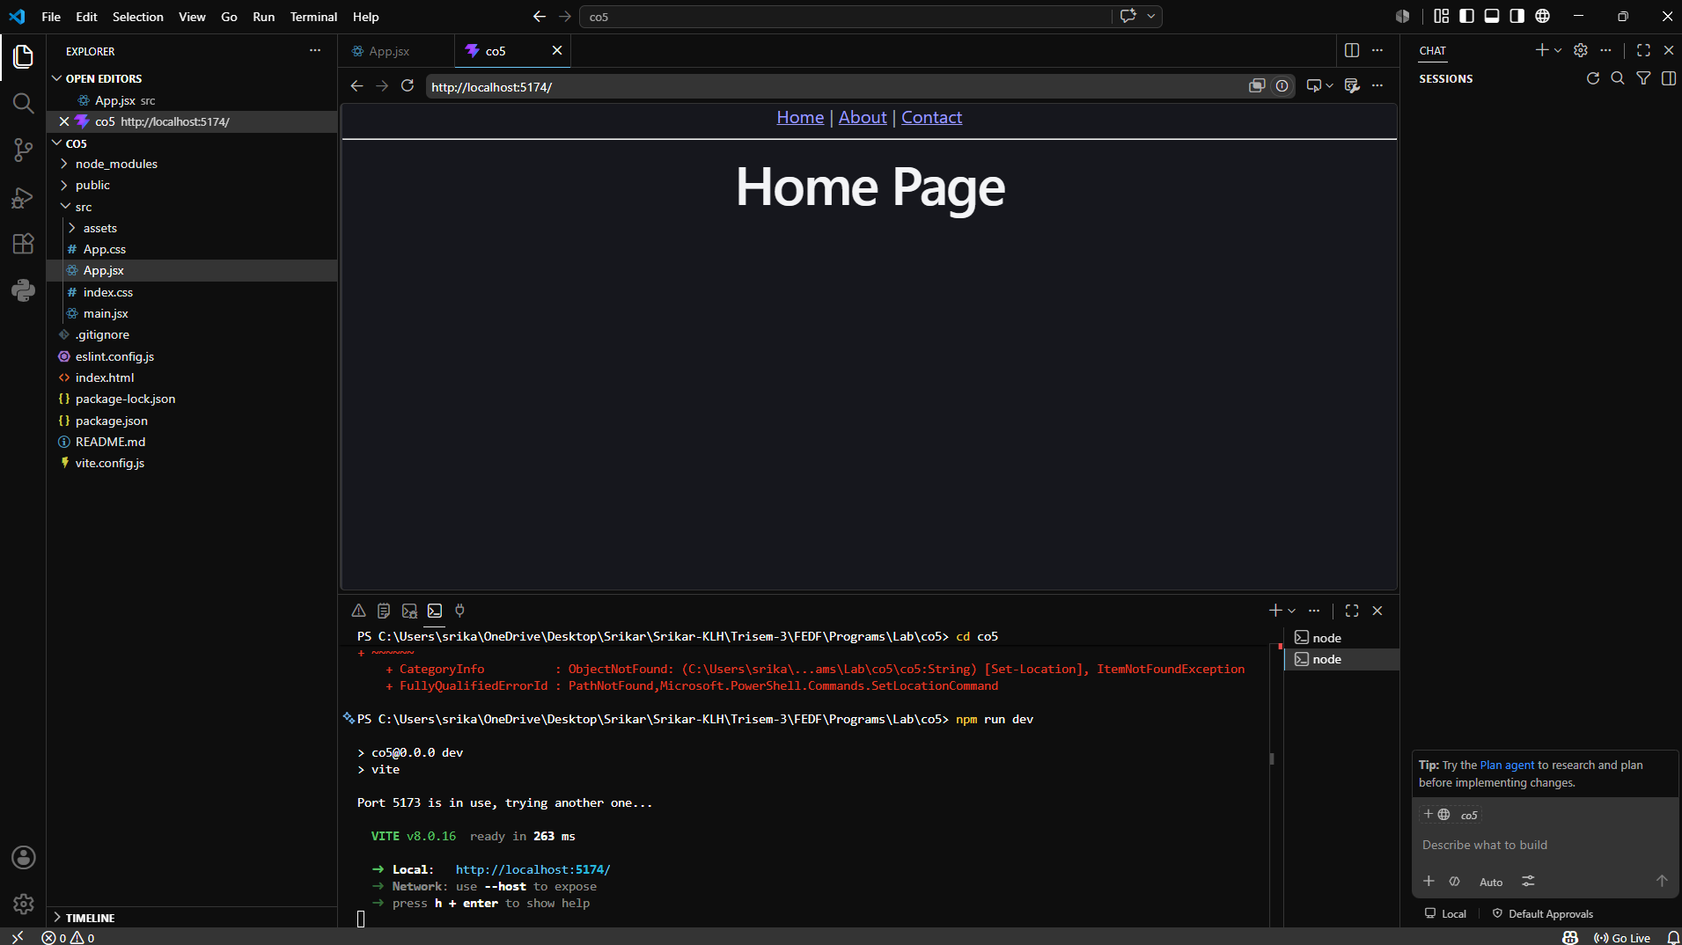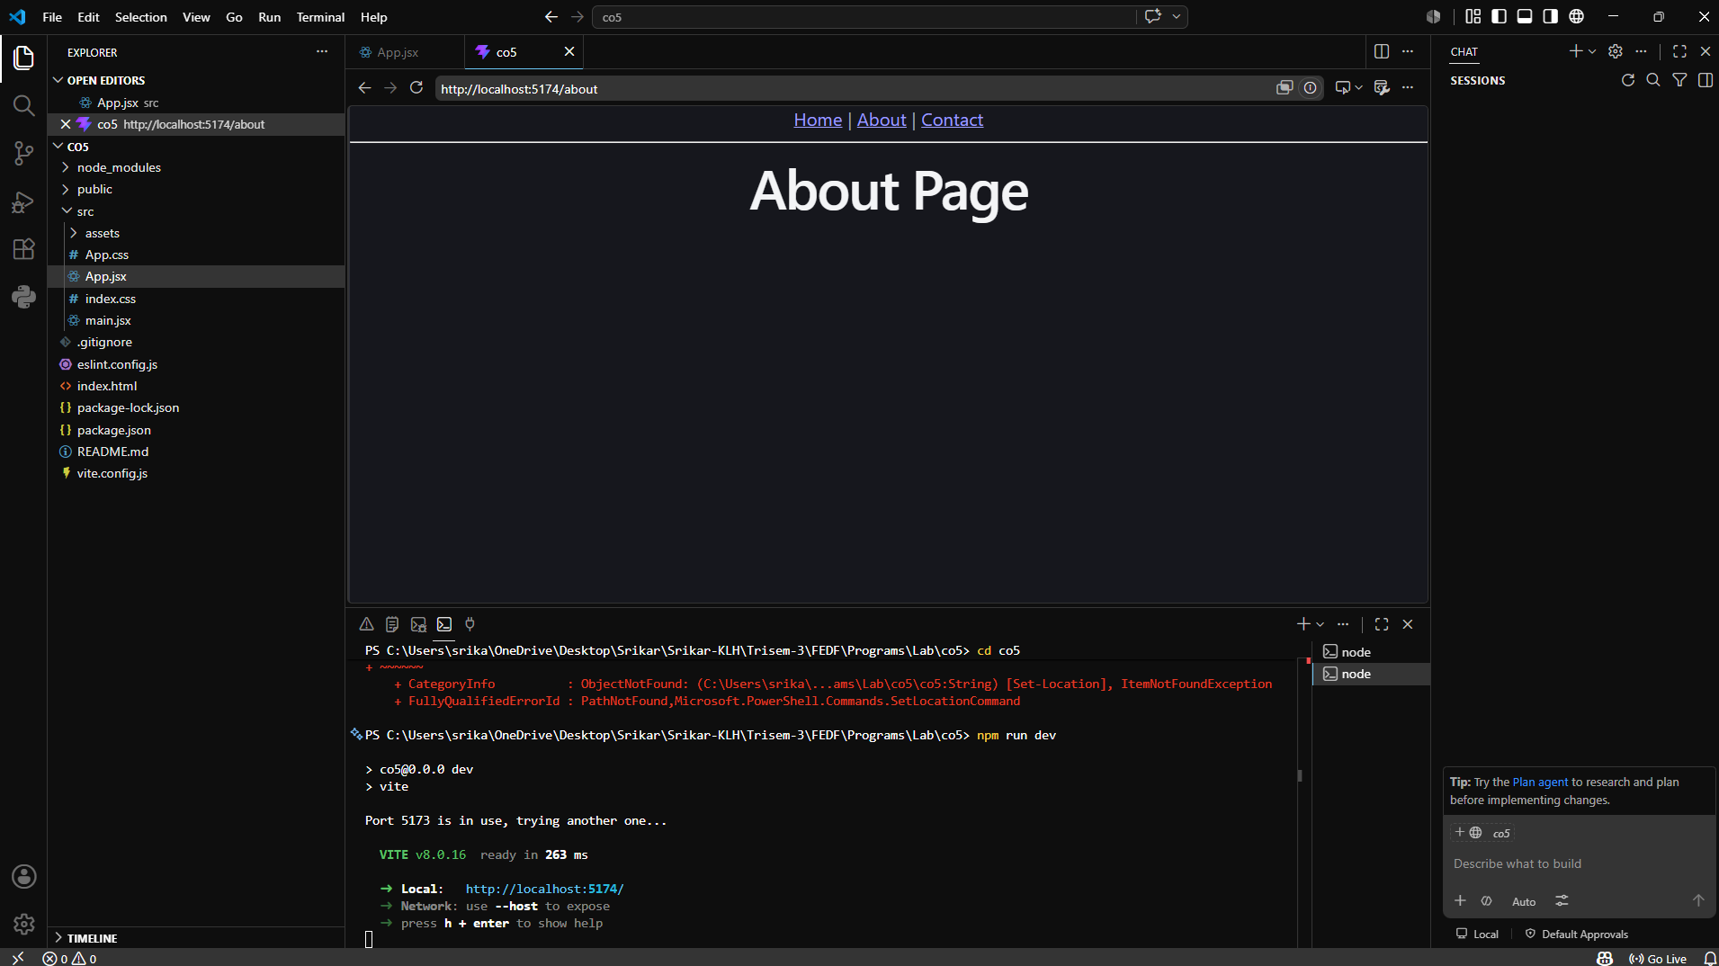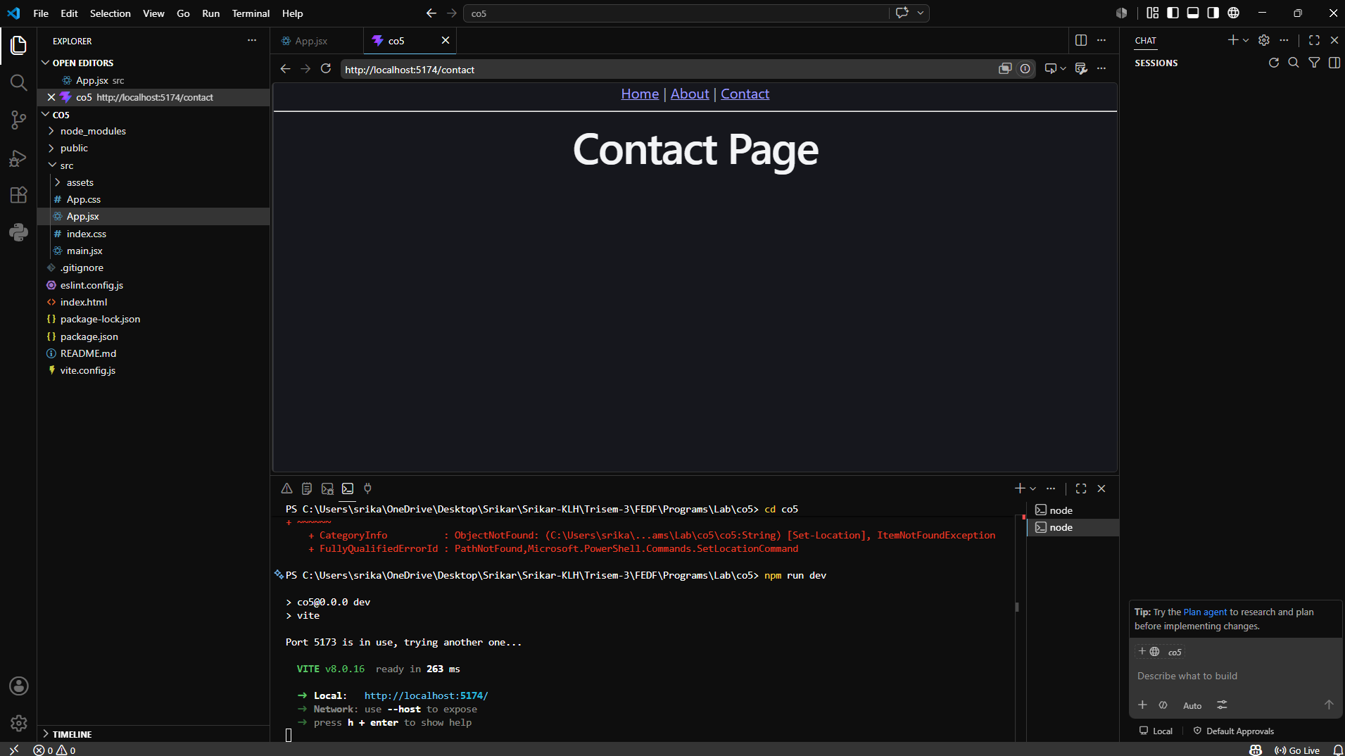
2)Nested Routing:
Code:
import React from "react";
import { BrowserRouter, Routes, Route, Link, Outlet } from "react-router-dom";

function Home() {
return <h1>Home Page</h1>;
}

function Products() {
return (
<div>
<h1>Products Page</h1>

<nav>
<Link to="car">Cars</Link> |{" "}
<Link to="bike">Bikes</Link>
</nav>

<hr />

<Outlet />
</div>
);
}

function CarProducts() {
return (
<div>
<h2>Cars</h2>
<ul>
<li>Audi</li>
<li>BMW</li>
<li>Volvo</li>
</ul>
</div>
);
}

function BikeProducts() {
return (
<div>
<h2>Bikes</h2>
<ul>
<li>Yamaha</li>
<li>Suzuki</li>
<li>Honda</li>
</ul>
</div>
);
}

function Contact() {
return <h1>Contact Page</h1>;
}

export default function App() {
return (
<BrowserRouter>
<nav>
<Link to="/">Home</Link> |{" "}
<Link to="/products">Products</Link> |{" "}
<Link to="/contact">Contact</Link>
</nav>

<hr />

<Routes>
<Route path="/" element={<Home />} />

<Route path="/products" element={<Products />}>
<Route path="car" element={<CarProducts />} />
<Route path="bike" element={<BikeProducts />} />
</Route>

<Route path="/contact" element={<Contact />} />
</Routes>
</BrowserRouter>
);
}
Output:
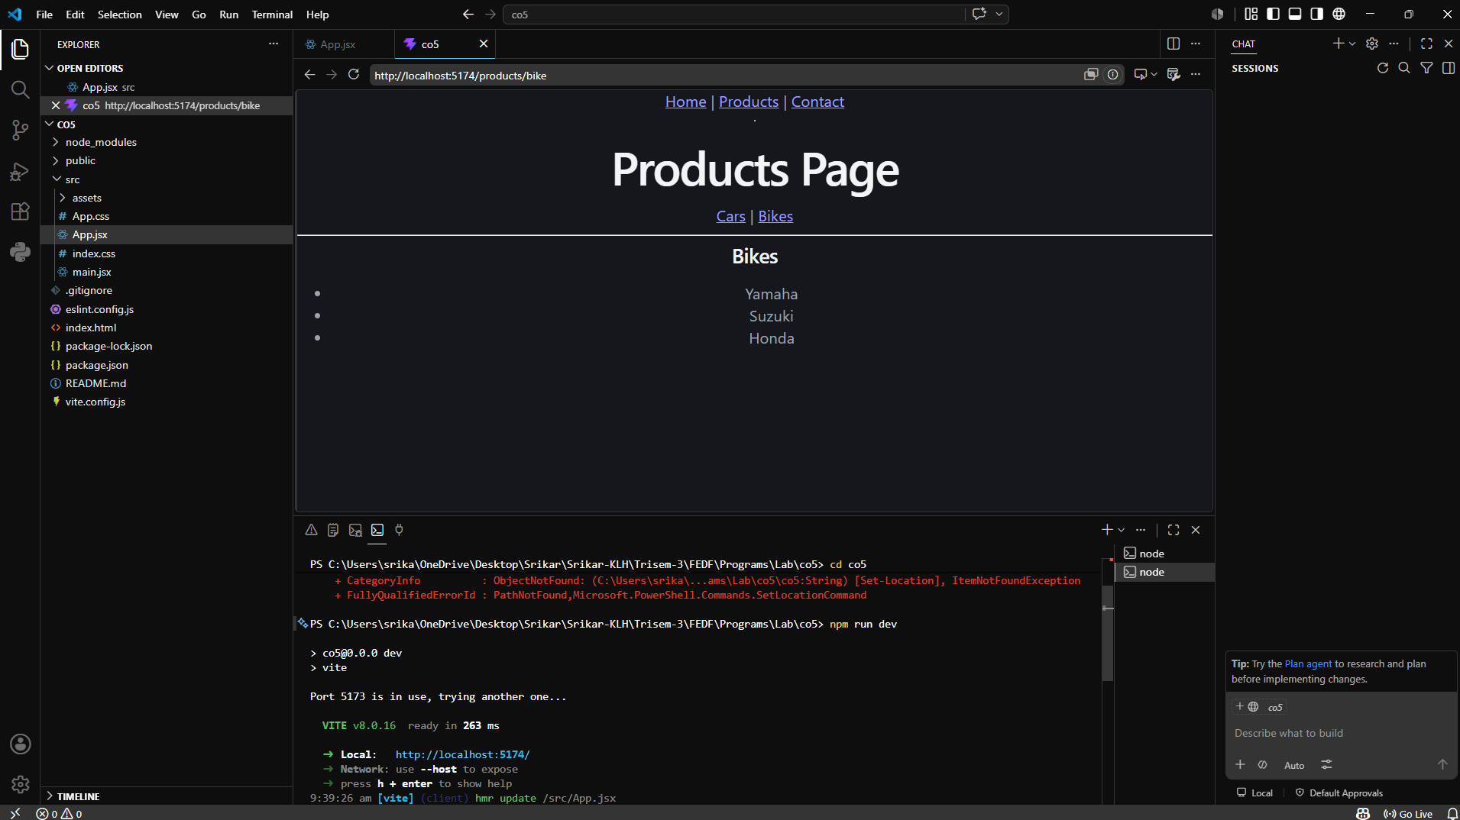

3)Dynamic Routing:
Code:
import { Routes, Route, Link, useParams } from "react-router-dom";

// Home Component
function Home() {
return <h1>Home Page</h1>;
}

// User Component (Dynamic Route)
function User() {
const { id } = useParams();

return (
<div>
<h1>User Details</h1>
<h2>User ID: {id}</h2>
</div>
);
}

// Main Component
export default function DynamicRouting() {
return (
<>
<nav>
<Link to="/">Home</Link> |{" "}
<Link to="/user/101">User 101</Link> |{" "}
<Link to="/user/202">User 202</Link> |{" "}
<Link to="/user/303">User 303</Link>
</nav>

<Routes>
<Route path="/" element={<Home />} />
<Route path="/user/:id" element={<User />} />
</Routes>
</>
);
}
Output:
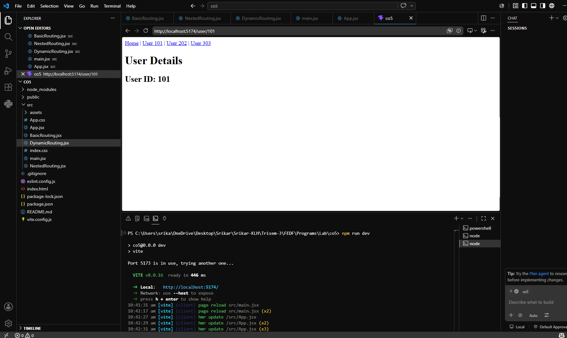

4)Protected Routing
Codes:
Dashboard.jsx:
function Dashboard() {
return <h2>Welcome to Dashboard</h2>;
}

export default Dashboard;

Login.jsx:
import { useNavigate } from "react-router-dom";

function Login() {
const navigate = useNavigate();

function handleLogin() {
localStorage.setItem(
"isLoggedIn",
"false"
);

navigate("/Dashboard");
}

return (
<button onClick={handleLogin}>
Login
</button>
);
}

export default Login;

Protectedroute.jsx:
import { Navigate } from "react-router-dom";

function ProtectedRoute({ children }) {

const isLoggedIn =
localStorage.getItem("isLoggedIn");

if (!isLoggedIn) {
return <Navigate to="/" />;
}

return children;
}

export default ProtectedRoute;

protectedrouteApp.jsx:
import { Routes, Route } from "react-router-dom";

import Login from "../ProtectedRoutes/Login";
import Dashboard from "../ProtectedRoutes/Dashboard";
import ProtectedRoute from "../ProtectedRoutes/ProtectedRoute";

function App() {
return (
<Routes>

<Route
path="/"
element={<Login />}
/>

<Route
path="/dashboard"
element={
<ProtectedRoute>
<Dashboard />
</ProtectedRoute>
}
/>

</Routes>
);
}

export default App;

Output:
