Java Script Programs:
- Arthematic_operations:
<!DOCTYPE html>
<html>
<head>
<title>JavaScript Arithmetic Operations</title>
</head>
<body>

<h2>JavaScript Arithmetic Operations</h2>

<script>
let a = 10;
let b = 5;

document.write("Addition: " + (a + b) + "<br>");
document.write("Subtraction: " + (a - b) + "<br>");
document.write("Multiplication: " + (a * b) + "<br>");
document.write("Division: " + (a / b) + "<br>");
</script>

</body>
</html>

Output:
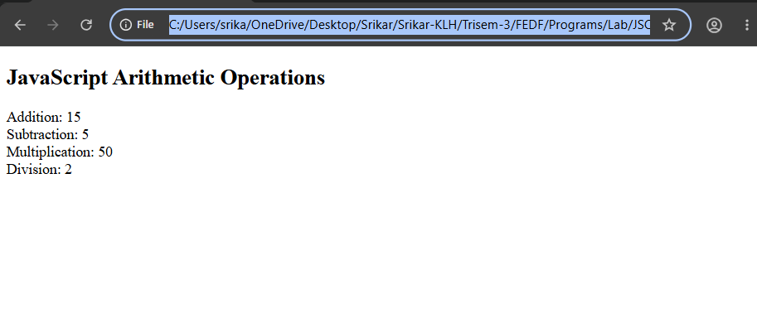
2)Arrays.html
<html>
<body>
<h1>JavaScript Arrays</h1>

<p id="demo"></p>

<script>
const fruits = ["Banana", "Orange", "Apple", "Mango"];
let size = fruits.length;

let numbers1 = [1, 2, 3, 4];
let result = numbers1.map(num => num * 2);

let numbers2 = [1, 2, 3, 4, 5, 6];
let evens = numbers2.filter(num => num % 2 === 0);

let numbers3 = [10, 20, 30];
let sum = numbers3.reduce((total, num) => total + num, 0);

// Display in HTML
document.getElementById("demo").innerHTML =
"Length: " + size + "<br>" +
"Map: " + result + "<br>" +
"Filter: " + evens + "<br>" +
"Reduce: " + sum;

</script>

</body>
</html>
Output:
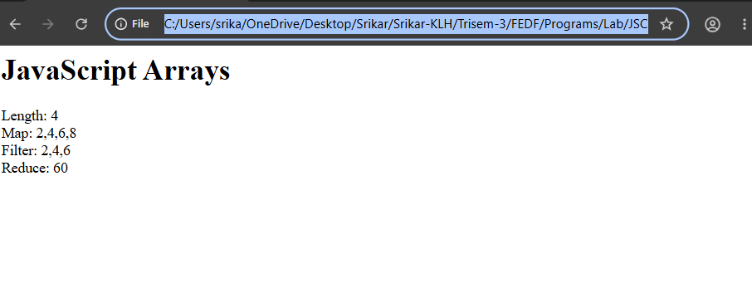
3)clickevent.html

<html>
<body>

<h2 id="heading">Welcome Students</h2>

<button onclick="changeText()">Change Text</button>
<button onclick="changeColor()">Change Text Color</button>
<button onclick="showMessage()">Show Alert</button>
<button onclick="changeBackground()">Change Background</button>

<script>
function changeText() {
document.getElementById("heading").textContent = "Text Changed!";
}

function changeColor() {
document.getElementById("heading").style.color = "blue";
}

function showMessage() {
alert("Button Clicked Successfully!");
}

function changeBackground() {
document.body.style.backgroundColor = "lightyellow";
}
</script>

</body>
</html>

output: 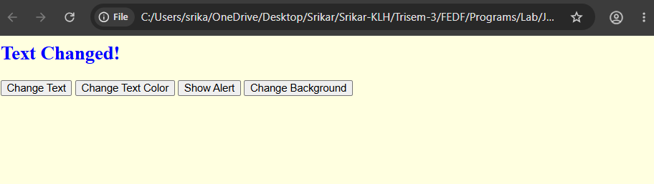

4)conditions.html
<!DOCTYPE html>
<html>
<head>
<title>JavaScript Conditions Example</title>
</head>
<body>

<h2>JavaScript Conditions</h2>

<script>
let marks = 75;

// if, else if, else
if (marks >= 90) {
document.write("Grade: A<br>");
} else if (marks >= 60) {
document.write("Grade: B<br>");
} else {
document.write("Grade: C<br>");
}

// Ternary Operator
let result = (marks >= 40) ? "Pass" : "Fail";
document.write("Result: " + result);
</script>

</body>
</html>

Output:
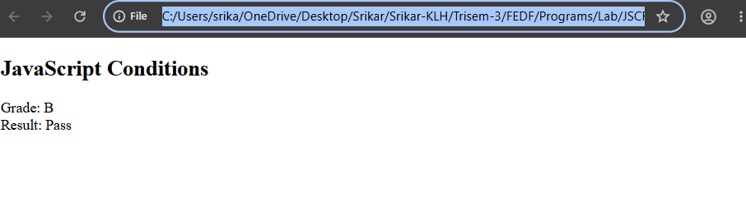
5)functions.html
<!DOCTYPE html>
<html>
<body>
<h1>JavaScript Functions</h1>
<h2>The return Statement</h2>
<p>A function that returns the greeting: "Hello World":</p>

<p id="demo"></p>

<script>
function sayHello() {
return "Hello World";
}

let greeting = sayHello();

document.getElementById("demo").innerHTML = greeting;
</script>

</body>
</html>

Output:
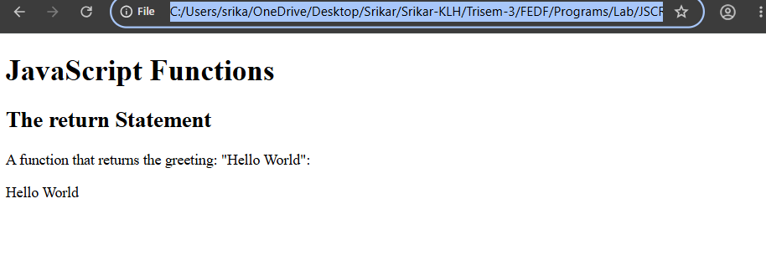
6)loops.html:
<!DOCTYPE html>
<html>
<head>
<title>JavaScript Loops Example</title>
</head>
<body>

<h2>JavaScript Loops</h2>

<script src="loops.js"></script>

</body>
</html>

Output:
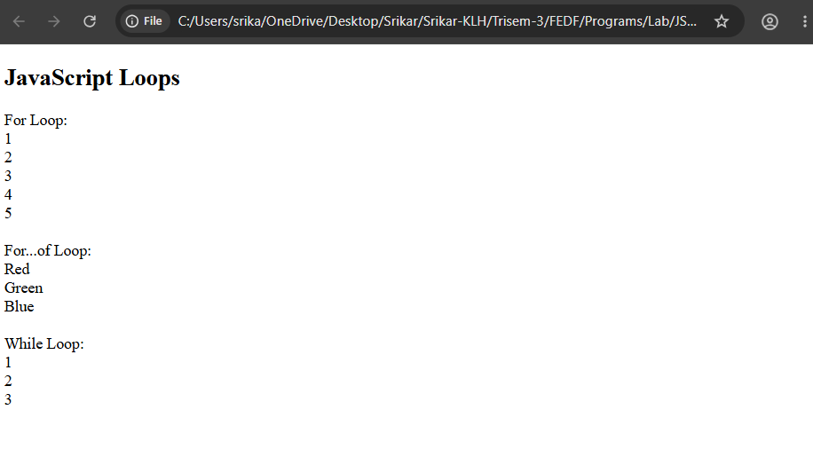
JSX Program:
Buggy Timer:
import React, { useState, useEffect } from "react";

export default function BuggyTimer() {
const [count, setCount] = useState(0);

useEffect(() => {
const id = setInterval(() => {
setCount(count +1); //

}, 1000);
return () => clearInterval(id);
}, []);
return <h2>Buggy: {count}</h2>;
}
Output:
