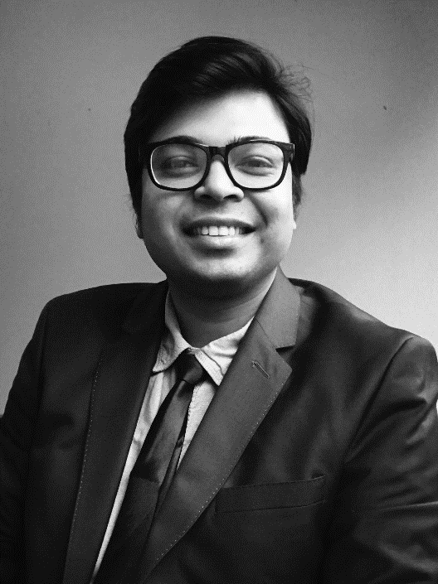

**Professional Experience**

10/2020 – present

**Autonomous Driving Intern, Bosch**

**Renningen, Germany**

* + Synchronization of data labels with Lidar and Camera data
  + Data Augmentation of 3D Point Cloud Data

02/2020 – 10/2020

**Consultant Intern, IMP³ROVE European Innovation Management Academy EWIV (A Kearney Subsidiary)**

**Düsseldorf, Germany**

* + Database migration with SQL and Python
  + Design of website with WordPress
  + Research for consulting projects

09/2012 – 09/2019

**Engineer (R&QA), U.R. Rao Satellite Centre, Indian Space Research Organization**

**Bengaluru, India**

* + Vibration testing on Spacecraft and sub-systems
  + Project Manager (QA-Mech) for Oceansat-3 spacecraft
  + Database Management Tool for digitization of workflow

**Profile**

* 7 years of work experience in Space Industry
* Internship experience in Autonomous Driving, Machine Learning, Database Migration and Web-development
* Academic projects in supply chain modelling, optimization, machine learning and reinforcement learning.
* Seeking Master’s Thesis opportunity in the Industry

**Sattwik Suman Das**

M.Sc. Data Analytics and Decision Science

RWTH Aachen Business School

**Address:**

Autenstrasse 21/1,

71254 Ditzingen, Germany

**Phone:**

+49 15225853167

**Email:**

sattwik.das@rwth-aachen.de, [sattwiksuman@gmail.com](mailto:sattwiksuman@gmail.com)

**Web:**

linkedin.com/in/sattwiksuman, github.com/sattwiksuman

**Nationality:**

Indian

**Birth:**

24.12.1989

**Marital Status:**

Married, No children

**Languages:**

* English, Hindi, Odiya (Native level proficiency)
* German (A2)

**Achievements and Awards:**

* National Talent Search Scholarship
* D.A.V Scholarship
* 7th rank in State in All India Senior School Certificate Examination

**Education**

10/2019 – present

**M.Sc. Data Analytics and Decision Science, RWTH Business School, Aachen, Germany**

Coursework: Data Structures and Algorithms, Machine Learning, Predictive Modelling, Optimization Models, Heuristics Optimization and Strategic Management.

Overall Grade: 1.1 (after 2 semesters)

08/2008 – 06/2012

**B.Tech. Aerospace Engineering, Indian Institute of Space science and Technology, Thiruvananthapuram, India**

Minor: Navigation, Guidance and Control

Overall Grade: 8.78/ 10

**Skills:**

* Data Science
* Machine Learning
* Artificial Intelligence
* Time Series Analysis
* Optimization
* Supply Chain Management
* Database Management
* Web-design
* Project Management
* Quality Assurance
* Vibration Testing

**Programming Languages:**

* Python
* R
* SQL, C++, MATLAB (Elementary Proficiency)

**Tools and Utilities:**

* Microsoft Office
* Spyder, PyCharm, Jupyter Notebook
* WordPress
* Photoshop

**Additional Training:**

* Machine Learning A-Z
* The Python Mega-course
* Artificial Intelligence in Business
* Basics of Data Analytics
* Vibration and Noise Control in Engineering Structures and Systems
* Structural Analysis and Design optimisation for Engineering Structures and Systems
* ISO 9001 2015 Internal Quality Auditor

**Hobbies and Interests:**

* Driving
* Podcasts
* Teaching
* Music
* Cooking

**References**

**Lisa Berle**, Project Leader & Partner Management, IMP³ROVE European Innovation Management Academy EWIV [lisa.berle@kearney.com](mailto:lisa.berle@kearney.com)

**Sumeet Kumar**, Project Manager, Indian Space Research Organization

[sumeet@ursc.gov.in](mailto:sumeet@ursc.gov.in)

**Publications**

2016

**Indian National Society for Aerospace and Related Mechanisms Conference**

Raghavendra B. Kulkarni, Sattwik Suman Das, Simulation Methodologies for various mechanism sub-systems for dynamic testing

2012

**9th International Airship Conference, Ashford**

Sattwik Suman Das, Shashank S, Tanveer Ali, Pankaj Priyadarshi, Design and Analysis of low-cost unmanned airship for flood relief

**Academic Projects**

02/2021 – 03/2021

**Efficient trash collection using Artificial Intelligence**, RWTH Aachen Business School

The project involved creating a Reinforcement Learning model to aide efficient garbage collection.

04/2020 – 07/2020

**Robust and Stochastic method for Supply Planning by modelling the uncertainty in demand**, RWTH Aachen Business School with Barkawi Management Consultants

The project involved Forecasting over historical demand data, Deterministic Dynamic Programming for supply planning and Stochastic Modelling over demand scenarios to take care of uncertainty in demand.

11/2019 – 12/2019

**Predicting Bankruptcy using Machine Learning**, RWTH Aachen Business School

Project involved handling large data frames, implementing Machine Learning methodologies to make predictions, and analysing and reporting the results.

01/2012 – 04/2012

**Design and Analysis of low-cost unmanned airship for flood relief with a novel multi-chamber concept**, Indian Institute of Space science and Technology

The project involved designing, manufacturing and flight testing a scale model of the airship.