Shree Ganesh website: your text
Every piece of writing on the new website is in this document, page by page, with a picture of where it appears.

How to fill this in
- Find the text you want to change. The grey column shows what the website says now.
- Type your new wording in the yellow column on the same row.
- Leave the yellow box empty for anything you are happy with. Empty means "keep it as it is".
- Keep to roughly the length shown under each item, so it fits the design. Shorter is always fine.
- Save the document and send it back to us. We will update the website and send you the link to check.
Good to know
- Product names, photos and descriptions come from your product list (1,174 products). They are not in this document. If any need correcting, list them in an email.
- To change a picture, write what you want in the yellow box next to it and email us the new picture.
- Each item has a number (like H9). If you call or email us about a change, quoting the number helps.

Every page

Top of every page
The red bar at the very top shows these three messages one at a time.
# | Where | Current text | Your new text (leave empty to keep)
T1 | Top bar, message 1  up to about 40 characters | Shree Ganesh Herbs & Spices
T2 | Top bar, message 2  up to about 40 characters | Traditional Amdavadi Snacks
T3 | Top bar, message 3  up to about 50 characters | Shree Ganesh Pickles & Chutneys
T4 | Menu  up to about 90 characters | Home · Our Products · Departments · About Us · Contact
T5 | Menu button  up to about 25 characters | Enquire now

Business details (used everywhere)
These appear in the contact section, the Contact page and the footer. Change them once here and we update every place.
# | Where | Current text | Your new text (leave empty to keep)
B1 | Phone  up to about 25 characters | 0490 729 900
B2 | Email  up to about 40 characters | info@shreeganesh.com.au
B3 | Address  up to about 70 characters | Unit 3/32 Success St, Acacia Ridge QLD 4110
B4 | Trading hours  up to about 100 characters | Monday to Friday: 9:30am to 3:30pm. Saturday and Sunday: Closed.

Home page

1. Banner pictures
Four sliding pictures: Spices, Pickles, Snacks, Sweets. They have no separate text. If you want a picture changed, describe it here and email us the new picture.
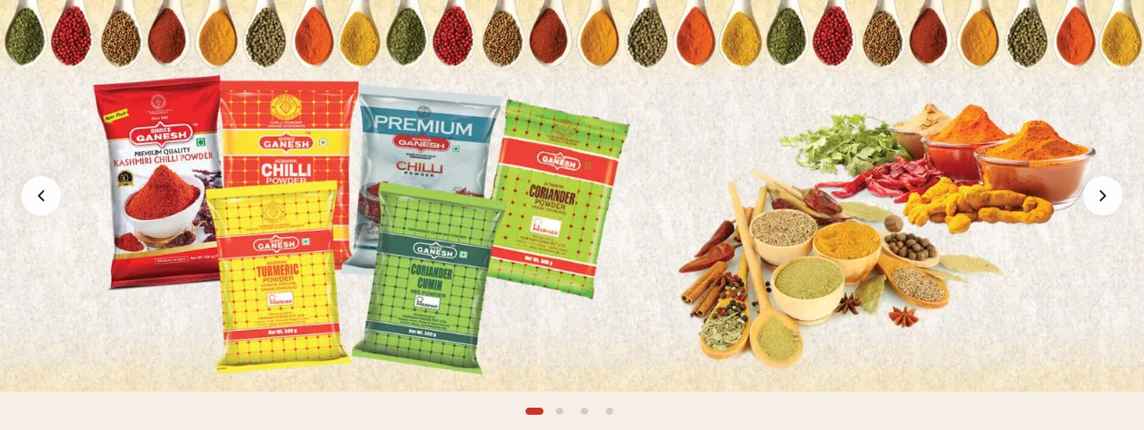
# | Where | Current text | Your new text (leave empty to keep)
H1 | Banner pictures  up to about 120 characters | 4 pictures: Spices · Pickles · Snacks · Sweets

2. Benefits strip
# | Where | Current text | Your new text (leave empty to keep)
H2 | Benefit 1, title  up to about 40 characters | Fast, Free Local Delivery
H3 | Benefit 1, text  up to about 60 characters | On all orders over $500.
H4 | Benefit 2, title  up to about 30 characters | Top Quality Products
H5 | Benefit 2, text  up to about 60 characters | Hand-selected, customer approved.
H6 | Benefit 3, title  up to about 30 characters | Unbeatable Prices
H7 | Benefit 3, text  up to about 60 characters | Wholesale pricing for everyone.

3. Welcome
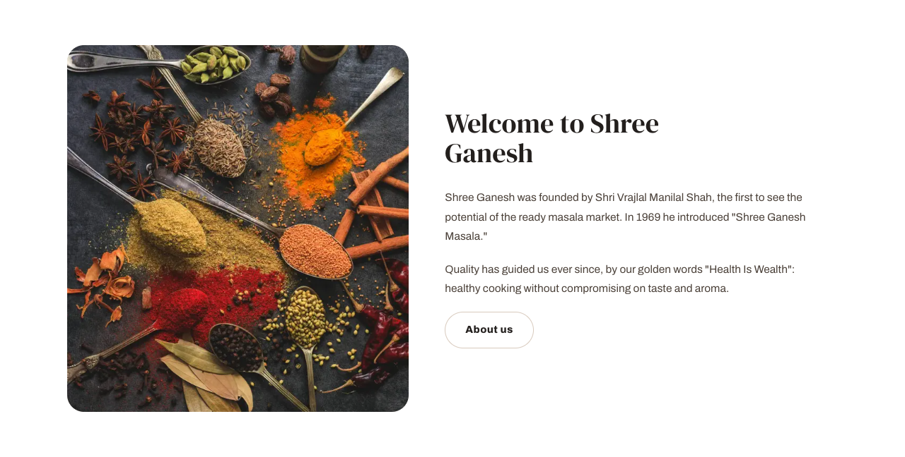
# | Where | Current text | Your new text (leave empty to keep)
H8 | Heading  up to about 40 characters | Welcome to Shree Ganesh
H9 | Paragraph 1  up to about 220 characters | Shree Ganesh was founded by Shri Vrajlal Manilal Shah, the first to see the potential of the ready masala market. In 1969 he introduced "Shree Ganesh Masala."
H10 | Paragraph 2  up to about 180 characters | Quality has guided us ever since, by our golden words "Health Is Wealth": healthy cooking without compromising on taste and aroma.
H11 | Button  up to about 25 characters | About us

4. What We Do
Also shown on the About page.
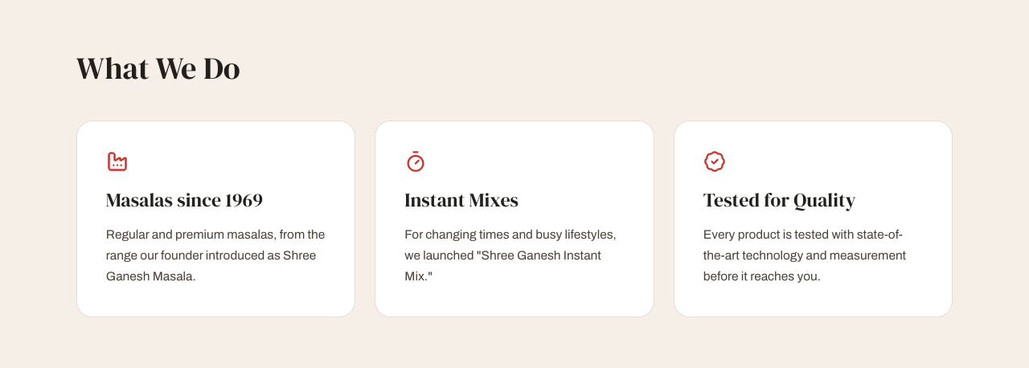
# | Where | Current text | Your new text (leave empty to keep)
H12 | Heading  up to about 30 characters | What We Do
H13 | Box 1, title  up to about 30 characters | Masalas since 1969
H14 | Box 1, text  up to about 130 characters | Regular and premium masalas, from the range our founder introduced as Shree Ganesh Masala.
H15 | Box 2, title  up to about 30 characters | Instant Mixes
H16 | Box 2, text  up to about 120 characters | For changing times and busy lifestyles, we launched "Shree Ganesh Instant Mix."
H17 | Box 3, title  up to about 30 characters | Tested for Quality
H18 | Box 3, text  up to about 130 characters | Every product is tested with state-of-the-art technology and measurement before it reaches you.

5. Our Products
Product names and photos come from your product list, not from this page. To change which products appear in a row, tell us the product names in the row's "Your new text" box.
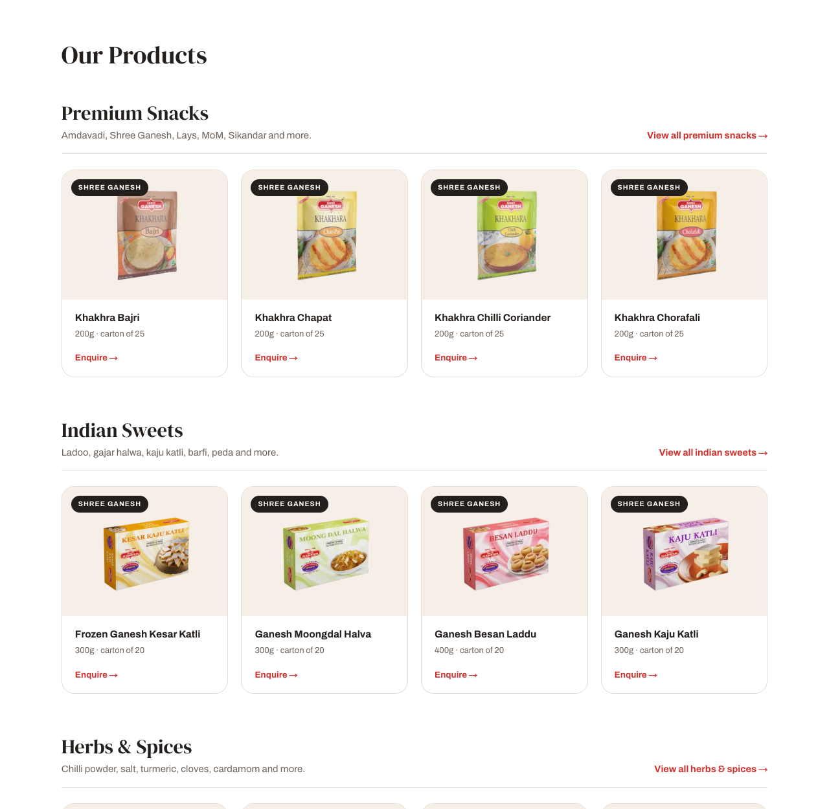
# | Where | Current text | Your new text (leave empty to keep)
H19 | Heading  up to about 30 characters | Our Products
H20 | Row 1, title  up to about 30 characters | Premium Snacks
H21 | Row 1, text  up to about 80 characters | Amdavadi, Shree Ganesh, Lays, MoM, Sikandar and more.
H22 | Row 2, title  up to about 30 characters | Indian Sweets
H23 | Row 2, text  up to about 80 characters | Ladoo, gajar halwa, kaju katli, barfi, peda and more.
H24 | Row 3, title  up to about 30 characters | Herbs & Spices
H25 | Row 3, text  up to about 90 characters | Chilli powder, salt, turmeric, cloves, cardamom and more.
H26 | Row 4, title  up to about 30 characters | Authentic Pickles
H27 | Row 4, text  up to about 100 characters | Mango pickle, chilli pickle, aamla pickle, garlic pickle and more.
H28 | Row 5, title  up to about 30 characters | Instant Mixes
H29 | Row 5, text  up to about 90 characters | Dosa mix, gulab jamun mix, dhokla mix, juice mix and more.

6. Departments, Brands and Why Choose Us
Department names come from your product list. Why Choose Us is also shown on the About page.
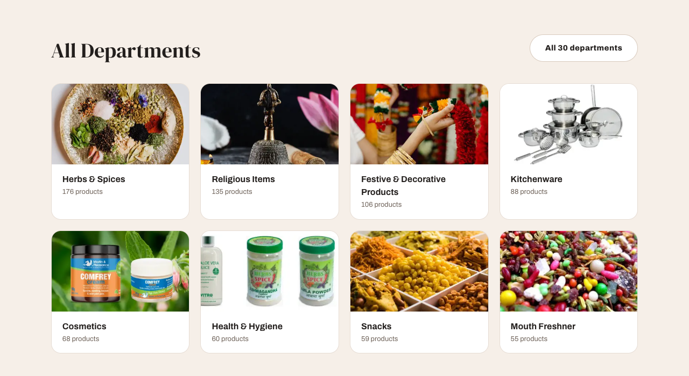
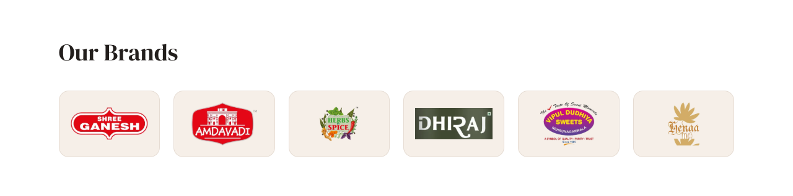
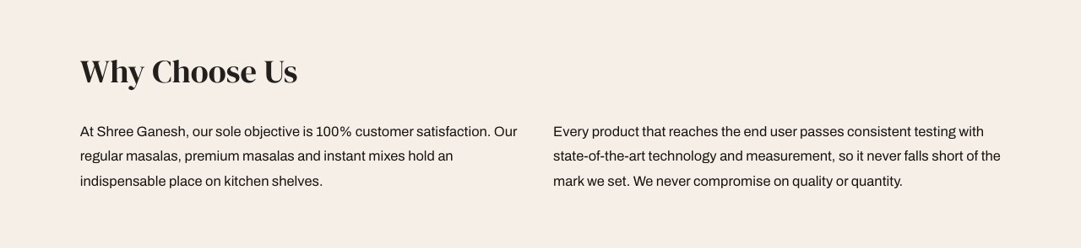
# | Where | Current text | Your new text (leave empty to keep)
H30 | Departments heading  up to about 30 characters | All Departments
H31 | Brands heading  up to about 30 characters | Our Brands
H32 | Why Choose Us heading  up to about 30 characters | Why Choose Us
H33 | Why Choose Us, paragraph 1  up to about 230 characters | At Shree Ganesh, our sole objective is 100% customer satisfaction. Our regular masalas, premium masalas and instant mixes hold an indispensable place on kitchen shelves.
H34 | Why Choose Us, paragraph 2  up to about 280 characters | Every product that reaches the end user passes consistent testing with state-of-the-art technology and measurement, so it never falls short of the mark we set. We never compromise on quality or quantity.

7. Certifications and Contact Us
Both also appear on the About page. Phone, email, address and hours are in Business details above.

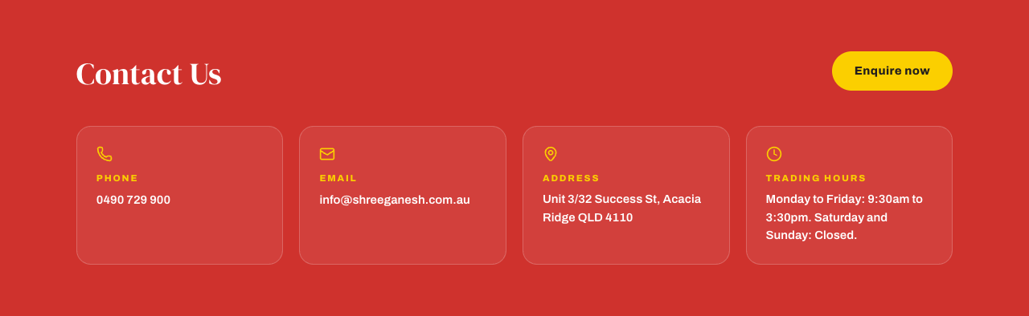
# | Where | Current text | Your new text (leave empty to keep)
H35 | Certifications heading  up to about 30 characters | Certifications
H36 | Badge 1 caption  up to about 30 characters | Owned & operated
H37 | Badge 2 caption  up to about 40 characters | Australian Owned certified
H38 | Badge 3 caption  up to about 30 characters | HACCP certified
H39 | Contact heading  up to about 30 characters | Contact Us

About page

Your story

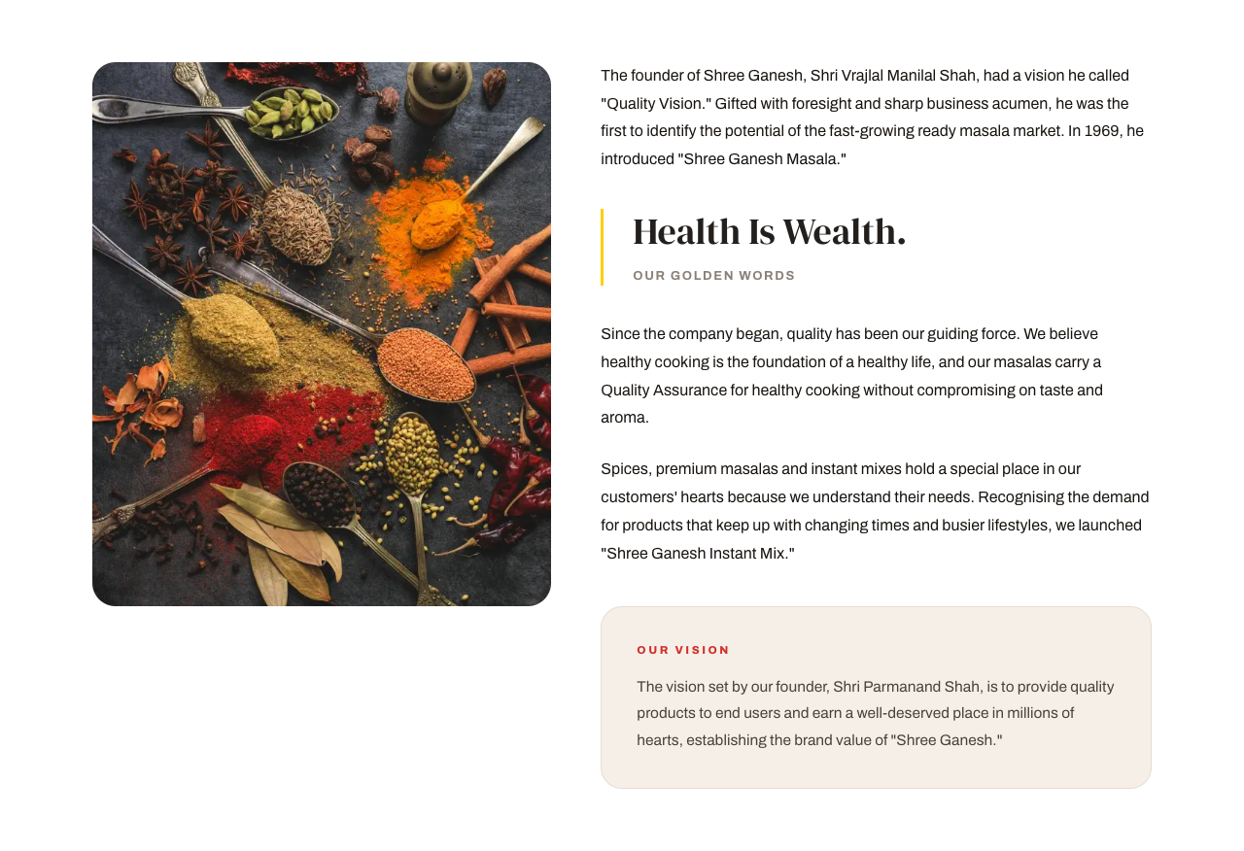
# | Where | Current text | Your new text (leave empty to keep)
A1 | Small label above title  up to about 25 characters | About us
A2 | Page title  up to about 40 characters | Welcome to Shree Ganesh
A3 | Paragraph 1  up to about 380 characters | The founder of Shree Ganesh, Shri Vrajlal Manilal Shah, had a vision he called "Quality Vision." Gifted with foresight and sharp business acumen, he was the first to identify the potential of the fast-growing ready masala market. In 1969, he introduced "Shree Ganesh Masala."
A4 | Quote  up to about 30 characters | Health Is Wealth.
A5 | Under the quote  up to about 30 characters | Our golden words
A6 | Paragraph 2  up to about 310 characters | Since the company began, quality has been our guiding force. We believe healthy cooking is the foundation of a healthy life, and our masalas carry a Quality Assurance for healthy cooking without compromising on taste and aroma.
A7 | Paragraph 3  up to about 350 characters | Spices, premium masalas and instant mixes hold a special place in our customers' hearts because we understand their needs. Recognising the demand for products that keep up with changing times and busier lifestyles, we launched "Shree Ganesh Instant Mix."
A8 | Vision box, label  up to about 25 characters | Our Vision
A9 | Vision box, text  up to about 270 characters | The vision set by our founder, Shri Parmanand Shah, is to provide quality products to end users and earn a well-deserved place in millions of hearts, establishing the brand value of "Shree Ganesh."

Products page

Products page
The numbers (departments, products) update by themselves.


# | Where | Current text | Your new text (leave empty to keep)
P1 | Page title  up to about 30 characters | Our Products
P2 | Text under title  up to about 120 characters | Our brands and more, across 30 departments. Wholesale pricing for everyone.
P3 | Red box, heading  up to about 50 characters | Wholesale pricing for everyone
P4 | Red box, text  up to about 80 characters | Fast, free local delivery on all orders over $500.

Brand descriptions
Shown on the brand cards on the Products page.
# | Where | Current text | Your new text (leave empty to keep)
P5 | Shree Ganesh  up to about 90 characters | Masalas, spices, pickles, instant mixes, khakhra and sweets.
P6 | Amdavadi  up to about 60 characters | Farsan, chevda, gathia, sev and mukhvas.
P7 | Herbs & Spices  up to about 110 characters | Herbal powders: amla, ashwagandha, neem, shikakai, triphala and more.
P8 | Dhiraj  up to about 110 characters | Cookies: cashew, chocolate, coconut, Surti jeera butter and nankhati.
P9 | Vipul Dudhiya  up to about 100 characters | Frozen sweets: kaju katli, gajar halva, ghari, milk cake and more.
P10 | Henaa  up to about 60 characters | Incense sticks and basmati rice.

Each product's page
The same wording is used on every product page. Product names and descriptions come from your product list.
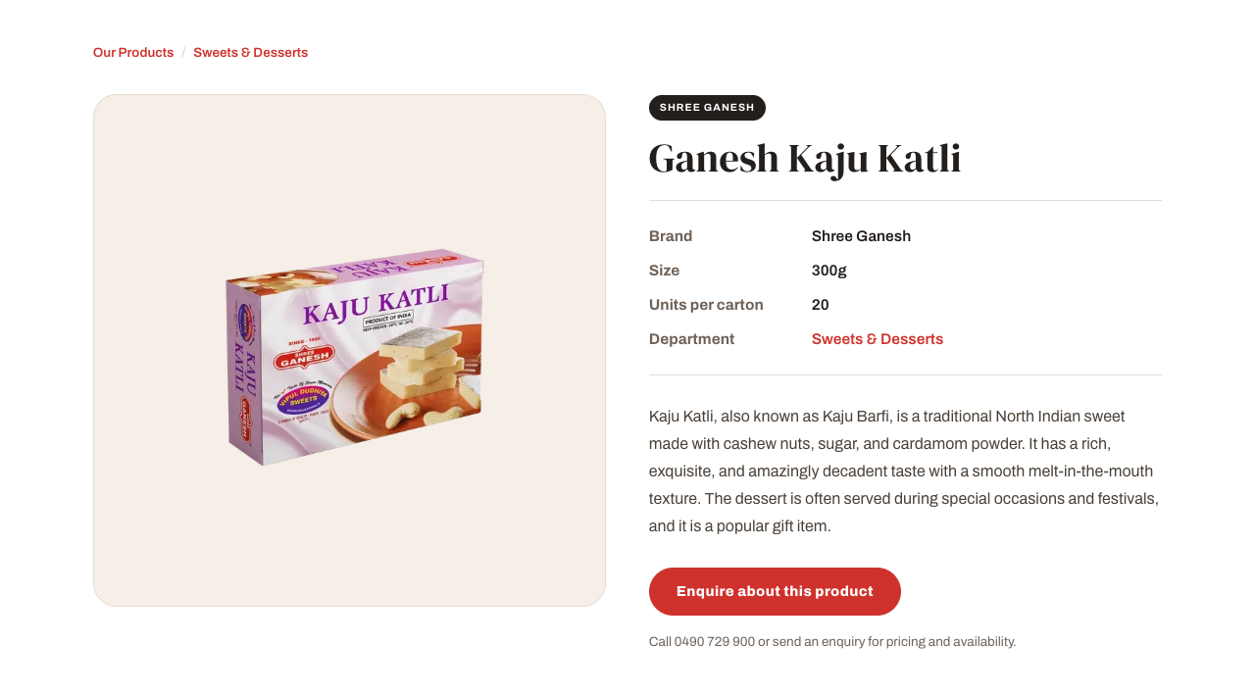
# | Where | Current text | Your new text (leave empty to keep)
P11 | Button  up to about 40 characters | Enquire about this product
P12 | Text under button  up to about 100 characters | Call 0490 729 900 or send an enquiry for pricing and availability.

Departments page

Departments page
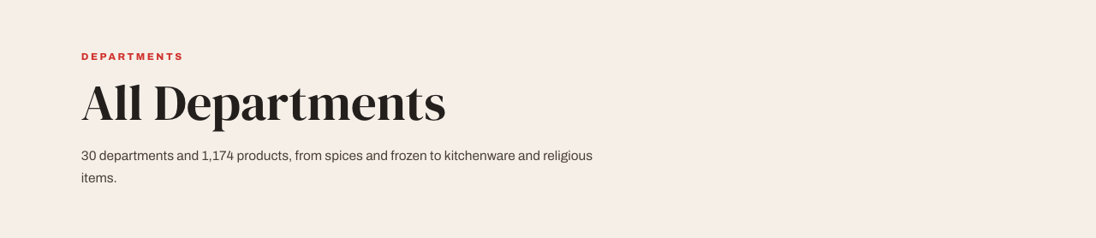

# | Where | Current text | Your new text (leave empty to keep)
D1 | Page title  up to about 30 characters | All Departments
D2 | Text under title  up to about 140 characters | 30 departments and 1,174 products, from spices and frozen to kitchenware and religious items.
D3 | Newsletter heading  up to about 30 characters | Newsletter
D4 | Newsletter text  up to about 90 characters | Subscribe to hear about new products. Unsubscribe any time.

Contact page

Contact page

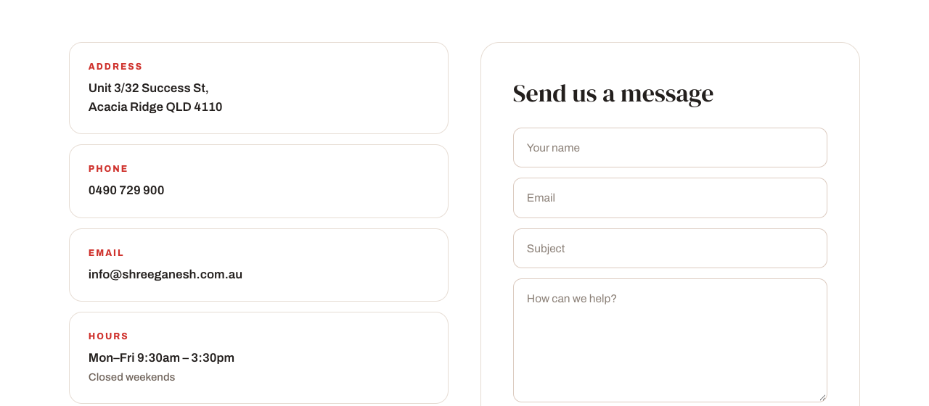
# | Where | Current text | Your new text (leave empty to keep)
C1 | Page title  up to about 30 characters | Customer Support
C2 | Text under title  up to about 60 characters | Call, email or send us a message.
C3 | Form heading  up to about 30 characters | Send us a message
C4 | After sending, heading  up to about 30 characters | Message sent
C5 | After sending, text  up to about 60 characters | Thanks, we'll get back to you soon.

Footer and Google

Footer
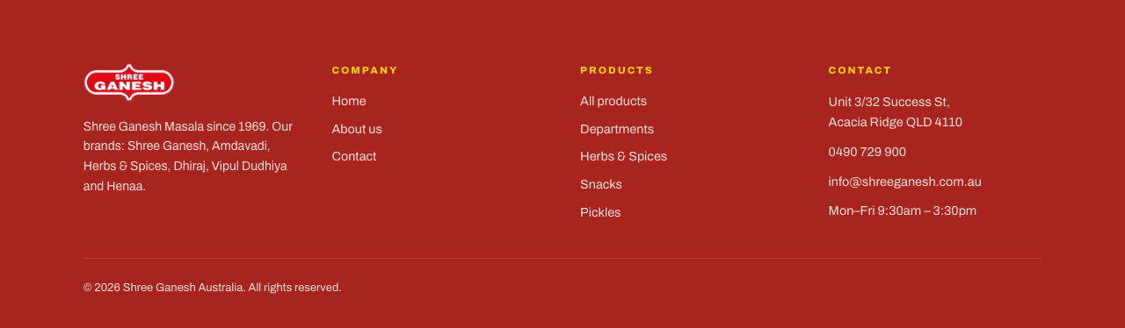
# | Where | Current text | Your new text (leave empty to keep)
F1 | Footer text  up to about 160 characters | Shree Ganesh Masala since 1969. Our brands: Shree Ganesh, Amdavadi, Herbs & Spices, Dhiraj, Vipul Dudhiya and Henaa.
F2 | Copyright line  up to about 80 characters | © 2026 Shree Ganesh Australia. All rights reserved.

Google search description
Not shown on the page. Google may show it under your website's name in search results.
# | Where | Current text | Your new text (leave empty to keep)
G1 | Search description  up to about 250 characters | Shree Ganesh: masalas, spices, pickles, sweets and instant mixes since 1969. Wholesale pricing for everyone, with fast, free local delivery on orders over $500. Acacia Ridge, Brisbane.

