1. Given an array of strings words, return the first palindromic string in the array. If there is

no such string, return an empty string "". A string is palindromic if it reads the same

forward and backward.

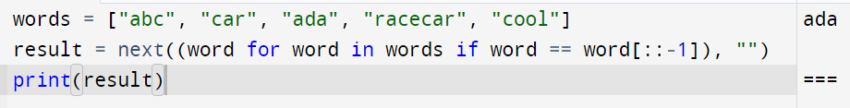

2. You are given two integer arrays nums1 and nums2 of sizes n and m, respectively.

Calculate the following values: answer1 : the number of indices i such that nums1[i]

exists in nums2. answer2 : the number of indices i such that nums2[i] exists in nums1

Return [answer1,answer2].

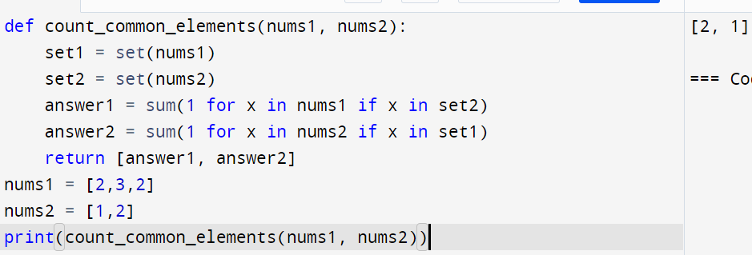

3. You are given a 0-indexed integer array nums. The distinct count of a subarray of nums is

defined as: Let nums[i..j] be a subarray of nums consisting of all the indices from i to j

such that 0 <= i <= j < nums.length. Then the number of distinct values in nums[i..j] is

called the distinct count of nums[i..j]. Return the sum of the squares of distinct counts of

all subarrays of nums. A subarray is a contiguous non-empty sequence of elements within

an array.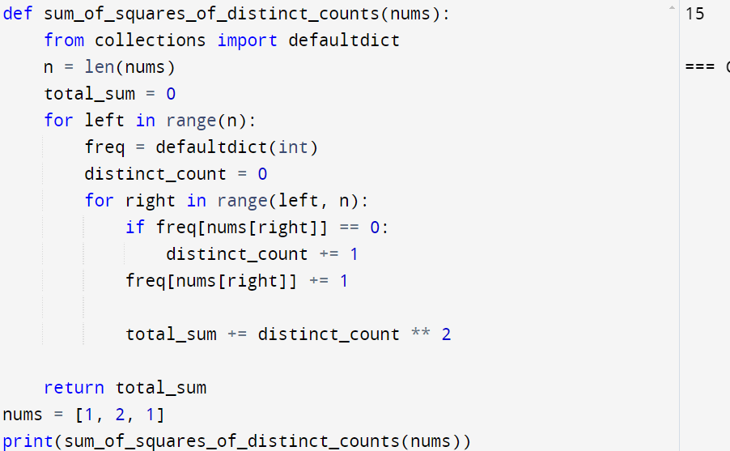

4. Given a 0-indexed integer array nums of length n and an integer k, return the number of

pairs (i, j) where 0 <= i < j < n, such that nums[i] == nums[j] and (i \* j) is divisible by k.

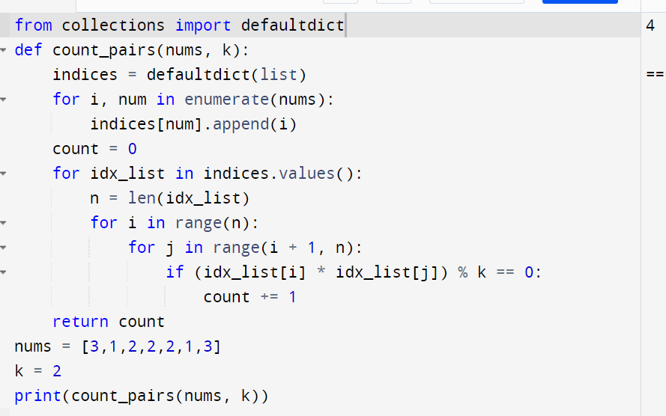

5. Write a program FOR THE BELOW TEST CASES with least time complexity



6. You have an algorithm that process a list of numbers. It firsts sorts the list using an

efficient sorting algorithm and then finds the maximum element in sorted list. Write the

code for the same.

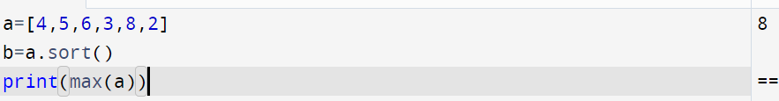

7. Write a program that takes an input list of n numbers and creates a new list containing

only the unique elements from the original list. What is the space complexity of the

algorithm?

