1. Given an m x n grid and a ball at a starting cell, find the number of ways to move the ball

out of the grid boundary in exactly N steps.

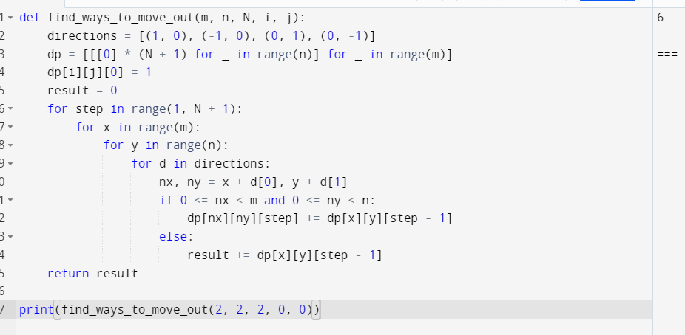

2. You are a professional robber planning to rob houses along a street. Each house has a

certain amount of money stashed. All houses at this place are arranged in a circle. That

means the first house is the neighbor of the last one. Meanwhile, adjacent houses have

security systems connected, and it will automatically contact the police if two adjacent

houses were broken into on the same night.

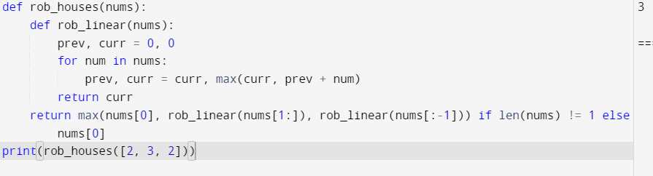

3. You are climbing a staircase. It takes n steps to reach the top. Each time you can either

climb 1 or 2 steps. In how many distinct ways can you climb to the top?

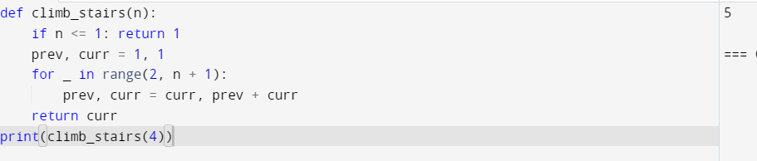

4. A robot is located at the top-left corner of a m×n grid .The robot can only move either

down or right at any point in time. The robot is trying to reach the bottom-right corner of

the grid. How many possible unique paths are there?

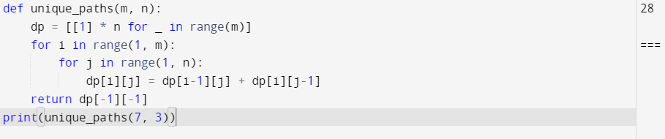

5. In a string S of lowercase letters, these letters form consecutive groups of the same

character. For example, a string like s = "abbxxxxzyy" has the groups "a", "bb", "xxxx",

"z", and "yy". A group is identified by an interval [start, end], where start and end denote

the start and end indices (inclusive) of the group. In the above example, "xxxx" has the

interval [3,6]. A group is considered large if it has 3 or more characters. Return the

intervals of every large group sorted in increasing order by start index.

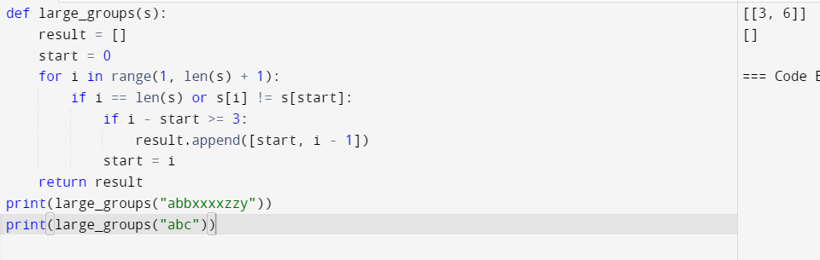

6. "The Game of Life, also known simply as Life, is a cellular automaton devised by the

British mathematician John Horton Conway in 1970." The board is made up of an m x n

grid of cells, where each cell has an initial state: live (represented by a 1) or dead

(represented by a 0). Each cell interacts with its eight neighbors (horizontal, vertical,

diagonal) using the following four rules

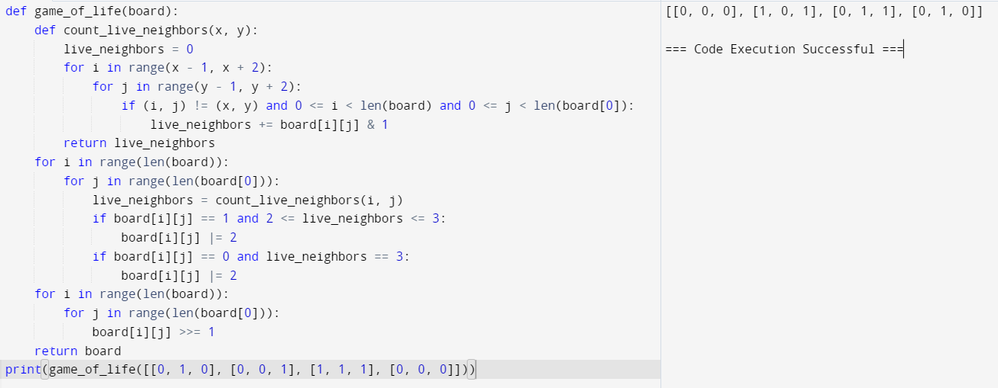

7. We stack glasses in a pyramid, where the first row has 1 glass, the second row has 2

glasses, and so on until the 100th row. Each glass holds one cup of champagne. Then,

some champagne is poured into the first glass at the top. When the topmost glass is full,

any excess liquid poured will fall equally to the glass immediately to the left and right of

it. When those glasses become full, any excess champagne will fall equally to the left

and right of those glasses, and so on. (A glass at the bottom row has its excess

champagne fall on the floor.) For example, after one cup of champagne is poured, the top

most glass is full. After two cups of champagne are poured, the two glasses on the

second row are half full. After three cups of champagne are poured, those two cups

become full - there are 3 full glasses total now. After four cups of champagne are

poured, the third row has the middle glass half full, and the two outside glasses are a

quarter full, as pictured below.