1. Write a Program to find both the maximum and minimum values in the array. Implement

using any programming language of your choice. Execute your code and provide the

maximum and minimum values found.

Input : N= 8, a[] = {5,7,3,4,9,12,6,2}

Output : Min = 2, Max = 12

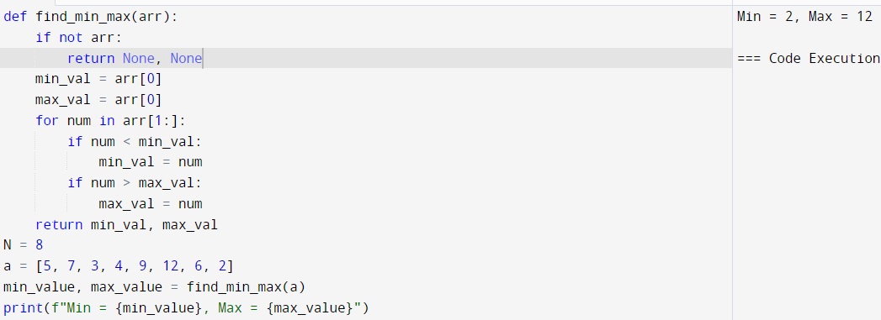  
2. Consider an array of integers sorted in ascending order: 2,4,6,8,10,12,14,18. Write a

Program to find both the maximum and minimum values in the array. Implement using

any programming language of your choice. Execute your code and provide the maximum

and minimum values found.

Input : N=8, 2,4,6,8,10,12,14,18.

Output : Min = 2, Max =18

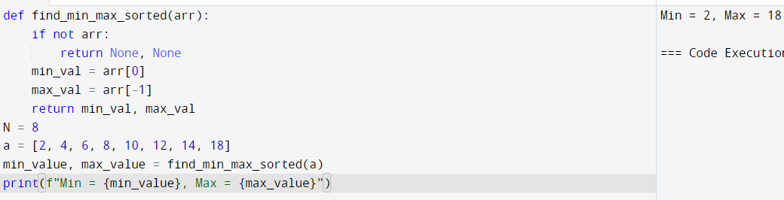

3. You are given an unsorted array 31,23,35,27,11,21,15,28. Write a program for Merge Sort

and implement using any programming language of your choice.

Test Cases :

Input : N= 8, a[] = {31,23,35,27,11,21,15,28}

Output : 11,15,21,23,27,28,31,35

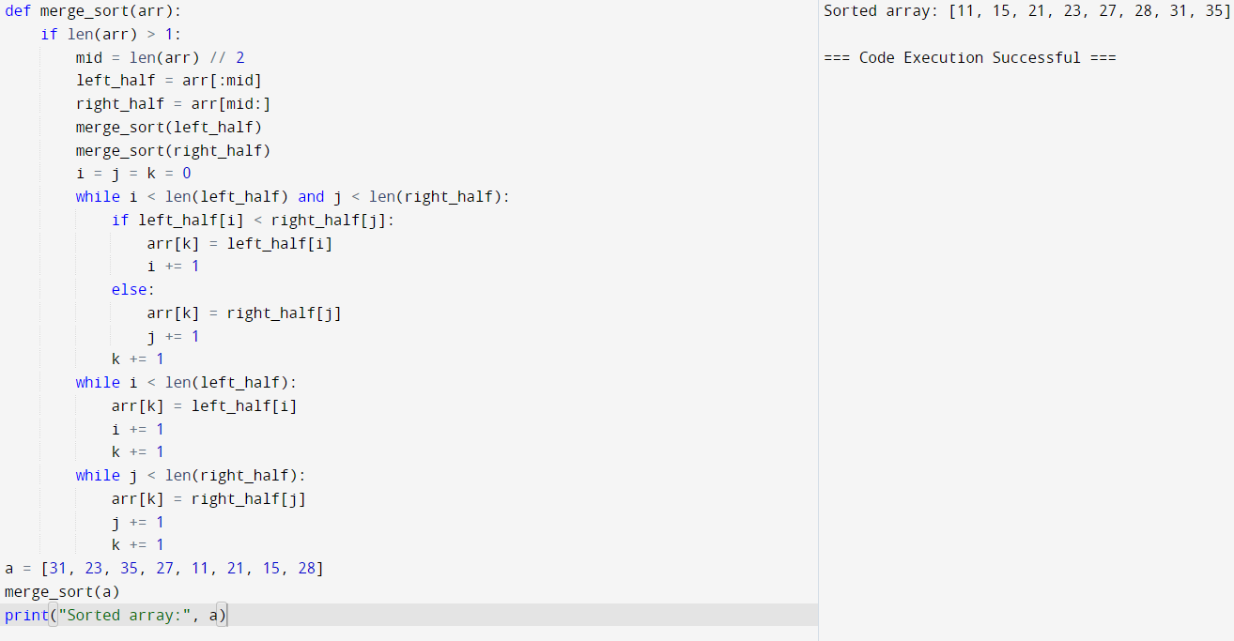

4. Implement the Merge Sort algorithm in a programming language of your choice and test it

on the array 12,4,78,23,45,67,89,1. Modify your implementation to count the number of

comparisons made during the sorting process. Print this count along with the sorted array.

Test Cases :

Input : N= 8, a[] = {12,4,78,23,45,67,89,1}

Output : 1,4,12,23,45,67,78,89

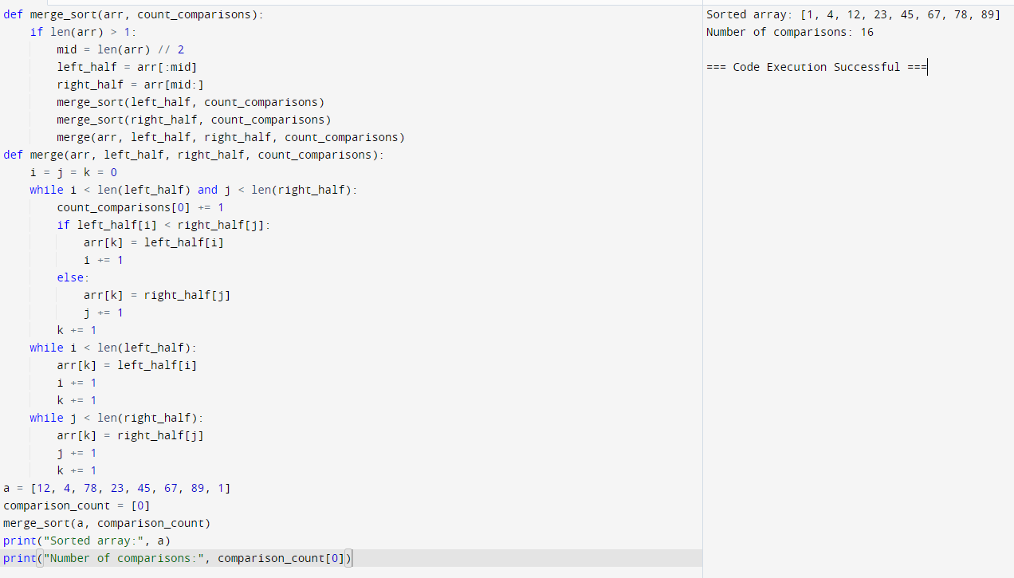

5. Given an unsorted array 10,16,8,12,15,6,3,9,5 Write a program to perform Quick Sort.

Choose the first element as the pivot and partition the array accordingly. Show the array

after this partition. Recursively apply Quick Sort on the sub-arrays formed. Display the

array after each recursive call until the entire array is sorted.

Input : N= 9, a[]= {10,16,8,12,15,6,3,9,5}

Output : 3,5,6,8,9,10,12,15,16

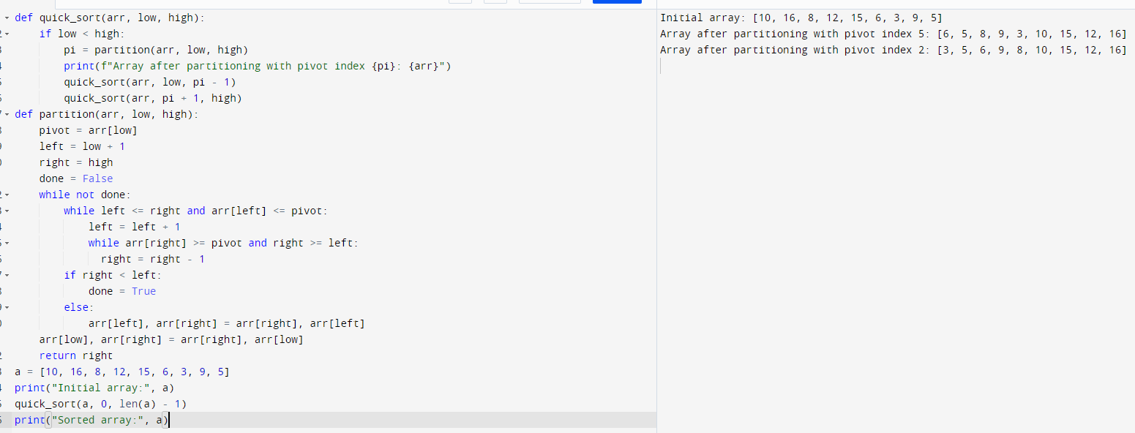

6. Implement the Quick Sort algorithm in a programming language of your choice and test it

on the array 19,72,35,46,58,91,22,31. Choose the middle element as the pivot and partition

the array accordingly. Show the array after this partition. Recursively apply Quick Sort on

the sub-arrays formed. Display the array after each recursive call until the entire array is

sorted. Execute your code and show the sorted array.

Input : N= 8, a[] = {19,72,35,46,58,91,22,31}

Output : 19,22,31,35,46,58,72,91

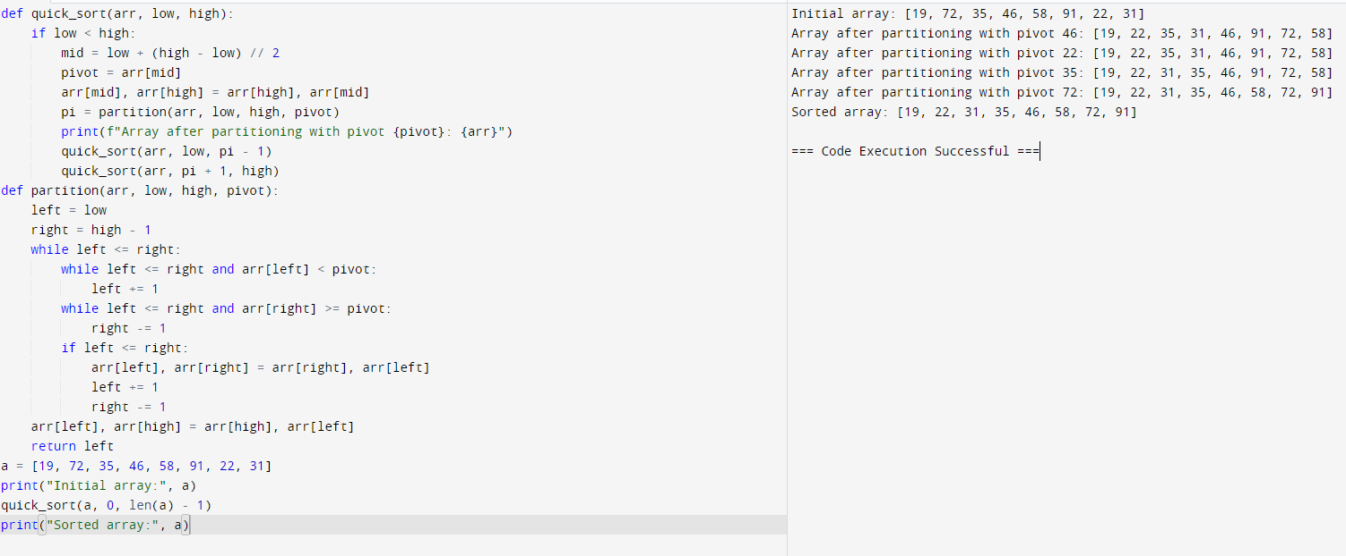

7. Implement the Binary Search algorithm in a programming language of your choice and test

it on the array 5,10,15,20,25,30,35,40,45 to find the position of the element 20. Execute

your code and provide the index of the element 20. Modify your implementation to count

the number of comparisons made during the search process. Print this count along with the

result.

Input : N= 9, a[] = {5,10,15,20,25,30,35,40,45}, search key = 20

Output : 4

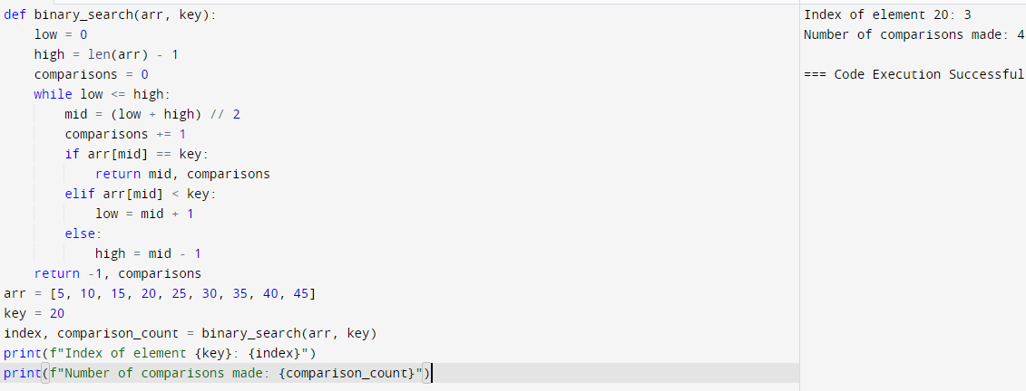

8. You are given a sorted array 3,9,14,19,25,31,42,47,53 and asked to find the position of the

element 31 using Binary Search. Show the mid-point calculations and the steps involved in

finding the element. Display, what would happen if the array was not sorted, how would

this impact the performance and correctness of the Binary Search algorithm?

Input : N= 9, a[] = {3,9,14,19,25,31,42,47,53}, search key = 31

Output : 6

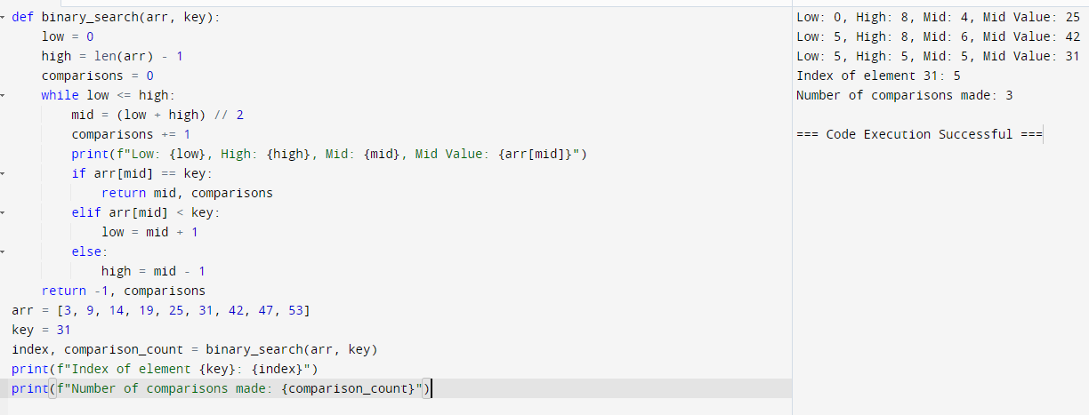

9. Given an array of points where points[i] = [xi, yi] represents a point on the X-Y plane and

an integer k, return the k closest points to the origin (0, 0).

(i) Input : points = [[1,3],[-2,2],[5,8],[0,1]],k=2

Output:[[-2, 2], [0, 1]]

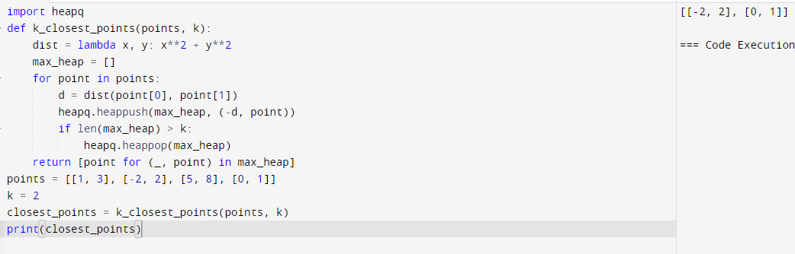

10. Given four lists A, B, C, D of integer values,Write a program to compute how many tuples

n(i, j, k, l) there are such that A[i] + B[j] + C[k] + D[l] is zero.

(i) Input: A = [1, 2], B = [-2, -1], C = [-1, 2], D = [0, 2]

Output: 2

