1. Implement Floyd's Algorithm to find the shortest path between all pairs of cities. Display

the distance matrix before and after applying the algorithm. Identify and print the shortest

path

Input: n = 4, edges = [[0,1,3],[1,2,1],[1,3,4],[2,3,1]], distanceThreshold = 4

Output: 3

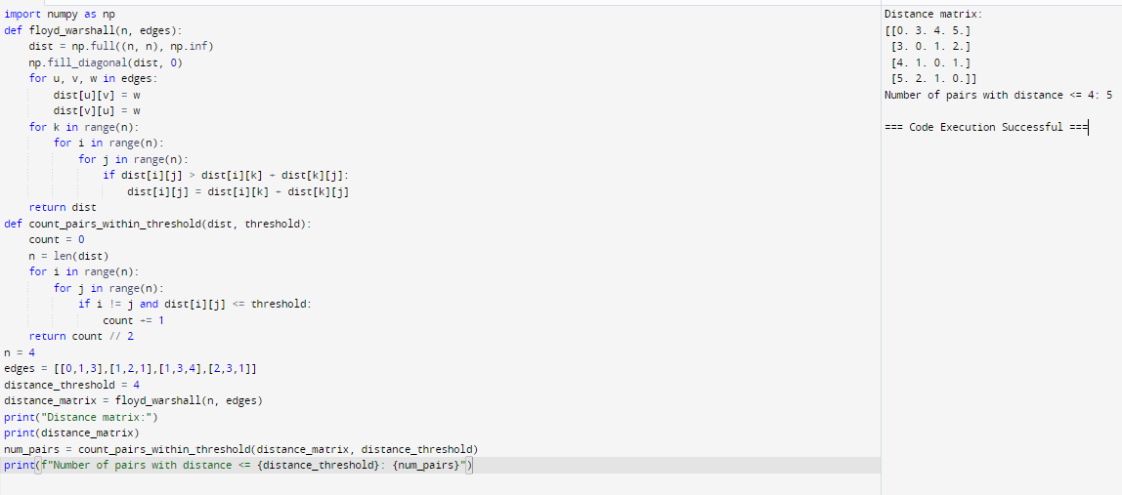

2. Write a Program to implement Floyd's Algorithm to calculate the shortest paths between all

pairs of routers. Simulate a change where the link between Router B and Router D fails.

Update the distance matrix accordingly. Display the shortest path from Router A to Router

F before and after the link failure.

Input as above

Output : Router A to Router F = 5

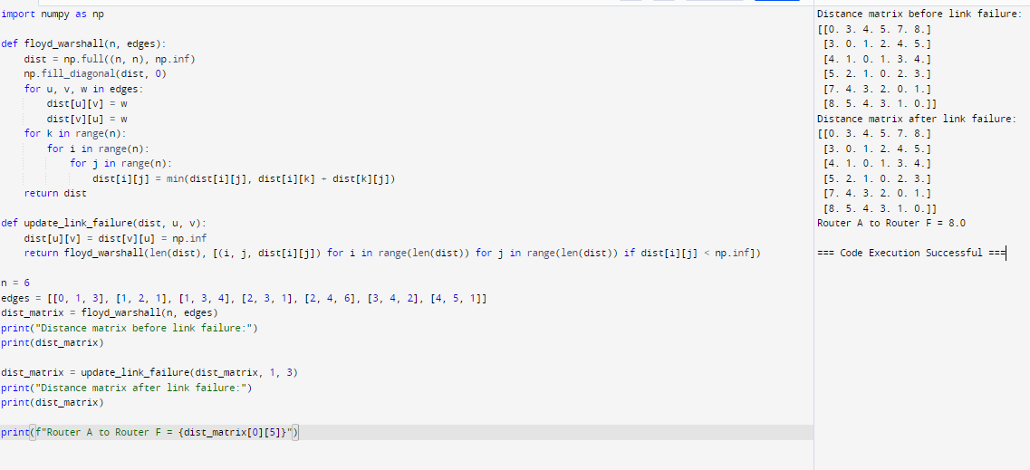

3. Implement Floyd's Algorithm to find the shortest path between all pairs of cities. Display

the distance matrix before and after applying the algorithm. Identify and print the shortest

path

Input: n = 5, edges = [[0,1,2],[0,4,8],[1,2,3],[1,4,2],[2,3,1],[3,4,1]], distanceThreshold = 2

Output: 0

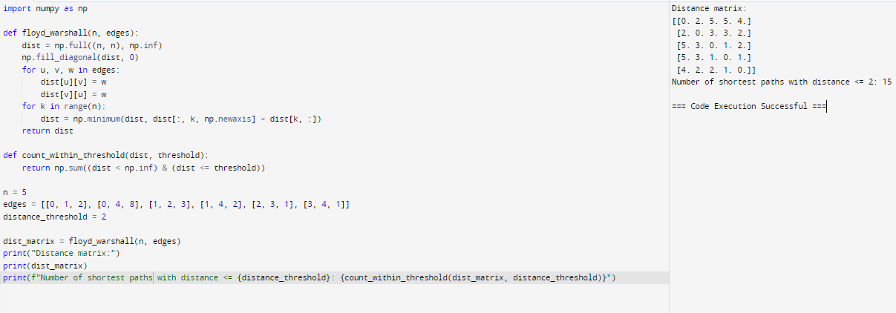

4. Implement the Optimal Binary Search Tree algorithm for the keys A,B,C,D with

frequencies 0.1,0.2,0.4,0.3 Write the code using any programming language to construct

the OBST for the given keys and frequencies. Execute your code and display the resulting

OBST and its cost. Print the cost and root matrix.

Input N =4, Keys = {A,B,C,D} Frequencies = {01.02.,0.3,0.4}

Output : 1.7

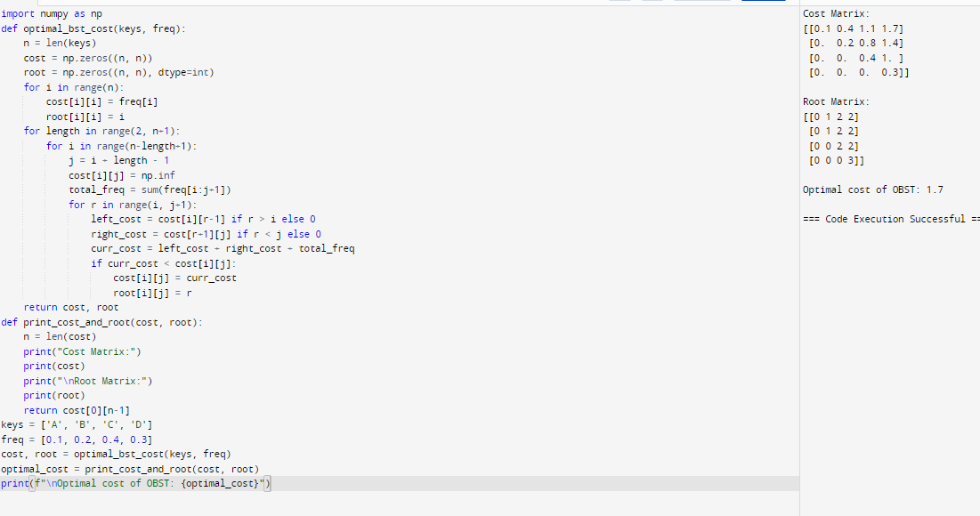

5. Consider a set of keys 10,12,16,21 with frequencies 4,2,6,3 and the respective

probabilities. Write a Program to construct an OBST in a programming language of your

choice. Execute your code and display the resulting OBST, its cost and root matrix.

Input N =4, Keys = {10,12,16,21} Frequencies = {4,2,6,3}

Output : 26

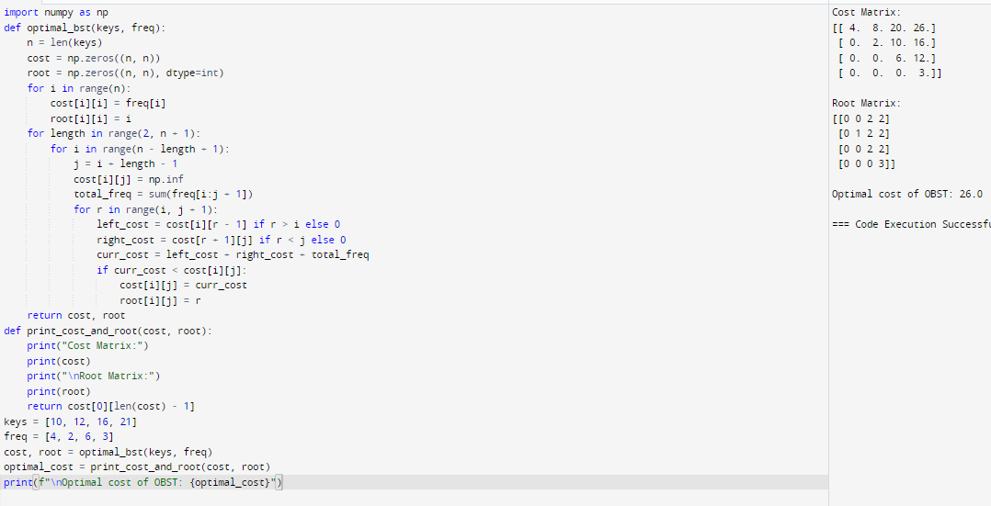

6. A game on an undirected graph is played by two players, Mouse and Cat, who alternate

turns. The graph is given as follows: graph[a] is a list of all nodes b such that ab is an edge

of the graph. The mouse starts at node 1 and goes first, the cat starts at node 2 and goes

second, and there is a hole at node 0. During each player's turn, they must travel along one

edge of the graph that meets where they are. For example, if the Mouse is at node 1, it

must travel to any node in graph[1]. Additionally, it is not allowed for the Cat to travel to

the Hole (node 0).Then, the game can end in three ways:

If ever the Cat occupies the same node as the Mouse, the Cat wins.

If ever the Mouse reaches the Hole, the Mouse wins.

If ever a position is repeated (i.e., the players are in the same position as a previous

turn, and it is the same player's turn to move), the game is a draw.

Given a graph, and assuming both players play optimally, return

1 if the mouse wins the game,

2 if the cat wins the game, or

0 if the game is a draw.

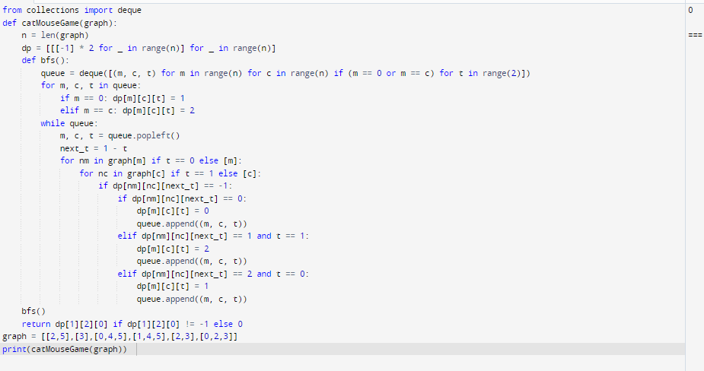

7. You are given an undirected weighted graph of n nodes (0-indexed), represented by an

edge list where edges[i] = [a, b] is an undirected edge connecting the nodes a and b with a

probability of success of traversing that edge succProb[i]. Given two nodes start and end,

find the path with the maximum probability of success to go from start to end and return its

success probability. If there is no path from start to end, return 0. Your answer will be

accepted if it differs from the correct answer by at most 1e-5.

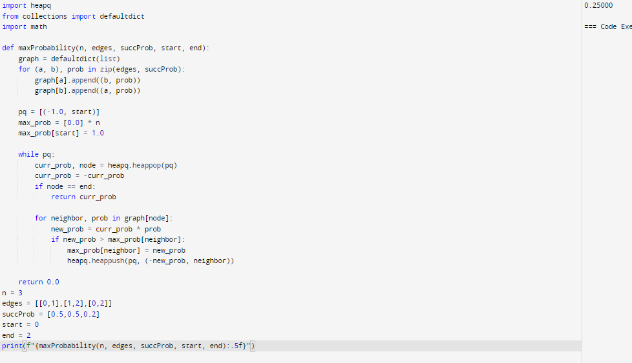

8. There is a robot on an m x n grid. The robot is initially located at the top-left corner (i.e.,

grid[0][0]). The robot tries to move to the bottom-right corner (i.e., grid[m - 1][n - 1]). The

robot can only move either down or right at any point in time. Given the two integers m

and n, return the number of possible unique paths that the robot can take to reach the

bottom-right corner. The test cases are generated so that the answer will be less than or

equal to 2 \* 10 9.

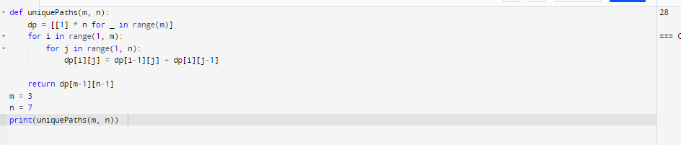

9. Given an array of integers nums, return the number of good pairs. A pair (i, j) is called

good if nums[i] == nums[j] and i < j.

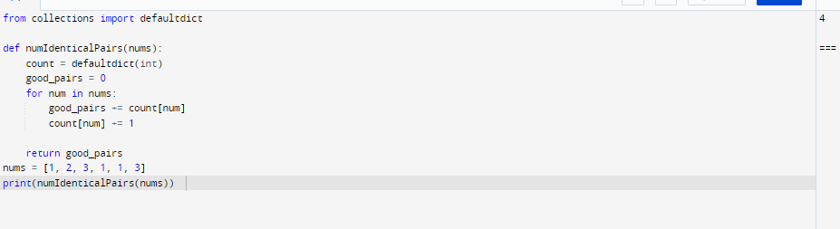

10. There are n cities numbered from 0 to n-1. Given the array edges where edges[i] = [fromi,

toi, weighti] represents a bidirectional and weighted edge between cities fromi and toi, and

given the integer distanceThreshold. Return the city with the smallest number of cities that

are reachable through some path and whose distance is at most distanceThreshold, If there

are multiple such cities, return the city with the greatest number. Notice that the distance of

a path connecting cities i and j is equal to the sum of the edges' weights along that path.

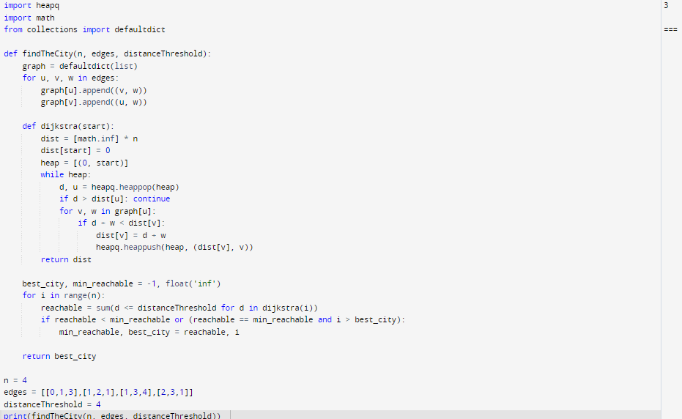

11. You are given a network of n nodes, labeled from 1 to n. You are also given times, a list of

travel times as directed edges times[i] = (ui, vi, wi), where ui is the source node, vi is the

target node, and wi is the time it takes for a signal to travel from source to target. We will

send a signal from a given node k. Return the minimum time it takes for all the n nodes to

receive the signal. If it is impossible for all the n nodes to receive the signal, return -1.

