Thesis Interim Report
Project: A PAM3 Simultaneous Bidirectional Transceiver for Die-to-Die Links
Supervisor: Prof. Ali Sheikholeslami
Student: Satvick Acharya (1007984512)

Table of Contents
List of Figures and Tables 3
Section 1: Introduction 4
Section 2: Literature Review 6
2.1 Chiplet Architectures 6
2.2 Die-to-Die Links vs. Long-Reach Interconnects 6
2.3 Key Performance Metrics 6
2.4 Signaling Schemes 7
2.5 Simultaneous Bidirectional Signaling 8
2.6 Equalization 10
2.7 PAM3 Transceiver Architectures 11
Section 3: Progress 13
Literature Review (August) 13
Preliminary Simulation and Validation (September) 13
High-Fidelity Cadence Modeling (October – November) 14
Extension to PAM3 Signaling (December – January) 15
Section 4: Future Work 17
References 18
Appendices 20

TODO: fancy page numbers

List of Figures and Tables
TODO

Section 1: Introduction
As manufacturing costs for large monolithic integrated circuits have increased at advanced technology nodes and as aggressively scaled transistors increasingly suffer from reliability challenges such as electromigration, device aging, and quantum-mechanical effects, heterogeneous integration has emerged as a practical and scalable alternative [1–5]. In this paradigm, complex systems are decomposed into smaller chiplets, with only the most performance-critical functions implemented in advanced logic processes and subsequently integrated within a system-in-package. This approach improves manufacturing yield, reduces cost, and enables greater architectural flexibility. For compute-intensive workloads such as artificial intelligence, high-performance computing, and high-speed networking, chiplet-based systems demand extremely high-bandwidth and power-efficient die-to-die (D2D) interconnects to maintain overall system scalability [6].
Conventional non-return-to-zero (NRZ) signaling is widely adopted due to its simplicity and robust noise margins. However, at high data rates, limited channel bandwidth necessitates aggressive equalization and wideband analog circuitry, leading to poor energy efficiency. To improve spectral efficiency, multi-level modulation schemes have been explored. Pulse-amplitude modulation with four levels (PAM4) transmits two bits per symbol, doubling bandwidth efficiency relative to NRZ. This improvement comes at the cost of a 9.5 dB signal-to-noise ratio (SNR) penalty for a fixed voltage swing, which results in a substantial reduction in noise margin as well as stringent linearity requirements in both the transmitter and receiver, reducing robustness under noise, jitter, and process variation [7].
An alternative approach to increasing throughput without increasing modulation order is simultaneous bidirectional (SBD) signaling, in which data is transmitted concurrently in opposite directions over a single-ended channel [8–11]. Hybrid circuits at each transceiver suppress reflections of the locally transmitted signal while isolating the incoming signal from the far end, effectively doubling pin efficiency. Existing SBD implementations predominantly employ NRZ signaling and therefore inherit the fundamental spectral efficiency limitations of binary modulation.
This thesis addresses the following research question: Can a PAM3-based simultaneous bidirectional die-to-die transceiver outperform NRZ SBD in throughput and energy efficiency while avoiding the noise-margin and linearity penalties associated with PAM4?
To address this question, this work proposes combining pulse-amplitude modulation with three levels (PAM3) and simultaneous bidirectional transmission. PAM3 provides a 50% increase in data rate relative to NRZ while maintaining substantially larger noise margins than PAM4, positioning it as a promising compromise between spectral efficiency, circuit complexity, and robustness [12]. While PAM3 has been explored in unidirectional short-reach links, its integration into a simultaneous bidirectional architecture introduces new challenges in echo cancellation, level detection, and hybrid design that have not been systematically studied for D2D interconnects.
The primary objectives of this research are:
- To develop a system-level model of PAM3 simultaneous bidirectional signaling for representative D2D channels.
- To quantitatively compare the performance of NRZ, PAM3, and PAM4 signaling (both unidirectional and bidirectional) in terms of bit-error rate (BER), noise margin, spectral efficiency, and sensitivity to jitter and channel impairments.
- To design and evaluate circuit-level building blocks, including transmitter drivers, receiver front ends, hybrid and echo-cancellation circuits, and multi-level detection schemes, suitable for PAM3 SBD operation.
System-level modeling will be conducted using MATLAB and Python to evaluate BER performance, eye diagrams, and spectral characteristics under realistic noise and jitter conditions. Circuit-level design and simulation will be carried out in Cadence Virtuoso and LTspice to assess feasibility, complexity, and robustness. Hybrid-based echo cancellation is specifically investigated due to its demonstrated effectiveness in NRZ SBD systems and its potential extensibility to multi-level signaling with manageable additional complexity.
This work is expected to contribute: (1) a novel PAM3 simultaneous bidirectional transceiver architecture tailored for die-to-die interconnects; (2) a systematic evaluation of trade-offs among data rate, noise margin, linearity, and circuit complexity across NRZ, PAM3, and PAM4 schemes; and (3) circuit-level insights into hybrid-based echo cancellation for multi-level bidirectional links. These results provide a structured framework for evaluating PAM3 SBD as a scalable and power-efficient signaling solution for next-generation chiplet interconnects.

Section 2: Literature Review

2.1 Chiplet Architectures
Chiplet-based architectures have emerged as a compelling response to rising fabrication costs and reliability limitations at advanced technology nodes. By partitioning complex systems into smaller, functionally specialized dies integrated within a single package, as shown in Figure 1, chiplet approaches improve yield and enable heterogeneous integration. However, sustaining system-level performance in such architectures places stringent requirements on the die-to-die interconnect, which must deliver extremely high bandwidth density while maintaining energy efficiencies typically below 0.5 pJ/bit [1–6].
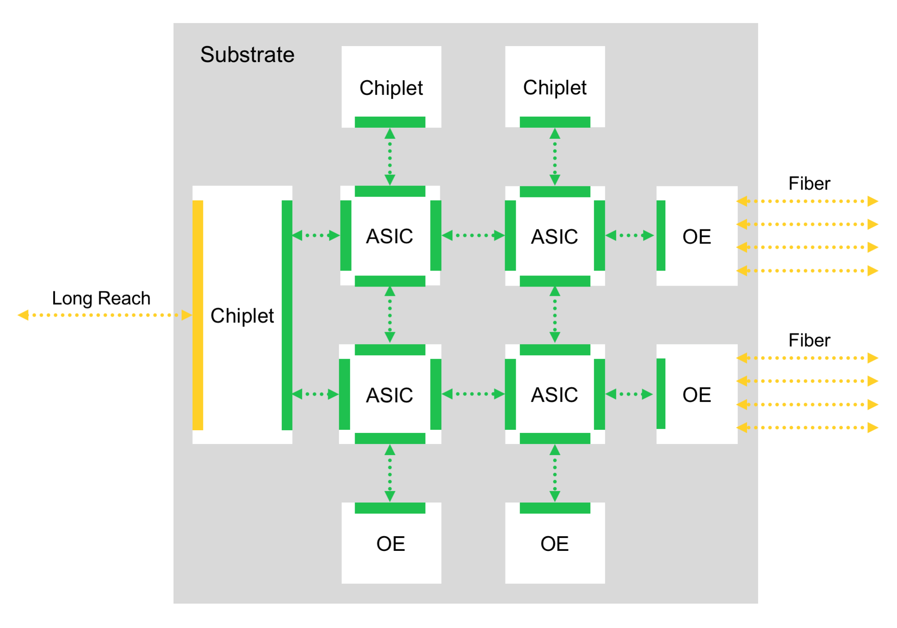
Figure 1: Sample chiplet architecture with die-to-die interconnect (green).

2.2 Die-to-Die Links vs. Long-Reach Interconnects
Die-to-die links operate over distances orders of magnitude shorter than conventional off-package interconnects, resulting in significantly lower insertion loss. This enables the use of single-ended signaling to maximize bandwidth density and minimize micro-bump count, albeit with increased sensitivity to common-mode noise. Short link lengths also relax timing and jitter constraints, reducing reliance on complex clock-and-data recovery (CDR) circuits. Instead, clock-forwarding architectures are commonly employed to simplify transceiver design and improve power efficiency [6].

2.3 Key Performance Metrics
The performance of die-to-die interconnects is typically evaluated using:
- Beachfront density, measuring achievable bandwidth per unit die-edge length,
- Energy efficiency, expressed in energy per transmitted bit, and
- Bit-error rate (BER), quantifying link reliability under operating conditions [7].
State-of-the-art D2D links often target beachfront densities exceeding 1 Tb/s/mm while maintaining BERs below 10⁻¹².

2.4 Signaling Schemes
NRZ signaling employs two voltage levels, allowing each symbol to represent one bit. While robust and simple to implement, NRZ becomes energy-inefficient at high data rates due to increased switching activity and the need for wideband analog circuitry.
PAM4 improves spectral efficiency by transmitting two bits per symbol using four voltage levels. At a fixed symbol rate, PAM4 doubles throughput relative to NRZ, or equivalently halves the symbol rate for a fixed data rate. However, for equally spaced levels and identical peak-to-peak swing, PAM4 incurs an approximately 9.5 dB SNR penalty relative to NRZ. The reduced vertical eye openings increase susceptibility to noise and inter-symbol interference (ISI) and impose stringent linearity requirements on transmitter drivers, receivers, and clocking circuits [7].
These limitations have motivated interest in alternative multi-level schemes such as PAM3, which seek to balance the robustness of NRZ with the bandwidth efficiency of PAM4. By using three voltage levels, PAM3 achieves higher bandwidth density than NRZ while retaining significantly larger noise margins than PAM4, making it well-suited for short-reach die-to-die interconnects [12]. Figure 2 illustrates the trade-off between signal integrity and bandwidth efficiency among NRZ, PAM3, and PAM4 signaling.
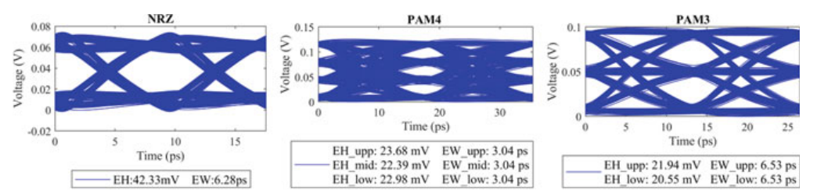
Figure 2: Eye diagram comparison between NRZ, PAM4 and PAM3 signaling schemes [12].
Practical PAM3 implementations rely on fixed-length mappings between binary and ternary symbols. The 3B2T encoding scheme maps three bits to two trits, achieving an efficiency of 1.5 bits/symbol, while higher-order mappings such as 11B7T reach efficiencies of approximately 1.57 bits/symbol at the cost of increased encoding complexity [12].

2.5 Simultaneous Bidirectional Signaling
Simultaneous bidirectional (SBD) signaling enables concurrent transmission and reception over a single-ended channel, effectively doubling pin efficiency. By operating at half the Nyquist frequency of an equivalent unidirectional link, SBD reduces ISI, crosstalk, and clocking power. In NRZ SBD systems, signals transmitted from opposite ends of the channel superimpose linearly, producing a three-level waveform on the interconnect. Hybrid circuits at each receiver suppress the locally transmitted component while recovering the far-end signal [7–11]. Figure 3 illustrates the operating principle of SBD signaling as well as the role and impact of the hybrid circuit.
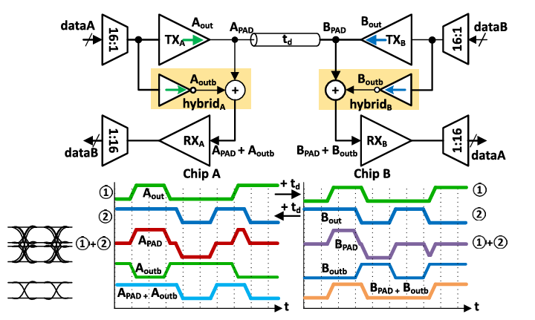
Figure 3: Simultaneous bidirectional transceiver schematic and operating principle [7].
Recent work has demonstrated the feasibility of SBD signaling for ultra-short-reach die-to-die links. Nishi et al. [7] present an inverter-based SBD transceiver (Figure 4) implemented in 5 nm CMOS achieving 50.4 Gb/s per wire with energy efficiency below 0.3 pJ/bit.
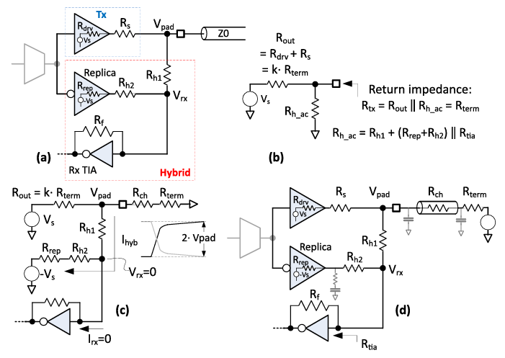
Figure 4: Transceiver architecture for simultaneous bidirectional signaling on die-to-die links [7].
A hybrid circuit generates a scaled replica of the local transmit signal and subtracts it from the pad voltage to recover the far-end data and hybrid resistor ($R_{\text{h1}}$, $R_{\text{h2}}$) values are chosen to cancel the outbound signal entirely at $V_{rx}$.
With the far-end driver assumed to be at ground, we can define $R_{out}, R_{hac}, R_{tx}$ as shown in Figure 4b. Setting $V_{rx}=0$, we obtain the following expression for the voltage at the pad:
$$V_{pad}=V_{s}\frac{{(R}_{ch}+R_{term})||R_{h1}}{{(R}_{ch}+R_{term})||R_{h1}+kR_{term}}$$
Next, defining $I_{hyb}$ as in Figure 4c, and recognizing that $V_{rx}=0$ implies no current flows into the Rx TIA, the entire hybrid current must flow through $R_{rep}+R_{h2}$ into the replica source at $-V_{s}$. Using these observations, we obtain the following closed-form condition for cancellation of the locally transmitted component:
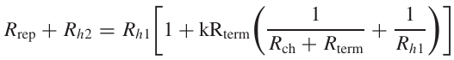
This equation, paired with the condition for channel termination, $R_{tx}=Z_{0}=R_{term}$ fully determines the hybrid resistor values required to achieve perfect self-interference cancellation at $V_{rx}$.
The key contribution of this work is a fully inverter-based hybrid implementation using passive resistors, avoiding replica drivers or asymmetric transconductance structures. This approach preserves full NRZ signal swing while avoiding the linearity constraints associated with PAM4, making SBD particularly attractive for dense interposer-based interconnects.

2.6 Equalization
As in long-reach interconnects, die-to-die transceivers employ equalization circuitry to compensate for channel impairments such as frequency-dependent loss and ISI, thereby maintaining signal integrity at high data rates. Equalization may be implemented at the transmitter, the receiver, or both, depending on system constraints and performance targets. In general, equalizers boost the high-frequency components of the signal (particularly those associated with symbol transitions) which are most heavily attenuated by the channel. Figure 5 illustrates how the cascade of the channel and equalizer frequency responses results in a flatter overall gain across the signal bandwidth.
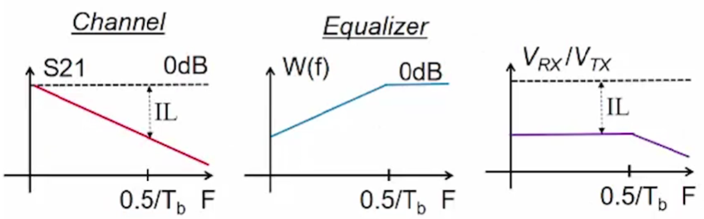
Figure 5: Frequency-domain impact of equalization.
Transmitter-side equalization performs pre-emphasis by shaping the outbound waveform through the intentional addition of energy to adjacent symbols. One commonly used technique is finite impulse response (FIR) equalization, also referred to as feed-forward equalization (FFE). In this scheme, weighted and delayed replicas of previous symbols are summed with a scaled version of the current symbol, and the resulting signal is transmitted. Proper selection of tap weights allows partial cancellation of post-cursor ISI introduced by the channel.
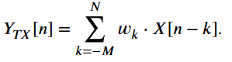
FIR equalization may also be applied at the receiver (Rx FIR or Rx FFE) to achieve a similar ISI-mitigating effect. However, receiver-side FIR equalization can amplify channel noise and crosstalk, and the implementation of accurate precursor taps is often limited by timing resolution and analog precision.
Another common receiver-side technique is continuous-time linear equalization (CTLE), which operates in the continuous-time domain to compensate for channel loss using frequency-selective amplification. CTLE is typically realized as a programmable high-pass or peaking filter that boosts high-frequency components prior to sampling, improving eye opening while avoiding the discrete-time noise enhancement associated with FIR equalizers.
Finally, decision-feedback equalization (DFE) mitigates ISI by subtracting estimated interference from previously detected symbols. Using past symbol decisions and a feedback filter, DFE cancels post-cursor ISI without amplifying channel noise. While DFE can provide substantial performance improvements, its reliance on correct prior decisions makes it susceptible to error propagation, particularly in low-SNR conditions.

2.7 PAM3 Transceiver Architectures
Early PAM3 implementations established the feasibility of multi-level signaling for short-reach single-ended interfaces. Park et al. [13] present a 30 Gb/s PAM3 transceiver in 28 nm CMOS for DRAM interfaces, achieving 1.11 pJ/bit using 3B2T encoding and operating at two-thirds the clock frequency of an equivalent NRZ link, thereby reducing jitter sensitivity. The block diagram in Figure 6a illustrates how three-bit sequences are mapped to sequences of two trits using a half-rate encoder and 2-to-1 mux. Figure 6b shows how the resultant bits are used to modulate the output signal of the PAM3 driver. Four NMOS transistors are selectively toggled to produce output voltage values from $0V$, $0.25V_{DD}$ and $0.5V_{DD}$.
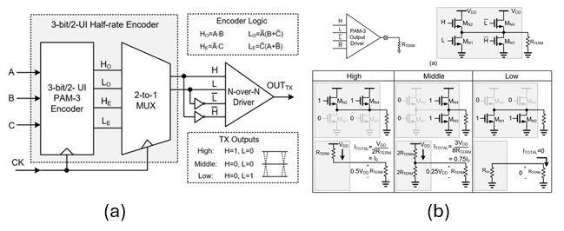
Figure 6: PAM3 transceiver and output driver from [13].
More recently, Kim et al. [14] demonstrate a 42 Gb/s/pin clock-referenced PAM3 (CR-PAM3) transceiver targeting chiplet interconnects with a state-of-the-art energy efficiency of 0.275 pJ/bit.
The transceiver leverages a unique clock-referenced signaling scheme whereby the clock signal and its complement are transmitted alongside the outbound data such that they are each subject to the same noise $n(t)$:
$$D\left(t\right)=a_{k}+n\left(t\right)$$
$$CLK_{p}\left(t\right)=+A+n(t)$$
$$CLK_{n}\left(t\right)=-A+n(t)$$
In doing so, the signal can be decoded at the receiver using the forwarded clocks as implicit PAM3 reference levels, enabling cancellation of the noise term, thereby structurally suppressing supply-induced reference offsets and improving noise tolerance:
$$y_{p}\left(t\right)=D\left(t\right)-CLK_{p}\left(t\right)=a_{k}-A$$
$$y_{n}\left(t\right)=D\left(t\right)-CLK_{n}\left(t\right)=a_{k}+A$$
The driver in [14] draws upon the architecture of the one presented in [13], utilizing a similar NMOS-based driver topology with two bits used to actuate the creation of the three voltage levels required for PAM3. One key difference, however, is through its incorporation of two additional fractional-spaced puller (FS-puller) transistors and ________. One key drawback of the driver from [13] is its ________.
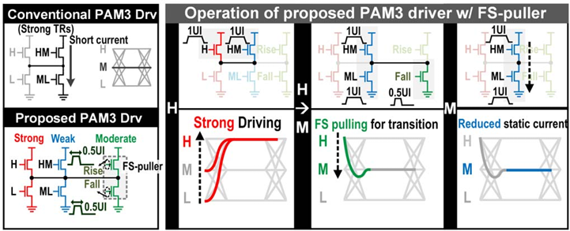
Together, these works establish PAM3 as a robust and energy-efficient signaling scheme for short-reach links. Their techniques (particularly clock-referenced detection and reduced baud-rate operation) are directly relevant to PAM3 simultaneous bidirectional architectures, where reference stability and echo cancellation accuracy are critical.

Section 3: Progress

Literature Review (August)
An in-depth review was conducted on die-to-die interconnects and simultaneous bidirectional (SBD) signaling. Key findings guided the selection of transceiver architectures and signaling schemes suitable for short reach chiplet links.

Preliminary Simulation and Validation (September)
Initial simulations were performed in LTSpice using the transceiver design from [7]. The die-to-die channel was modeled as a transmission line with characteristic impedance matching the reference. CMOS-inverter-based NRZ drivers were stimulated with a precomputed PRBS. The circuit successfully achieved termination and signal cancellation, confirming the correct implementation of the baseline transceiver and serving as a proof-of-concept for the transceiver’s operating principle.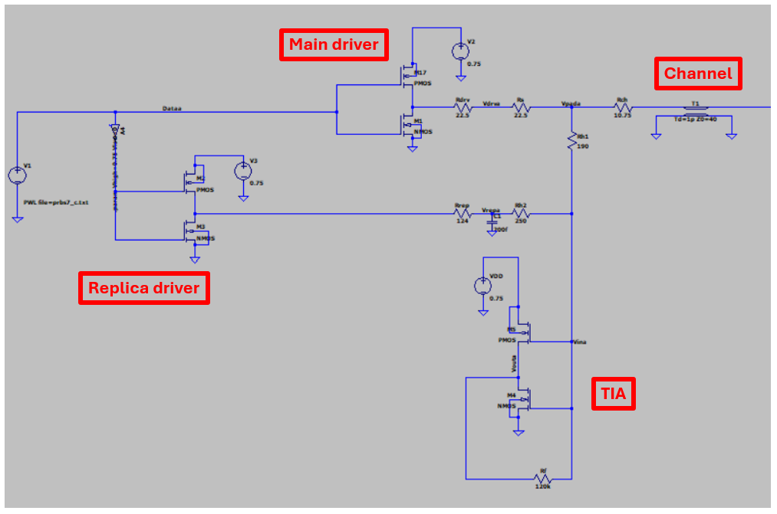
Figure 7: LTSpice schematic for [7]
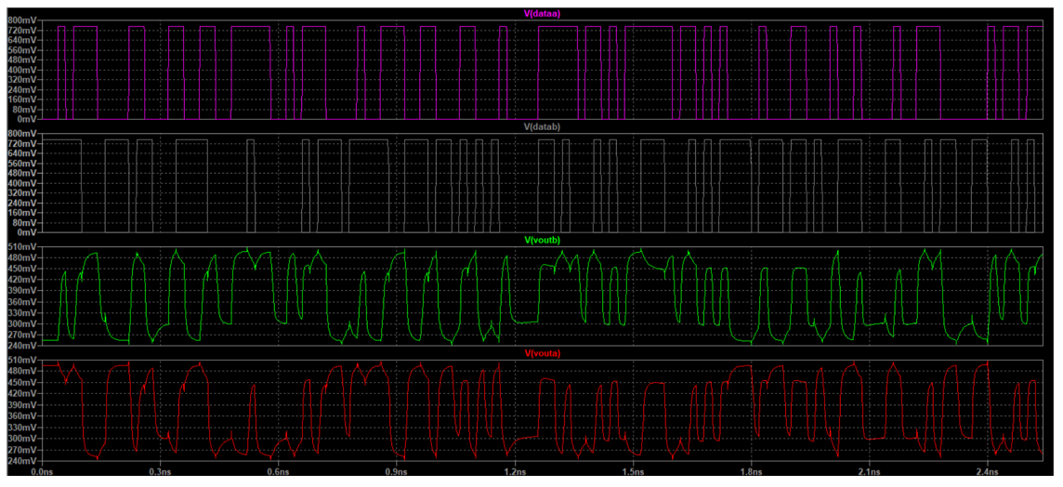
Figure 8: LTSpice simulation results for [7] (dataA=voutA and dataB=voutB as desired)

High-Fidelity Cadence Modeling (October – November)
Simulations were migrated to Cadence to enable more accurate modeling with 45 nm CMOS technology. Since the transistor behavior differed significantly from the 5 nm technology in [7], Python scripts were developed to automate the calculation of proper driver output resistance, termination, and Rh1/Rh2 values for accurate SBD signal cancellation and optimal transistor dimensions. The die-to-die channel was modeled using a Cadence nport which was fed a Touchstone s2p file representing a long-reach link.
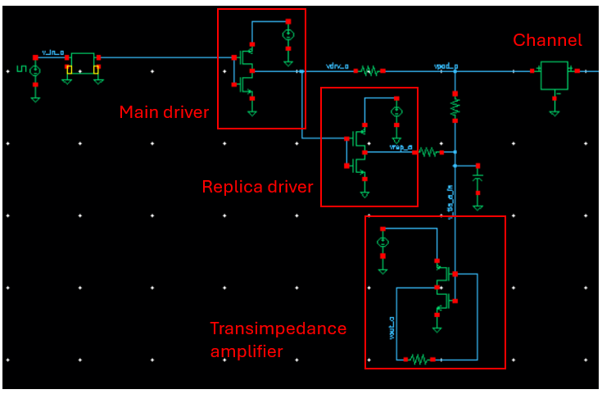
Figure 9: Cadence schematic for [7]
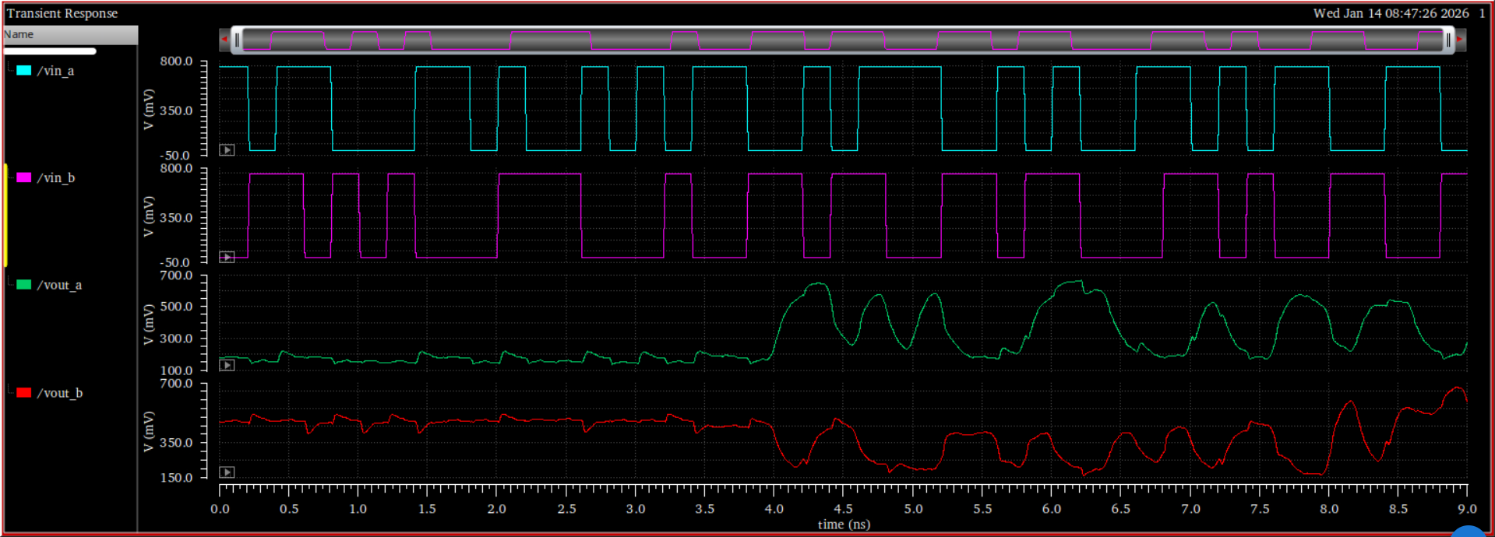
Figure 10: Cadence simulation results for [7]

Extension to PAM3 Signaling (December – January)
The Cadence simulation framework was extended to implement PAM3 signaling based on the transceiver architecture in [7]. The PAM3 output driver from the transceiver in [12] was chosen for its simplicity and was used to replace the CMOS-inverter-based drivers in [7].
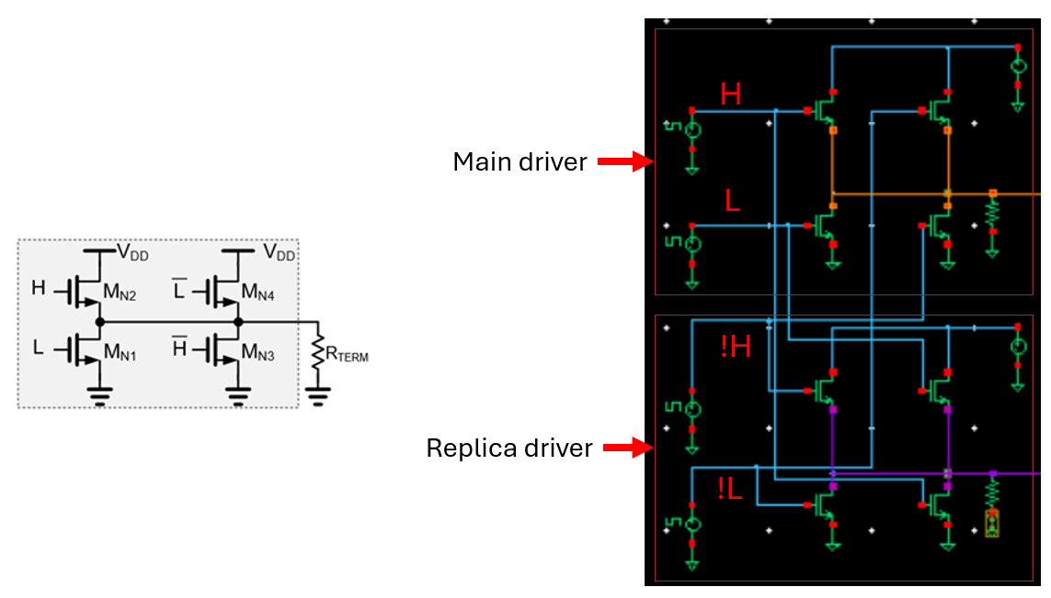
Figure 11: PAM3 driver schematic and Cadence implementation.

Figure 12: Cadence simulation results for [7]

Section 4: Future Work

References
[1] R. Viswanath, A. Chandrasekhar, S. Srinivasan, Z. Qian, and R. Mahajan, “Heterogeneous SoC integration with EMIB,” in Proc. IEEE Electr. Design Adv. Packag. Syst. Symp. (EDAPS), Dec. 2018, pp. 1–3.
[2] T. Li, J. Hou, J. Yan, R. Liu, H. Yang, and Z. Sun, “Chiplet heterogeneous integration technology—Status and challenges,” Electronics, vol. 9, no. 4, p. 670, Apr. 2020.
[3] Chiplets: Designing, Manufacturing, and Testing, Semicond. Eng., Silicon Valley, CA, USA, 2023.
[4] P. Gargini, “Roadmap evolution: From NTRS to ITRS, from ITRS 2.0 to IRDS,” in Proc. 5th Berkeley Symp. Energy Effic. Electron. Syst. Steep Transistors Workshop (E3S), 2017, pp. 1–62.
[5] Samsung’s June 2023 Reveal: Enhanced 3nm & 4nm Chip Fabrication Process, Electropages, Poole, U.K., Accessed: Mar. 25, 2024.
[6] D. Jarrett-Amor and T. C. Carusone, "Simultaneous Bidirectional Signaling for Die-to-Die Links: Signal Integrity Challenges and Hybrid Circuits," in IEEE Open Journal of the Solid-State Circuits Society, vol. 5, pp. 116-129, 2025, doi: 10.1109/OJSSCS.2025.3546889.
[7] Y. Nishi et al., "A 0.297-pJ/Bit 50.4-Gb/s/Wire Inverter-Based Short-Reach Simultaneous Bi-Directional Transceiver for Die-to-Die Interface in 5-nm CMOS," in IEEE Journal of Solid-State Circuits, vol. 58, no. 4, pp. 1062-1073, April 2023, doi: 10.1109/JSSC.2022.3232024.
[8] R.Drost and B.Wooley, “An8-Gb/s/pin simultaneously bidirectional transceiver in 0.35-/spl μ/m CMOS,” IEEE J. Solid-State Circuits, vol. 39, no. 11, pp. 1894–1908, Nov. 2004.
[9] J.-H. Kim et al., “A 4-Gb/s/pin low-power memory I/O interface using 4-level simultaneous bi-directional signaling,” IEEE J. Solid-State Circuits, vol. 40, no. 1, pp. 89–101, Jan. 2005.
[10] Y. Tomita et al., “A 20-Gb/s simultaneous bidirectional transceiver using a resistor-transconductor hybrid in 0.11-μmCMOS,” IEEE J. Solid-State Circuits, vol. 42, no. 3, pp. 627–636, Mar. 2007.
[11] Y.-H. Fan et al., “A 32-Gb/s simultaneous bidirectional source synchronous transceiver with adaptive echo cancellation techniques,”
[12] S. S. Chen, F. de Paulis, D. R. Stauffer, and B. Holden, “PAM3: History, algorithm, and performance comparison to NRZ and PAM4,” in Interconnect Technologies for Integrated Circuits and Flexible Electronics, Y. Agrawal, K. Mummaneni, and P. U. Sathyakam, Eds., Springer, Singapore, 2023, pp. 137–160, doi: 10.1007/978-981-99-4476-7_9.
[13] H. Park et al., "30-Gb/s 1.11-pJ/bit Single-Ended PAM-3 Transceiver for High-Speed Memory Links," in IEEE Journal of Solid-State Circuits, vol. 56, no. 2, pp. 581-590, Feb. 2021, doi: 10.1109/JSSC.2020.3006864.
[14] K. Kim, J. -H. Park, H. -J. Park, J. Park, J. Kim and W. -S. Choi, "22.1 A 0.275pJ/b 42Gb/s/pin Clock-Referenced PAM3 Transceiver Tolerant to Supply Noise, Reference Offset and Crosstalk for Chiplets and Short-Reach Memory Interfaces," 2025 IEEE International Solid-State Circuits Conference (ISSCC), San Francisco, CA, USA, 2025, pp. 394-396, doi: 10.1109/ISSCC49661.2025.10904729.

Appendices
cancellation_and_termination.py: Python script to determine appropriate values of Rdrv, Rrep, Rh1, Rh2 to satisfy termination and cancellation conditions
def parallel(r1, r2):
return (r1 * r2) / (r1 + r2)

rch = 9.5
rterm = 100
rtia = 200

for rdrv in range(10, 1000, 1):
rrep = rdrv * 5
rs = rdrv
k = (rs + rdrv) / rterm

pairs = []
for rh1 in range(1, 1000, 1):
if rh1 >= 2 * rs:
rhs = rh1 * (1 + k * rterm * ((1 / (rch + rterm)) + (1 / rh1)))
rh2 = rhs - rrep
if rh2 > 0:
pairs.append((rh1, rh2))

for rh1, rh2 in pairs:
rout = rdrv + rs
rhac = rh1 + parallel(rrep + rh2, rtia)

rtx = parallel(rout, rhac)

if (rtx > 0.99 * rterm) and (rtx < 1.01 * rterm):
# if rdrv == 55:
print(f"rdrv = {rdrv} Ω, rrep = {rrep} Ω, R_h1 = {rh1:.2f} Ω, R_h2 = {rh2:.2f} Ω, Rtx = {rtx:.2f} Ω")

transistor_sizing.py: Python script to calculate widths of 45nm NMOS and PMOS transistors in CMOS-inverter-based output drivers based on transistor parameters listed in technology file
coxn = 0.01973
coxp = 0.018665

u0n = 0.04359
u0p = 0.00432

vtn = 0.471
vtp = 0.423

vgs = 0.75
vdd = 0.75

length = 45e-9

# driver
rdrv = 56

wln_driver = 1 / (rdrv * u0n * coxn * (vgs - vtn))
wlp_driver = 1 / (rdrv * u0p * coxp * (vgs - vtp))

wn_driver = wln_driver * length
wp_driver = wlp_driver * length

# replica
rrep = 280

wln_replica = 1 / (rrep * u0n * coxn * (vgs - vtn))
wlp_replica = 1 / (rrep * u0p * coxp * (vgs - vtp))

wn_replica = wln_replica * length
wp_replica = wlp_replica * length

print("Driver NMOS width (m):", wn_driver)
print("Driver PMOS width (m):", wp_driver)
print("Replica NMOS width (m):", wn_replica)
print("Replica PMOS width (m):", wp_replica)

