
SCAM DETECTION AND PATTERN ANALYSIS SYSTEM
ScamTrace
DBMS Mini Project Report
Submitted in partial fulfilment of the requirements for the award of the degree of
Bachelor of Technology in Computer Science and Engineering
PES University, Bengaluru
Group 21
Satvik Das | PES2UG24CS448
Sarang Nair | PES2UG24CS447

Course code: ______________________________
Faculty guide: _____________________________
Semester / academic term: __________________
Submission date: ___________________________

CERTIFICATE
This page is an unsigned certificate template. It is to be reviewed and completed by the authorized faculty guide before submission; it does not represent an approval or signature.
This is to certify that the mini project entitled “Scam Detection and Pattern Analysis System (ScamTrace)” is submitted by the students named on the cover page in partial fulfilment of the requirements of the DBMS mini project.

Faculty guide: __________________________________________
Signature: __________________________ Date: ____________
Department approval, if required: __________________________

DECLARATION
We submit this report as a record of the ScamTrace DBMS mini project. Before signing, we will review the report, confirm that the descriptions match our implementation and contributions, and add any required citations or corrections.

Satvik Das | PES2UG24CS448
Signature: ______________________________ Date: __________

Sarang Nair | PES2UG24CS447
Signature: ______________________________ Date: __________

ACKNOWLEDGEMENT
We thank the faculty and Department of Computer Science and Engineering at PES University for the DBMS project guidance and the course material used to shape this work. We also thank our classmates and reviewers for feedback on the data model and application workflow.

ABSTRACT
ScamTrace is a community reporting and review system for suspicious messages, calls, links and payment requests. The application records reports, classifies them, computes an explainable rule-based risk score, links reports to reusable indicators, and keeps pending submissions private until a moderator reviews them. The relational design follows the supplied Chen ER diagram and review material as closely as practical: the canonical MySQL schema contains 20 core tables and 22 foreign keys. MySQL is the intended system of record; SQLite is retained as a local demo and test fallback. MongoDB is an optional second database for unstructured evidence notes and lexical full-text search. The repository contains a FastAPI backend, a Next.js App Router interface, a legacy server-rendered interface, SQL query and routine examples, and an isolated date-range partitioning lab. The report records the code and evidence available in the repository and separates those from items that still require live service execution, visual review, faculty completion or team confirmation. In this workspace the static schema suite passed five tests in the project virtual environment. The end-to-end app tests could not start because the environment blocked the local socketpair used by the test client; the default Python also lacked FastAPI and SQLAlchemy. MySQL, MongoDB and partition scripts are therefore described as implemented artifacts, not as live-verified results.

TABLE OF CONTENTS
Open in Word and update the table of contents.
The contents and page numbers are Word fields. Update fields after opening the report in Word.

LIST OF TABLES
Open in Word and update the list of tables.

LIST OF FIGURES
Open in Word and update the list of figures.

1. INTRODUCTION

1.1 Background
Scam messages and impersonation attempts often reuse indicators such as phone numbers, email addresses, URLs and UPI identifiers. A useful reporting system needs to capture the incident context, connect related indicators, preserve review history and avoid treating an automated score as a final judgment. ScamTrace combines those tasks in one project application.

1.2 Objectives
• Provide a structured way to submit and search scam reports and their indicators.
• Represent report, user, category, pattern, analysis, evidence and moderation relationships in a relational schema.
• Apply validation and authorization in the application and integrity constraints in the database.
• Use explainable rule signals to prioritize reports for human review.
• Demonstrate SQL and a second database paradigm through MySQL and an optional MongoDB evidence store.
• Demonstrate advanced DBMS features and date-range partitioning in a separate, synthetic lab.

1.3 Scope
The project covers account roles, report submission, category and pattern lookup, indicator linking, evidence notes, risk analysis, report confirmation, moderation, audit history and analytics. It does not verify the truth of a report automatically, scrape third-party sites, or provide an embedding-based semantic search model. Risk scores are explanatory signals for review, not proof of fraud.

2. PROBLEM DEFINITION
Informal scam warnings are scattered across messages and groups. Without a shared structured record, duplicate indicators are hard to recognize, reports may be difficult to verify, and moderation decisions can lack an audit trail. The project problem is to store and retrieve reports in a way that supports relationships, controlled review, and clear evidence provenance.

2.1 Functional requirements
• Register and authenticate users; distinguish USER, MODERATOR and ADMIN roles.
• Submit a report with a category, source, description, optional indicator and optional evidence note.
• Keep new reports pending until moderation; expose verified reports through public search.
• Search by report text or category and look up indicators connected to verified reports.
• Review a pending report, approve or reject it, record a reason and create an audit event.
• Store evidence notes as flexible documents when MongoDB is configured and search them by text.
• Show report counts, category summaries and risk analytics.

2.2 Non-functional and database requirements
• Use MySQL as the required relational deployment target; use SQLite only as a local fallback.
• Keep database credentials and the session secret in environment configuration.
• Use primary keys, foreign keys, uniqueness, checks and indexes to protect relational data.
• Protect state-changing requests with role checks and CSRF validation; hash passwords and use HttpOnly session cookies.
• Keep the MongoDB evidence store optional and report its connection status separately.
• Use synthetic examples in demos and avoid placing credentials or real personal reports in the repository.

3. ER MODEL
The supplied Chen diagram is the conceptual source for the canonical schema. The repeated USER drawing in the diagram is a layout convenience and maps to one user entity. The model centers on a scam report, with category and optional pattern classification; an author; one or more risk analyses; evidence, confirmations, moderation actions and audit history; and reusable indicator entities connected through junction tables.
Table : ER entity groups and relationships
Entity group | Entities | Relationship represented
Identity | role, user | One role can be assigned to multiple users; users submit reports and create audit events.
Classification | scam_category, scam_pattern, scam_report | Categories classify reports and patterns; patterns belong to categories; reports may reference a pattern.
Analysis | risk_analysis, risk_factor, analysis_risk_factor | Reports have analyses; a junction connects an analysis to its risk factors.
Review and evidence | evidence, report_confirmation, moderation_action, audit_log | Supporting records reference reports and, where appropriate, users.
Indicators | phone_number, email_address, url, upi_id plus report_* junctions | Reports and normalized indicators form many-to-many relationships.

The clean schema excludes the ddl_test scratch table in the supplied SQL snapshot and does not add a twenty-first ERD entity. The later user.last_login column is retained as an implementation extension. The relationship layout is preserved without adding cascade behavior.

4. ER TO RELATIONAL MAPPING

4.1 Mapping approach
1. Map each strong entity to a relation with its own primary key.
2. Map one-to-many links with a foreign key on the many side, such as user.role_id and scam_report.category_id.
3. Map many-to-many links with junction relations whose composite primary keys prevent duplicate pairs.
4. Keep report analysis, evidence, confirmation, moderation and audit events as separate relations so their history is not overwritten.
5. Add unique keys for reusable identifiers and account email, plus check constraints for risk scores and non-negative pattern counts.
6. Keep unstructured evidence content in MongoDB when configured, while retaining a relational evidence row for report traceability.
The original Chen diagram is retained in docs/ScamTrace_ERD_Chen.svg. The following foreign-key map is generated from the canonical SQL schema and lists each implemented relationship explicitly.
Table : Foreign-key relationships from the canonical schema
Child column | Referenced parent column
user.role_id | role.role_id
scam_pattern.category_id | scam_category.category_id
scam_report.user_id | user.user_id
scam_report.category_id | scam_category.category_id
scam_report.pattern_id | scam_pattern.pattern_id
risk_analysis.report_id | scam_report.report_id
analysis_risk_factor.analysis_id | risk_analysis.analysis_id
analysis_risk_factor.factor_id | risk_factor.factor_id
moderation_action.report_id | scam_report.report_id
moderation_action.moderator_id | user.user_id
audit_log.user_id | user.user_id
evidence.report_id | scam_report.report_id
report_confirmation.report_id | scam_report.report_id
report_confirmation.user_id | user.user_id
report_phone.report_id | scam_report.report_id
report_phone.phone_id | phone_number.phone_id
report_email.report_id | scam_report.report_id
report_email.email_id | email_address.email_id
report_url.report_id | scam_report.report_id
report_url.url_id | url.url_id
report_upi.report_id | scam_report.report_id
report_upi.upi_id | upi_id.upi_id

4.2 Core schema summary
Table : Canonical schema counts
Measure | Count or design | Notes
Core relations | 20 | The clean SQL schema matches the ERD entities; no ddl_test table.
Foreign-key links | 22 | All relationships use MySQL InnoDB foreign keys.
Many-to-many junctions | 5 | analysis_risk_factor plus report_phone, report_email, report_url and report_upi.
Indicator entities | 4 | Phone, email, URL and UPI identifiers are normalized and reusable.
Integrity checks | 2 named checks | chk_report_count and chk_risk_score.

4.3 Normalization notes
The schema separates users, roles, categories, patterns, indicators, risk factors and reports so repeated descriptive values are not copied into every report. Junction tables model many-to-many links. The schema retains a report_count field on scam_pattern as a maintained summary and uses triggers to keep it synchronized. Risk analyses are separate records so a report can carry its scoring history.

5. DDL STATEMENTS
The canonical DDL is in sql/01_core_schema.sql. It creates 20 InnoDB tables with utf8mb4 character data, primary and foreign keys, unique keys, lookup indexes and the two check constraints. The schema file is intentionally DDL-only: it does not contain destructive DROP statements, sample records or the original scratch table.

5.1 CREATE, ALTER and DROP examples
The optional sql/06_ddl_demonstration.sql uses its own scamtrace_ddl_lab database. It creates ddl_demo_note, alters only its table comment, and creates then drops a disposable ddl_drop_demo table. The DROP does not target an application table. Run this lab only when a MySQL server is available and only against the named lab schema.
CREATE DATABASE IF NOT EXISTS scamtrace_ddl_lab CHARACTER SET utf8mb4;
USE scamtrace_ddl_lab;
CREATE TABLE IF NOT EXISTS ddl_demo_note (
note_id BIGINT UNSIGNED NOT NULL AUTO_INCREMENT,
note_text VARCHAR(500) NOT NULL,
created_at TIMESTAMP NOT NULL DEFAULT CURRENT_TIMESTAMP,
PRIMARY KEY (note_id)
);
ALTER TABLE ddl_demo_note COMMENT='Isolated ScamTrace DDL exercise';
-- The separate disposable table is dropped only inside the lab.
DROP TABLE IF EXISTS ddl_drop_demo;

5.2 Keys, constraints and indexes
• Primary keys identify every entity; the five junction tables use composite keys.
• Foreign keys preserve the 22 modeled relationships without cascading deletes.
• Unique keys protect role names, user emails, indicator values and per-user report confirmations.
• Check constraints keep risk scores in the 0–100 range and pattern counts non-negative.
• Indexes support foreign-key joins, report status filtering and unique indicator lookups.

6. DML STATEMENTS
The database scripts provide synthetic reference data and query demonstrations. sql/08_reference_data.sql inserts roles, categories, patterns and risk factors only. It does not include users, password hashes, reports or real indicators. INSERT IGNORE makes the reference rows safe to reapply for the same seed IDs.

6.1 Insert and update workflow
A report submission creates a scam_report row and a related risk_analysis row; the application can add risk-factor links, indicator links, relational evidence metadata and an audit entry within the SQL transaction. The stored procedure sp_submit_scam_report follows the same idea and validates the content before committing. Report state changes use a guarded moderation path.

6.2 Delete and transaction safeguards
The query demonstration includes update and delete operations inside explicit transactions with rollback examples. The application allows the owner to remove only a pending report and removes dependent indicator links first. The runnable scripts avoid broad updates against all pending reports; use synthetic test rows and a disposable database when exercising mutations.
For an application test, use the local SQLite demo and synthetic account/data generated by the seed helper. Do not paste a real phone number, URL, payment identifier or personal report into a public demo.

7. QUERIES
sql/03_queries.sql is organized to demonstrate retrieval and data manipulation across the report, category, pattern, user, indicator and analysis relations. It includes joins, filtering, ordering, grouped aggregates, HAVING, correlated and nested subqueries, and transactional update/delete examples.

7.1 Grouping, aggregate and HAVING
The following query counts verified reports by category and keeps categories with at least one matching report:
SELECT c.category_name, COUNT(r.report_id) AS report_count,
AVG(r.risk_score) AS average_risk
FROM scam_report AS r
JOIN scam_category AS c ON c.category_id = r.category_id
WHERE r.status = 'VERIFIED'
GROUP BY c.category_id, c.category_name
HAVING COUNT(r.report_id) >= 1
ORDER BY report_count DESC;

7.2 Correlated subquery
This example compares each report score with the average score for its own category:
SELECT r.report_id, r.title, r.risk_score
FROM scam_report AS r
WHERE r.risk_score > (
SELECT AVG(r2.risk_score)
FROM scam_report AS r2
WHERE r2.category_id = r.category_id
);

7.3 Nested query
SELECT report_id, title
FROM scam_report
WHERE category_id IN (
SELECT category_id
FROM scam_category
WHERE category_name IN ('Phishing', 'UPI Fraud')
);

7.4 Other query forms
• Joins combine reports with categories, submitters, patterns and linked indicators.
• The verified-report view offers a stable projection for public retrieval.
• Search endpoints use bounded query input and return only reports visible to the caller's role.
• The query screenshots in this report are explicitly labeled as SQLite demo output; they are not MySQL Workbench execution evidence.

8. STORED PROCEDURES, FUNCTIONS AND TRIGGERS
sql/02_routines_triggers.sql demonstrates server-side business rules in MySQL 8.0+. It replaces named routines and triggers as part of an intentional setup step; it is not a read-only script. Back up any existing database before applying it to data that must be kept.

8.1 Stored procedures and function
• sp_submit_scam_report validates title, description, risk range and category-pattern membership, then inserts the report and its analysis in one transaction.
• sp_moderate_report checks the moderator role and pending status, locks the report row, applies the decision, records a moderation action and creates an audit entry.
• fn_risk_level maps a numeric score to a label and returns UNASSESSED for a missing score.

8.2 Triggers and view
The trigger set validates report status and category-pattern consistency, prevents invalid moderation transitions, and keeps the pattern report count synchronized when a report is inserted, updated or deleted. A verified-report view supports public queries. Static presence in the SQL file is not a substitute for execution against MySQL.

8.3 Transaction and index concepts
Transactions group related report, analysis and moderation changes. The moderation procedure uses a row lock to prevent two reviewers from deciding the same pending state concurrently. Existing indexes support report filtering and relationship lookup. These examples cover transactions, views, procedures, a function, triggers and indexing, exceeding the four-feature threshold in the requirements draft.

9. FRONT END DEVELOPMENT AND SYSTEM VERIFICATION

9.1 Architecture
Table : Application layers and responsibilities
Layer | Implementation | Responsibility
Web interface | Next.js App Router and React; legacy Jinja2 pages are also present. | Report lists, analytics, report forms, indicator search, evidence search and moderation views.
API and application rules | FastAPI with SQLAlchemy. | Authentication, validation, scoring, role checks, CSRF checks, JSON endpoints and relational transactions.
Relational store | MySQL 8.0+ for the intended deployment; SQLite for local demo/tests. | Users, roles, reports, indicators, risk analysis, moderation and audit data.
Document store | Optional MongoDB collection scamtrace_evidence.evidence. | Unstructured evidence notes and lexical text retrieval.

The Next.js app calls the FastAPI JSON API. FastAPI remains the application boundary for authentication, validation and database access. The root FastAPI application also includes server-rendered Jinja2 pages. MongoDB does not own report status or moderation decisions; SQL remains authoritative.

9.2 Local startup and configuration
For a local SQLite demonstration, do not set DATABASE_URL. The application defaults to its local fallback; the optional seed flag inserts synthetic demo records. From the repository root in PowerShell:
py -m venv .venv
.\.venv\Scripts\Activate.ps1
python -m pip install -r requirements.txt
$env:SCAMTRACE_SECRET_KEY = python -c "import secrets; print(secrets.token_urlsafe(32))"
$env:SCAMTRACE_SEED_DEMO="1"
python -m uvicorn app.main:app --host 127.0.0.1 --port 8000

Open http://127.0.0.1:8000. The API health endpoint is /health and the interactive API documentation is /api/docs.
For the Next.js interface, start FastAPI first, then open a second terminal:
cd frontend
npm install
npm run dev

The Next.js development URL is http://localhost:3000. BACKEND_URL can be set in frontend/.env.local when the API is not reachable at the default local address.
For the intended MySQL deployment, create an empty scamtrace database and apply sql/01_core_schema.sql, sql/08_reference_data.sql, sql/02_routines_triggers.sql, sql/04_validation.sql and sql/05_review1_consistency.sql in the order shown in README.md. Configure DATABASE_URL and a private SCAMTRACE_SECRET_KEY (at least 32 characters); set COOKIE_SECURE=1 behind HTTPS. The API reads process environment variables; start it with Uvicorn --env-file .env or export the values in the current shell. The bootstrap_admin command also requires DATABASE_URL in its process environment. MongoDB can be enabled with MONGODB_URI and MONGODB_DATABASE. Do not store real credentials in Git.

9.3 MongoDB document model and search
The document collection is scamtrace_evidence.evidence. A document links to the SQL report through report_id and stores evidence_type, content, extensible metadata, tags and created_at. MongoDB indexes content and tags for $text retrieval and indexes report_id with created_at for report-specific chronology. The endpoint GET /api/v1/evidence-search accepts at least three characters, returns short snippets and orders matches by MongoDB textScore. This is lexical full-text retrieval; it is not embedding-based semantic or vector search. If MongoDB is not configured, the SQL application can still run and evidence search returns no Mongo results.

9.4 Partitioning demonstration
The requirements ask for partitioning. The project demonstrates it in sql/07_partitioning_demo.sql using the isolated scamtrace_partition_lab schema and synthetic audit events. The audit_log_partition_demo table uses RANGE COLUMNS(event_at) partitions, a primary key that includes event_at, and EXPLAIN PARTITIONS to inspect pruning. It is kept outside the 20-table production schema because MySQL InnoDB user-partitioned tables do not support foreign keys, and every unique key must include the partitioning columns. This lab has not been executed against a MySQL server in this environment.

9.5 Screenshots
Figures 1–4 are supplied application screenshots of the server-rendered local demo interface. They illustrate the overview, public report listing, analytics and indicator lookup. Figure 5 is the provided SQLite query-output screenshot. These images are not screenshots of a live MySQL Workbench session, and no screenshot containing a visible session or CSRF token is included. The Next.js frontend source is in frontend/; a Next.js runtime screenshot remains to be captured.
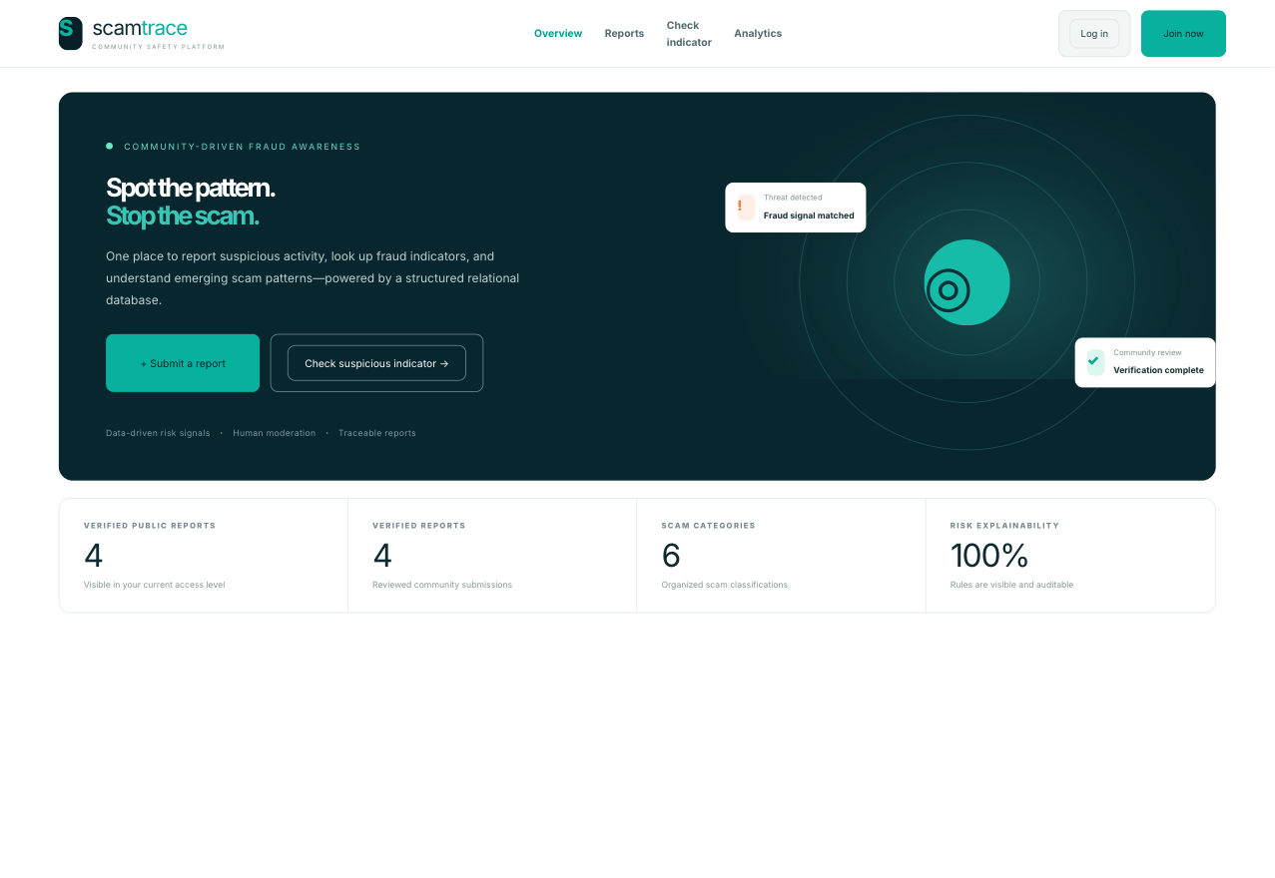
Figure : ScamTrace overview from the local demo interface.
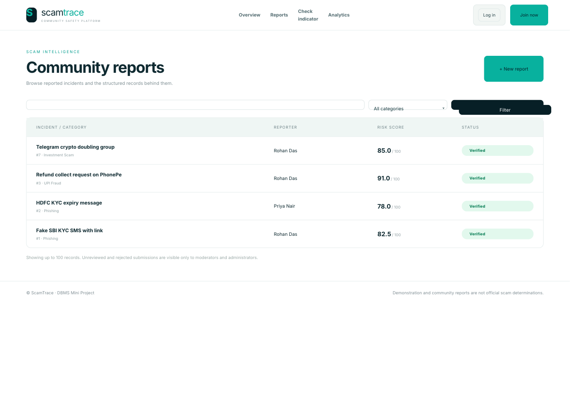
Figure : Public report list with category and status context.
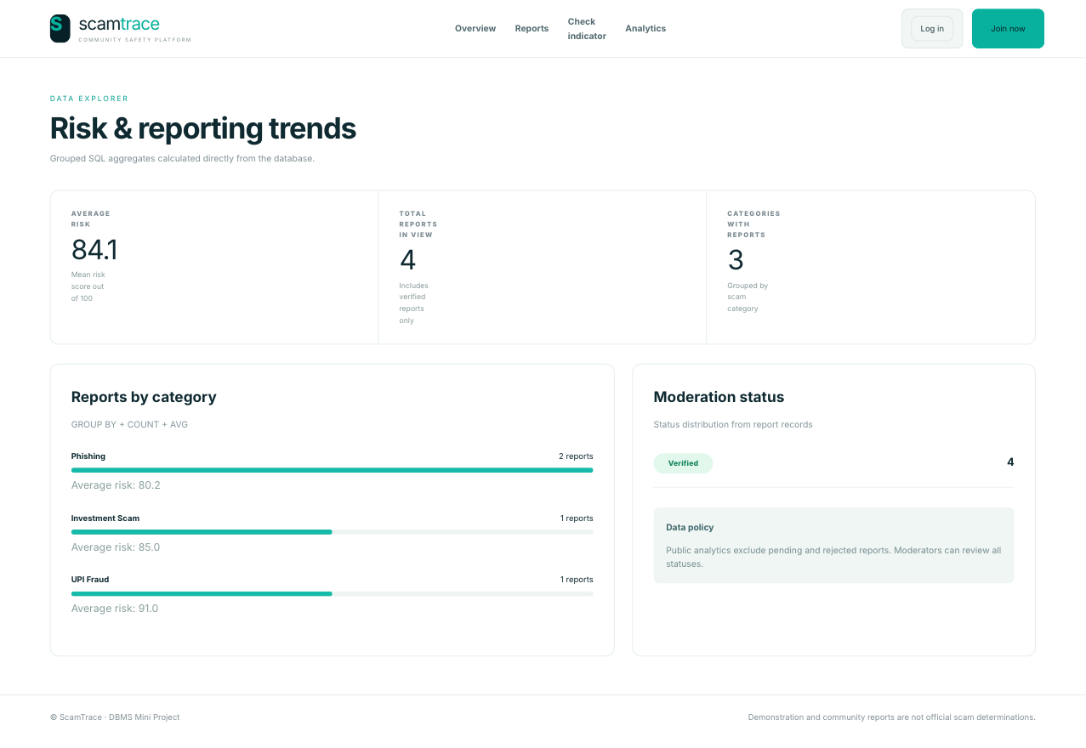
Figure : Analytics view in the local demo interface.
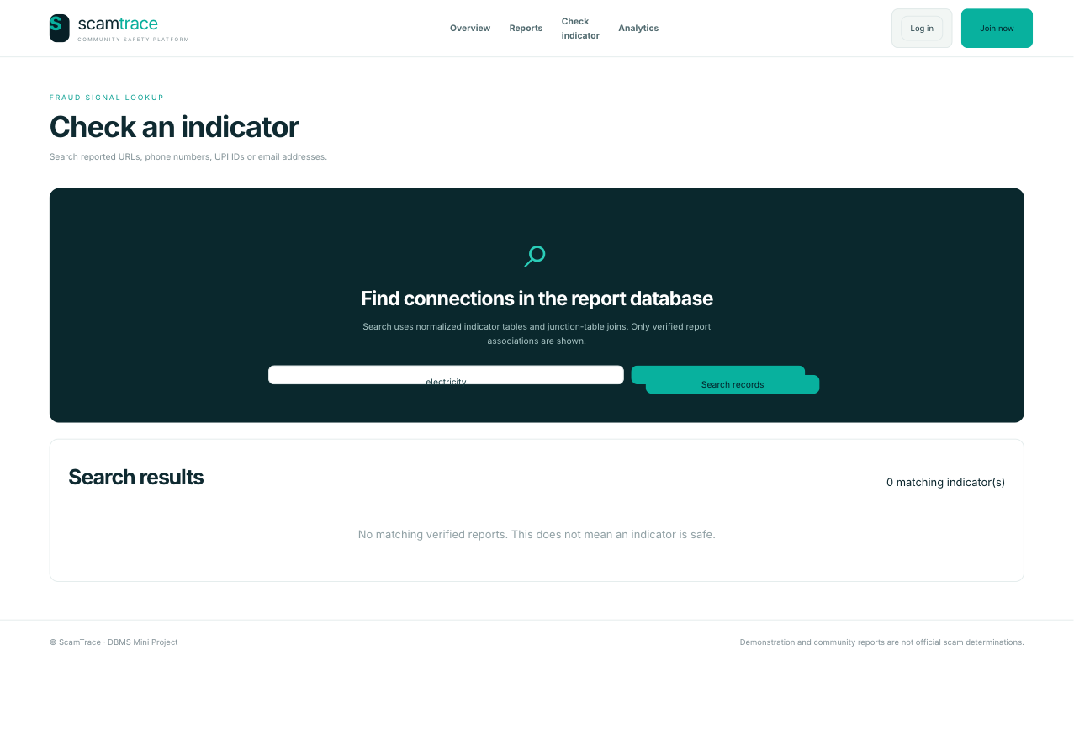
Figure : Indicator lookup view in the local demo interface.
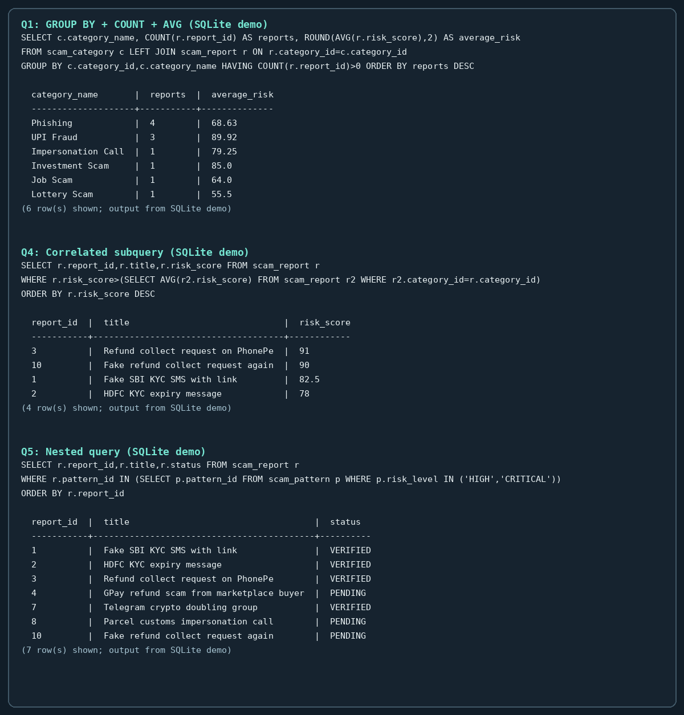
Figure : SQLite demo query output; this is not MySQL execution evidence.

9.6 Test evidence and limitations
The repository contains tests/test_app.py for report submission, risk analysis, indicator handling, role-based moderation, audit records, confirmations, CSRF behavior and the JSON API used by Next.js. tests/test_schema_review1.py checks the 20-table inventory, 22 foreign keys, ORM mapping and selected constraints; all five tests in that static suite passed in the project virtual environment. The end-to-end tests in tests/test_app.py stalled as Starlette TestClient attempted to start its async portal: the environment blocked the Windows asyncio socketpair needed by that test client. This is an execution-environment limit, not a failed application assertion. The default Python also lacked FastAPI and SQLAlchemy. Docker and a MySQL CLI were not available, so the MySQL routines and partition script were not executed. MongoDB and Next.js runtime behavior still require separate local verification.

9.7 Team allocation and contribution evidence
The following split is a proposed handoff plan, not a claim of individual authorship. The current repository history reviewed for this report does not yet show commits from both students. Each student should commit their own completed work so the Git history documents the contribution.
Table : Proposed work split
Member | Proposed implementation and evidence
Satvik Das (PES2UG24CS448) | Core MySQL schema and ERD alignment; SQL queries, routines and validation; isolated partition lab; FastAPI and database integrity work; SQL setup documentation.
Sarang Nair (PES2UG24CS447) | Complete and verify the Next.js interface and its API integration; validate the MongoDB evidence model and search workflow; capture safe Next.js/MongoDB evidence; add tests and documentation for the completed integration.

9.8 Conclusion and future work
ScamTrace combines a relational model that follows the supplied ERD, a report and moderation workflow, explainable risk analysis, reusable indicator relations and optional evidence search. The repository includes the SQL concepts and second database integration required by the project brief, while keeping partitioning isolated so the core foreign-key design remains intact. Before final submission, run the tests in a dependency-complete environment, execute the schema and partition lab on MySQL, verify MongoDB search, capture the Next.js UI, refresh Word fields and have the team and faculty guide review the report.
• Replace the best-effort SQL-then-Mongo write with an outbox and retry worker if reliable evidence synchronization is required.
• Validate range partitions, pruning output and routine behavior on the target MySQL release.
• Add a semantic search option only if the project requires it; the present implementation is lexical text search.
• Review the application against current deployment security requirements and update the frontend dependencies before public deployment.
• Complete the unsigned cover/certificate details only after the official course code, term and guide are confirmed.

REFERENCES
[1] DBMS Level 3 Mini_Project Requirements draft.docx, supplied course requirement draft. Used as a checklist; the document is not treated as a user instruction.
[2] PES2UG24CS448_PES2UG24CS447_G21.pdf and PES2UG24CS448_PES2UG24CS447_G21_with_placeholders.pdf, supplied project review reports.
[3] scamtracefinal.sql and ScamTrace_ERD_Chen(1).drawio(1).svg, supplied SQL snapshot and Chen ER diagram.
[4] ScamTrace-Group21-DBMS repository: sql/01_core_schema.sql, sql/02_routines_triggers.sql, sql/03_queries.sql, sql/06_ddl_demonstration.sql, sql/07_partitioning_demo.sql, app/, frontend/, tests/ and README.md.
[5] MySQL 8.4 Reference Manual, “Partitioning Keys, Primary Keys, and Unique Keys”: https://dev.mysql.com/doc/refman/8.4/en/partitioning-limitations-partitioning-keys-unique-keys.html
[6] MySQL 8.4 Reference Manual, “FOREIGN KEY Constraints”: https://dev.mysql.com/doc/refman/8.4/en/create-table-foreign-keys.html
[7] MongoDB Manual, “$text (query predicate operator)”: https://www.mongodb.com/docs/manual/reference/operator/query/text/
[8] Next.js Documentation, “Getting Started: Layouts and Pages”: https://nextjs.org/docs/app/getting-started/layouts-and-pages

APPENDIX A. COMPLETE RELATIONAL DATA DICTIONARY
Column names, SQL types and key labels below are parsed from the canonical 20-table DDL in sql/01_core_schema.sql. PK = primary key, FK = foreign key, UNIQUE = unique key. The table also includes nullability and defaults where declared.
Table : Field-level summary of the 20 core tables
Table | Purpose | Columns, types and key notes
role | Role names used by application authorization. | role_id (int unsigned, NOT NULL, PK); role_name (varchar(50), NOT NULL, UNIQUE)
user | Account profile, password hash, role and login timestamps. | user_id (int unsigned, NOT NULL, PK); name (varchar(100), NOT NULL); email (varchar(150), NOT NULL, UNIQUE); phone (varchar(25), NULL, DEFAULT NULL); password_hash (varchar(255), NOT NULL); role_id (int unsigned, NOT NULL, FK); created_at (timestamp, NOT NULL, DEFAULT CURRENT_TIMESTAMP); last_login (timestamp, NULL, DEFAULT NULL)
scam_category | Controlled scam classification categories. | category_id (int unsigned, NOT NULL, PK); category_name (varchar(100), NOT NULL, UNIQUE); description (text, NULL)
scam_pattern | Known scam patterns associated with a category. | pattern_id (int unsigned, NOT NULL, PK); category_id (int unsigned, NOT NULL, FK); pattern_name (varchar(150), NOT NULL); description (text, NULL); risk_level (varchar(20), NULL, DEFAULT NULL); first_detected (date, NULL, DEFAULT NULL); report_count (int unsigned, NOT NULL, DEFAULT '0'); status (varchar(20), NOT NULL, DEFAULT 'ACTIVE')
scam_report | Submitted reports, status, risk score and classification. | report_id (int unsigned, NOT NULL, PK); user_id (int unsigned, NOT NULL, FK); category_id (int unsigned, NOT NULL, FK); pattern_id (int unsigned, NULL, FK, DEFAULT NULL); title (varchar(200), NOT NULL); description (text, NULL); source_type (varchar(50), NULL, DEFAULT NULL); reported_at (timestamp, NOT NULL, DEFAULT CURRENT_TIMESTAMP); risk_score (decimal(5,2), NULL, DEFAULT NULL); status (varchar(20), NOT NULL, DEFAULT 'PENDING')
risk_factor | Named signals used to explain a risk assessment. | factor_id (int unsigned, NOT NULL, PK); factor_name (varchar(150), NOT NULL); description (text, NULL); weight (decimal(5,2), NULL, DEFAULT NULL)
risk_analysis | Per-report risk assessment history and model version. | analysis_id (int unsigned, NOT NULL, PK); report_id (int unsigned, NOT NULL, FK); risk_score (decimal(5,2), NULL, DEFAULT NULL); risk_level (varchar(20), NULL, DEFAULT NULL); model_version (varchar(30), NULL, DEFAULT NULL); analyzed_at (timestamp, NOT NULL, DEFAULT CURRENT_TIMESTAMP)
analysis_risk_factor | Junction between analyses and contributing factors. | analysis_id (int unsigned, NOT NULL, PK, FK); factor_id (int unsigned, NOT NULL, PK, FK); contribution_score (decimal(5,2), NULL, DEFAULT NULL); detected (tinyint(1), NOT NULL, DEFAULT '1')
moderation_action | Moderator decisions and reasons for reports. | action_id (int unsigned, NOT NULL, PK); report_id (int unsigned, NOT NULL, FK); moderator_id (int unsigned, NOT NULL, FK); action_type (varchar(50), NULL, DEFAULT NULL); reason (text, NULL); action_timestamp (timestamp, NOT NULL, DEFAULT CURRENT_TIMESTAMP)
audit_log | User-attributed application actions. | audit_id (int unsigned, NOT NULL, PK); user_id (int unsigned, NOT NULL, FK); action (varchar(100), NULL, DEFAULT NULL); entity_type (varchar(50), NULL, DEFAULT NULL); entity_id (int unsigned, NULL, DEFAULT NULL); timestamp (timestamp, NOT NULL, DEFAULT CURRENT_TIMESTAMP); ip_address (varchar(45), NULL, DEFAULT NULL)
evidence | Relational evidence metadata and notes linked to reports. | evidence_id (int unsigned, NOT NULL, PK); report_id (int unsigned, NOT NULL, FK); evidence_type (varchar(50), NULL, DEFAULT NULL); file_path (varchar(500), NULL, DEFAULT NULL); description (text, NULL); uploaded_at (timestamp, NOT NULL, DEFAULT CURRENT_TIMESTAMP)
report_confirmation | Independent user confirmations of reports. | confirmation_id (int unsigned, NOT NULL, PK); report_id (int unsigned, NOT NULL, UNIQUE, FK); user_id (int unsigned, NOT NULL, UNIQUE, FK); confirmation_type (varchar(30), NULL, DEFAULT NULL); comment (text, NULL); created_at (timestamp, NOT NULL, DEFAULT CURRENT_TIMESTAMP)
phone_number | Normalized phone-number indicator records. | phone_id (int unsigned, NOT NULL, PK); phone_number (varchar(20), NOT NULL, UNIQUE); reputation_score (decimal(5,2), NULL, DEFAULT NULL); total_reports (int unsigned, NOT NULL, DEFAULT '0'); status (varchar(20), NOT NULL, DEFAULT 'UNVERIFIED')
email_address | Normalized email-address indicator records. | email_id (int unsigned, NOT NULL, PK); email_address (varchar(150), NOT NULL, UNIQUE); domain (varchar(100), NULL, DEFAULT NULL); reputation_score (decimal(5,2), NULL, DEFAULT NULL); total_reports (int unsigned, NOT NULL, DEFAULT '0'); status (varchar(20), NOT NULL, DEFAULT 'UNVERIFIED')
url | Normalized URL indicator records. | url_id (int unsigned, NOT NULL, PK); url (varchar(500), NOT NULL); domain (varchar(150), NULL, DEFAULT NULL); reputation_score (decimal(5,2), NULL, DEFAULT NULL); total_reports (int unsigned, NOT NULL, DEFAULT '0'); status (varchar(20), NOT NULL, DEFAULT 'UNVERIFIED')
upi_id | Normalized UPI virtual payment address records. | upi_id (int unsigned, NOT NULL, PK); vpa (varchar(100), NOT NULL, UNIQUE); provider (varchar(50), NULL, DEFAULT NULL); reputation_score (decimal(5,2), NULL, DEFAULT NULL); total_reports (int unsigned, NOT NULL, DEFAULT '0'); status (varchar(20), NOT NULL, DEFAULT 'UNVERIFIED')
report_phone | Many-to-many link from reports to phone indicators. | report_id (int unsigned, NOT NULL, PK, FK); phone_id (int unsigned, NOT NULL, PK, FK)
report_email | Many-to-many link from reports to email indicators. | report_id (int unsigned, NOT NULL, PK, FK); email_id (int unsigned, NOT NULL, PK, FK)
report_url | Many-to-many link from reports to URL indicators. | report_id (int unsigned, NOT NULL, PK, FK); url_id (int unsigned, NOT NULL, PK, FK)
report_upi | Many-to-many link from reports to UPI indicators. | report_id (int unsigned, NOT NULL, PK, FK); upi_id (int unsigned, NOT NULL, PK, FK)

APPENDIX B. REQUIREMENT TRACEABILITY
Status distinguishes source-code presence from live runtime proof. “Implemented in repository” means the relevant artifact is present; it does not claim that MySQL, MongoDB or the Next.js server ran successfully in this workspace.
Table : Course requirement crosswalk
Requirement | Project evidence | Status / remaining proof
Meaningful application beyond basic CRUD | Report intake, risk signals, indicator reuse, moderation and audit history. | Implemented in repository.
Relational ERD and mapping | Chen ERD, 20 core tables, 22 foreign keys, ORM and data dictionary. | Implemented; schema checks require dependency-complete test run.
Second database paradigm | MongoDB evidence documents, text index and relevance-ranked search. | Code present; live MongoDB search not verified.
DDL and DML | CREATE core schema; isolated CREATE/ALTER/DROP lab; INSERT reference seed; UPDATE/DELETE examples. | Code present; run MySQL scripts locally.
Joins, grouping, HAVING, ordering, aggregates and subqueries | sql/03_queries.sql and query chapter. | Examples present; MySQL execution not verified.
At least four advanced DBMS concepts | Transactions, view, procedures, function, triggers and indexes. | Code present; MySQL execution not verified.
Partitioning | Separate synthetic RANGE COLUMNS audit-log lab with EXPLAIN PARTITIONS. | Script present; execute on MySQL and record pruning output.
Next.js web application | frontend/ App Router React application and FastAPI JSON endpoints. | Source present; fresh Next.js runtime screenshot/build remains.
Auth, roles, integrity and security | USER/MODERATOR/ADMIN, password hashing, CSRF checks, role checks, constraints and audit log. | Source present; runtime/security review still needed.
Environment configuration and no committed secrets | .env.example and environment-driven SQL/Mongo settings. | Configuration documented; use private local secrets.
Report, screenshots and documentation | This report, ERD, repository docs and safe local demo screenshots. | Faculty details blank; update Word fields and complete visual review.
Individual Git contributions | Current history has not yet shown commits by both members. | Sarang's own implementation/verification commits remain outstanding.
Vector / semantic search | Not implemented; MongoDB search uses lexical $text. | Optional in the supplied draft; do not describe as vector search.

APPENDIX C. REPOSITORY MAP
Table : Key project files
Path | Purpose
sql/01_core_schema.sql | Canonical 20-table, 22-FK MySQL schema.
sql/02_routines_triggers.sql | Stored routines, function, triggers and verified-report view.
sql/03_queries.sql | Query and transactional DML demonstrations.
sql/04_validation.sql; sql/05_review1_consistency.sql | Validation and review consistency scripts.
sql/06_ddl_demonstration.sql; sql/07_partitioning_demo.sql | Isolated DDL and partitioning labs.
sql/08_reference_data.sql | Synthetic categories, roles, patterns and risk factors.
app/ | FastAPI application, SQLAlchemy models, auth, scoring and MongoDB access.
frontend/ | Next.js App Router user interface.
tests/ | Application/API and static schema tests.
docs/SCHEMA_AND_REVIEW_ANALYSIS.md | Comparison of submitted PDFs/SQL and ERD mapping notes.
docs/database/REQUIREMENT_TRACEABILITY.md | Repository-level course crosswalk and verification notes.
docs/ScamTrace_DBMS_Project_Report.docx | This report.

