First:_______________ Last:_____________________

Scoring The correct output values are shown in the figure on the right. Your grade will be based both on the numerical results returned by your program and on your programming style. In particular, write code that is easy to understand, easy to debug, easy to change. Please employ good labels, pretty structure, and good comments.

Performance Score=  Run by TA at the checkout |  | TA:

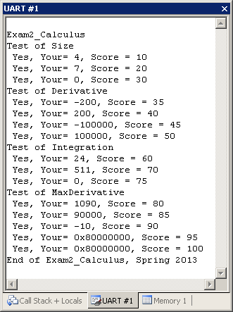
I promise to follow these rules
This is a closed book exam. You must develop the software solution using the Keil uVision simulator. You have 60 minutes, so allocate your time accordingly. You must bring a laptop and are allowed to bring only some pens and pencils (no books, cell phones, hats, disks, CDs, or notes). You will have to leave other materials up front. Each person works alone (no groups). You have full access to Keil uVision, with the Keil uVision help. You may use the Window’s calculator. You sit in front of a computer and edit/assemble/run/debug the programming assignment. You do NOT have access the book, internet or manuals. You may not take this paper, scratch paper, or rough drafts out of the room. You may not access your network drive or the internet. You are not allowed to discuss this exam with other EE319K students until Friday afternoon.

The following activities occurring during the exam will be considered scholastic dishonesty:
1) running any program from the PC other than Keil uVision, or a calculator,
2) communicating with other students by any means about this exam until Friday,
3) using material/equipment other than a pen/pencil.
Students caught cheating will be turned to the Dean of Students.

Signed: ____________________ March 28, 2013

Procedure
First, you will log onto the computer and download files from the web as instructed by the TAs.
Web site xxxx
user: xxxx
password: xxxx

Unzip the folder placing it in a temporary folder. You are not allowed to archive this exam. Within Keil uVision open the project, put your name on the first comment line of the file Exam2.c. Before writing any code, please build and run the system. You should get output like the figure above (but a much lower score). You may wish create backup versions of your program. If you wish to roll back to a previous version, simply open one of the backup versions.
My main program will call your subroutines multiple times, and will give your solution a performance score of 0 to 100. You should not modify my main program or my example data. Each time you add a block of code, you should run my main program, which will output the results to the UART#1 window. After you are finished, raise your hand and wait for a TA. The TA will direct you on how to complete the submission formalities. The TA will run your program in front of you and record your performance score on your exam cover sheet. The scoring page will not be returned to you.
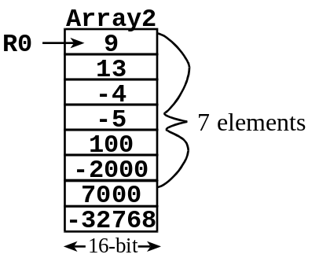
The format of the arrays in parts a) c) and d) are the same. Each element in the array is a 16-bit signed number. The array is terminated with a -32768. The -32768 is not one of the data elements. Look at the comments to see the test data.

Part a) The first subroutine, called Size, determines the number of elements in a variable-length array.

Part b) The second subroutine, called Derivative, calculates the derivative given two points. The return value should be (second-first)*10.

Part c) Write the third subroutine, called Integration, calculates the integral of the data. For this problem first calculate the sum of all data, and then divide by 10.

Part d) Write the fourth subroutine, called MaxDerivative, calculates the derivatives of all adjacent elements in the array. An array with n elements will require the calculation of (n-1) derivatives. Then this subroutine returns the largest derivative.

Part e) Write the fifth subroutine, called Ave6, calculates the average of 6 numbers. This part is extra credit worth 5 more points.

Important Notes:
- Your subroutines should work for all cases shown in the starter file.
- Handle the simple cases first and the special cases last.

Note that calling your subroutine in part (b) in part (d) will greatly reduce the amount of code you will need to write.

Submission Guidelines:
- Log onto Canvas and submit your Exam2.c source file into the Exam2 field. Be careful because only one submission will be allowed.

