EID:___________________ First:__________________ Last:___________________________

Scoring The correct output values are shown in the figure. Your grade will be based both on the numerical results returned by your program and on your programming style. In particular, write code that is easy to understand, easy to debug, easy to change. Please employ good labels, pretty structure, and good comments.
Instructor (Circle):
Performance Score=  Run by TA at the checkout |  | TA:  NT MT RY VJR JV
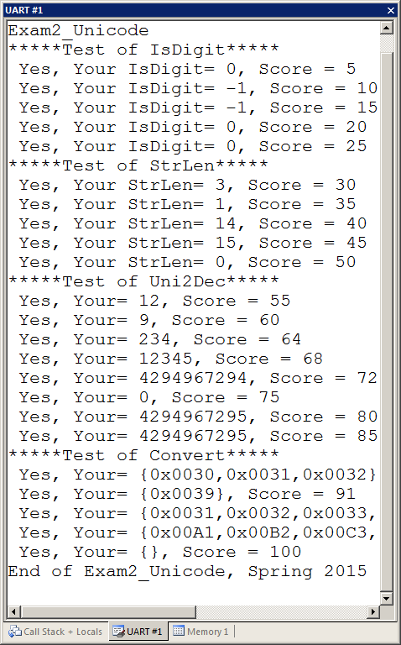

I promise to follow these rules
This is a closed book exam. You must develop the software solution using the Keil uVision simulator. You have 70 minutes, so allocate your time accordingly. You must bring a laptop and are allowed to bring only some pens and pencils (no books, cell phones, hats, disks, CDs, or notes). You will have to leave other materials up front. Each person works alone (no groups). You have full access to Keil uVision, with the Keil uVision help. You may use the Window’s calculator. You sit in front of a computer. You edit, assemble, run, and debug the assignment. You do NOT have access the book, internet or manuals. You may not run out of DropBox, GoogleDrive, Box or similar backup service during the exam. You may not take this paper, scratch paper, or rough drafts out of the room. You may not access your network drive or the internet. You are not allowed to discuss this exam with other EE319K students until Friday afternoon.

The following activities occurring during the exam will be considered scholastic dishonesty:
1) running any program from the PC other than Keil uVision, or a calculator,
2) communicating with anyone else except for the instructors by any means about this exam until Friday
3) using material/equipment other than a pen/pencil,
4) hard-coding so it outputs answers that give points without actually solving the problem,
5) modifying anything other than Exam2.c
Students caught cheating will be turned to the Dean of Students. Your signature is your promise that you have not cheated and will not cheat on this exam, nor will you help others to cheat on this exam:

Signed: ________________________________________ April 9, 2015

Procedure
First, you will log onto the computer and download files from the web as instructed by the TAs.
Web site xxx
User: xxx
Password: xxx

UNZIP the folder placing it ON THE DESKTOP. You are not allowed to archive this exam during the exam time. Within Keil uVision open the project, put your name on the first comment line of the file Exam2.c. Before writing any code, please build and run the system. You should get output like the figure above (but a much lower score). You are allowed to create backup versions of your program. If you wish to roll back to a previous version, simply open one of the backup versions.
My main program will call your subroutines multiple times, and will give your solution a performance score of 0 to 100. You should not modify my main program or my example data. Each time you add a block of code, you should run my main program, which will output the results to the UART#1 window. After you are finished, raise your hand and wait for a TA. The TA will direct you on how to complete the submission formalities. The TA will run your program in front of you and record your performance score on your exam cover sheet. The scoring page will not be returned to you.

The exam has four parts a) through d), details of which are given in the starter code (Exam2.c):

Part a) Unicode characters are 16-bit unsigned values. The first subroutine you will write, called IsDigit, checks whether or not the Unicode character is a valid decimal digit (‘0’-‘9’). If it is a digit (0x0030≤in≤0x0039 then return a -1. Return a 0 if the Unicode character is not a valid decimal digit.

Part b) The second subroutine you will write, called StrLen, returns the length of a null-terminated string of Unicode characters. The figure illustrates an example of a Unicode string with 3 characters terminated with a null. When this string is passed to your function, you should return 3 because there are three characters.
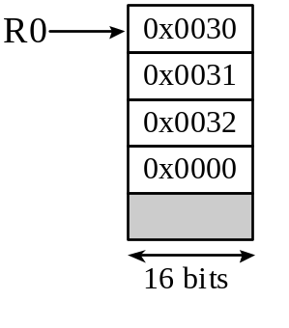

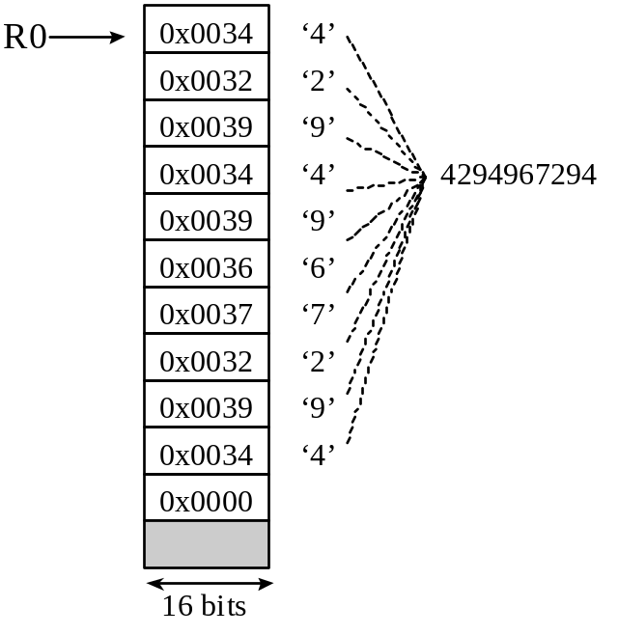
Part c) The third subroutine you will write, called Uni2Dec, takes a null-terminated string of Unicode characters and calculates the decimal value represented by the characters. Considering the first figure, the decimal characters are ‘0’, ‘1’, and ‘2’. The value of these three decimal digits is 0*100+1*10+2 = 12. Notice it can be calculated as

(((0)*10)+1)*10+2,

If any of the Unicode characters is not a valid decimal digit, return 0xFFFFFFFF. The input string may have 0 to 10 characters. You should return 0 if the input string is empty. Considering the second figure showing the largest valid number, the decimal characters are ‘4’, ‘2’, ‘9’, ‘4’, ‘9’, ‘6’, ‘7’, ‘2’, ‘9’, and ‘4’. The value of these ten decimal digits is 4294967294. Notice 4294967294 can be calculated as

(((((((((4)*10+2)*10+9)*10+4)*10+9)*10+6)*10+7)*10+2)*10+9)*10+4

Inside a loop you calculate n = 10*n+digit
Do not worry about overflow during calculations
Part d) The fourth subroutine you will write, called Convert, will convert an ASCII string into a Unicode string. ASCII characters are 8 bits. For each 8-bit ASCII character, the equivalent 16-bit Unicode character has the same unsigned value (do an unsigned promotion from 8 to 16 bits). The figure illustrates the first test case. The input string is 3 ASCII characters occupying 4 bytes in RAM. The input buffer has enough space for 7 Unicode characters (16 bytes). Your function should convert that same buffer to 3 Unicode characters with Unicode null.

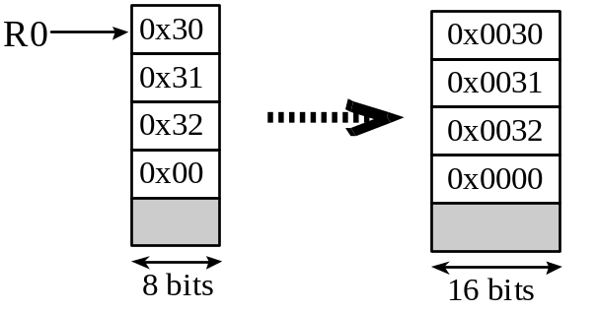

Important Notes:
- Your subroutines should work for all cases shown in the starter file.
- Handle the simple cases first and the special cases last.
- You are NOT required to call your subroutines from within other subroutines, but doing so may be beneficial in some cases.

Submission Guidelines:
- Log onto Canvas and submit your Exam2.c source file into the Exam2 submission link. Be careful because only one submission will be allowed.

