Figure 1 illustrates two trains that do not touch and do not overlap

Train1 is x=0, length=2; Train2 is x=5, length =3

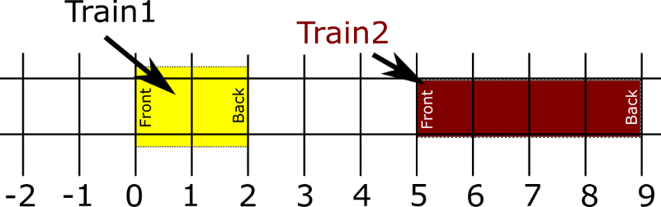
Figure 1. No touching, and no overlapping.

Figures 2 and 3 illustrate two trains that do touch but do not overlap

Train1 is x=0, length=4; Train2 is x=4, length =3

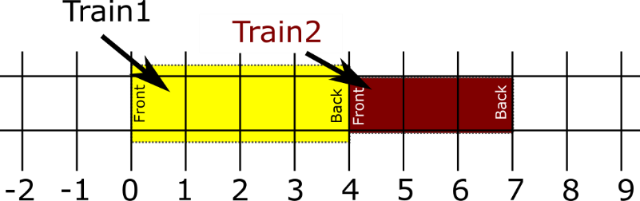
Figure 2. Touching, but not overlapping.

Train1 is x=4, length=2; Train2 is x=1, length =3
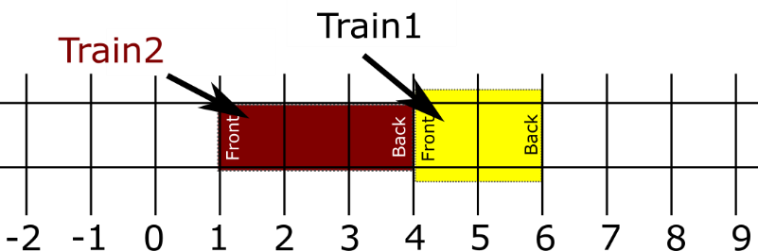

Figure 3. Touching, but not overlapping.

Figures 4 and 5 illustrate two trains that overlap but do not touch

Train1 is x=4, length=4; Train2 is x=2, length =3
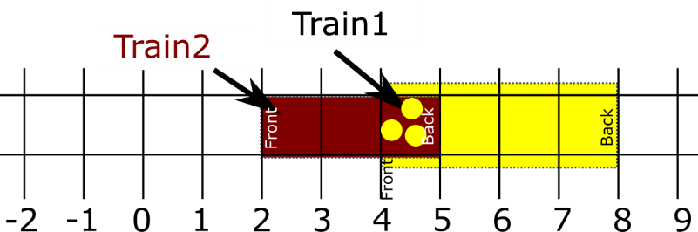

Figure 4. Overlapping but not touching.

Train1 is x=1, length=4; Train2 is x=3, length =3
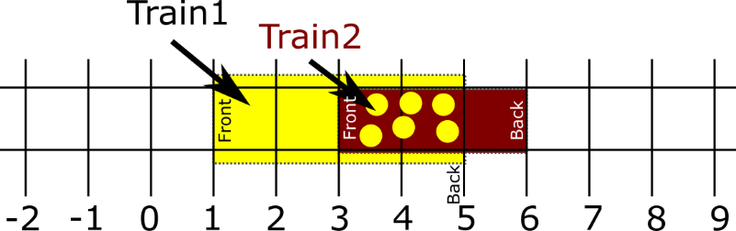
Figure 5. Overlapping but not touching.

