EXPERIMENT NO. 27
AIM
To implement a binary semaphore for controlling access to a critical section using SystemC.
ALGORITHM
- Initialize the binary semaphore to 1.
- Create two concurrent tasks.
- A task enters the critical section only when the semaphore is available.
- Release the semaphore after the critical section.
- Run the simulation and observe access.
PROGRAM
#include <systemc.h>
SC_MODULE(binary_semaphore)
{
int sem;
void task1()
{
while(true)
{
if(sem > 0)
{
sem--;
cout << "Task1 Entered Critical Section at "
<< sc_time_stamp() << endl;
wait(1, SC_SEC);
sem++;
}
wait(1, SC_SEC);
}
}
void task2()
{
while(true)
{
if(sem > 0)
{
sem--;
cout << "Task2 Entered Critical Section at "
<< sc_time_stamp() << endl;
wait(1, SC_SEC);
sem++;
}
wait(1, SC_SEC);
}
}
SC_CTOR(binary_semaphore)
{
sem = 1;
SC_THREAD(task1);
SC_THREAD(task2);
}
};
int sc_main(int argc, char* argv[])
{
binary_semaphore obj("Binary_Semaphore");
sc_start(10, SC_SEC);
return 0;
}
OUTPUT
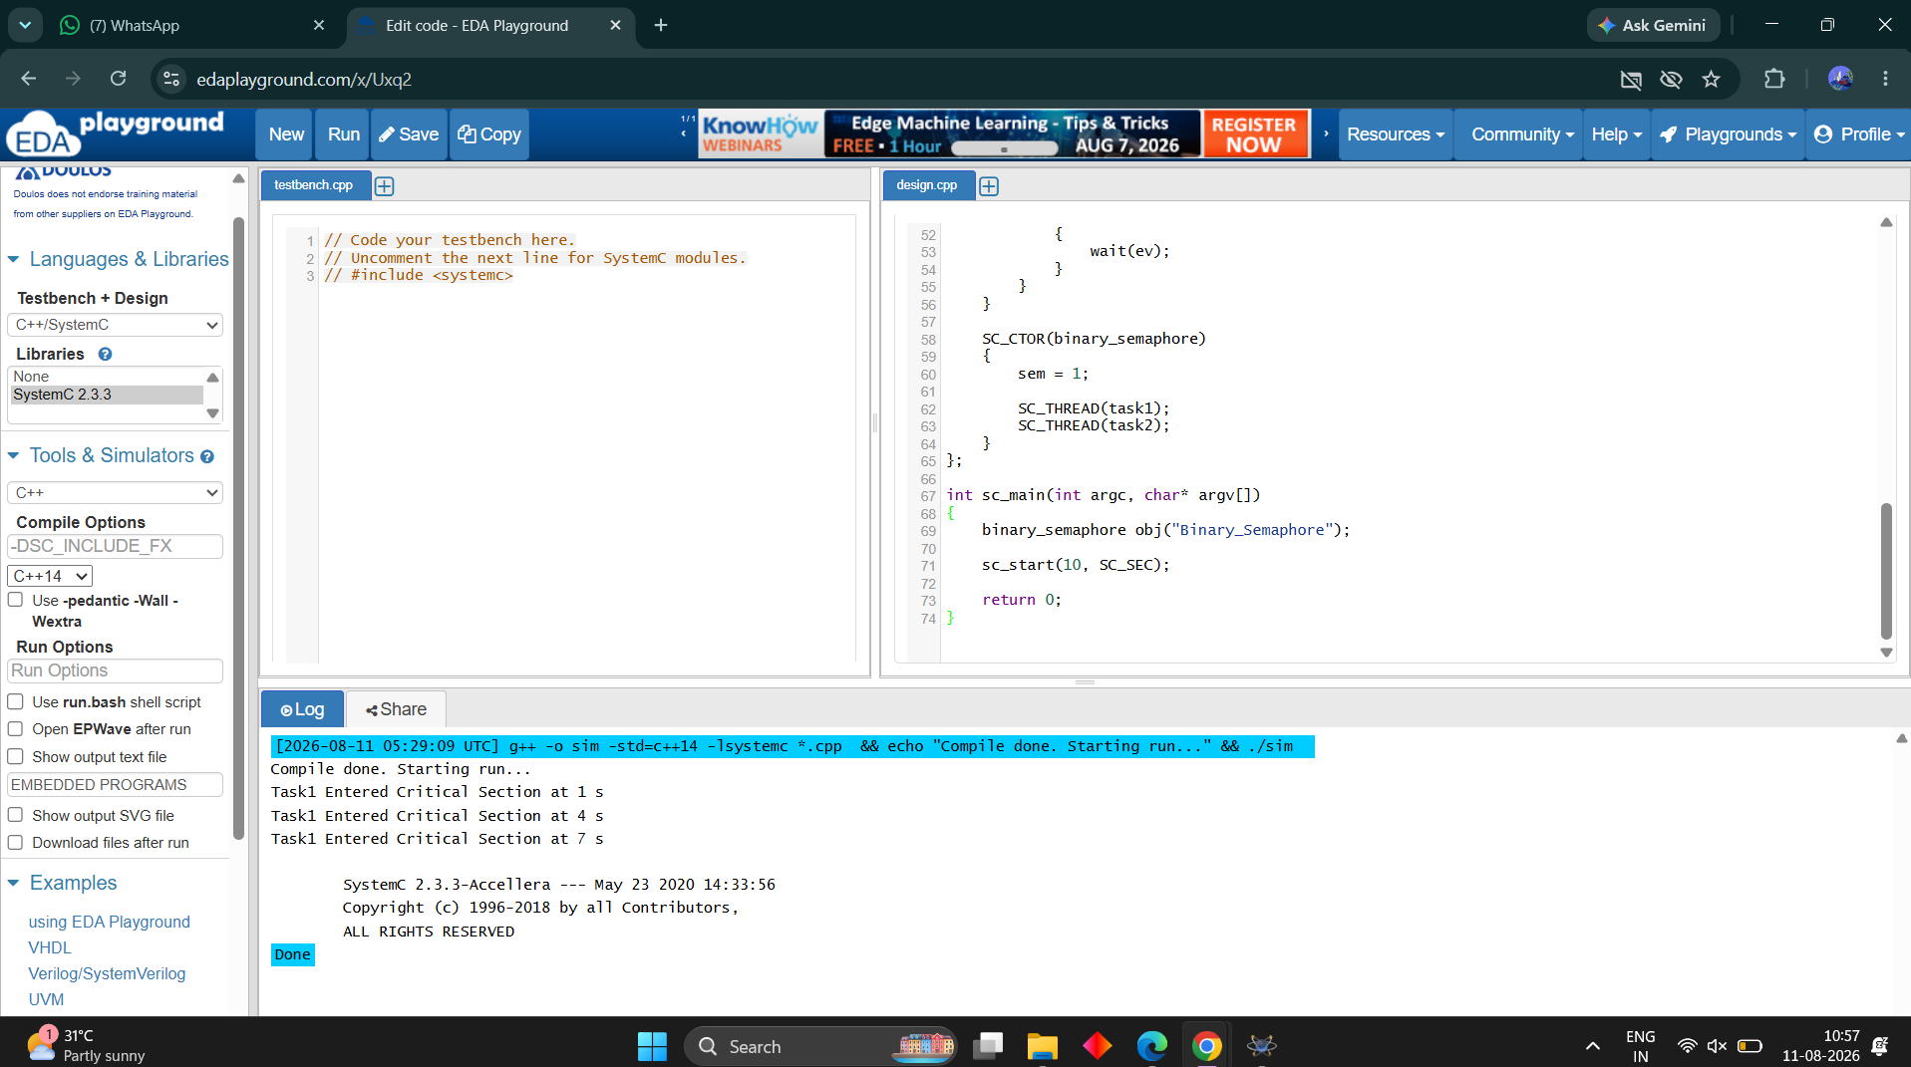
RESULT
Thus the binary semaphore was successfully implemented and verified for critical-section access.

