EXPERIMENT NO. 29
AIM
To demonstrate priority-based interrupt handling using SystemC.
ALGORITHM
- Create low-priority and high-priority interrupt processes.
- Generate the low-priority interrupt at 1 second.
- Generate the high-priority interrupt at 2 seconds.
- Handle and display the interrupt events according to their priority.
PROGRAM
#include <systemc.h>
SC_MODULE(priority_interrupt)
{
sc_event high_int;
void low_ISR()
{
wait(1, SC_SEC);
cout << "Low Priority Interrupt at "
<< sc_time_stamp() << endl;
}
void high_ISR()
{
wait(high_int);
cout << "High Priority Interrupt at "
<< sc_time_stamp() << endl;
}
void generator()
{
wait(2, SC_SEC);
high_int.notify();
}
SC_CTOR(priority_interrupt)
{
SC_THREAD(low_ISR);
SC_THREAD(high_ISR);
SC_THREAD(generator);
}
};
int sc_main(int argc, char* argv[])
{
priority_interrupt obj("Priority_INT");
sc_start(10, SC_SEC);
return 0;
}
OUTPUT
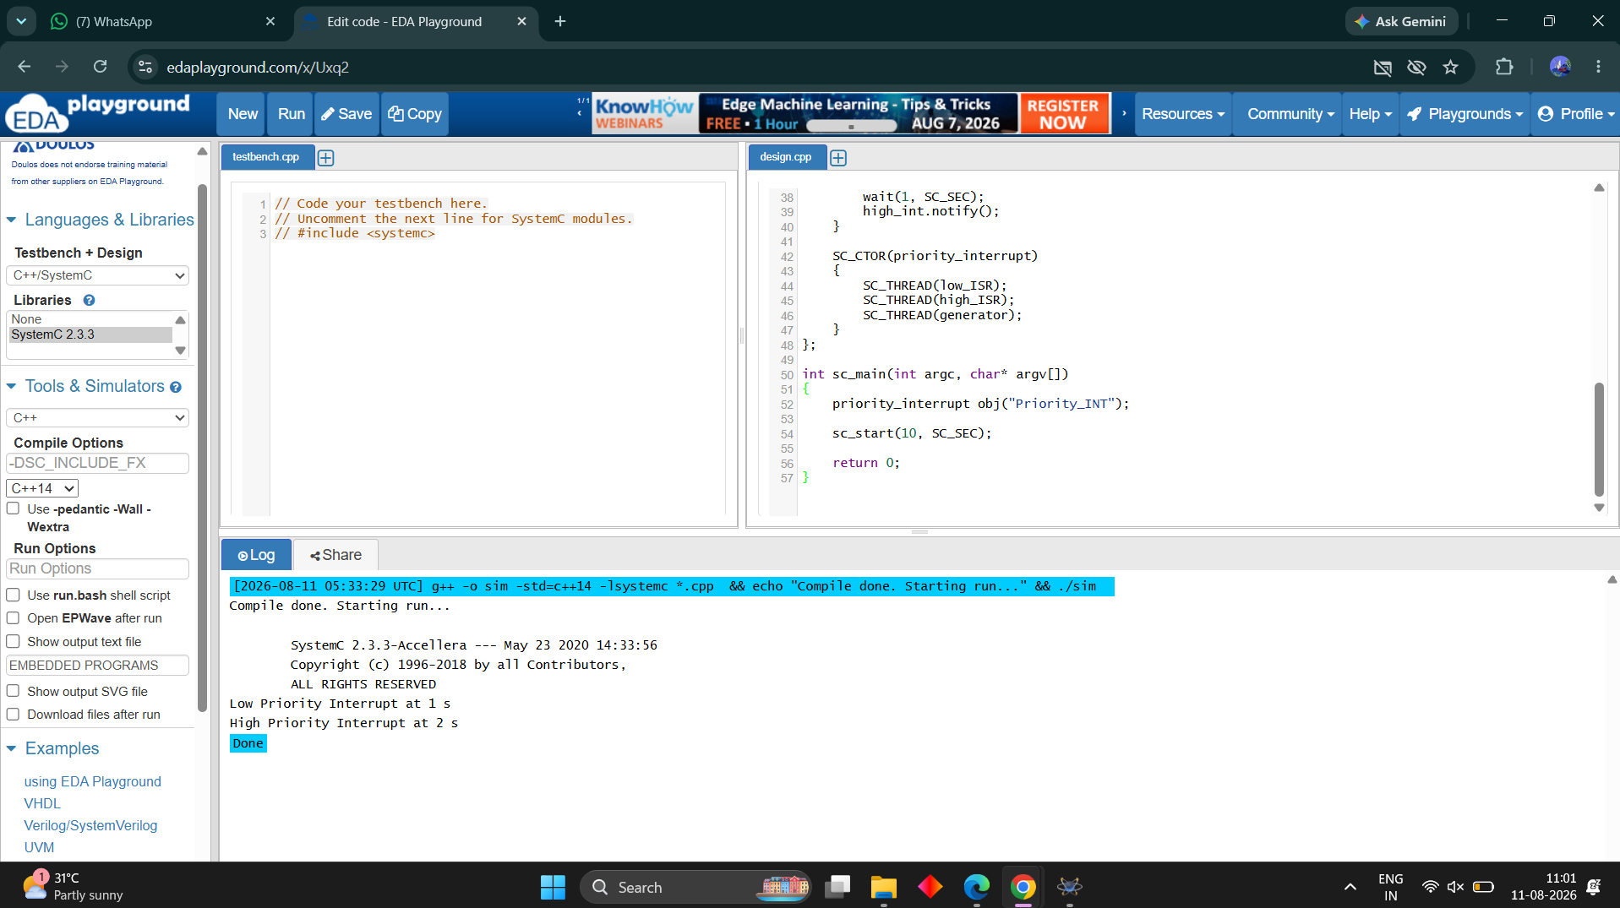
RESULT
Thus the priority-based interrupt handling was successfully implemented and verified.

