EXPERIMENT – 9
Ultrasonic Distance Measurement using Arduino UNO
Aim
To interface an ultrasonic sensor with Arduino UNO and measure the distance of an object, displaying the measured distance through the Virtual Terminal in Proteus.
Components / Software Required
- Arduino UNO
- Ultrasonic sensor (HC-SR04)
- Virtual Terminal
- Proteus 8 Professional
- Arduino IDE
Connections
Component | Arduino Pin
Ultrasonic TRIG | D9
Ultrasonic ECHO | D10
Virtual Terminal RXD | D1 (TX)
Virtual Terminal TXD | D0 (RX)
VCC | 5V
GND | GND
Algorithm
1. Start the program.
2. Initialize the ultrasonic sensor pins and serial communication.
3. Send a short HIGH pulse to the TRIG pin.
4. Measure the duration of the pulse received at the ECHO pin.
5. Calculate distance using: Distance = (Time × 0.0343) / 2.
6. Display the distance in centimetres on the Virtual Terminal.
7. Repeat the process continuously.
Arduino Program
const int trigPin = 9;
const int echoPin = 10;
long duration;
float distance;
void setup()
{
pinMode(trigPin, OUTPUT);
pinMode(echoPin, INPUT);
Serial.begin(9600);
}
void loop()
{
digitalWrite(trigPin, LOW);
delayMicroseconds(2);
digitalWrite(trigPin, HIGH);
delayMicroseconds(10);
digitalWrite(trigPin, LOW);
duration = pulseIn(echoPin, HIGH);
distance = (duration * 0.0343) / 2.0;
Serial.print("Distance = ");
Serial.print(distance);
Serial.println(" cm");
delay(500);
}
Output
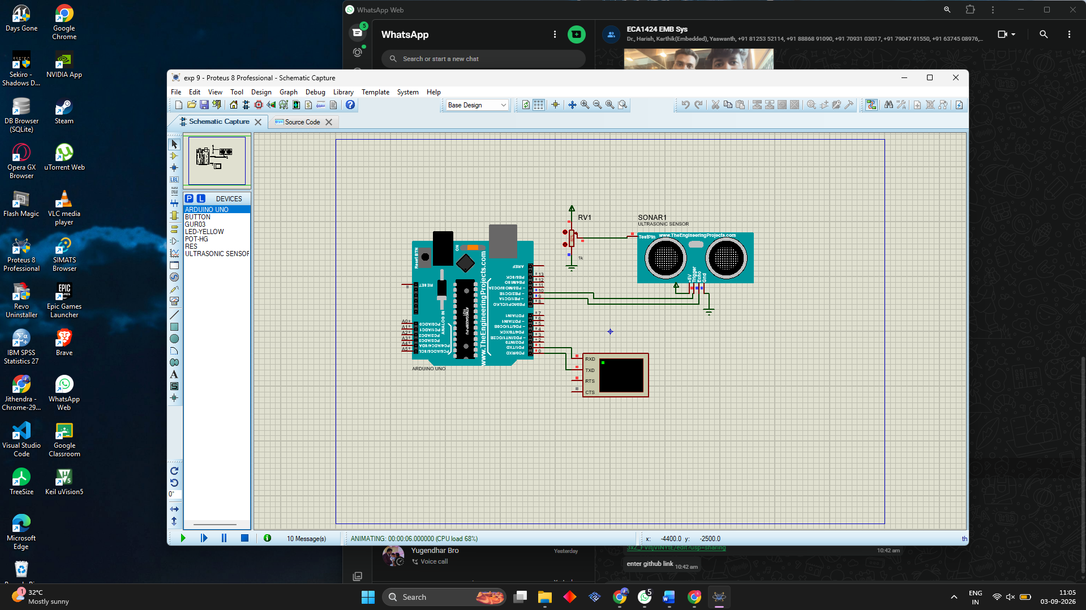Result
Thus, the ultrasonic sensor was successfully interfaced with Arduino UNO and the distance of the object was measured and displayed through the Virtual Terminal.
Viva – Important Questions
What is the purpose of the ultrasonic sensor? It measures the distance of an object.
What is the formula used? Distance = (Time × 0.0343) / 2.
Why is the division by 2 required? The ultrasonic wave travels to the object and back.
What does pulseIn() do? It measures the duration of a HIGH pulse.
Why is Serial.begin(9600) used? To initialize serial communication at 9600 baud.

