Exp No: 18
GENERATION OF PWM USING TIMER INTERRUPT
AIM : To generate PWM using Timer interrupt.

SOFTWARE REQUIRED :
- PC with Windows OS
- Keil $μ$Vision IDE
- 8051 Simulator (Keil built-in)
- Serial Window (UART #1)
PROGRAM :
#include <reg51.h>
sbit PWM = P1^0;
unsigned char count = 0;
unsigned char duty = 100; // Change this value (0–200)

void timer0_ISR(void) interrupt 1
{
TH0 = 0xFC; // Reload for 1ms delay
TL0 = 0x66;

count++;

if(count < duty)
PWM = 1; // ON time
else
PWM = 0; // OFF time

if(count >= 200) // Total period = 200ms
{
count = 0;
}
}

void main()
{
TMOD = 0x01; // Timer0 Mode 1 (16-bit)
TH0 = 0xFC; // 1ms preload
TL0 = 0x66;

IE = 0x82; // EA = 1, ET0 = 1
TR0 = 1; // Start Timer0

while(1);
}
Circuit Diagram:
15% Duty Cycle:
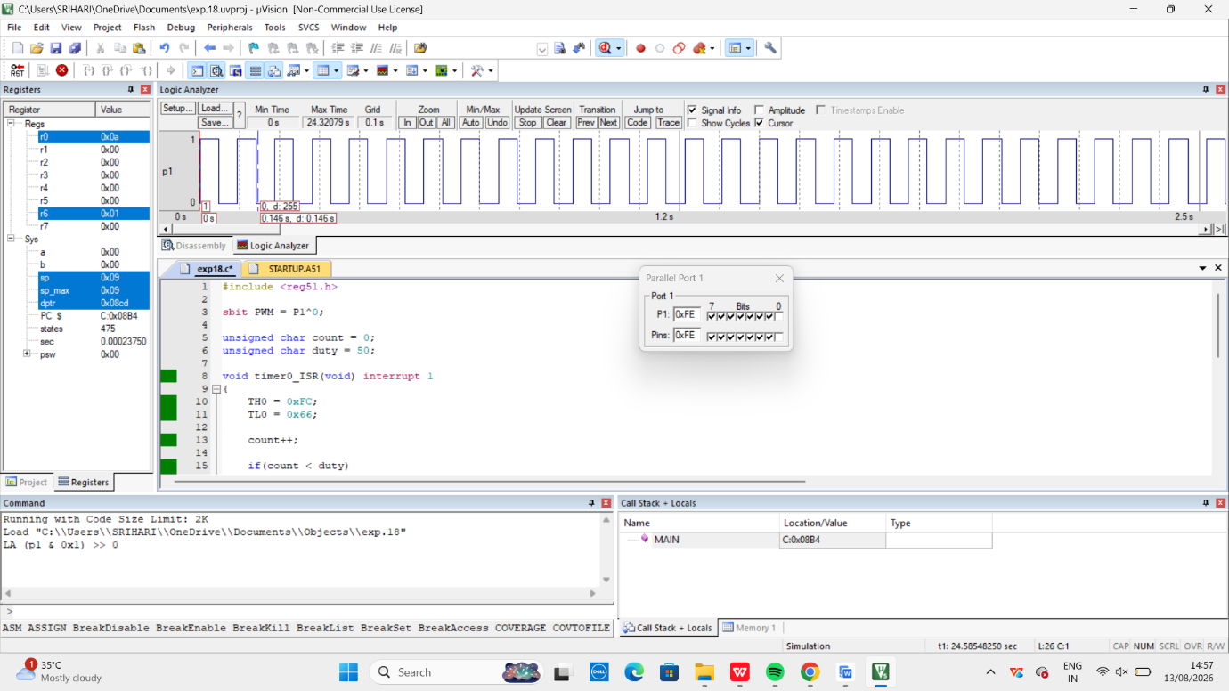
50% Duty Cycle:
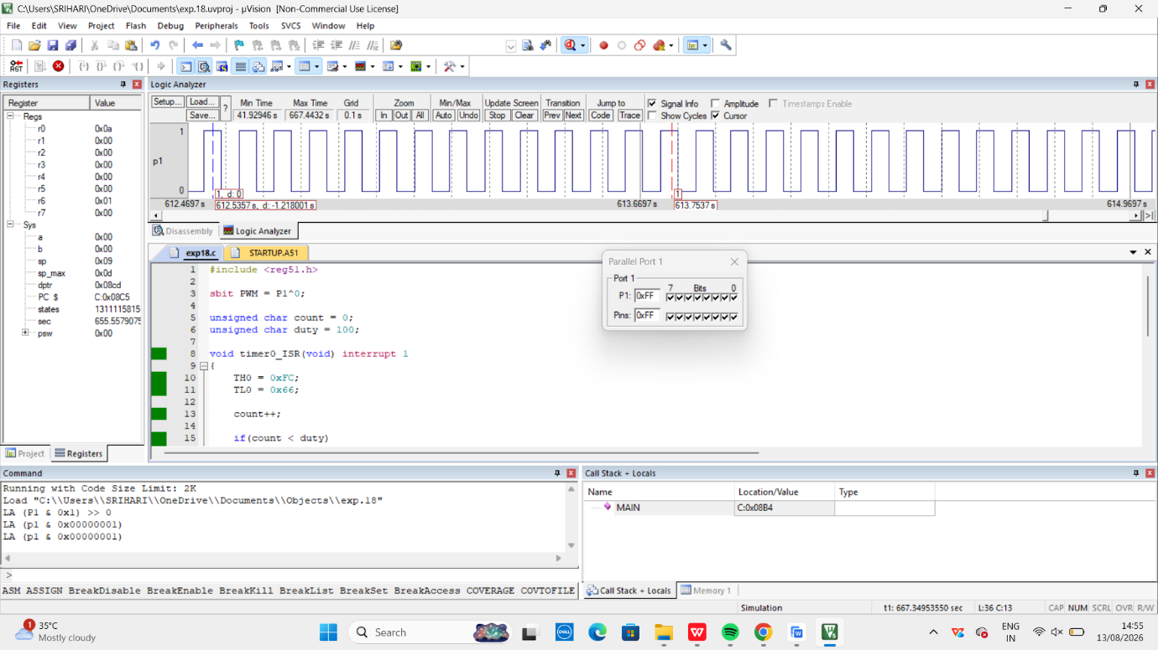
75% Duty Cycle:
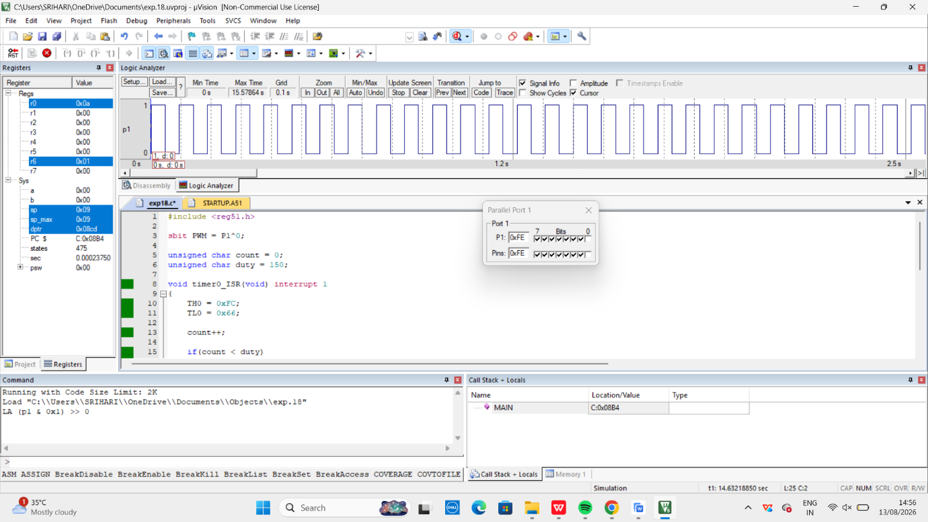
RESULT :
Thus, the serial interrupt using UART was successfully implemented and verified in Keil simulator. The interrupt was triggered upon keyboard input and serviced correctly using an Interrupt Service Routine.

