EXPERIMENT NO. 26
AIM
To model Transaction Level Modeling (TLM) using SystemC.
ALGORITHM
- Create an Initiator and Target module.
- Create TLM initiator and target sockets.
- Bind the initiator socket to the target socket.
- Send the value 555 using b_transport.
- Display the sent and received values.
PROGRAM
#include <systemc.h>
#include <tlm>
#include <tlm_utils/simple_initiator_socket.h>
#include <tlm_utils/simple_target_socket.h>
using namespace tlm;
struct Target : sc_module
{
tlm_utils::simple_target_socket<Target> socket;
SC_CTOR(Target)
{
socket.register_b_transport(this, &Target::b_transport);
}
void b_transport(tlm_generic_payload& trans, sc_time& delay)
{
int data = *reinterpret_cast<int*>(trans.get_data_ptr());
cout << "Target received: " << data << endl;
}
};
struct Initiator : sc_module
{
tlm_utils::simple_initiator_socket<Initiator> socket;
SC_CTOR(Initiator)
{
SC_THREAD(thread_process);
}
void thread_process()
{
int data = 555;
tlm_generic_payload trans;
sc_time delay = SC_ZERO_TIME;
trans.set_data_ptr(reinterpret_cast<unsigned char*>(&data));
trans.set_data_length(sizeof(data));
cout << "Initiator sending: " << data << endl;
socket->b_transport(trans, delay);
wait(delay);
}
};
int sc_main(int argc, char* argv[])
{
Initiator initiator("initiator");
Target target("target");
initiator.socket.bind(target.socket);
sc_start();
return 0;
}
OUTPUT
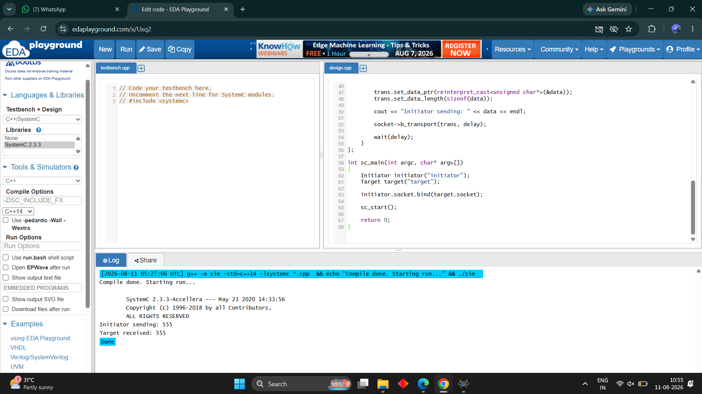
RESULT
Thus the Transaction Level Modeling communication between the Initiator and Target was successfully implemented and verified.

