EXPERIMENT NO. 28
AIM
To implement a counting semaphore for controlling access to shared resources using SystemC.
ALGORITHM
- Initialize the counting semaphore to 2.
- Create concurrent tasks sharing the resource.
- Allow a task to access the resource only when a semaphore count is available.
- Decrease the count on entry and increase it after access.
- Display the remaining count.
PROGRAM
#include <systemc.h>
SC_MODULE(counting_semaphore)
{
int sem;
void task()
{
while(true)
{
if(sem > 0)
{
sem--;
cout << "Task Accessing Resource at "
<< sc_time_stamp()
<< " R Remaining: " << sem << endl;
wait(1, SC_SEC);
sem++;
}
wait(1, SC_SEC);
}
}
SC_CTOR(counting_semaphore)
{
sem = 2;
SC_THREAD(task);
SC_THREAD(task);
SC_THREAD(task);
}
};
int sc_main(int argc, char* argv[])
{
counting_semaphore obj("Counting");
sc_start(10, SC_SEC);
return 0;
}
OUTPUT
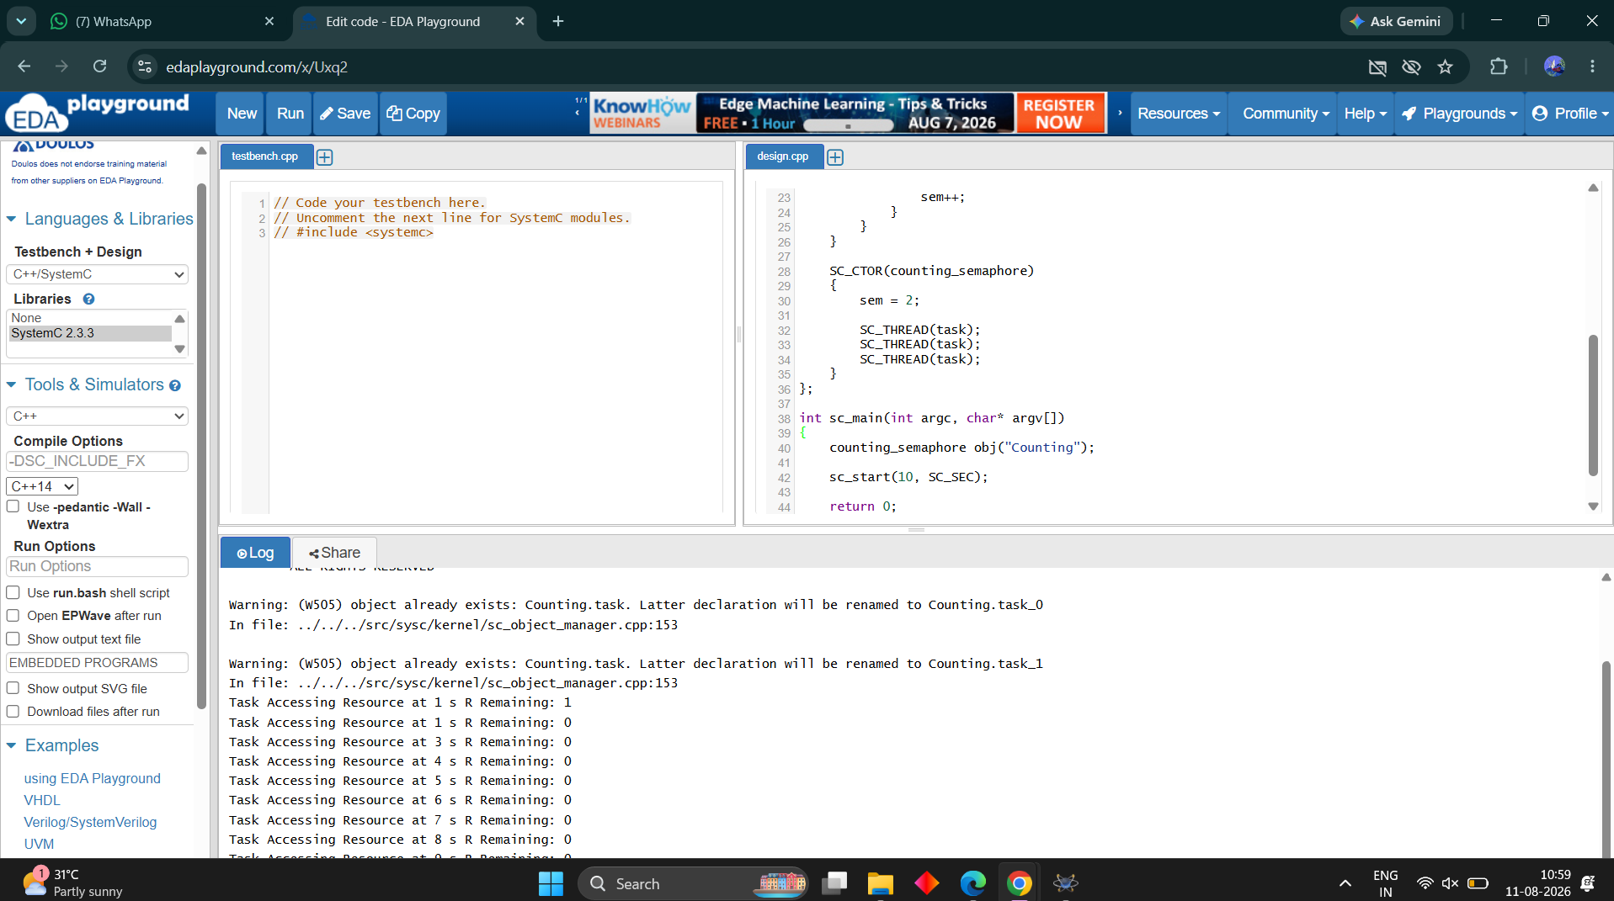
RESULT
Thus the counting semaphore was successfully implemented and verified for shared-resource access.

