EXPERIMENT NO. 30
AIM
To demonstrate RTOS task scheduling using SystemC.
ALGORITHM
- Create two RTOS tasks.
- Execute each task periodically using wait().
- Display the execution time of each task.
- Run the scheduler for 6 seconds.
PROGRAM
#include <systemc.h>
SC_MODULE(rtos_scheduler)
{
void task1()
{
while(true)
{
cout << "Task1 Running at "
<< sc_time_stamp() << endl;
wait(1, SC_SEC);
}
}
void task2()
{
while(true)
{
cout << "Task2 Running at "
<< sc_time_stamp() << endl;
wait(1, SC_SEC);
}
}
SC_CTOR(rtos_scheduler)
{
SC_THREAD(task1);
SC_THREAD(task2);
}
};
int sc_main(int argc, char* argv[])
{
rtos_scheduler obj("Scheduler");
sc_start(6, SC_SEC);
return 0;
}
OUTPUT
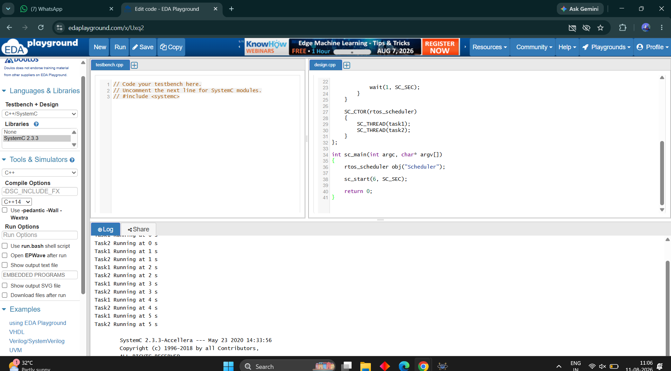
RESULT
Thus the RTOS task scheduling was successfully implemented and verified.

