ER and Diag => Drop Down Selections
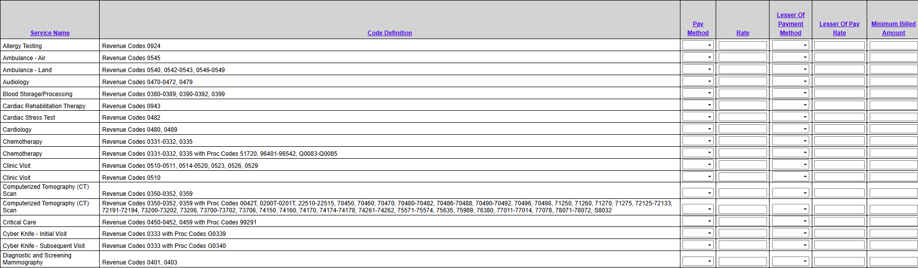
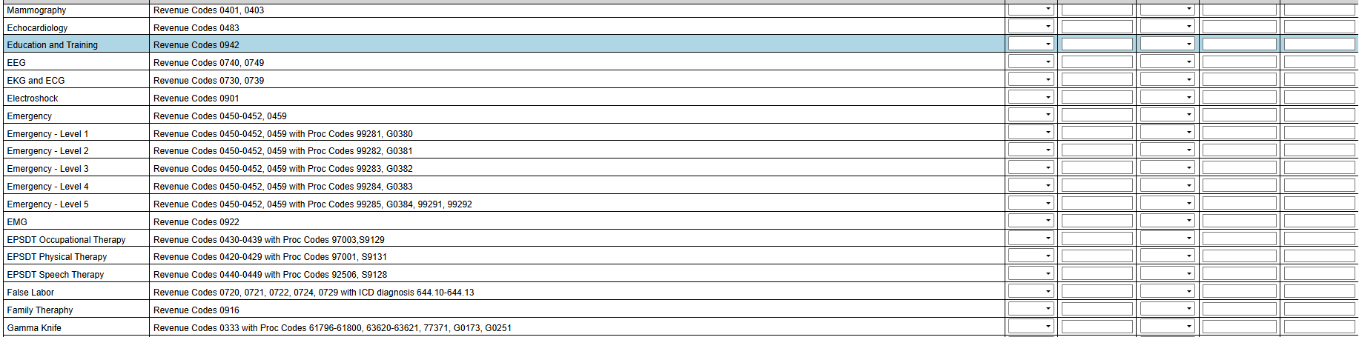
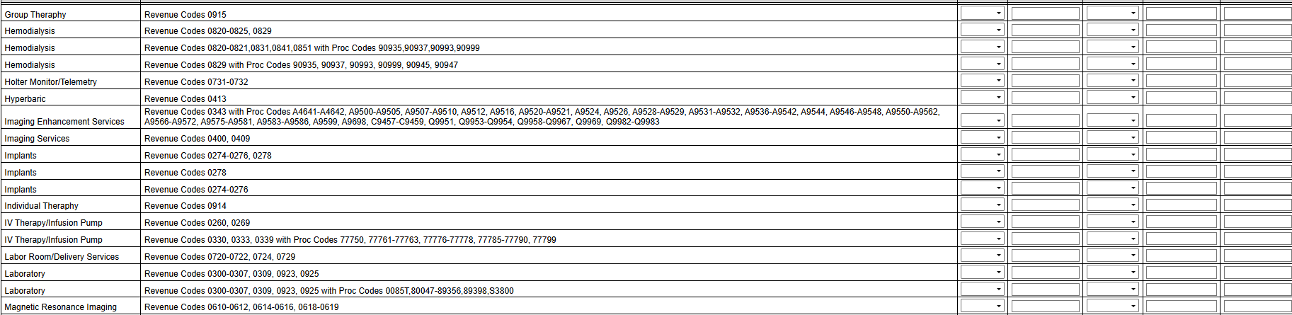
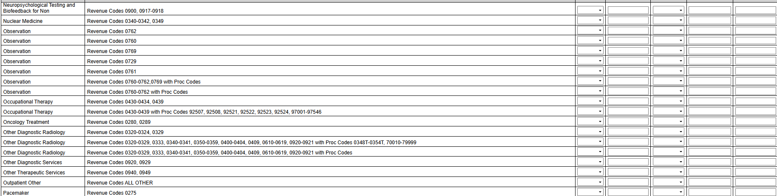
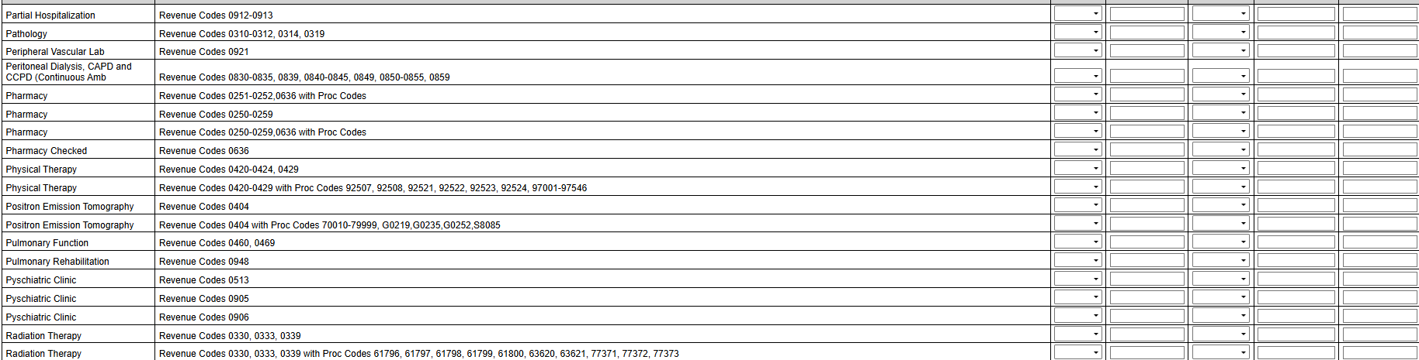
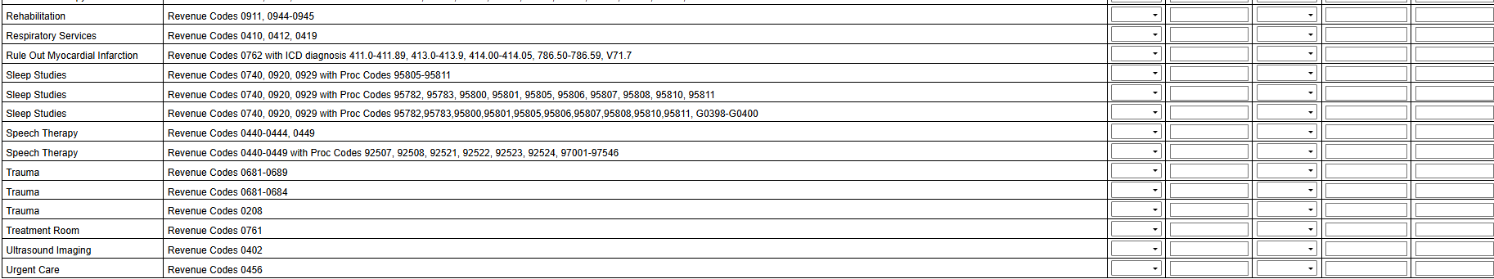
Procedures => Drop Down Selections
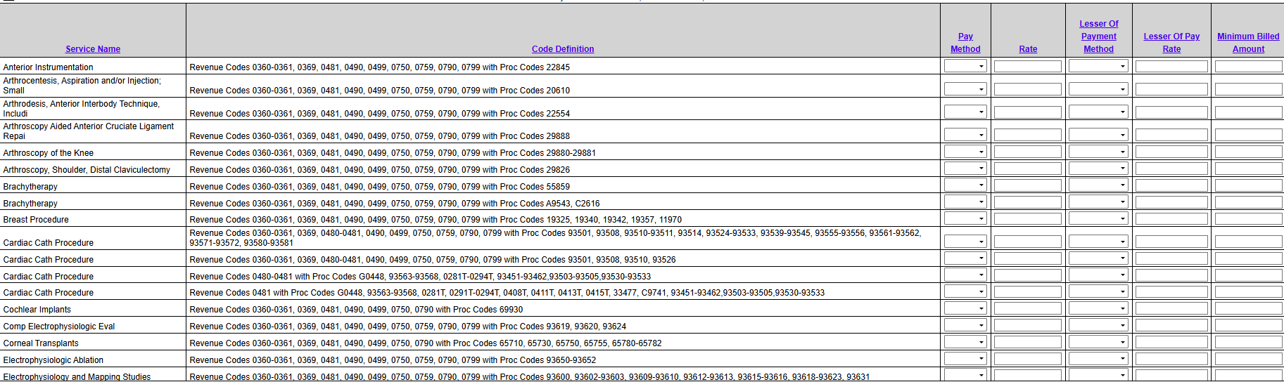
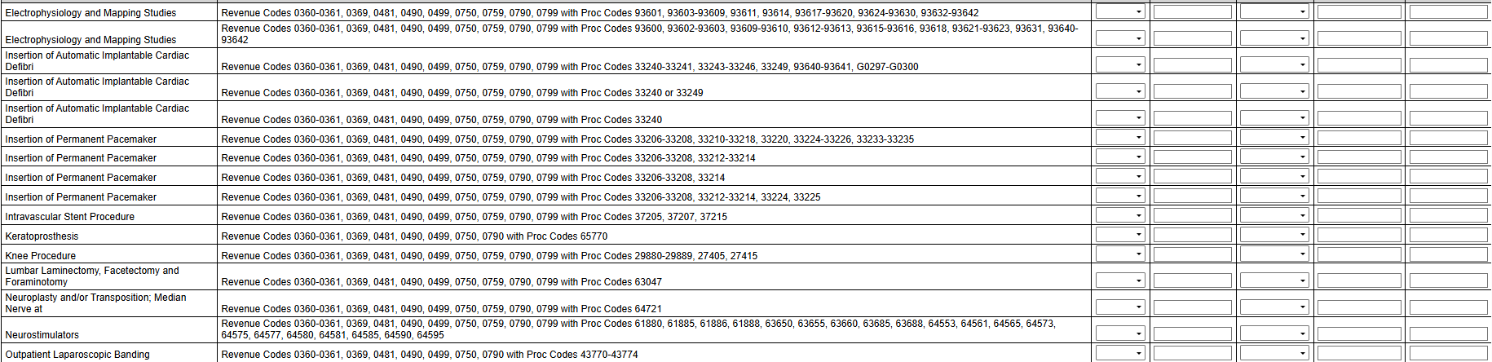
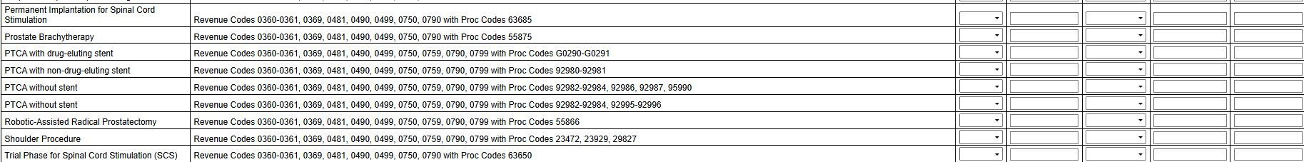
Surgery Special => Drop Down Selections


