1)

Results with predictands both:

df_train, df_test, X_train, y_train, X_test, y_test, predictors, predictands = preprocess_data(scalertype='minmax',  
 outlier_method='iqr',  
 scale_predictands=True,  
 selected_predictands=predictands,  
 train_fraction=0.75)

Batch Size 64

Epoch 30/30 | Train Loss: 0.0408 | Val Loss: 0.0409 | LR: 0.000500

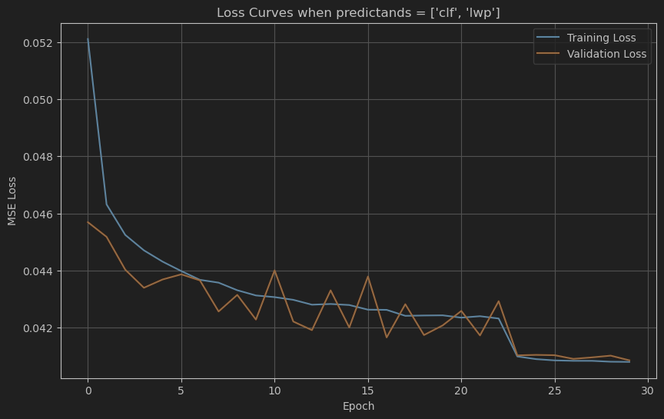2) Predictand = clf

Batch Size 64

df_train, df_test, X_train, y_train, X_test, y_test, predictors, predictands = preprocess_data(scalertype='minmax',  
 outlier_method='iqr',  
 scale_predictands=True,  
 selected_predictands=predictands,  
 train_fraction=0.75)

Epoch 30/30 | Train Loss: 0.0450 | Val Loss: 0.0483 | LR: 0.000500

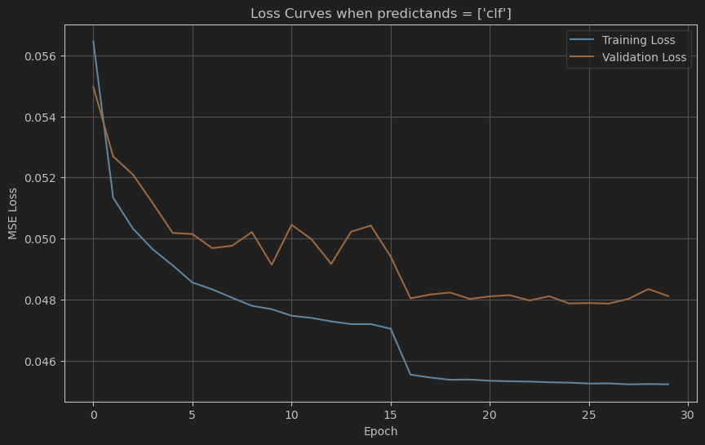

3)

predictand=’lwp’

Batch Size 64

df_train, df_test, X_train, y_train, X_test, y_test, predictors, predictands = preprocess_data(scalertype='minmax',  
 outlier_method='iqr',  
 scale_predictands=True,  
 selected_predictands=predictands,  
 train_fraction=0.75)

Epoch 30/30 | Train Loss: 0.0353 | Val Loss: 0.0334 | LR: 0.000500

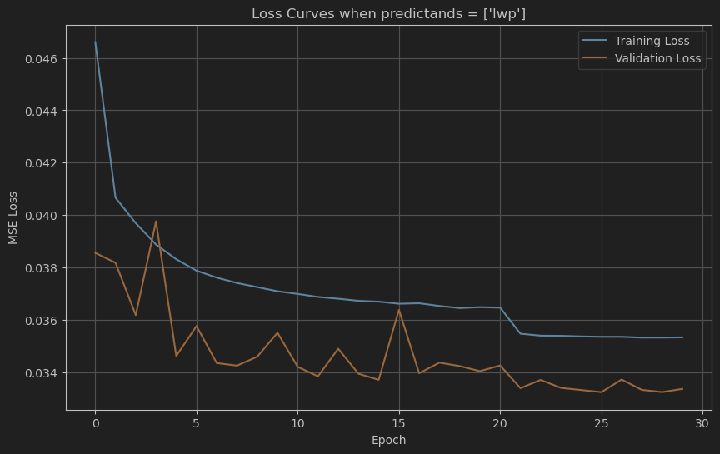

STANDARD SCALER:

predictands = 'both' # 'clf', 'lwp', or 'both'  
  
df_train, df_test, X_train, y_train, X_test, y_test, predictors, predictands = preprocess_data(scalertype='standard',  
 outlier_method='iqr',  
 scale_predictands=True,  
 selected_predictands=predictands,  
 train_fraction=0.75)

Batch size: 64

Epoch 30/30 | Train Loss: 0.5291 | Val Loss: 0.5391 | LR: 0.000005

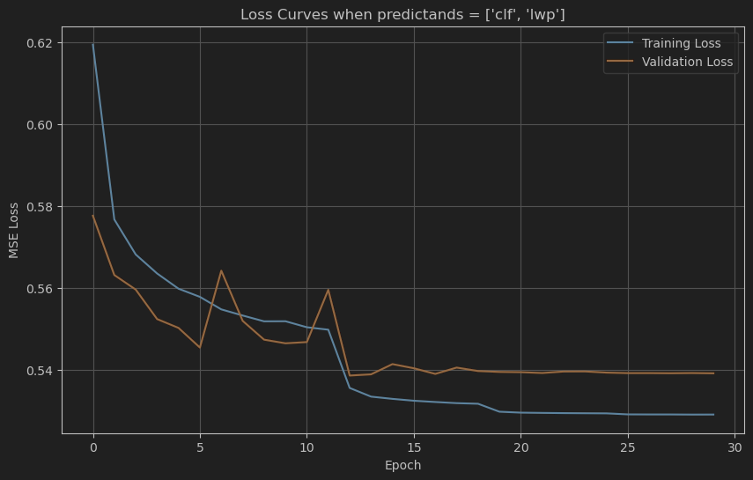

**WITHOUT OUTLIER REMOVAL**

predictands = 'both' # 'clf', 'lwp', or 'both'  
df_train, df_test, X_train, y_train, X_test, y_test, predictors, predictands = preprocess_data(scalertype='minmax',   
 outlier_method=None,  
 scale_predictands=Tru  
 selected_predictands=  
 train_fraction=0.75)

Epoch 30/30 | Train Loss: 0.0265 | Val Loss: 0.0275 | LR: 0.000500

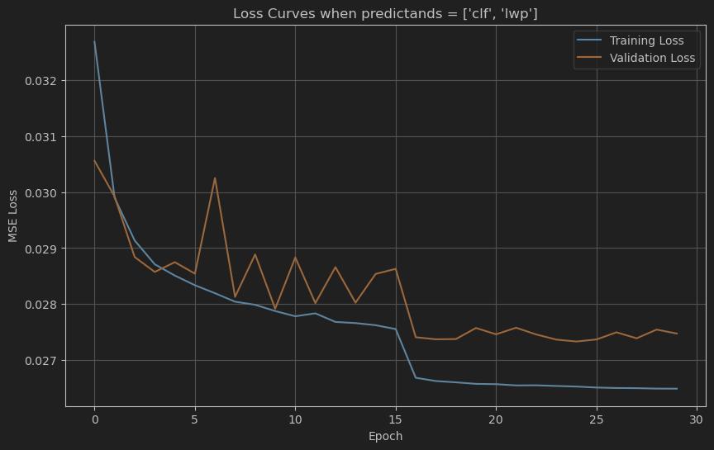<Figure size 1000x600 with 1 Axes>

Final Model Evaluation:

MSE: 0.0275

RMSE: 0.1657

MAE: 0.1151

R²: 0.3984