MANIPAL ACADEMY OF HIGHER EDUCATION
(Institution of Eminence Deemed to be University)

MANIPAL INSTITUTE OF TECHNOLOGY
School of Computer Engineering

[Insert official MAHE / MIT Manipal emblem here]

CES 2112 Digital Systems Lab
(Open Ended Experiment Report)
on
TWO-CAR ELEVATOR COORDINATOR: A SYNCHRONOUS DIGITAL CONTROLLER IN VERILOG HDL

Submitted by
Team member name | Section | Registration / Roll No.
[Member 1 full name] | [Sec.] | [Reg. No.] / [Roll No.]
[Member 2 full name] | [Sec.] | [Reg. No.] / [Roll No.]
[Member 3 full name] | [Sec.] | [Reg. No.] / [Roll No.]
[Member 4 full name] | [Sec.] | [Reg. No.] / [Roll No.]
[Member 5 full name] | [Sec.] | [Reg. No.] / [Roll No.]

Under the guidance of:
Dr. Avik Bose, Assistant Professor
School of Computer Engineering, MIT Manipal

Date: 21/10/2026

TABLE OF CONTENTS
1. PROBLEM STATEMENT 3
System requirements 3
2. OBJECTIVES 3
2.1 Primary objective 3
2.2 Specific objectives 4
2.3 Scope and deliverables 4
3. SYSTEM DESIGN AND BLOCK DIAGRAM 4
3.1 Proposed architecture 4
3.2 Module description 5
3.3 Design decisions 6
4. VERILOG HDL IMPLEMENTATION 6
4.1 Design module 7
4.2 Code explanation 11
4.3 Testbench 12
5. SIMULATION, VERIFICATION AND RESULTS 12
5.1 Experimental setup 12
5.2 Test cases and expected outcomes 12
5.3 Simulation waveform 13
5.4 Results and discussion 14
6. INDIVIDUAL CONTRIBUTION 14
Contribution statement 15
7. CONCLUSION AND FUTURE SCOPE 15
7.1 Conclusion 15
7.2 Limitations and future scope 15
REFERENCES 15

1. PROBLEM STATEMENT
A building with more than one lift needs a group controller: a circuit that decides which car answers each button pressed on a landing. The decision has to be made continuously, while the cars are moving and new calls keep arriving. A poor controller sends both cars to the same floor, leaves one car idle while the other is overloaded, or forgets a request so that a passenger waits indefinitely [5].
Group controllers are usually software on a microcontroller or PLC, whose timing depends on the program and is hard to reason about cycle by cycle. The same function can instead be built as a small synchronous digital circuit in which every decision is held in a register and can be checked clock by clock in simulation.
This project designs, in synthesizable Verilog HDL [3], [4], a coordinator for two elevator cars serving eight floors (F0 to F7). Hall calls (the UP and DOWN buttons on each landing) are stored and assigned, one per clock cycle, to the car that is nearer to the calling floor. Each car is a four-state finite state machine that collects its own cabin calls and the hall calls assigned to it, and visits them by continuing in its current direction while work remains in that direction. Travel time and door-open time are modelled with counters, so that behaviour is realistic in clock cycles.
Scope and assumptions. Inputs are 8-bit button vectors (bit k = floor k) that are high for one clock cycle per press and are synchronous to the system clock. Outputs are the floor, state, direction, timer and cabin calls of each car, the door-open signal, and the six hall-call registers that would drive the landing lamps. One floor takes 8 clock cycles and the door stays open for 10. Motor drives, load weighing, emergency and fire modes, button debouncing and physical FPGA implementation are outside the scope; the design is verified in simulation.

System requirements
TABLE I. SYSTEM REQUIREMENTS
ID | Requirement | Verification method
R1 | Every hall call is latched until answered and is assigned to exactly one car; the nearer car wins and a tie goes to Car A. | Test cases T3 to T6; waveform (Fig. 3)
R2 | Each car serves its cabin calls and assigned hall calls, keeping its direction while work remains ahead. | Test case T2; trace inspection
R3 | Travel takes 8 clock cycles per floor and the door stays open for 10 clock cycles. | Waveform: timer counts 0 to 7 and 0 to 9
R4 | Safety: a door is never open while a car moves; the floor register changes only in a MOVE state. | Test case T7, checked on every cycle
R5 | Liveness: every hall call is answered within 600 clock cycles under random traffic. | Test case T8, five random seeds
R6 | Synchronous reset clears every register; single clock, no combinational feedback loops. | Test case T1; code review

2. OBJECTIVES

2.1 Primary objective
To design and verify a synthesizable Verilog controller that assigns every hall call of an eight-floor building to the nearer of two elevator cars and drives both cars safely to all of their requests.

2.2 Specific objectives
- Implement the controller from standard combinational and sequential building blocks taught in the course: a 3-to-8 decoder, an 8-to-3 priority encoder, magnitude comparators, subtractors, multiplexers, registers, counters and a finite state machine [1], [2].
- Split the design into five design components (combinational building blocks, car FSM, hall-call dispatcher, top-level integration with testbench, and visualisation with co-simulation) so that each team member owns one component.
- Verify the design with a testbench driven by reproducible random stimulus, checking safety and liveness on every clock cycle.
- Cross-check the Verilog against an independent cycle-accurate reference model on every register and every cycle.
- Measure performance (waiting time and car utilisation) over several random traffic patterns.

2.3 Scope and deliverables
- Seven Verilog-2005 modules (rtl/): decoder3to8, floor_masks, priority_encoder8, distance, elevator_car, hall_call_dispatcher and the top level elevator_coordinator.
- Testbench tb/tb_elevator_coordinator.v, a seeded stimulus generator, and a one-command flow (run.sh) that compiles, simulates and runs all checks.
- VCD waveforms viewable in GTKWave [7], and an interactive web visualisation driven by the same register values.

3. SYSTEM DESIGN AND BLOCK DIAGRAM
The design is a single-clock synchronous system made of three blocks: one hall-call dispatcher and two identical elevator cars. All storage is in edge-triggered D flip-flops that update together on the rising edge of clk; a synchronous active-high reset rst clears them. Every request is held in an 8-bit floor vector in which bit k stands for floor k, so set operations on requests become single gates applied to all eight bits in parallel: OR is union, AND is intersection, and AND-NOT removes a served floor.

3.1 Proposed architecture
Fig. 1 shows the complete architecture. Hall buttons go only to the dispatcher; cabin buttons go straight to their own car. The dispatcher tells each car which hall calls belong to it (up_asg0, dn_asg0, up_asg1, dn_asg1); each car reports its current floor and, while its door is open, which hall calls it has just answered (serve_up, serve_dn). The cars never communicate directly, and the top-level module elevator_coordinator contains no logic of its own: it only instantiates and wires the three blocks.
Inside the dispatcher (left), the free calls (pending and not yet assigned) feed two priority encoders; a 2-to-1 multiplexer gives UP calls precedence; two distance circuits and a comparator choose the nearer car; and a decoder turns the chosen floor back into a one-hot vector that sets the asgd and owner bits. Inside each car (right), a decoder and a floor-mask table turn the 3-bit floor number into the vectors here, above and below, which are ANDed with the car's target floors and OR-reduced to give the three status signals used by the state machine. Car B is an identical copy of Car A.
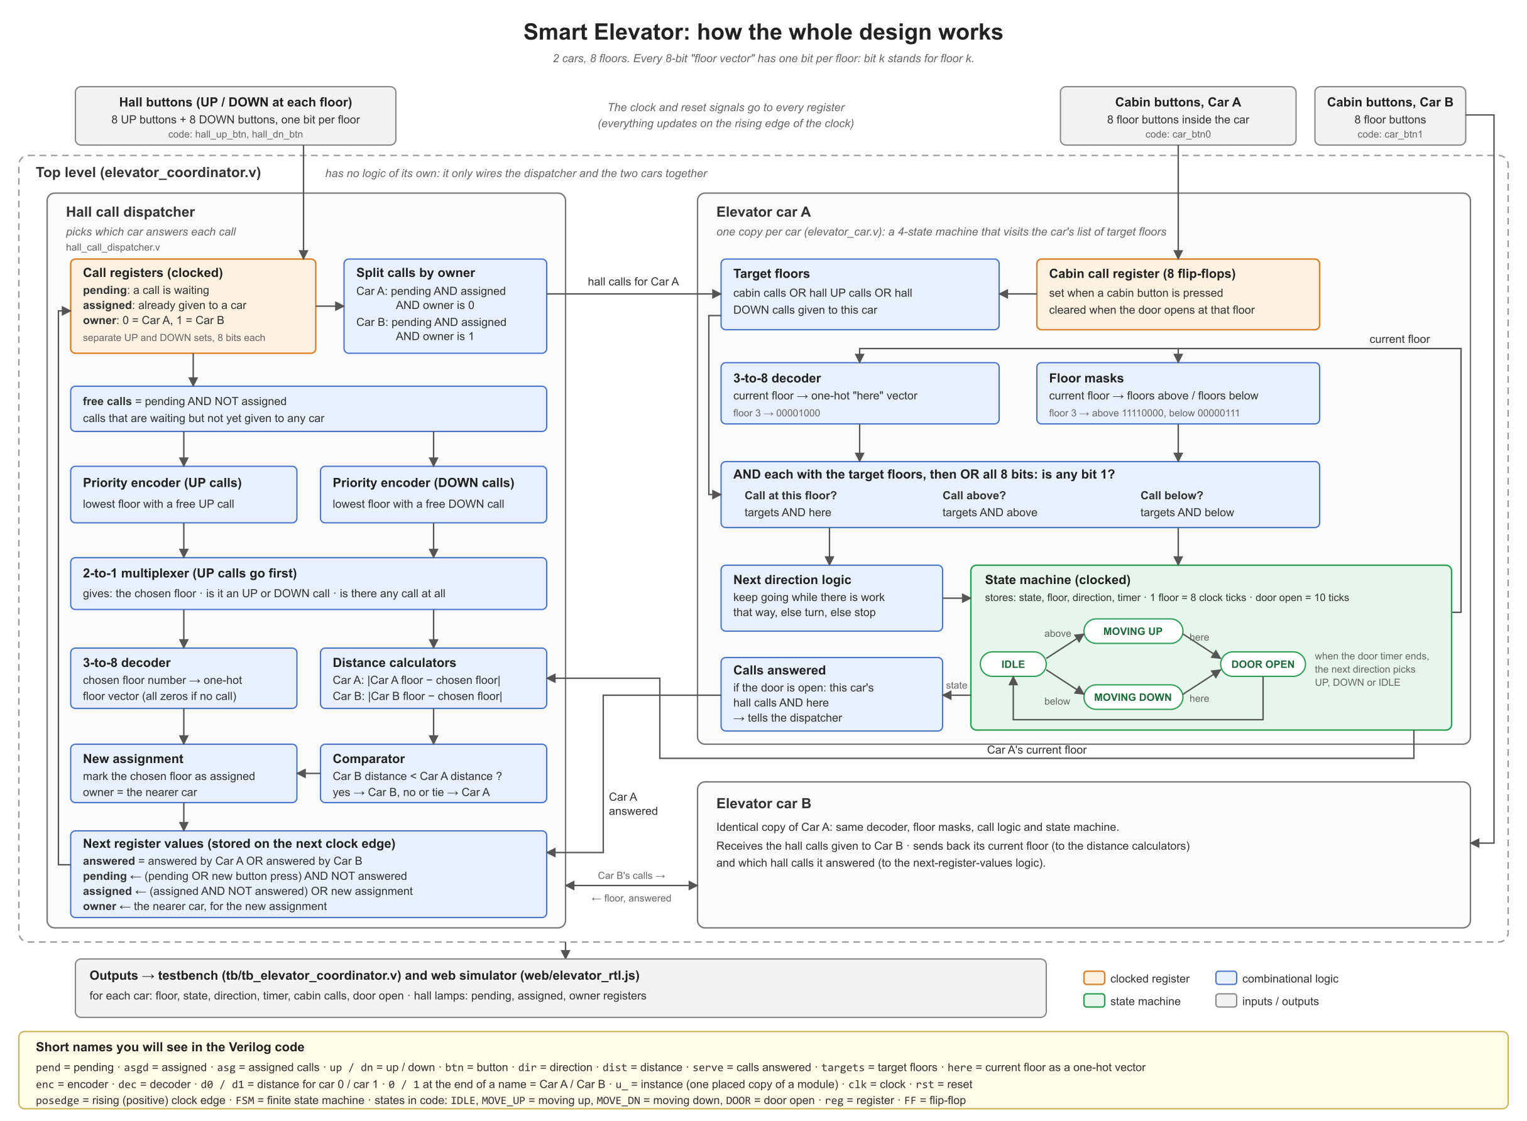
Fig. 1. Block diagram of the two-car elevator coordinator: hall-call dispatcher (left) and elevator car datapath with state machine (right).

3.2 Module description
TABLE II. MODULE DESCRIPTION
Module | Inputs | Outputs | Function
elevator_coordinator (top) | clk, rst, hall_up_btn, hall_dn_btn, car_btn0, car_btn1 | Status of both cars; six hall-call registers | Structural top level; instantiates the dispatcher and two cars and wires them together.
hall_call_dispatcher | clk, rst, hall buttons, floor0, floor1, serve strobes of both cars | up/dn_pend, up/dn_asgd, up/dn_owner; calls assigned to each car | Stores hall calls, assigns one free call per cycle to the nearer car, clears calls when served.
elevator_car (x2) | clk, rst, car_btn, hall_up_asg, hall_dn_asg | floor, state, dir, timer, car_calls, next_dir, door_open, serve_up, serve_dn | Four-state FSM with a datapath that moves one car between floors and opens its door.
priority_encoder8 | w[7:0] | y[2:0], valid | Index of the lowest 1 bit (lowest waiting call); valid = any bit set.
decoder3to8 | en, w[2:0] | y[7:0] | Floor number to one-hot floor vector; all zeros when disabled.
distance | a[2:0], b[2:0] | d[2:0] | |a - b| using a comparator, two subtractors and a 2-to-1 multiplexer.
floor_masks | floor[2:0] | above[7:0], below[7:0] | Truth table of the floors above and below the car.

3.3 Design decisions
- Single clock, synchronous reset. Every register is written in an always @(posedge clk) block with if (rst) inside, so reset acts only on a clock edge and there is one clock domain.
- Combinational vs. sequential split. Decoders, masks, the priority encoders, distances, the comparator and the serve logic are combinational (assign and always @(...) with blocking =). Only 86 bits are stored (19 per car: state 2, floor 3, dir 2, timer 4 and car_calls 8; 48 in the dispatcher), all with non-blocking <=. The car's serve strobes depend on the dispatcher's registers, and the dispatcher's next state depends on the strobes; that loop passes through flip-flops, so there is no combinational feedback.
- Binary state encoding. The four car states use 2 bits (IDLE=00, MOVE_UP=01, MOVE_DN=10, DOOR=11); directions use NONE=00, UP=01, DN=10.
- Parameterised timing. TRAVEL_TICKS = 8 and DOOR_TICKS = 10 are module parameters; the 4-bit timer is a modulo counter with synchronous clear.
- Assignment rule. One free call is assigned per clock cycle, lowest floor first and UP before DOWN. A car needs 8 cycles to move one floor, so this is fast enough. The call goes to the car with the smaller distance (1); on a tie, Car A wins, which keeps the hardware deterministic:
dist0 = | floor0 − pick_floor |, dist1 = | floor1 − pick_floor | (1)
pick_car1 = ( dist1 < dist0 ) (2)
Here floor0 and floor1 are the current floors of Car A and Car B and pick_floor is the floor of the call chosen by the priority encoder; pick_car1 = 1 assigns the call to Car B. Each car's behaviour is the state machine of Fig. 2. A car leaves IDLE for DOOR if it has a target on its floor, otherwise for the direction that has work. While moving it counts 8 ticks per floor; at each floor (timer = 0) it stops if there is a target there. After 10 door ticks it continues in the direction chosen by next_dir, which keeps the current direction while work remains ahead (the SCAN rule [5]).
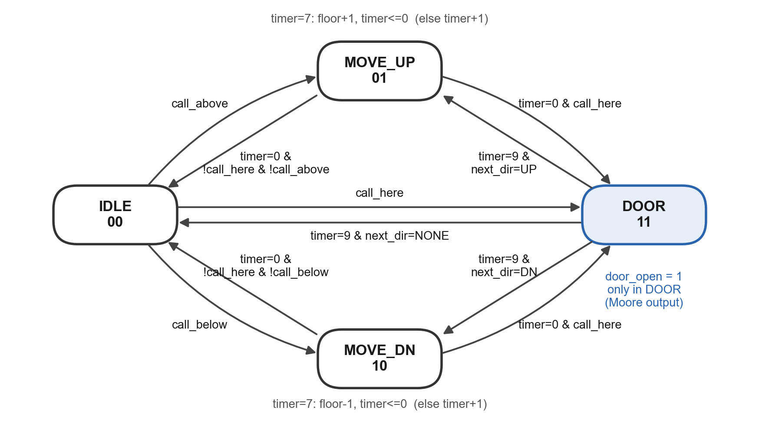
Fig. 2. State diagram of elevator_car (Moore output door_open = 1 only in DOOR).

4. VERILOG HDL IMPLEMENTATION
The design uses only Verilog-2005 constructs covered in the course: modules connected by position, assign, always blocks with if/case/casex, reduction operators, and non-blocking assignment for registers [3], [4]. Listings 1 to 7 give the complete synthesizable code. To save space, the explanatory comment blocks of the source files are omitted here; end-of-line comments are kept.

4.1 Design module
Listing 1: rtl/decoder3to8.v
module decoder3to8 (en, w, y);
input en; // enable
input [2:0] w; // floor number
output reg [7:0] y; // one-hot output
always @(en or w)
begin
y = 8'b00000000; // start with every output 0
if (en == 1)
case (w)
0: y = 8'b00000001;
1: y = 8'b00000010;
2: y = 8'b00000100;
3: y = 8'b00001000;
4: y = 8'b00010000;
5: y = 8'b00100000;
6: y = 8'b01000000;
7: y = 8'b10000000;
endcase
end
endmodule
Listing 2: rtl/floor_masks.v
module floor_masks (floor, above, below);
input [2:0] floor; // the floor the car is at
output reg [7:0] above; // 1 for every floor higher than 'floor'
output reg [7:0] below; // 1 for every floor lower than 'floor'
always @(floor)
case (floor)
0: begin above = 8'b11111110; below = 8'b00000000; end
1: begin above = 8'b11111100; below = 8'b00000001; end
2: begin above = 8'b11111000; below = 8'b00000011; end
3: begin above = 8'b11110000; below = 8'b00000111; end
4: begin above = 8'b11100000; below = 8'b00001111; end
5: begin above = 8'b11000000; below = 8'b00011111; end
6: begin above = 8'b10000000; below = 8'b00111111; end
7: begin above = 8'b00000000; below = 8'b01111111; end
endcase
endmodule
Listing 3: rtl/priority_encoder8.v
module priority_encoder8 (w, y, valid);
input [7:0] w;
output reg [2:0] y;
output reg valid;
always @(w)
begin
valid = 1;
casex (w)
8'bxxxxxxx1: y = 0;
8'bxxxxxx10: y = 1;
8'bxxxxx100: y = 2;
8'bxxxx1000: y = 3;
8'bxxx10000: y = 4;
8'bxx100000: y = 5;
8'bx1000000: y = 6;
8'b10000000: y = 7;
default: begin y = 0; valid = 0; end // w = 00000000
endcase
end
endmodule
Listing 4: rtl/distance.v
module distance (a, b, d);
input [2:0] a, b;
output [2:0] d;
assign d = (a > b) ? (a - b) : (b - a);
endmodule
Listing 5: rtl/elevator_car.v
module elevator_car (clk, rst, car_btn, hall_up_asg, hall_dn_asg,
floor, state, dir, timer, car_calls,
next_dir, door_open, serve_up, serve_dn);
parameter TRAVEL_TICKS = 8; // clock cycles to move one floor
parameter DOOR_TICKS = 10; // clock cycles the door stays open
parameter IDLE = 2'b00;
parameter MOVE_UP = 2'b01;
parameter MOVE_DN = 2'b10;
parameter DOOR = 2'b11;
parameter NONE = 2'b00;
parameter UP = 2'b01;
parameter DN = 2'b10;
input clk; // clock
input rst; // synchronous reset, active high
input [7:0] car_btn; // cabin buttons (bit k = floor k), 1 for one clock
input [7:0] hall_up_asg; // hall UP calls the dispatcher gave to this car
input [7:0] hall_dn_asg; // hall DOWN calls the dispatcher gave to this car
output reg [2:0] floor; // floor the car is at (or last passed)
output reg [1:0] state; // IDLE / MOVE_UP / MOVE_DN / DOOR
output reg [1:0] dir; // direction the car is travelling in
output reg [3:0] timer; // counts clock cycles while moving / door open
output reg [7:0] car_calls; // cabin buttons pressed and not yet served
output reg [1:0] next_dir; // where the car will go next (combinational)
output door_open; // 1 while the door is open
output [7:0] serve_up; // hall UP call answered at this floor right now
output [7:0] serve_dn; // hall DOWN call answered at this floor right now
wire [7:0] here; // one-hot: the floor the car is on
wire [7:0] above; // mask of floors above the car
wire [7:0] below; // mask of floors below the car
wire [7:0] targets; // every floor this car must visit
wire call_here; // is there a target on this floor?
wire call_above; // is there a target above?
wire call_below; // is there a target below?
decoder3to8 dec_here (1'b1, floor, here);
floor_masks masks (floor, above, below);
assign targets = car_calls | hall_up_asg | hall_dn_asg;
assign call_here = |(targets & here);
assign call_above = |(targets & above);
assign call_below = |(targets & below);
always @(dir or call_above or call_below)
begin
if (dir == UP && call_above)
next_dir = UP;
else if (dir == DN && call_below)
next_dir = DN;
else if (call_above)
next_dir = UP;
else if (call_below)
next_dir = DN;
else
next_dir = NONE;
end
assign door_open = (state == DOOR);
assign serve_up = door_open ? (hall_up_asg & here) : 8'b00000000;
assign serve_dn = door_open ? (hall_dn_asg & here) : 8'b00000000;
always @(posedge clk)
begin
if (rst)
car_calls <= 8'b00000000;
else if (state == DOOR)
car_calls <= (car_calls | car_btn) & ~here;
else
car_calls <= car_calls | car_btn;
end
always @(posedge clk)
begin
if (rst)
begin
state <= IDLE;
floor <= 0;
dir <= NONE;
timer <= 0;
end
else
case (state)
IDLE:
begin
timer <= 0;
if (call_here)
state <= DOOR; // rule 1
else if (call_above)
begin
state <= MOVE_UP;
dir <= UP;
end
else if (call_below)
begin
state <= MOVE_DN;
dir <= DN;
end
else
dir <= NONE; // rule 4
end
MOVE_UP:
begin
if (timer == 0 && call_here)
state <= DOOR; // rule 1: stop here
else if (timer == 0 && !call_above)
begin
state <= IDLE; // safety: nothing above
dir <= NONE;
end
else if (timer == TRAVEL_TICKS - 1)
begin
floor <= floor + 1; // reached the next floor
timer <= 0;
end
else
timer <= timer + 1; // still between floors
end
MOVE_DN:
begin
if (timer == 0 && call_here)
state <= DOOR;
else if (timer == 0 && !call_below)
begin
state <= IDLE;
dir <= NONE;
end
else if (timer == TRAVEL_TICKS - 1)
begin
floor <= floor - 1;
timer <= 0;
end
else
timer <= timer + 1;
end
DOOR:
begin
if (timer == DOOR_TICKS - 1)
begin
timer <= 0; // door closes
if (next_dir == UP) // rules 2 and 3
begin
state <= MOVE_UP;
dir <= UP;
end
else if (next_dir == DN)
begin
state <= MOVE_DN;
dir <= DN;
end
else
begin
state <= IDLE;
dir <= NONE;
end
end
else
timer <= timer + 1;
end
endcase
end
endmodule
Listing 6: rtl/hall_call_dispatcher.v
module hall_call_dispatcher (clk, rst, hall_up_btn, hall_dn_btn,
floor0, floor1,
serve_up0, serve_dn0, serve_up1, serve_dn1,
up_pend, up_asgd, up_owner,
dn_pend, dn_asgd, dn_owner,
up_asg0, dn_asg0, up_asg1, dn_asg1);
input clk, rst;
input [7:0] hall_up_btn; // hall UP buttons (1 for one clock when pressed)
input [7:0] hall_dn_btn; // hall DOWN buttons
input [2:0] floor0; // where Car A is
input [2:0] floor1; // where Car B is
input [7:0] serve_up0, serve_dn0; // calls Car A answered this cycle
input [7:0] serve_up1, serve_dn1; // calls Car B answered this cycle
output reg [7:0] up_pend, up_asgd, up_owner; // UP call registers
output reg [7:0] dn_pend, dn_asgd, dn_owner; // DOWN call registers
output [7:0] up_asg0, dn_asg0; // calls given to Car A
output [7:0] up_asg1, dn_asg1; // calls given to Car B
wire [7:0] free_up, free_dn; // waiting but not yet given to a car
wire [2:0] up_floor, dn_floor; // lowest free call of each kind
wire up_valid, dn_valid; // is there a free call of that kind?
wire pick_valid; // is there any call to hand out?
wire pick_up; // 1 = it is an UP call, 0 = a DOWN call
wire [2:0] pick_floor; // floor of the call being handed out
wire [7:0] pick_vec; // the same floor as a one-hot vector
wire [2:0] dist0, dist1; // how far each car is from pick_floor
wire pick_car1; // 1 = give it to Car B, 0 = Car A
wire [7:0] new_up, new_dn; // the call handed out this cycle
wire [7:0] served_up, served_dn; // calls answered by either car
assign up_asg0 = up_pend & up_asgd & ~up_owner;
assign dn_asg0 = dn_pend & dn_asgd & ~dn_owner;
assign up_asg1 = up_pend & up_asgd & up_owner;
assign dn_asg1 = dn_pend & dn_asgd & dn_owner;
assign free_up = up_pend & ~up_asgd;
assign free_dn = dn_pend & ~dn_asgd;
priority_encoder8 enc_up (free_up, up_floor, up_valid);
priority_encoder8 enc_dn (free_dn, dn_floor, dn_valid);
assign pick_valid = up_valid | dn_valid;
assign pick_up = up_valid; // UP calls go first
assign pick_floor = up_valid ? up_floor : dn_floor; // 2-to-1 multiplexer
distance d0 (floor0, pick_floor, dist0);
distance d1 (floor1, pick_floor, dist1);
assign pick_car1 = (dist1 < dist0); // tie -> Car A
decoder3to8 dec_pick (pick_valid, pick_floor, pick_vec);
assign new_up = pick_up ? pick_vec : 8'b00000000;
assign new_dn = pick_up ? 8'b00000000 : pick_vec;
assign served_up = serve_up0 | serve_up1;
assign served_dn = serve_dn0 | serve_dn1;
always @(posedge clk)
begin
if (rst)
begin
up_pend <= 0; up_asgd <= 0; up_owner <= 0;
dn_pend <= 0; dn_asgd <= 0; dn_owner <= 0;
end
else
begin
up_pend <= (up_pend | hall_up_btn) & ~served_up;
dn_pend <= (dn_pend | hall_dn_btn) & ~served_dn;
up_asgd <= (up_asgd & ~served_up) | new_up;
dn_asgd <= (dn_asgd & ~served_dn) | new_dn;
if (pick_car1)
begin
up_owner <= up_owner | new_up; // new call belongs to Car B
dn_owner <= dn_owner | new_dn;
end
else
begin
up_owner <= up_owner & ~new_up; // new call belongs to Car A
dn_owner <= dn_owner & ~new_dn;
end
end
end
endmodule
Listing 7: rtl/elevator_coordinator.v
module elevator_coordinator (clk, rst,
hall_up_btn, hall_dn_btn, car_btn0, car_btn1,
floor0, state0, dir0, timer0, calls0, door0,
floor1, state1, dir1, timer1, calls1, door1,
up_pend, up_asgd, up_owner,
dn_pend, dn_asgd, dn_owner);
input clk, rst;
input [7:0] hall_up_btn, hall_dn_btn; // landing buttons
input [7:0] car_btn0, car_btn1; // buttons inside Car A / Car B
output [2:0] floor0, floor1;
output [1:0] state0, state1;
output [1:0] dir0, dir1;
output [3:0] timer0, timer1;
output [7:0] calls0, calls1;
output door0, door1;
output [7:0] up_pend, up_asgd, up_owner;
output [7:0] dn_pend, dn_asgd, dn_owner;
wire [7:0] up_asg0, dn_asg0, up_asg1, dn_asg1; // dispatcher -> cars
wire [7:0] serve_up0, serve_dn0, serve_up1, serve_dn1; // cars -> dispatcher
wire [1:0] next_dir0, next_dir1; // (shown on the website)
hall_call_dispatcher u_dispatch (
clk, rst,
hall_up_btn, hall_dn_btn,
floor0, floor1,
serve_up0, serve_dn0, serve_up1, serve_dn1,
up_pend, up_asgd, up_owner,
dn_pend, dn_asgd, dn_owner,
up_asg0, dn_asg0, up_asg1, dn_asg1);
elevator_car u_car0 (
clk, rst, car_btn0, up_asg0, dn_asg0,
floor0, state0, dir0, timer0, calls0, // registers
next_dir0, door0, serve_up0, serve_dn0); // combinational outputs
elevator_car u_car1 (
clk, rst, car_btn1, up_asg1, dn_asg1,
floor1, state1, dir1, timer1, calls1,
next_dir1, door1, serve_up1, serve_dn1);
endmodule

4.2 Code explanation
Building blocks. decoder3to8 turns a 3-bit floor number into a one-hot floor vector and is used twice: for the car's current floor (here) and for the floor picked by the dispatcher (pick_vec, disabled when there is no call). floor_masks is a lookup table, written with case, that returns the floors above and below the car. priority_encoder8 uses casex with don't-care bits so that the lowest set bit wins. distance computes |a − b| without signed arithmetic: the comparator a > b selects which subtraction to output.
elevator_car. Part 1 is combinational. targets is the union of the cabin calls and the hall calls assigned to this car; ANDing it with here, above and below and OR-reducing gives call_here, call_above and call_below. next_dir is a priority multiplexer: keep the current direction if there is work that way, otherwise turn towards any work, otherwise NONE. door_open is a Moore output (state == DOOR), and serve_up/serve_dn report the assigned hall calls on this floor while the door is open. Part 2 is the cabin-call register: set by a button press (OR) and cleared for the current floor while the door is open (AND-NOT). Part 3 is the state machine, which also updates the floor up/down counter, the dir register and the timer counter. floor changes only inside MOVE_UP/MOVE_DN, and the door is open only in DOOR, so safety (R4) holds by construction.
hall_call_dispatcher. For each direction, pend is set by a button and cleared when either car serves the call; asgd is set when the call is handed out and cleared when served; owner records the chosen car. A call is free when pend & ~asgd. The vectors given to each car are pure AND logic: Car A gets pend & asgd & ~owner and Car B gets pend & asgd & owner. A call cannot be picked and served in the same cycle, because picking needs asgd = 0 and serving needs asgd = 1.
elevator_coordinator. Structural only: it instantiates u_dispatch, u_car0 and u_car1 and connects them by position. next_dir0/next_dir1 are brought out only so that the visualisation can display them.

4.3 Testbench
The testbench (Listing 8) follows the lab layout: it includes the design files, declares a reg for each input and a wire for each output, instantiates the design, and generates a 10 ns clock with forever. Reset is held for the first two rising edges (5 ns and 15 ns) and released at 16 ns. The button presses come from build/stimulus.v, written by scripts/gen_stimulus.js with a seeded pseudo-random generator (mulberry32), so every run can be reproduced exactly from its seed. Each line applies one clock cycle of inputs and waits 10 ns, so inputs change 1 ns after each rising edge and are stable for 9 ns before the next one. Per cycle there is a 3.5 % chance of an UP call, 3.5 % of a DOWN call and 1.5 % of a cabin call in each car; impossible calls (UP at F7, DOWN at F0) are never generated.
Listing 8: tb/tb_elevator_coordinator.v (essential part; port declarations and include lines omitted)
elevator_coordinator dut (clk, rst, hall_up_btn, hall_dn_btn, car_btn0, car_btn1,
floor0, state0, dir0, timer0, calls0, door0,
floor1, state1, dir1, timer1, calls1, door1,
up_pend, up_asgd, up_owner, dn_pend, dn_asgd, dn_owner);
initial begin // clock: period 10 ns
clk = 0;
forever #5 clk = ~clk;
end
initial begin
$dumpfile("build/elevator.vcd");
$dumpvars(0, tb_elevator_coordinator);
rst = 1; // reset for the first two clock edges
hall_up_btn = 0; hall_dn_btn = 0; car_btn0 = 0; car_btn1 = 0;
#16;
rst = 0;
`include "stimulus.v" // one line per clock cycle, e.g.
// hall_up_btn = 8'h00; hall_dn_btn = 8'h04; car_btn0 = 8'h20; car_btn1 = 8'h00; #10;
$display("Test complete");
$finish;
end
Pass/fail is decided automatically from the VCD dump: scripts/verify.js checks liveness and compares all 16 output registers with a reference model on every cycle, and scripts/vcd2js.js compares 154 named signals, including internal nets such as next_dir, pick_floor and pick_car1.

5. SIMULATION, VERIFICATION AND RESULTS

5.1 Experimental setup
TABLE III. EXPERIMENTAL SETUP
Item | Details
HDL / language | Verilog-2005 (IEEE Std 1364-2005 [4]), compiled with -g2005 -Wall
Simulator / version | Icarus Verilog 14.0 (devel) [6], iverilog + vvp; VCD waveforms, viewable in GTKWave [7]
Synthesis tool / device | N/A (simulation only)
Stimulus / checking | Seeded random traffic, 4,000 cycles per run (seeds 1, 7, 42, 99, 2026); checks in Node.js v24
Test cases | 9 checks (T1 to T9): directed cases found in the runs, plus whole-run safety, liveness and equivalence

5.2 Test cases and expected outcomes
Times are simulation times in the seed-2026 run; an input is applied 1 ns after a rising edge and registered on the next edge.
TABLE IV. TEST CASES
Test ID | Input / condition | Expected output | Observed result
T1 | Reset held for the first two rising edges | All registers 0; both cars IDLE at F0 with doors closed | All 16 output registers 0 until the first press. Pass
T2 | Cabin button F1 in Car B at 56 ns, car idle at F0 | Car B moves up, reaches F1 after 8 cycles, opens door for 10 cycles | MOVE_UP at 75 ns, floor1 = 1 at 155 ns, DOOR 165 to 265 ns, then IDLE. Pass
T3 | UP call at F1 at 176 ns while Car B's door is open at F1 | Assigned to Car B (distance 0) and answered at once | Pending at 185 ns, assigned to B at 195 ns, cleared at 205 ns. Pass
T4 | DOWN call at F2 at 506 ns; Car A at F0, Car B at F1 | Nearer car (B, d1 = 1 < d0 = 2) gets the call | dn_owner bit 2 = 1 at 525 ns; Car B opens at F2 at 625 ns. Pass
T5 | Tie: DOWN call at F7 at 3376 ns; both cars at F3 | d0 = d1 = 4, so Car A gets the call | pick_car1 = 0; dn_owner bit 7 = 0 at 3395 ns. Pass
T6 | UP F5 and DOWN F7 pressed in the same cycle (38956 ns) | One call per cycle, UP first | UP F5 assigned at 38975 ns, DOWN F7 at 38985 ns. Pass
T7 | Safety, every cycle, both cars | door_open only in DOOR; floor changes only in MOVE states | 0 violations in 8,000 car-cycles. Pass
T8 | Liveness, five seeds | Every hall call answered within 600 cycles | 1,033 calls answered; longest wait 193 cycles. Pass
T9 | Co-simulation against the reference model | Identical values on every cycle | 16 registers and 154 signals, every cycle, 5 seeds: 0 mismatches. Pass

5.3 Simulation waveform
Fig. 3 is drawn from the VCD dump of the seed-2026 run and shows test case T4. The numbered markers are: (1) at 506 ns a DOWN call at F2 and a cabin call for F5 in Car A arrive; (2) at the 515 ns edge the call is latched in dn_pend and the priority encoder outputs pick_floor = 2 with dist0 = 2 and dist1 = 1, so pick_car1 = 1; (3) at 525 ns dn_asgd and dn_owner bit 2 are set (owner Car B), and Car A starts moving up towards its cabin call; (4) at 615 ns Car B's timer wraps and floor1 becomes 2; (5) at 625 ns Car B enters DOOR, door1 rises and serve_dn1 = 04; (6) at 635 ns the call is cleared. The door then stays open for exactly 10 cycles (timer1 0 to 9).
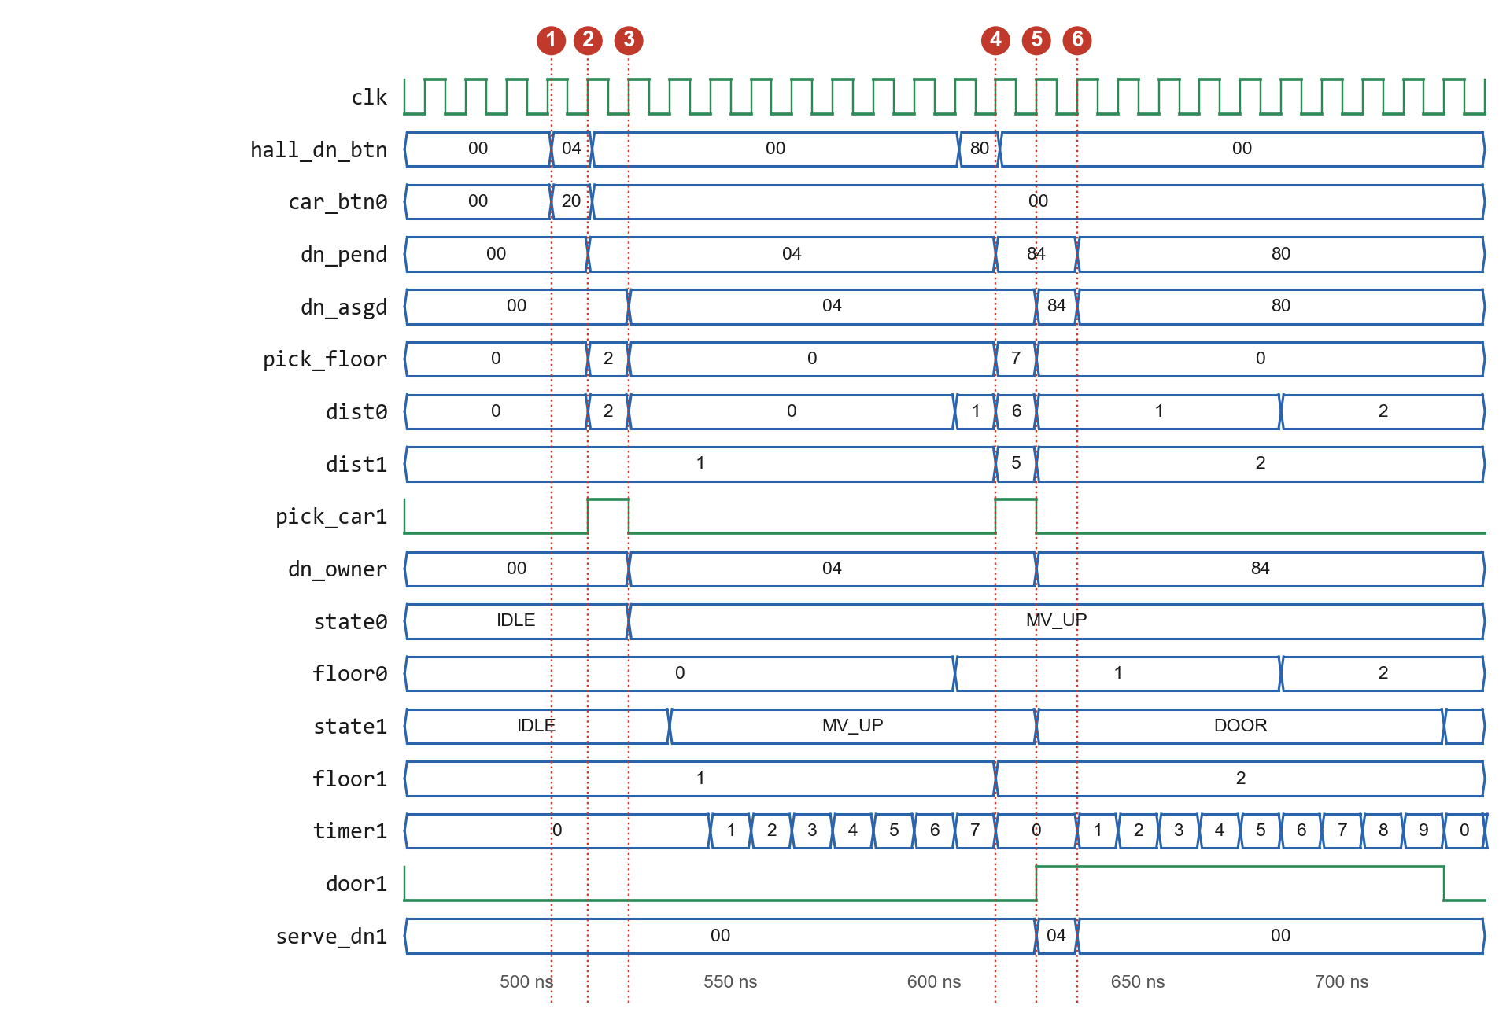
Fig. 3. Simulation waveform for test case T4 (seed 2026, 470 to 735 ns).

5.4 Results and discussion
All nine test cases and all whole-run checks passed: the observed outputs match the expected outputs in every case. Table V summarises performance over the five seeds. Wait is the number of cycles a hall call spends in a pend register; utilisation is the share of the 8,000 car-cycles per run spent in each state.
TABLE V. PERFORMANCE OVER FIVE RANDOM SEEDS (4,000 CYCLES EACH)
Seed | Calls answered | Mean wait (cycles) | Median wait (cycles) | Longest wait (cycles) | Moving (%) | Door open (%) | Idle (%)
1 | 222 | 37.2 | 23 | 165 | 51.4 | 31.8 | 16.9
7 | 205 | 52.3 | 38 | 186 | 53.3 | 32.8 | 14.0
42 | 192 | 39.5 | 27 | 193 | 46.9 | 30.6 | 22.5
99 | 213 | 37.5 | 23 | 159 | 50.3 | 33.3 | 16.5
2026 | 201 | 42.4 | 27 | 168 | 51.1 | 32.4 | 16.5

Every call was answered, with a longest wait of 193 cycles against the 600-cycle bound. The median is always below the mean: most calls are answered within about three floors of travel, while a few that arrive just after a car has passed must wait for the next sweep. Both cars are busy for 78 to 86 % of the time under this load (about one hall call every 14 cycles plus cabin calls). No timing or area figures are reported because the design was not synthesized.

6. INDIVIDUAL CONTRIBUTION
The project was divided into five design components so that each member owned one component end to end (design, code, unit checks and the matching part of this report).
TABLE VI. INDIVIDUAL CONTRIBUTIONS
Team member | Section / Reg. No. / Roll No. | Individual tasks performed | Evidence / deliverables
[Member 1] | [Sec., Reg. No., Roll No.] | Component 1: combinational building blocks. Designed the 3-to-8 decoder, floor-mask table, 8-to-3 priority encoder and distance circuit; checked each truth table. | decoder3to8.v, floor_masks.v, priority_encoder8.v, distance.v; Table II
[Member 2] | [Sec., Reg. No., Roll No.] | Component 2: elevator car. Designed the four-state FSM, direction logic, cabin-call register, timer and floor counters; drew the state diagram. | elevator_car.v; Fig. 2; Section 4.2
[Member 3] | [Sec., Reg. No., Roll No.] | Component 3: hall-call dispatcher. Designed the six call registers, free-call selection, nearest-car comparison and tie rule. | hall_call_dispatcher.v; Fig. 1; equations (1) and (2)
[Member 4] | [Sec., Reg. No., Roll No.] | Component 4: integration and verification. Wrote the top level, testbench, stimulus generator and run script; ran the five-seed regression and collected results. | elevator_coordinator.v, tb_elevator_coordinator.v, run.sh; Tables IV and V; Fig. 3
[Member 5] | [Sec., Reg. No., Roll No.] | Component 5: reference model and visualisation. Wrote the cycle-accurate JavaScript model, the co-simulation checks and the web visualisation with waveform viewer. | web/elevator_rtl.js, verify.js, vcd2js.js, web/; test case T9

Contribution statement
The interfaces between components (the floor-vector convention and the signals in Fig. 1) were agreed jointly at the start, so the components could be developed in parallel. Integration, debugging and the final regression were done together, led by the integration owner. Each member wrote the report section for their own component; the problem statement, objectives and conclusion were written jointly.

7. CONCLUSION AND FUTURE SCOPE

7.1 Conclusion
The project delivers a working two-car, eight-floor elevator coordinator in 86 flip-flops of synchronous logic, built from decoders, a priority encoder, comparators, subtractors, multiplexers, registers, counters and a finite state machine. All objectives were met in simulation: every requirement R1 to R6 was checked, all nine test cases passed, all 1,033 hall calls in five random runs were answered (longest wait 193 cycles), no safety violation occurred, and the Verilog matched an independent reference model on every register and cycle.

7.2 Limitations and future scope
- Distance-only dispatch. The nearer car wins even if it is moving away from the call; adding direction and current load to the cost would reduce waiting time.
- Direction of service. A car answers any assigned hall call at its floor when the door opens, even if it then leaves in the other direction; serving an UP call only when the car will go up would be more realistic.
- Assignments are final. A call stays with its car even if the other car later becomes better placed; periodic re-assignment of unreached calls is a natural extension.
- Not synthesized. Synthesis to an FPGA (for example with Yosys or Vivado) would give measured LUT and flip-flop counts and the maximum clock frequency, and allow testing on a development board with synchronized, debounced button inputs.

REFERENCES
[1] S. Brown and Z. Vranesic, Fundamentals of Digital Logic with Verilog Design, 3rd ed. New York, NY, USA: McGraw-Hill, 2014.
[2] M. M. Mano and M. D. Ciletti, Digital Design: With an Introduction to the Verilog HDL, VHDL, and SystemVerilog, 6th ed. Hoboken, NJ, USA: Pearson, 2018.
[3] S. Palnitkar, Verilog HDL: A Guide to Digital Design and Synthesis, 2nd ed. Upper Saddle River, NJ, USA: Prentice Hall, 2003.
[4] IEEE Standard for Verilog Hardware Description Language, IEEE Std 1364-2005, 2006.
[5] G. Barney and L. Al-Sharif, Elevator Traffic Handbook: Theory and Practice, 2nd ed. Abingdon, U.K.: Routledge, 2016.
[6] S. Williams, “Icarus Verilog.” Accessed: Oct. 20, 2026. [Online]. Available: https://steveicarus.github.io/iverilog/
[7] T. Bybell, “GTKWave.” Accessed: Oct. 20, 2026. [Online]. Available: https://gtkwave.sourceforge.net/

