**NEW PROJECT AS OWN GAME**

**TRY YOUR BEST IN IT AND SUBMIT BEFORE TIME**



**TILL NOW YOU LEARNT ABOUT MANY THINGS OF JAVASCRIPT TO DESIGN A GAME NOW ITS TIME TO**

**EXPLORE YOUR CREATIVITY TO DESIGN A GAME .**

**READ BELOW GIVEN ALL THINGS TO UNDERSTAND PROJECT……….**



**Satvik loves shinchan cartoon very much he wants to play a shinchan game but he doesn’t**

**Gotten that so he wished that someone design a game for him can you can be able to do ?**

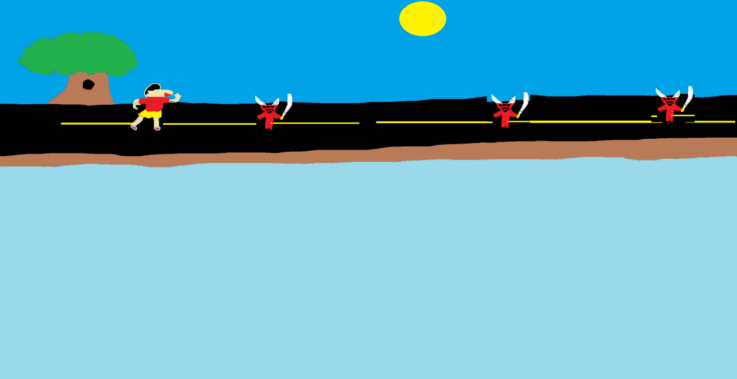

**\*\*This is just for your reference. We expect your own creativity.\*\***

**GAME STORY : -----**

**SHINCHAN IS A 5 YEAR YOUNG BOY HE WANTED TO GO SOME WHERE OUTSIDE BUT THERE FAMILY CAME SO FAR AND HIS FAMILY REACHED HOME BUT SHINCHAN LEFT IN CITY , SO HELP SHINCHAN TO REACH HIS HOME BY CROSSING DIFFERENT PLACES AND OBSTACLES . : )**



**1.Pin your github account**

**2.Click on ‘+’ or on ‘New’ and create new repository.**

**3.Now name it as Shinchan game or any thing and add files to it**

**4.Copy URL of your project and do share it with world .**

**Additional Activity :---**

**1.Also add a name option for player and add a play button.(if you want)**

**\*\*REMEMBER GIVE YOUR BEST THAT’S MORE IMPORTANT ………………………………………………**

**Satvikwhitehat2020PRO45-48doc**