**Ex 2. Test the ping command to test the communication between the guest OS and Host OS**

**Step 1:**

Select the VM from the Machine List

**Step 2:**

Click the **Settings** icon in a toolbar at the top of the Details panel

**Step 3:**

In the Settings wizard select **Network → Adapter1 → Host-only Adapter** and click **OK** as shown below

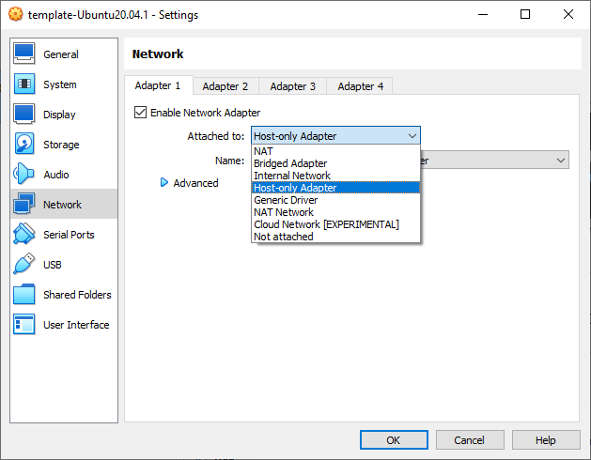

**Step 4:**

Login to the VM and run the command

|  |
| --- |
| **$ ifconfig**  Or ip addr show  Or ip address show |

in the terminal window as shown below and observe the IP address of the eth0 interface

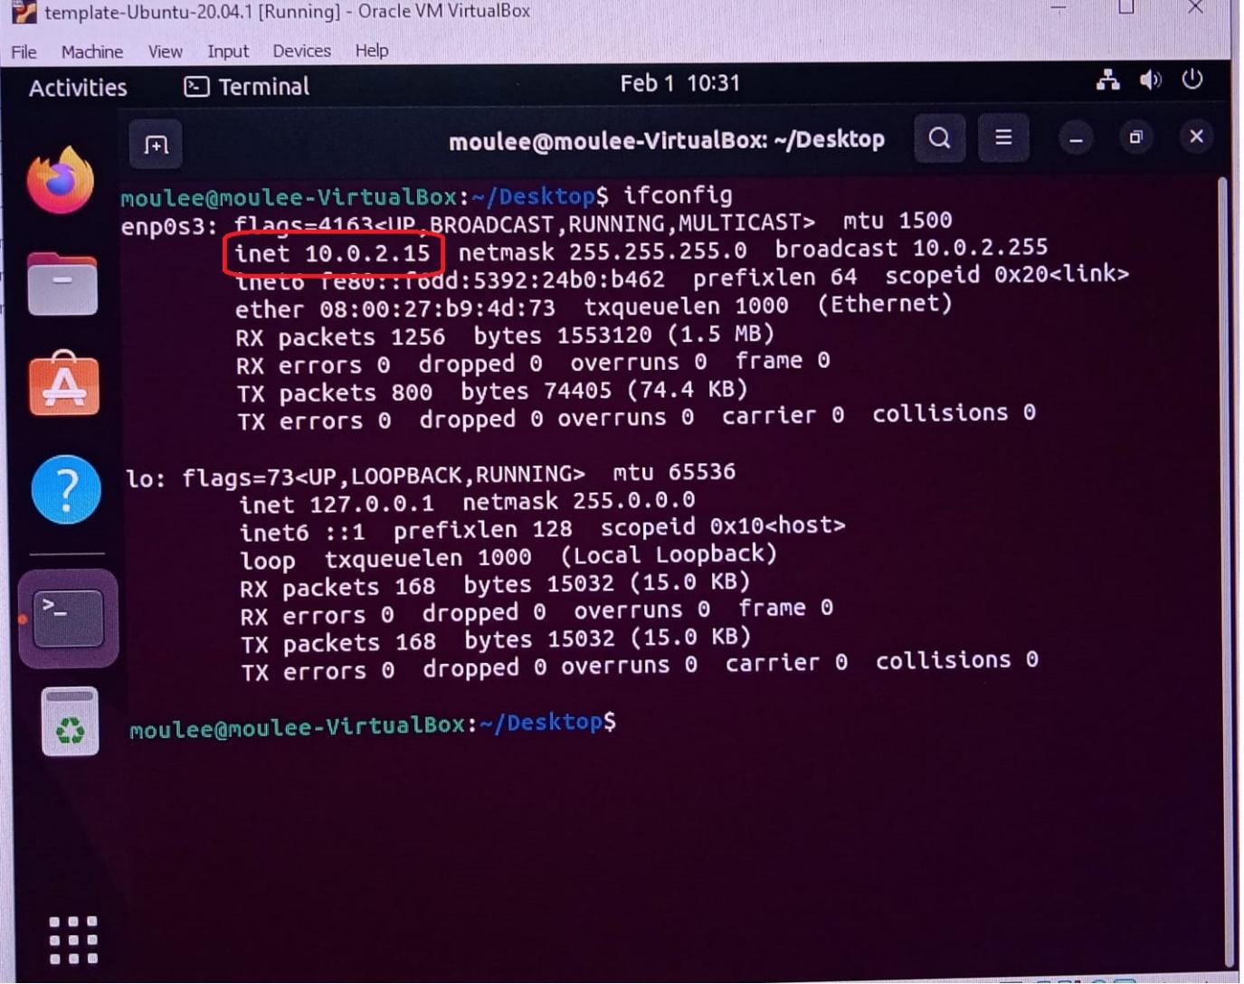

**Step 5:**

Now, ping the VM machine from the Host machine. Open the command prompt in Windows and type

|  |
| --- |
| **>ping 10.0.2.15** |

you will get the output as follows

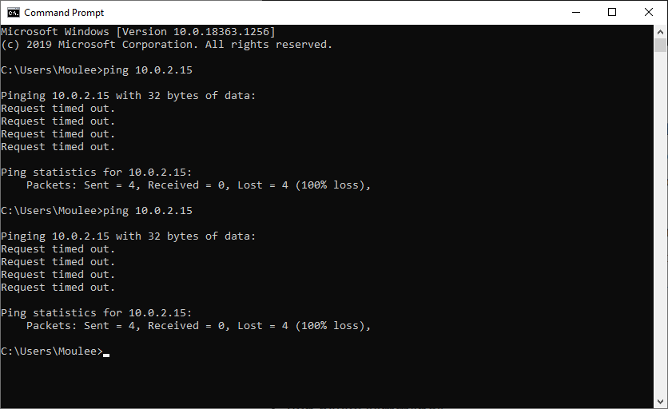

**Step 6:**

It will not work. Now, try to check the IP address of your host [Windows 10] by running the command

|  |
| --- |
| **> ipconfig** |

The output of the command is shown below. Observe that the IPv4 DNS range is different from the VM eth0 address. So, now we will assign a static IP to the VM so that both host and VM share the same DNS IP range and are able to communicate with each other

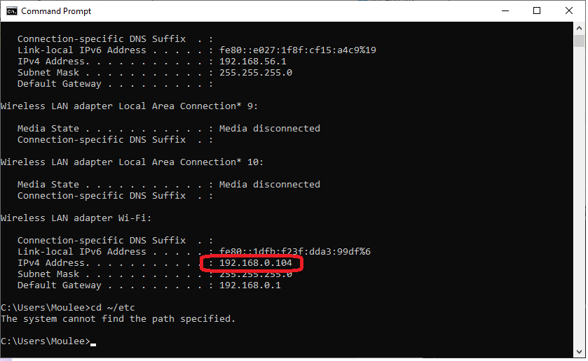

**Step 7:**

Open the terminal window in VM and run the command

|  |
| --- |
| **$ cd ~/etc/netplan $ ls** |

There will be a file called ***01-network-manager-all.yaml.***We need to update this file with the below content

|  |
| --- |
| **# Let NetworkManager manage all devices on this system network:  version: 2  renderer: NetworkManager  ethernets:  enp0s3:  addresses: [192.168.56.108/24]  dhcp4: false** |

We are basically applying the IP **192.168.56.108**to the VM

**Step 8:**

Run the below command

|  |
| --- |
| **$ sudo netplan apply** |

**Step 9:**

Go to your host machine terminal and run the command below

|  |
| --- |
| **>ping 192.168.56.108** |

Most probably, you will see the output below

