**4. Find a procedure to transfer the files from one virtual machine to another virtual machine**

**Step 1:**

* Create two VMs

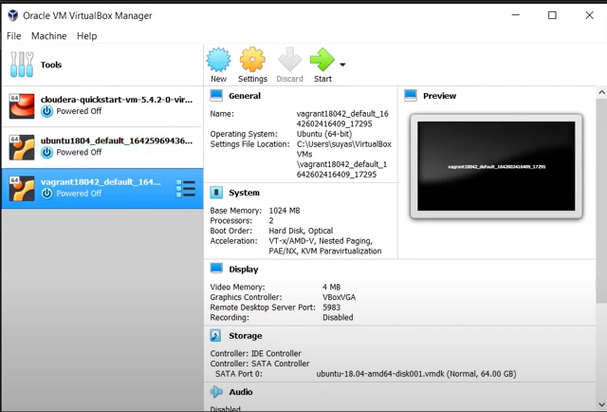

**Step 2:**

* Create NAT networks by clicking File Preferences Network
* Click on the + symbol on the rightmost edge

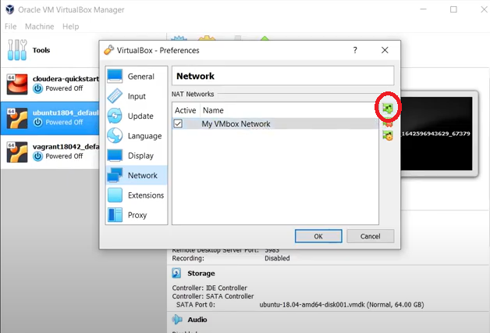

* The particular **NAT** network will be displayed.
* If you want to edit the name you can right-click and edit the net network
* Give the name and which particular CIDR should be there. What CIDR does is it will form a network inside the virtual box. So what the VirtualBox NAT engine does is it assigns dynamic IPs to all the VMs which will start at the boot time.

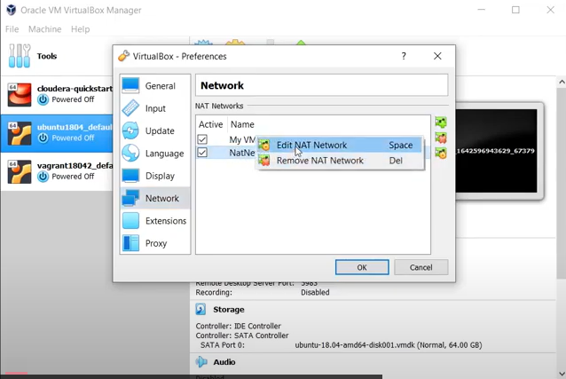

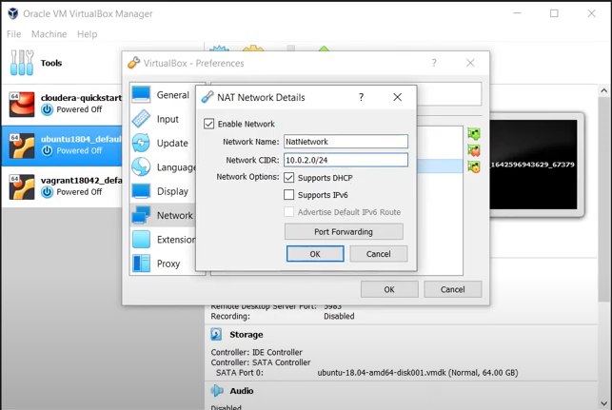

**Step 3:**

* Now check for the IP address of the Host OS using the command (as we discussed in Ex 2)

**>ipconfig**

**Or**

**$ ifconfig**

Or ip addr show

Or ip address show

* Change the CIDR address as shown below

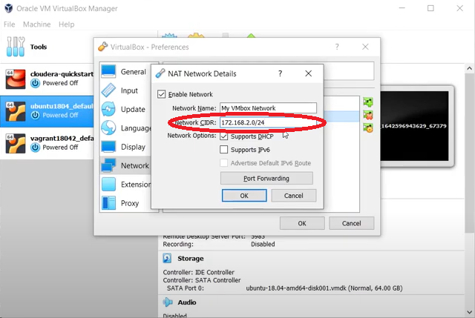

**Step 4:**

* Select the VM
* Click **Settings → Network → Adapter1**
* Change **Attached to** option to **NAT Network** and **Name** as displayed in the dropdown list

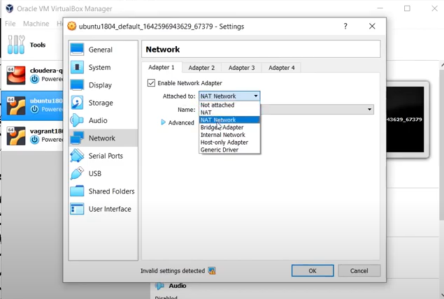

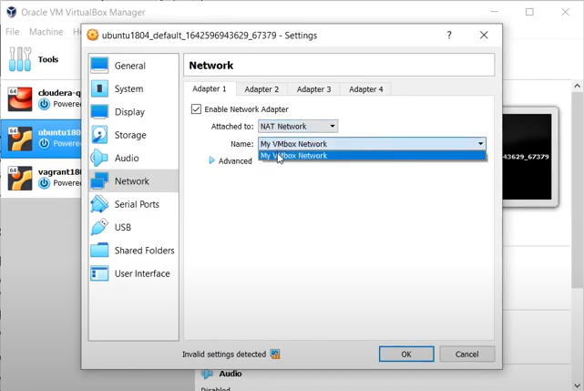

**Step 5:**

* Repeat the above steps for the other VM

**Step 6:**

* Start both the VMs and note down the IPs of these machines using the command **ifconfig**

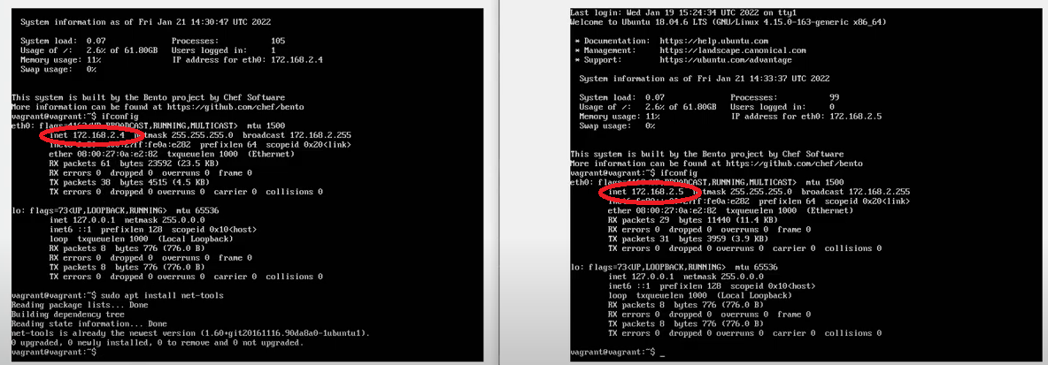

Ubuntu : IP address : 127.0.0.1

Windows IP Address : 10.0.2.15

169.254.216.87

Scp s.txt [vboxuser@127.0.0.1](mailto:vboxuser@127.0.0.1)

**Step 7:**

* Using the command

|  |
| --- |
| **scp [OPTION] [user@]SRC\_HOST:]file1 [user@]DEST\_HOST:]file2**  OPTION - [scp options](https://linux.die.net/man/1/scp" \t "_blank) such as cipher, ssh configuration, ssh port, limit, recursive copy …etc.  [user@]SRC\_HOST:]file1 - Source file.  [user@]DEST\_HOST:]file2 - Destination file |

transfer files from one VM to other. The snapshot below shows the successful transfer of files between two VMs

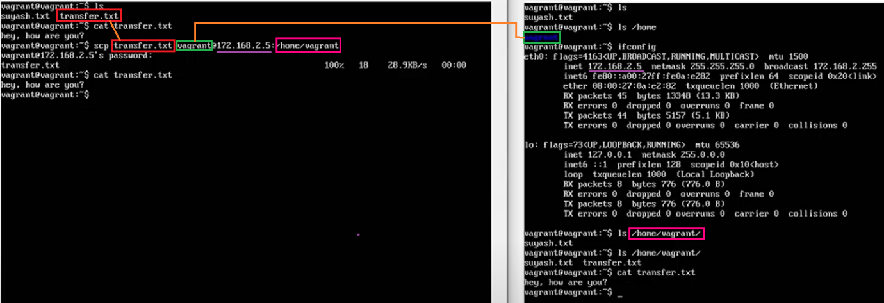

**Reference:**

* To know about the **scp** command use the link https://linuxize.com/post/how-to-use-scp-command-to-securely-transfer-files/

[How to transfer the files from one virtual machine to another virtual machine - YouTube](https://www.youtube.com/watch?v=0MaS0nZCTZc)

1. Create virtual box
2. Add two virtual machines in virtual box
3. Go go virtual box setting create a common network ( + Tab ) Nat Network
4. Under that network and select NAT Network instead of NAT for the virtual machines vm1 and vm2
5. Start both virtual machines
6. Open terminal and type : ip address show if Ubuntu machine
7. If windows machines ipconfig
8. In my vm ip address show : 10.0.2.5 and
9. In another machine ip address show : 10.0.2.15
10. Than create a file using touch file1.txt
11. Edit file using vi file1.txt [ Press I for insert and than content of the file after to save the file

Press escape tab and :wq for save.

1. Scp command to copy the file from from one virtual machine to another machine

Scp file1.txt [vboxuser@10.0.2.5](mailto:vboxuser@10.0.2.5):

Will copy the file1.txt from current virtual machine to home directory of another virtual machine whose ip address is 10.0.2.5:

Windows virtual machine installation

[Installation of Windows 2019 server in Virtual Box - YouTube](https://www.youtube.com/watch?v=YWUoyG8ei3s&t=0s)