**7.a.** **Use version control systems: Creating a central and local repository**

**7.1 Git Operations and commands:**

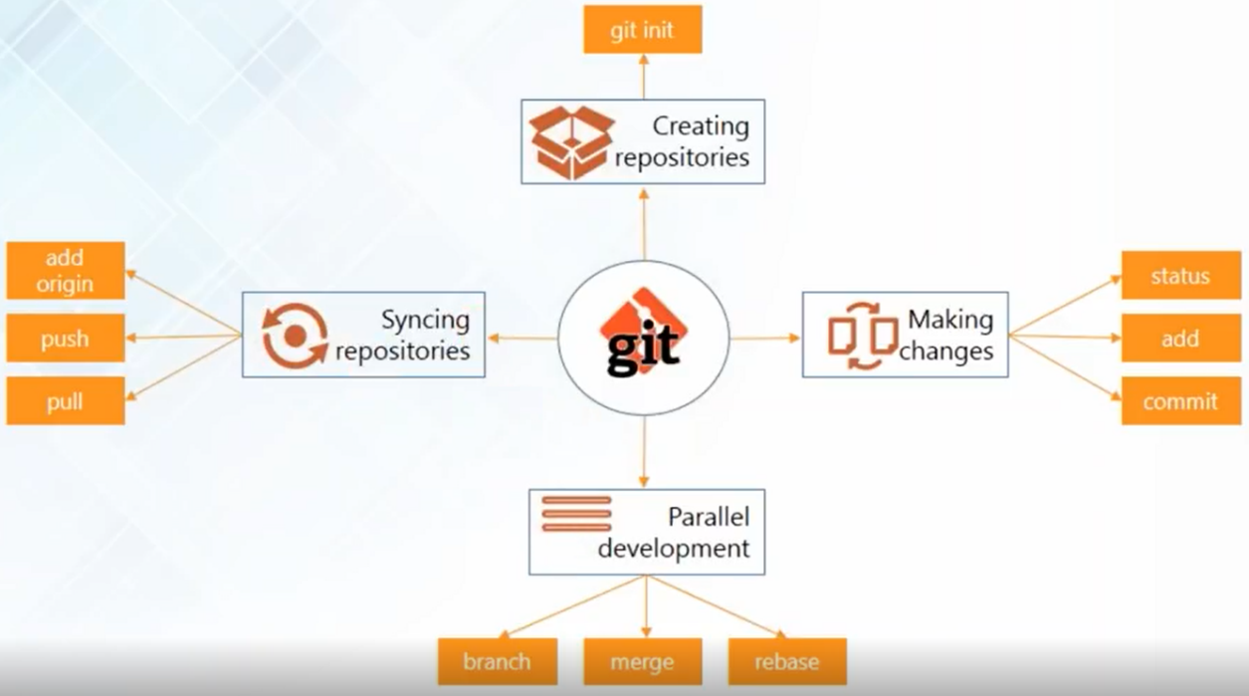

**7.2 Creating Repositories**

* The first thing is to create two repositories: a central repository and a local repository
* Now host the central repository on GitHub. For that, you need an account in GitHub and create a repository there
* For the local repository you have to install git in your system
* If you are working on a completely new project and if you want to start something fresh you can just use

**git init**

* to create your repository or if you want to join an ongoing project and if you're new to the project and you just join so you can clone the central repository using the command

**git clone**

**7.2.1 Creating Central Repository in GitHub**

**Step 1:**

* Go to github.com and if you don't have an account you can sign up for GitHub



**Step 2:**

* After creating an account sign in into account, you will find the page as shown below
* Click start a project

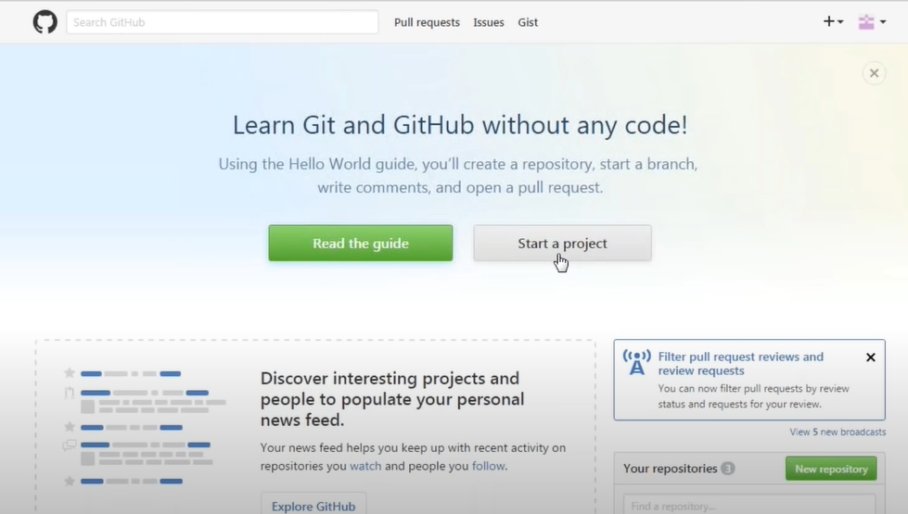

**Step 3:**

* Provide a repository name and the description of this repository
* Initialize your repository with the **readme**
* There might be some kind of files that you don't want when you're making operations like push or pull like some kind of log files or anything. So you can add those files in the **.gitignore** option
* Click **Create repository**

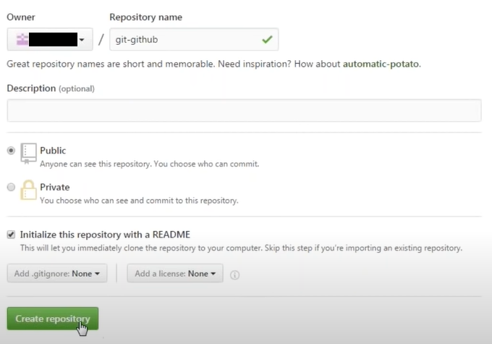

**Step 4:**

* The repository looks like

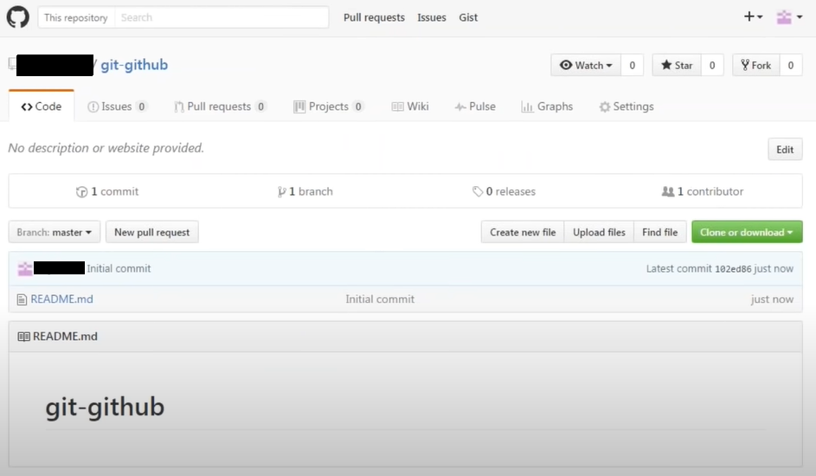

* If you want to make changes to the **readme** file just click on it as shown below

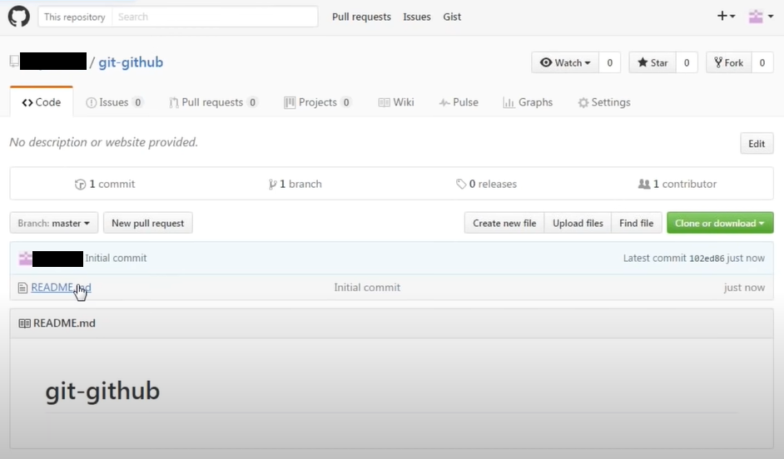

* Click on the **Edit pencil image** and make necessary changes and click the **Commit changes** button

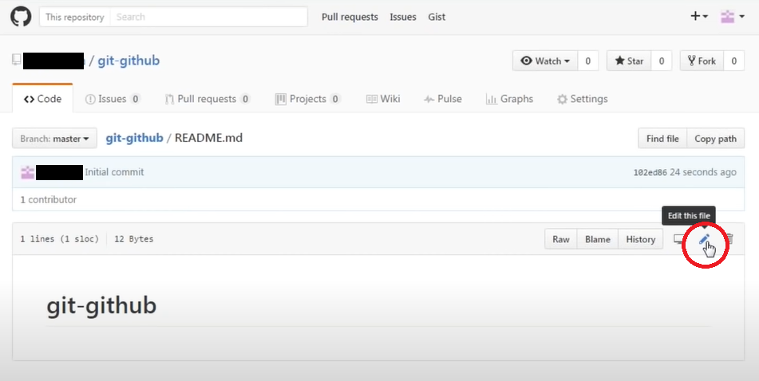

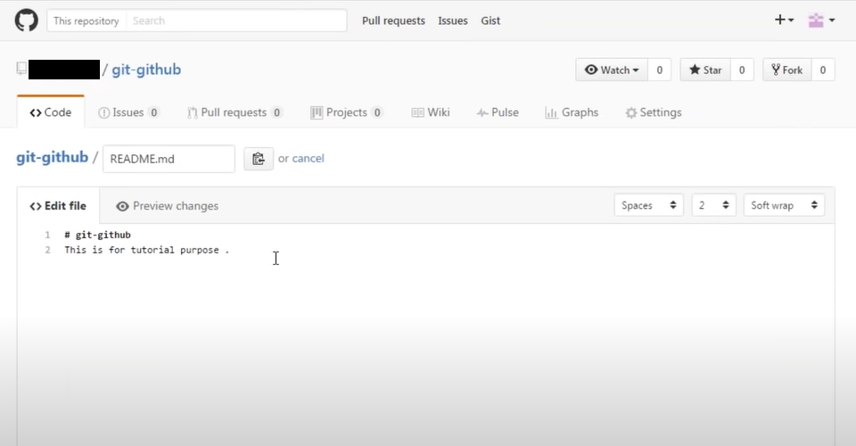

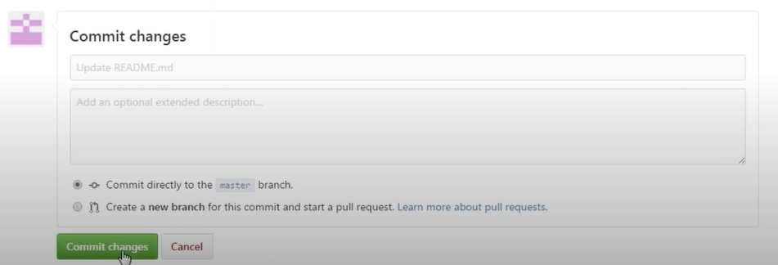

**Step 5:**

* After committing the changes, go back to the repository you will have the following information

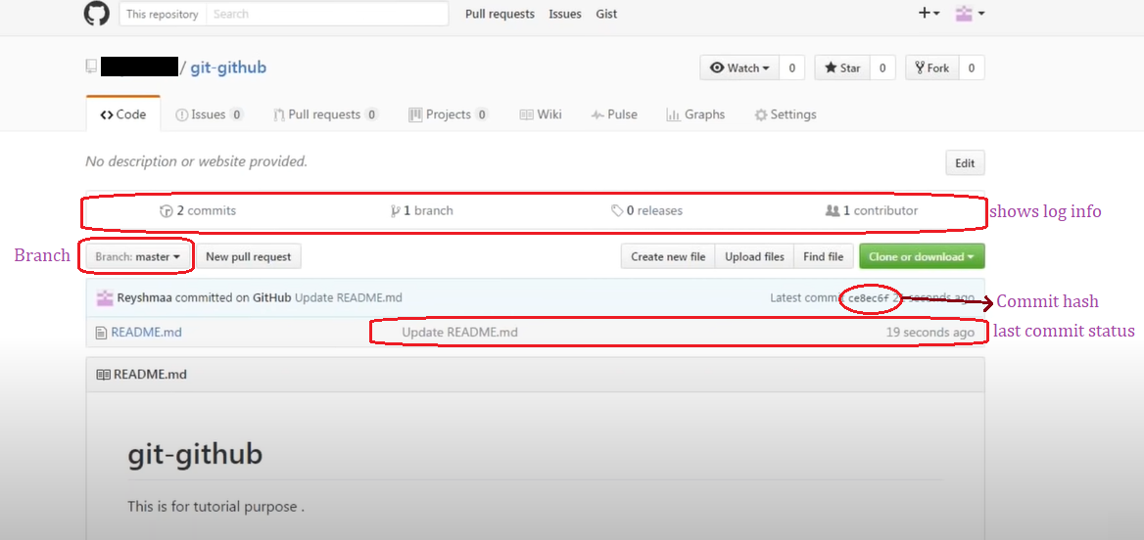

**7.3 Install git in local machine**

1.Browse to the official Git website: <https://git-scm.com/downloads>  
2. Click the download link for Windows and allow the download to complete.

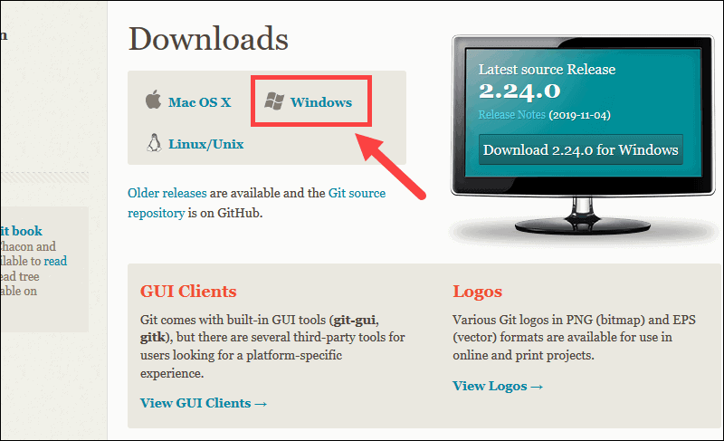

**7.3.1 Extract and Launch Git Installer**

3. Browse to the download location (or use the download shortcut in your browser). Double-click the file to extract and launch the installer.

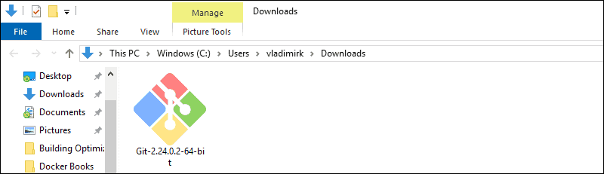

4. Allow the app to make changes to your device by clicking Yes on the User Account Control dialog that opens.

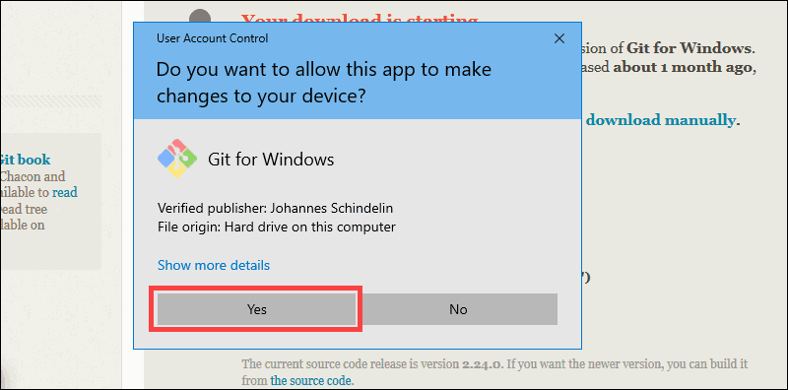

5. Review the GNU General Public License, and when you’re ready to install, click Next.

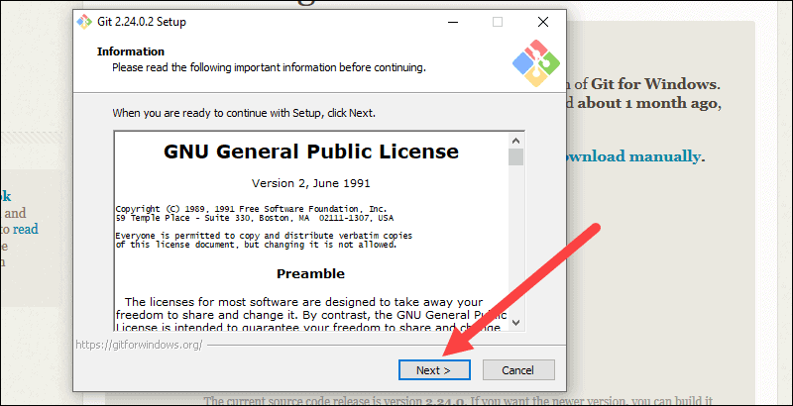

6. The installer will ask you for an installation location. Leave the default, unless you have reason to change it, and click Next.

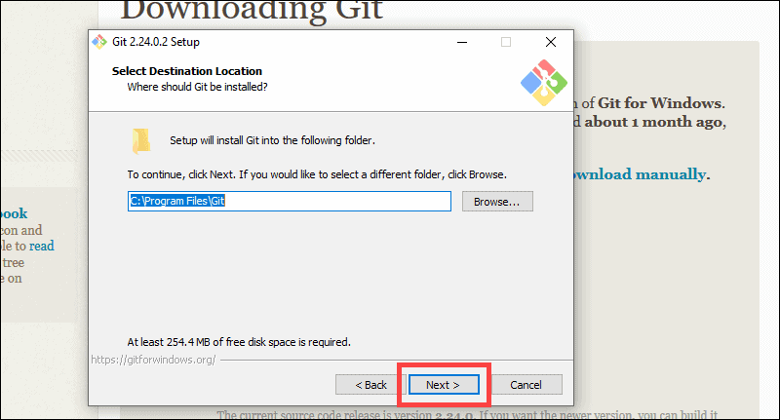

7. A component selection screen will appear. Leave the defaults unless you have a specific need to change them and click Next.

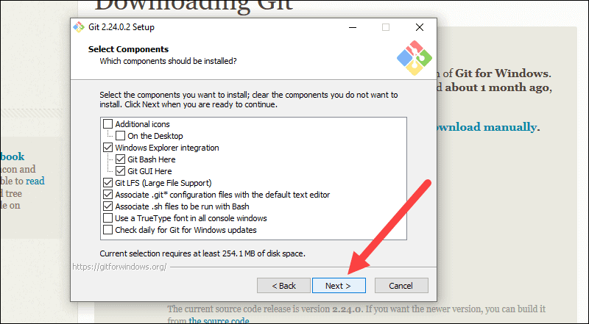

8. The installer will offer to create a start menu folder. Simply click Next.

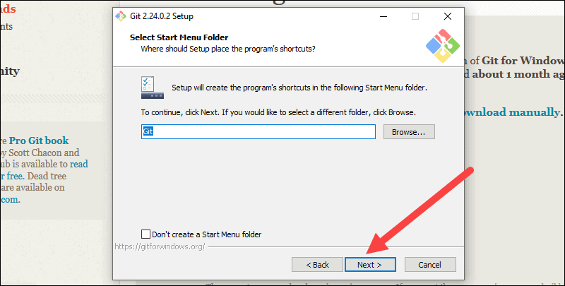

9. Select a text editor you’d like to use with Git. Use the drop-down menu to select Notepad++ (or whichever text editor you prefer) and click Next.

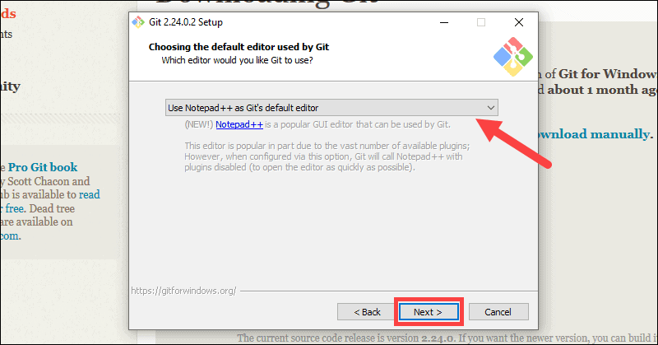

10. The next step allows you to choose a different name for your initial branch. The default is 'master.' Unless you're working in a team that requires a different name, leave the default option and click Next.

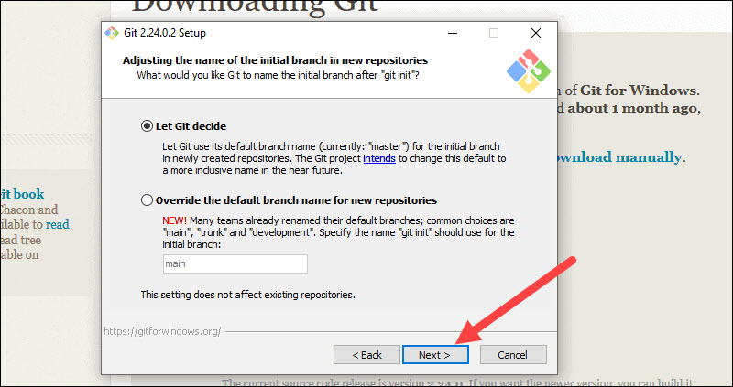

11. This installation step allows you to change the PATH environment. The PATH is the default set of directories included when you run a command from the command line. Leave this in the middle (recommended) selection and click Next.

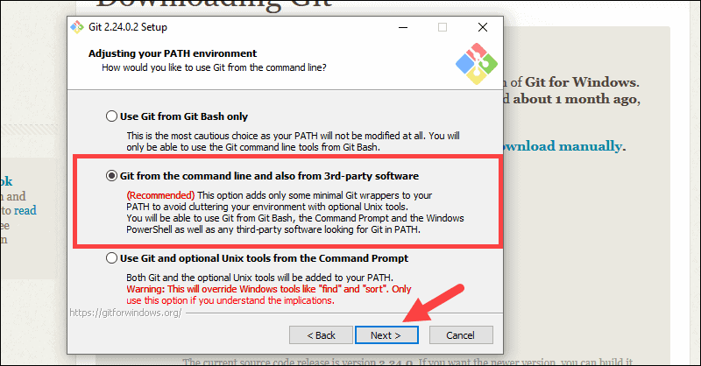

**7.3.2 Server Certificates, Line Endings and Terminal Emulators**

12. The installer now asks which SSH client you want Git to use. Git already comes with its own SSH client, so if you don't need a specific one, leave the default option and click Next.

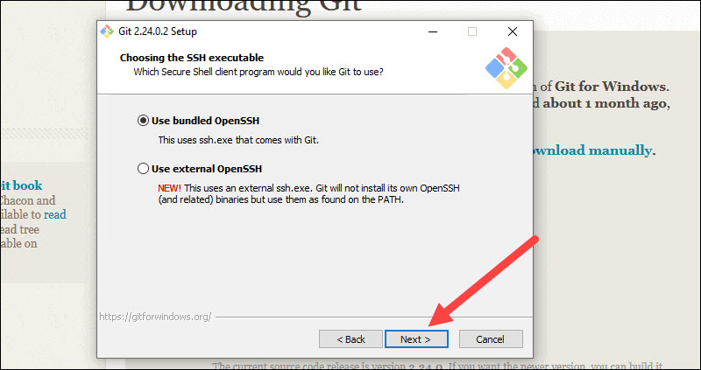

13. The next option relates to server certificates. Most users should use the default. If you’re working in an Active Directory environment, you may need to switch to Windows Store certificates. Click Next.

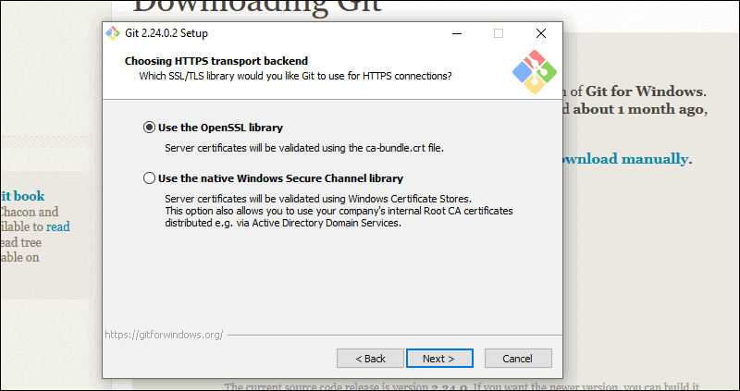

14. The next selection converts line endings. It is recommended that you leave the default selection. This relates to the way data is formatted and changing this option may cause problems. Click Next.

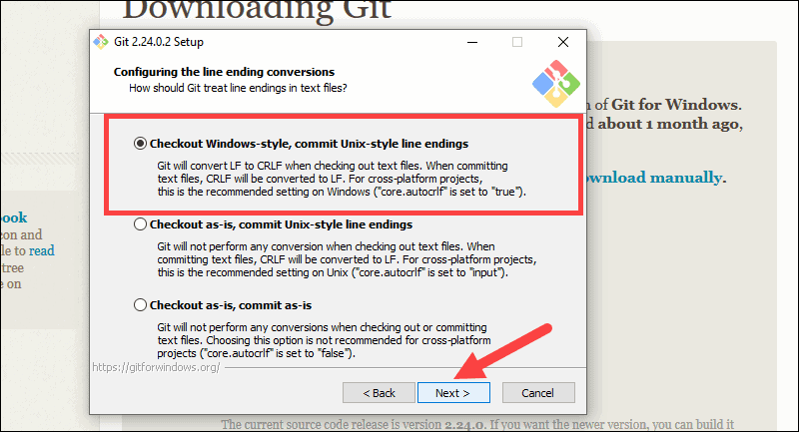

15. Choose the [terminal emulator](https://phoenixnap.com/glossary/terminal-emulation) you want to use. The default MinTTY is recommended, for its features. Click Next.

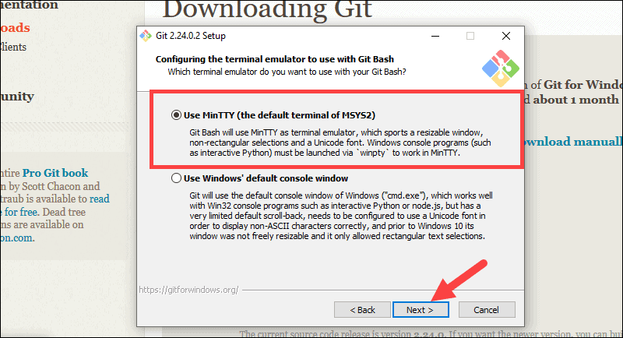

16. The installer now asks what the git pull command should do. The default option is recommended unless you specifically need to change its behavior. Click Next to continue with the installation.

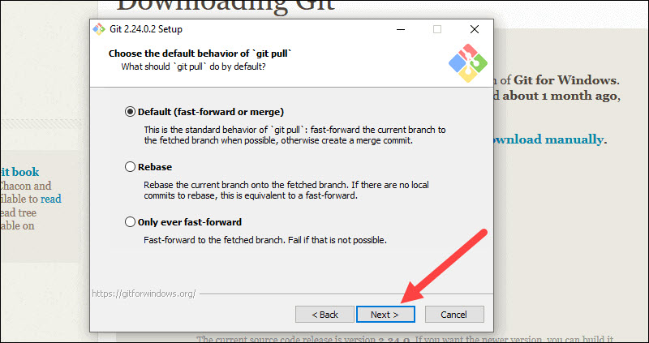

17. Next you should choose which credential helper to use. Git uses credential helpers to fetch or save credentials. Leave the default option as it is the most stable one, and click Next.

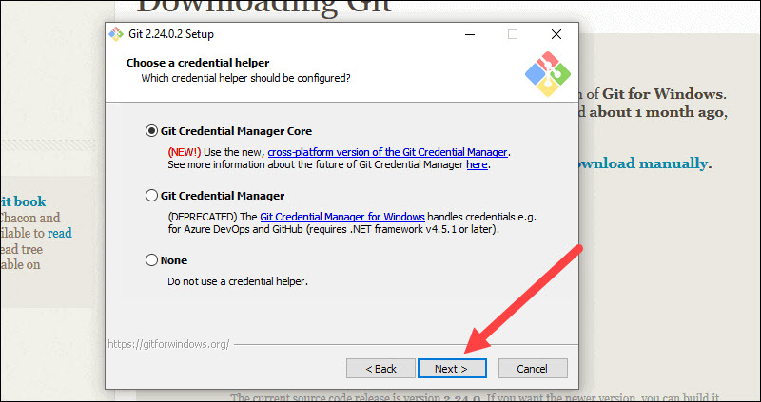

**7.3.3 Additional Customization Options**

18. The default options are recommended; however this step allows you to decide which extra option you would like to enable. If you use symbolic links, which are like shortcuts for the command line, tick the box. Click Next.

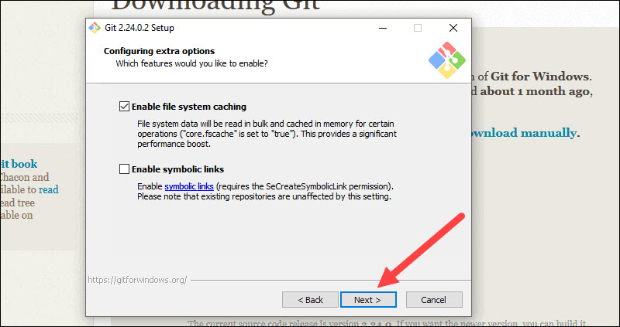

19. Depending on the version of Git you’re installing, it may offer to install experimental features. At the time this article was written, the options to include support for pseudo controls and a built-in file system monitor were offered. Unless you are feeling adventurous, leave them unchecked and click Install.

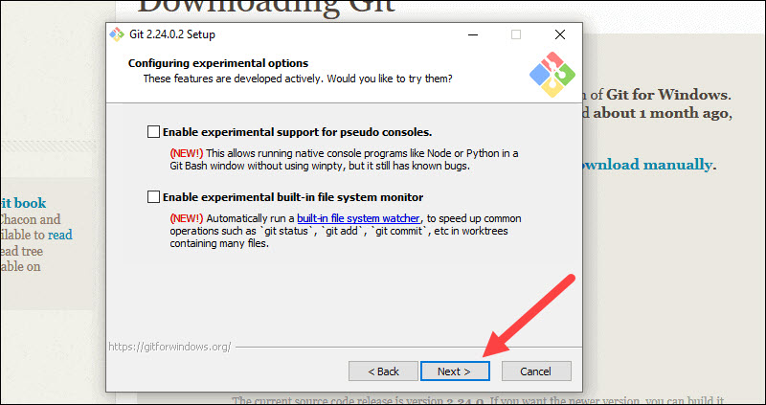

**7.3.4 Complete Git Installation Process**

20. Once the installation is complete, tick the boxes to view the Release Notes or Launch Git Bash, then click Finish.

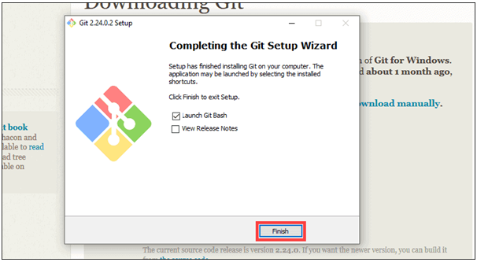

**7.4 Creating a Local repository in the local machine**

**Step 1:**

* Create a new directory in any drive as your wish
* Open that directory and right-click → select **Git Bash Here**

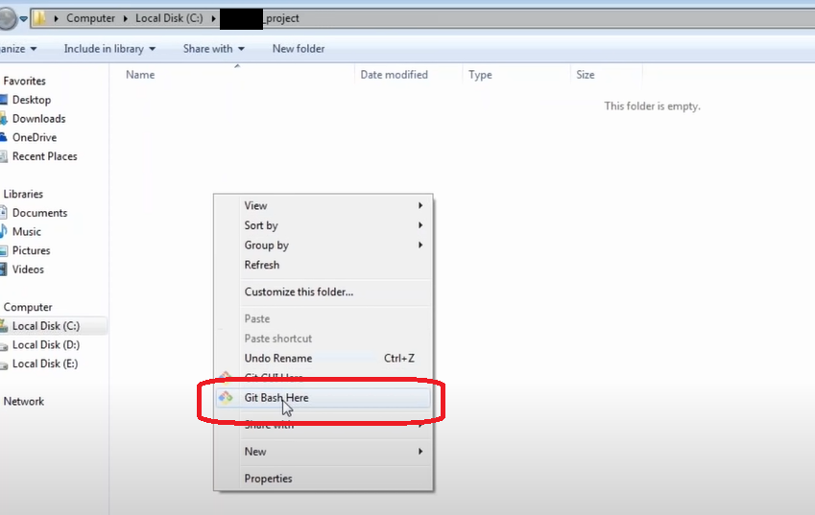

* It opens a terminal window called the git bash emulator and here type the command to create a local repository as follows

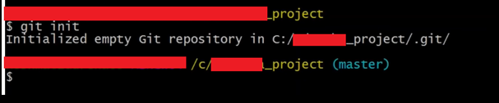

* You can see the **.git** folder created in that directory

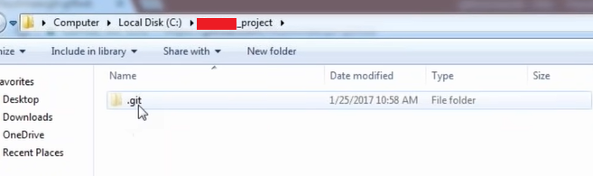

* It contains all the configurations and the object details and everything
* So, your repository is initialized and this is going to be your local repository

